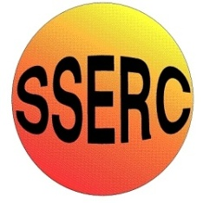
Chemical Demonstrations
Ether Runway

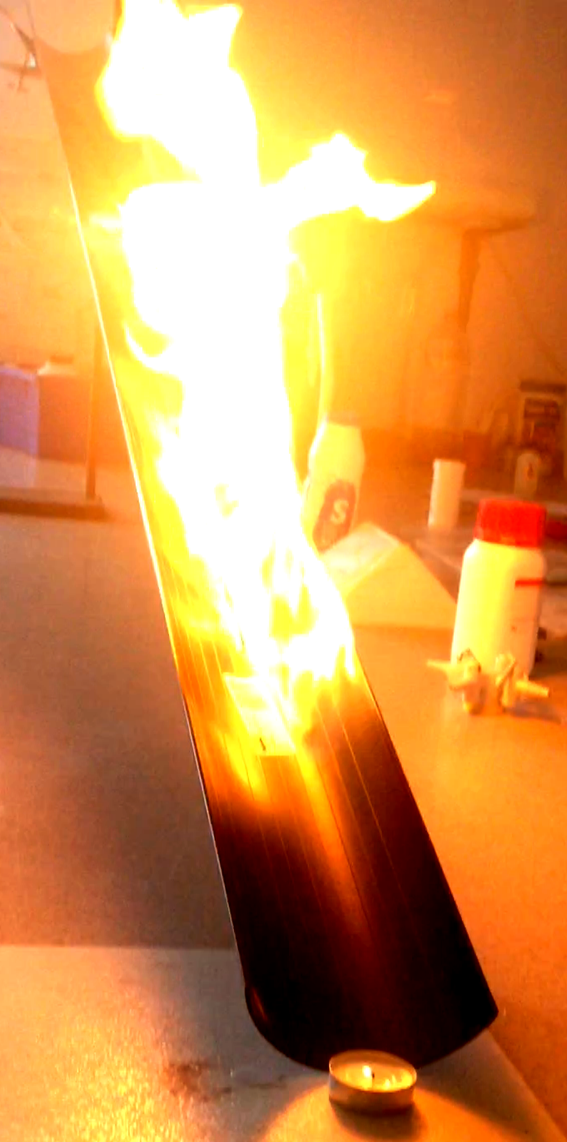
Introduction
This reaction can be applied to curriculum for excellence.
Through experimentation, I can identify indicators of chemical reactions having occurred ...
SCN 3-19a
N3 – Nature’s Chemistry
- Fuels and energy

CfE Advanced Higher – Organic Chemistry and Instrumental Analysis
- Ethers
Liquids that vaporise easily at ambient temperature to form heavy vapours pose particular hazards during handling e.g. when transferring from one container to another, or when spilled.
Petrol is the most common of these fluids and serious accidents have occurred during handling due to flashback from sources of ignition often at considerable distance away. Because the heavy vapour spreads along the ground it does not readily defuse into the air and become diluted below its explosive/flammable limit so the, even outdoors, it can be very dangerous. People attempting to kindle garden fires or BBQ’s with petrol have all too often been engulfed in flames due to the spread of the vapour beyond the intended area. Similarly liquid petroleum gas (LPG) has also caused appalling accidents when ‘fire balls’ have formed due to the ignition of dense clouds of the gas. Butane has a density of more than twice that of air.
These experiments attempt to simulate, and so demonstrate, this phenomenon. Ethoxyethane is used because it has a combination of high vapour pressure (440mm Hg at 20C) and density (2.55 {air = 1}) and has been responsible for many accidents in the laboratory and the chemical industry where it is often used as a solvent in chemical processes.
You will need
Face shield | Heat-resistant gloves
Length of guttering or other open tubing | Ethoxyethane
Heat resistant mats | Tealight or candle
Safety screens | The class will require eye protection

Cotton wool* (optional)

* Some versions of this experiment suggest soaking the ethoxyethane onto a ball of cotton wool at the top of the ‘runway’. In theory, this will help to emphasise that it is the fumes igniting. In practice, we found it difficult without using a significantly larger amount of ethoxyethane with its attendant risks.
Preparation
- Teacher should wear eye protection. Heat resistant gloves may be considered but may make handling the ethoxyethane more difficult.
- Class should wear eye protection and must be kept not less than 4 metres back.
- Safety screens must be positioned and secured to protect both students and the demonstrator.
- The experiment must not be carried out below a light fitting.
- Set up a length of guttering or similar so that one end is about 75 cm or so above the other – the top can be supported by a clamp.
- Position the bottom end on some heatproof mats.
- Place a tealight at the bottom of the channel.
- Measure out 5 – 10 cm³ of ethoxyethane and place in a container with a lid on.
The Demonstration

- Light the tealight at the bottom of the channel.
- Pour the ethoxyethane at the top of the guttering.
- The ethoxyethane will flow down the guttering but before it reaches the bottom the vapour, being heavier than air, will reach the tealight first. The tealight will ignite the vapour and the flame will travel up the channel to the source.

Safety

This demonstration can be extremely hazardous unless the procedures laid out above a strictly followed. In addition to the precautions above:
- the quantities prescribed must NOT be exceeded; do NOT be tempted to use more ether.
- Do not dispense the ethoxyethane anywhere near the flame (or any other source of ignition.

What is happening?
Ethoxyethane evaporates rapidly and produces heavier than air fumes. On reaching the flame, these vapours ignite.
Petrol behaves in a similar way so this demonstration can be used to illustrate one issue to do with fire safety.
As well as being used for teaching about fire in general, this demonstration can be linked to the more general aspects of assessing risks and taking action to reduce risks to themselves and others.

It is the responsibility of teachers doing this demonstration to carry out an appropriate risk assessment.

