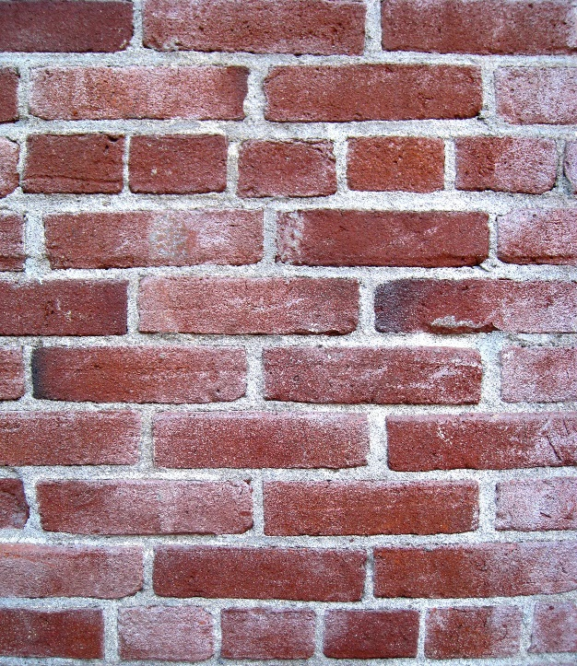

**Teacher’s Guide**

**Curriculum Links**

I have carried out research into novel materials and can begin to explain the scientific basis of their properties and discuss the possible impacts they may have on society.

**SCN 4-16a**

Through evaluation of a range of data, I can describe the formation, characteristics and uses of soils, minerals and basic types of rocks.

**SCN 3-17a**

I have helped to design and carry out practical activities to develop my understanding of chemical reactions involving the Earth’s materials. I can explain how we apply knowledge of these reactions in practical ways.

**SCN 3-19b**

Through experimentation, I can identify indicators of chemical reactions having occurred. I can describe ways of controlling the rate of reactions and can relate my findings to the world around me.

**SCN 3-19a**

**Background Information**

Concrete is the most widely used man-made material in the world. As of 2006, about 7.5 cubic kilometres of concrete were made each year—more than one cubic metre for every person on Earth.

The three basic ingredients of concrete are aggregate, cement and water.

**C:\Documents and Settings\esoc\Local Settings\Temporary Internet Files\Content.IE5\NGW7IPYO\MC900217466[1].wmfAggregates** are just chemically inert substances that are bound together by the cement. They are there to give bulk to the concrete and are not involved in the chemical processes. A common example is the stone chippings in normal concrete.

**Cement** is made by mixing **crushed clay and limestone together** and roasting it in a kiln. The roasted lumps are then ground to a fine powder.

*The resulting powder is a mixture of five chemicals. There are lots of variations but a typical composition is:*

|  |  |
| --- | --- |
| *Chemical* | *Percentage in cement* |
| *tricalcium silicate* | *50%* |
| *dicalcium silicate* | *25%* |
| *tricalcium aluminate* | *10%* |
| *tetracalcium aluminoferrite* | *10%* |
| *gypsum or hydrated calcium suphate* | *5%* |

C:\Documents and Settings\esoc\Local Settings\Temporary Internet Files\Content.IE5\RCWRPZTT\MC900151959[1].wmfWhen cement is mixed with water, its constituents are hydrated. The calcium silicates form calcium silicate hydrate, calcium hydroxide and heat.

These products contribute to the strength of the concrete.

**The chemistry of these reactions is complex.**

Cement sets when mixed with water by way of a complex series of chemical reactions still only partly understood.

1. The different constituents slowly crystallise and the interlocking of their crystals gives cement its strength.
2. When the calcium silicates first come into contact with water, reactions occurs in which calcium ions are formed and the water molecules are broken down to form hydroxide ions. It is this bond breaking that produces heat. (Tricalcium silicate reacts quickly producing a lot of heat. Dicalcium silicate reacts more slowly and produces less heat.)
3. Calcium hydroxide is not very soluble so it is soon saturated and forms a solid.
4. At the same time, calcium silicate hydrate is formed which is also a solid.
5. As long as water is in contact with the cement, these reactions continue but they get slower and slower, and can take several years to reach full strength.
6. Carbon dioxide is slowly absorbed to convert the calcium hydroxide into insoluble calcium carbonate.

The aggregate is not involved in the reaction, but forms a surface for the solids to form on. This will be easy at first, as there are large areas of water ad cement mixed together. As the solid is formed, however, there is less and less space between the grains of aggregate and silicate hydrate for the water to move around and reach un-reacted cement. This means that the reaction will slow down as the pores between the aggregate get smaller.

Starting with this basic mixture, all sorts of other substances can be added (admixtures) to give the concrete different properties.

* Some admixtures improve the workability and plasticity of the concrete so that less water is needed, improving the strength.
* Other admixtures help construction forms adapt to different environmental factors.
  + There are retarding admixtures to delay the setting time in hot climates (for example sugar).
  + There are also accelerating admixtures to speed up setting in colder climates (for example calcium chloride).

A typical concrete sets in about 6 hours and develops its strength as follows:

|  |  |
| --- | --- |
| Time after setting | Compressive strength  *In principle, the strength continues to rise slowly as long as water is available for continued hydration, but concrete is usually allowed to dry out after a few weeks and this causes strength growth to stop* |
| 24 hours | 8 MPa |
| 3 days | 15 MPa |
| 1 week | 23 MPa |
| 4 weeks | 35 MPa |
| 3 months | 41 MPa |

Prompt Natural cement also develops its strength slowly – even more so.

|  |  |
| --- | --- |
| Time after setting | Compressive strength |
| 30 mins | 4 MPa |
| 24 hours | 6 MPa |
| 10 days | 11 MPa |
| 4 weeks | 17 MPa |
| 3 months | 28 MPa |
| 1 year | 33 MPa |

There are problems, though, using cement in the classroom.

Bags of cement routinely have health and safety warnings printed on them because not only is cement highly alkaline, but the setting process is exothermic.

As a result, wet cement is corrosive and can easily cause severe skin burns if not promptly washed off with water.

Similarly, dry cement powder in contact with mucous membranes can cause severe eye or respiratory irritation. Cement users should wear protective clothing.

That is why the method we are using involves mixing the dry mortar and water in a Ziploc bag.

Appropriate precautions still need to be taken by anyone handling the dry powder. (see risk assessment)

The Prompt natural cement we are using is not as alkaline as ordinary Portland cement so is much less corrosive.

**Carbonation**

**What is carbonation?**

It is well known that making cement produces CO2. 60% of this CO2 roughly, comes from the heating of the calcium carbonate, a process called calcination.

CaCO3  🡪 CaO + CO2

What is less well known is that, during its lifespan, the cement (or concrete) reabsorbs most if not all of this CO2. This process is called carbonation.

The concrete will carbonate if CO2 from air or from water enters the concrete and reacts as follows:

  Ca(OH)2 + CO2 🡪 CaCO3 + H2O

When Ca(OH)2 is removed from the paste hydrated cement will liberate CaO which will also carbonate. The rate of carbonation depends on porosity & moisture content of the concrete.

The carbonation process requires the presence of water because CO2 dissolves in water forming H2CO3. If the concrete is too dry, CO2 cannot dissolve and no carbonation occurs.

If on the other hand it is too wet, CO2 cannot enter the air spaces in the concrete and the concrete will not carbonate. (about 50% humidity is optimal).

Normal carbonation results in a decrease of the porosity making the carbonated paste stronger. Carbonation is therefore an advantage in non-reinforced concrete. However, it is a disadvantage in reinforced concrete, as pH of carbonated concrete drops to about 7; a value below the level at which steel will rust.

**How do you recognize carbonation?**

Carbonation may be recognized in the field by the presence of a discoloured zone in the surface of the concrete. The colour may vary from light gray and difficult to recognize to strong orange and easy to recognize.

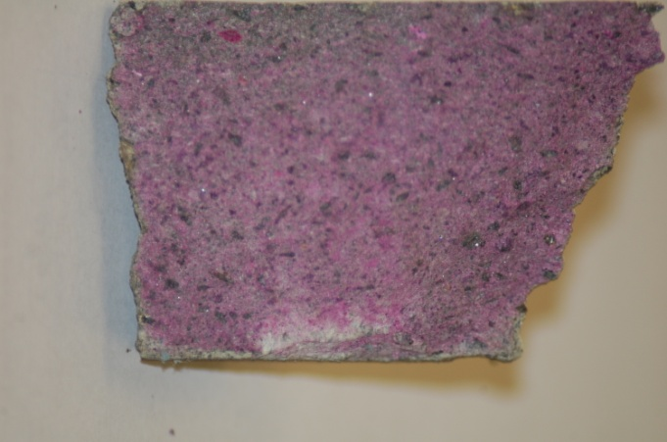Cement paste contains 25-50 wt% calcium hydroxide (Ca(OH)2), which means that the pH of the fresh cement paste is at least 12.5. The pH of a fully carbonated paste is about 7.

Because the carbonation process results in a drop in pH, it can be made easier to see by using a suitable acid/base indicator such as penolphthalein.

The photo on the right shows a thin clear layer that has not been stained by the phenolphthalein.

Theoretically, it should be possible to tell the age of a piece of concrete by looking at the depth of the carbonation but in practice that is not the case. There are so many variables, particularly the amount of water and the access of air, that two samples from the same block even may carbonate to different degrees.

**Making the mortar**

To fill one of the moulds, you will need

* 100g Prompt Natural Cement*
* 100g sand
* 65cm3 water

You can mix together the dry cement/sand mix beforehand but in this case make sure the sand is dry – builders’ sand is often quite damp.

For anyone used to working with cement, this will seem like a lot of water. The mortar mix is very runny to start with but it will set – very quickly

Within about 2 – 3 minutes (a bit longer if it is cold), the mortar will become too difficult to work with so it needs to be poured into the mould as soon as it is properly mixed.

The reaction is exothermic but not like Plaster of Paris – it is quite safe to hold while setting (in the bag!)

Anyone working with the cement mix should make sure they are aware of the risk assessment for this activity.

* The suggestion of using Prompt Natural Cement here is purely because it sets (at least initially) **much** faster – within a few minutes.

It is, however, harder to get hold of and more expensive. There is no reason at all why the same investigations cannot be done using ordinary Portland cement – it will simply take longer for the bars to set.

In this case use 1 part cement to 5 parts building sand and sufficient water to give a good texture. (More recipes can be found in a table at the back of this document)

**Acid Test**

An old piece of concrete will bubble noticeable as the acid reacts with the calcium carbonate to release CO2.

If you try this with freshly set Portland Cement, you get no bubbles – as the carbonation has not yet set in.

If you try it with the Natural Cement, you see a small amount of bubbling and if the pupils waft any gas given off towards their noses and smell it (carefully) they should just be able to pick up a faint smell of rotten eggs – hydrogen sulphide. This is produced by the action of the acid on sulphides in the clay that is part of the limestone. (Probably iron sulphide)

**Carbonation**

Carbonation is the reaction of the Calcium oxide and hydroxide in the mortar with atmospheric CO2 to produce calcium carbonate.

In simple cement/concrete, this is a slight advantage as it increases the strength. However, in reinforced concrete it causes a problem because the drop in pH (as shown by the phenolphthalein) creates conditions which allow the steel reinforcing bars to rust.

Depending on the environment, you may choose to bring in samples of concrete from different sources for the pupils to see the carbonation*.* Another option is to allow pupils to use a geological hammer (or hammer and masonry chisel) to obtain samples of concrete from various blocks, either ones lying around the area or that you have carefully placed as a sort of concrete treasure hunt. In this case, make sure they are wearing eye protection.

**Strength Test**

Depending on where this is being done, there are various options.

1. In a lab, simply prop the bar between a couple of blocks (or stools or benches) and place 100g masses on top of the bar in the centre (carefully) until it breaks.
2. In the field (if you are doing this all outside, you don’t really want to carry masses with you.

* 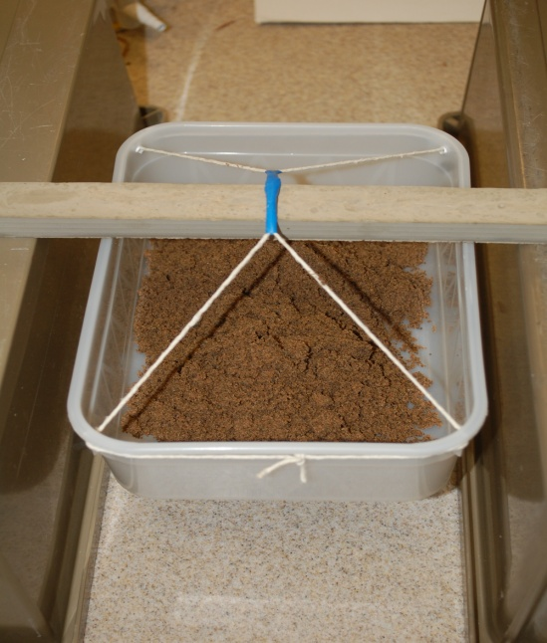You can make a simple weighing ‘boat’ using a sandwich box and some string (and perhaps some tape).
* Balance the bar across a measured gap between 2 objects (bricks, planks etc)
* Hang the weighing boat beneath the bar and add sand or gravel (or even soil) until the bar breaks (making sure your ‘boat full of sand and gravel does not fall and spill). Eg
* You can then weigh the contents – if you have a spring balance with you – or transfer the contents into a bag to take back to the lab to weigh at your leisure.

*Bars of this size made from Prompt Natural Cement, if left for about 40 minutes, will take (in our experience) a mass of between 450 and 700g to break them.*

**Further Investigations**

There are many different ways you can use this basic approach more extensively in an investigation. Here are a few.

* Investigate the strength of mortars with different composition –
  + different amounts of water,
  + different ratios of sand:cement etc.
* See what happens when you make concrete with this sort of cement.
  + What sort of aggregate makes the strongest bars?
* How can you control the setting time?
  + Citric acid slows the process. What concentration is best?
  + Do other carboxylic acids work, like vinegar?
* Can you relate the depth of carbonation of concrete to its age?



**Making the Moulds**

It is possible to make moulds for cement/concrete bars from almost anything. An easy, temporary version is to use 2 x 30cm rulers separated by a couple of pieces of wood and held together with rubber bands. (If you ‘fill’ these moulds with clingfilm to hold the mortar and place them on a flat, smooth surface, you get good bars.

However, we decided to make some slightly easier, more permanent moulds using Corriflute ™

1. Take a piece of Corriflute that is 300mm long by 14 ‘channels’ wide.
2. 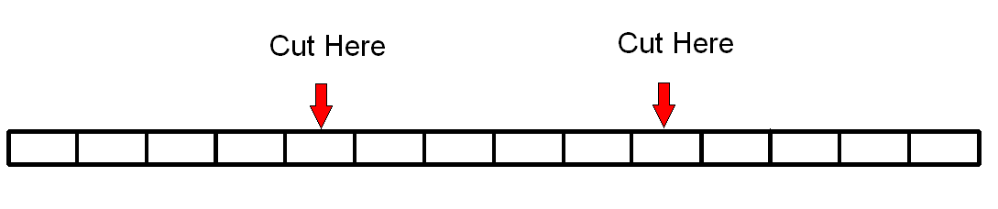Cut through the top layer along the length of two of the channels, leaving 4 whole channels on each side.
3. Tidy up the edges so you have something like this.
4. Now you need to make the end flaps.

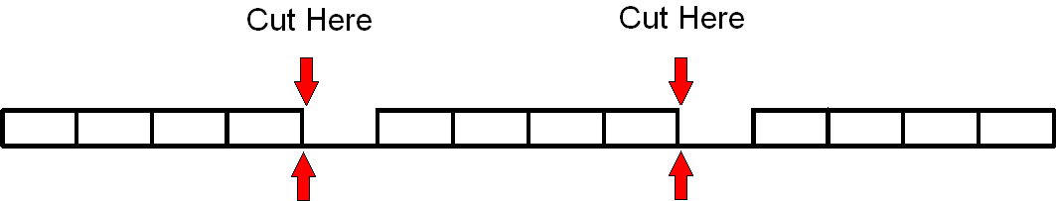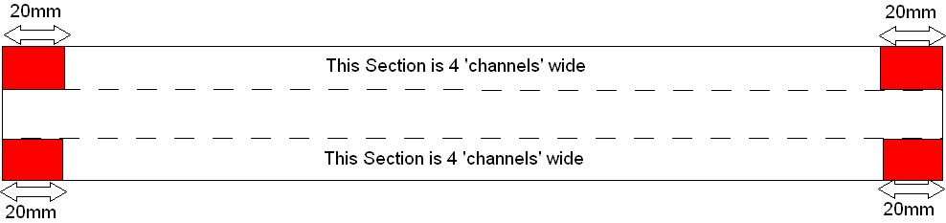**Top View**

**End view**

1. Turn the sheet over.
2. Now make a partial cut (through the top layer) across the middle section, 24mm from the end.

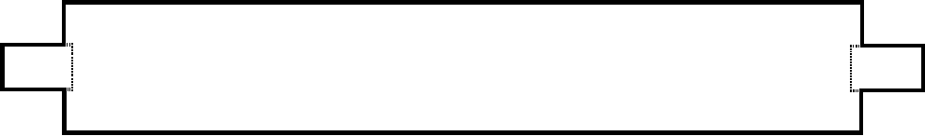

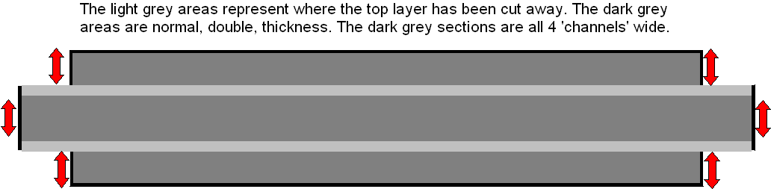

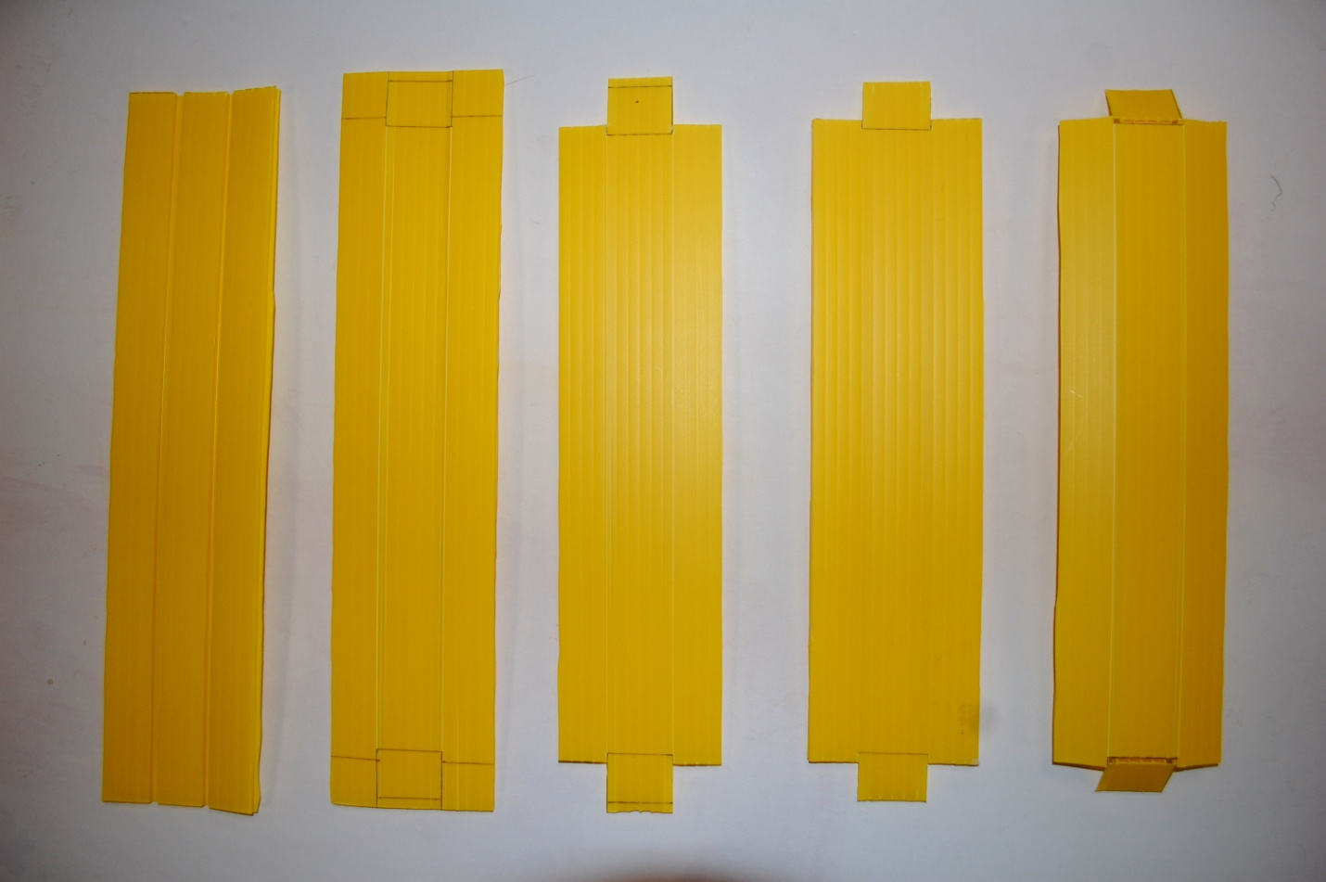



**Making the mortar**

To fill one of the moulds, you will need

* 100g Prompt Natural Cement
* 100g sand
* 65cm3 water

You can mix together the dry cement/sand mix beforehand but in this case make sure the sand is dry – builders’ sand is often quite damp.

For anyone used to working with cement, this will seem like a lot of water. The mortar mix is very runny to start with but it will set – very quickly

Within 2 – 3 minutes (a bit longer if it is cold), the mortar will become too difficult to work with so it needs to be poured into the mould as soon as it is properly mixed.

The reaction is exothermic but not like Plaster of Paris – it is quite safe to hold while setting (in the bag!)

**Carbonation**

Each group will need

* a dropping bottle (or a bottle and Pasteur pipette).
* phenolphthalein solution. (1% in ethanol – Flammable)

*(thymol phthalein will also work)*

* Samples of concrete in sealed bags (optional)*
* 50ml of 0.5M HCl (diluted slightly more so it doesn’t even rate as irritant)
* A handful of marble chips (or some small fragments of old concrete)
* A sandwich box with a lid
* A plastic drinking cup
* A pair of scissors – unless the drinking cup is already cut down.

*\* Another option is to allow pupils to use a geological hammer (or hammer and masonry chisel) to obtain samples of concrete from various blocks – using goggles)*

*If you are using the lumps of concrete, put a dot with a marker pen close to an outside edge so the pupils will know which edge to look for carbonation on*

**Acid Test**

Each group will need

* A piece of concrete
* A piece of natural cement

*(possibly a piece of fresh Portland cement mortar for comparison)*

* A dropping bottle of 0.5M HCl (or a small bottle and a Pasteur Pipette)

Pupils simply put some drops of HCl onto the concrete and see the effect.

**Strength Test**

Depending on where this is being done, there are various options.

1. In a lab, simply prop the bar between a couple of blocks (or stools or benches) and place 100g masses on top of the bar in the centre (carefully) until it breaks.
2. In the field (if you are doing this all outside, you don’t really want to carry masses with you.

* You can make a simple weighing ‘boat’ using a sandwich box and some string (and perhaps some tape).
* Balance the bar across a measured gap between 2 objects (bricks, planks etc)
* Hang the weighing boat beneath the bar and add sand or gravel until the bar breaks (making sure your ‘boat full of sand and gravel does not fall and spill). Eg
* You can then weigh the contents – if you have a balance with you – or transfer the contents into a bag to take back to the lab to weigh at your leisure.

*Bars of this size made from Prompt Natural Cement, if left for about 40 minutes, will take (in our experience) a mass of between 450 and 700g to break them.*

|  |  |
| --- | --- |
| **Mortar and Concrete Recipes** | |
| **Mortar** |  |
| **Application** | **Proportions by volume** |
| **General use** (bricklaying) | 1 part cement  5 parts building sand |
| **Render** (first coat) | 1 part cement  3.5 parts building sand |
| **Floor screeds** | 1 part cement  3.5 parts building sand |
| **Concrete** |  |
| **General purpose concrete** | 1 part cement  2 parts sharp sand  3 parts 20mm gravel  **Or**  1 part cement  4 parts 20mm ballast |
| **Paving / driveways** | 1 part cement  1.5 parts sharp sand  2.5 parts 20mm gravel |
| **Fine concrete (paths, steps etc)** | 1 part cement  2 parts sharp sand  4 parts 10mm gravel |
| **Foundations** | 1 part cement  2.5 parts sharp sand  3.5 parts 20mm gravel  **or**  1 part cement  5 parts 20mm gravel |