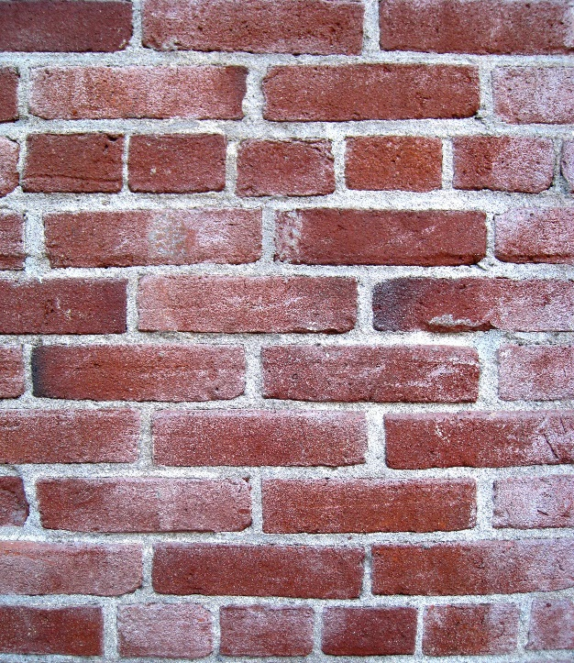



1. Measure out 65 cm3 of water and pour into the bag.
2. Take a bag of Natural cement* / sand (containing 100g of each).
3. Pour the water into the bag of cement.
4. C:\Documents and Settings\esoc\Local Settings\Temporary Internet Files\Content.IE5\2AROA0C7\MC900320984[1].wmfClose the bag and squish with your fingers to make sure the water and powder are thoroughly mixed. It will still be very runny.
5. Hold the bag in your hand (continue to squish it if you want) and feel the rise in temperature.
6. C:\Documents and Settings\esoc\Local Settings\Temporary Internet Files\Content.IE5\RCWRPZTT\MC900151959[1].wmfOnce it has set hard, place to one side (you will be using it later
7. Assemble your mould. (Fold up the ends and sides and tape them into place.)
8. Measure out another 65 cm3 of water and mix with another bag of cement/sand, just as before.

*C:\Documents and Settings\esoc\Local Settings\Temporary Internet Files\Content.IE5\NGW7IPYO\MC900217466[1].wmf(You will need to be quick as the cement becomes unworkable after 3 minutes or so)*

1. Cut the corner off the bag and pour the mortar into the mould, moving the bag up and down to get a fairly even spread. Once all the mortar is in, gently shake the mould a bit to get the mixture to settle evenly.
2. Place to one side to set

* If you are using ordinary cement to make the mortar, it takes much longer to set and you will not be able to feel a significant amount of warmth from it.

In this case, leave out steps 5 to 8 – Just mix the cement/sand mix with water in the bag and pour into the mould – there is much less hurry using this material.

**Chemical Tests**

**Reaction with acid**

C:\Documents and Settings\esoc\Local Settings\Temporary Internet Files\Content.IE5\2AROA0C7\MC900320984[1].wmfTake the piece of concrete paving slab out of its bag.

Use the dropping bottle to put a few drops of hydrochloric acid onto any of the sides without the dot on.

What happens?

Repeat the test with the Natural Cement. Is it the same? Waft any gas given off towards your nose and sniff it (carefully).

**Carbonation**

Look carefully at the side marked with a dot. Can you see anything different about the structure just near the edge nearest the dot?

Take the dropper bottle of phenolphthalein and coat that surface of the block.

C:\Documents and Settings\esoc\Local Settings\Temporary Internet Files\Content.IE5\RCWRPZTT\MC900151959[1].wmfLook again at the edge. What do you see now?

Place the lump of concrete in the sandwich box.

Take the bag of marble chips (or take some small pieces of concrete) and empty it into the cut-down drinking cup.

Place the cup in the sandwich box.

Empty the bottle of hydrochloric acid into the cup and place the lid on. Place it carefully to one side and leave for 30 minutes.

(The acid will react to produce a high level of carbon dioxide in the box.)

Open the box up and take out the concrete. What has happened to the phenolphthalein-stained side? (If you want to be sure, put some more phenolphthalein on another side to compare)

**Physical Tests**

**Strength test**

C:\Documents and Settings\esoc\Local Settings\Temporary Internet Files\Content.IE5\IK1ZEM8B\MC900318506[1].wmfTake your bar of Natural Cement out of the mould (carefully) and place it across a gap between 2 stools / tables or anything

Suspend the weighing container from the centre of the bar.

Add sand*, a spoonful at a time until the bar snaps (If it is more than a few cm from the ground/surface, be careful that the sand does not spill)

Weigh the container of sand and record the mass taken to snap the bar.

Repeat the experiment with a bar of Portland Cement (supplied)

What can you say about the strength of the two materials?

* Depending on where you are, you might be using sand, pebbles, soil or anything as a weight

C:\Documents and Settings\esoc\Local Settings\Temporary Internet Files\Content.IE5\K3T6CJFS\MC900280453[1].wmf