|  |
| --- |
| Chemical Demonstrations |
| Burning sodium in air and chlorine |

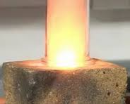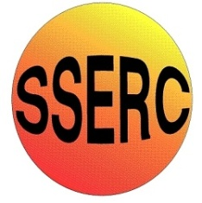

This reaction can be applied to curriculum for excellence.

*Through experimentation, I can identify indicators of chemical reactions having occurred ...* SCN 3-19a

*Having carried out a range of experiments using different chemicals, I can place metals in an order of reactivity, and relate my findings to their everyday uses.* SCN 4-19b

**N4 –** Chemistry in Society

*The properties of Metals and Alloys*

**N5 –** Chemistry in Society

*Metals*

**Introduction**

Because it reacts so violently with water, it is easy to assume that sodium reacts violently with everything. In particular, most people assume that it is highly flammable.

In this demonstration, a Bunsen burner is trained on a small piece of sodium (placed on a fire brick) and this shows just how long it takes for it to catch fire.

As an extension, if a gas jar filled with chlorine is inverted over the top of the burning sodium it will burn vigorously with a bright orange flame, producing clouds of white sodium chloride smoke.

**You will need**

|  |  |
| --- | --- |
| Sodium (a piece roughly 2-3 mm cubed | Bunsen burner |
| Scalpel, forceps and tile | Fire brick |
| Paper towel | Gas jar of chlorine |

**What you Do**

1. If it is not already prepared, cut the piece of sodium to size with a scalpel and, holding it in forceps, blot the oil off with paper towel.
2. Return the larger piece to the jar and replace the lid
3. Place the small piece of sodium on a fire brick.
4. Turn the collar of the Bunsen burner to a blue flame and, holding the Bunsen burner in your hand, point the hottest part of the flame at the piece of sodium.
5. From time to time take the flame away so the audience can see that the sodium is not alight. It will eventually catch fire shortly after melting.
6. The sodium burns steadily with a small, orange flame.
7. Take the gas jar of chlorine, in one smooth movement take the lid off and invert the jar over the burning piece of sodium so it is standing on the brick.
8. The flame will greatly increase in size and brightness and clouds of white smoke will appear.
9. Leave it alone until the sodium goes out then slide the lid of the gas jar underneath it back onto the jar.

**Safety**

Wear eye protection

Make sure the brick is dry.

**Notes**

If you invert the gas jar quickly enough only a minimal amount of chlorine will escape – practice a few times until you are confident.

Although we have not known a gas jar to break in this demonstration, if you are more comfortable, either hold the jar in a pair of tongs or use gloves.

**It is the responsibility of teachers doing this demonstration to carry out an appropriate risk assessment.**