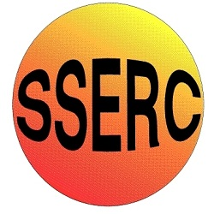

|  |
| --- |
| Chemical Demonstrations |
| Belousov-Zhabotinskii reaction |

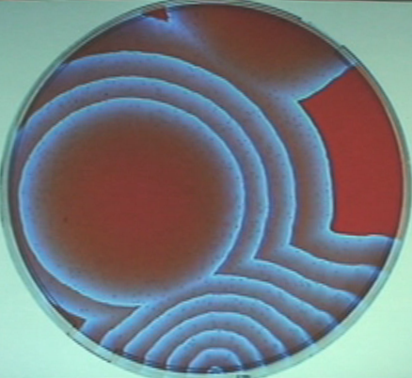

This reaction can be applied to curriculum for excellence.

*Through experimentation, I can identify indicators of chemical reactions having occurred ...*

SCN 3-19a

**Introduction**

This is a variation of the Belousov Zhabotinskii reaction. The colours produced are red and blue, and the system can oscillate both in time and in space, generating a pattern of ever widening concentric circles. The reaction is extremely sensitive to chloride ion, so all chloride must be excluded.

Initially the solution is red in colour. After a while, tiny blue spots will start to appear. Each spot will slowly expand, eventually producing a series of concentric rings. The reaction may continue for half an hour, or even longer.

The reaction is carried out in a 9-cm Petri dish.

**You will need** the following solutions:

**Solution A** - 5 g NaBrO3 dissolved in 100 cm3 water

**Solution B** - l0g NaBr dissolved in 100 cm3 water

**Solution C** - l0g malonic acid dissolved in 100 cm3 water

**Solution D** - 6M H2S04

**Solution E** - Ferroin solution: 1.35 g 1, l0 -phenanthroline (not the hydrochloride) + 0.7 g FeSO4 dissolved in 100 cm3 water

**What to do**

1. place about 5 cm3 of A in a beaker and add 1 cm3 each of B, C, and D.

*The mixture will be yellow because of bromine production.*

1. Swirl the beaker until the yellow colour completely disappears.
2. Then add 1 or 2 cm3 of E (the ferroin indicator solution), and swirl to mix.
3. Pour the mixture into a Petri dish, swirl the dish to make sure the mixture is homogeneous, and then and set the dish on an overhead projector stage.

In order to restart the process at any time, simply swirl the dish until the colour is homogeneous again.

(Potassium bromate or bromide can be used in place of the sodium salt.)



**Safety**



Wear eye protection Wear gloves

**It is the responsibility of teachers doing this demonstration to carry out an appropriate risk assessment.**