Chemical Demonstrations
This reaction can be applied to curriculum for excellence.
Through experimentation, I can identify indicators of chemical reactions having occurred ...
SCN 3-19a
CfE Higher Chemistry
Oxidising or Reducing agents

CfE Advanced Higher Chemistry
Oxidation states of transition metals

Balls of Fire

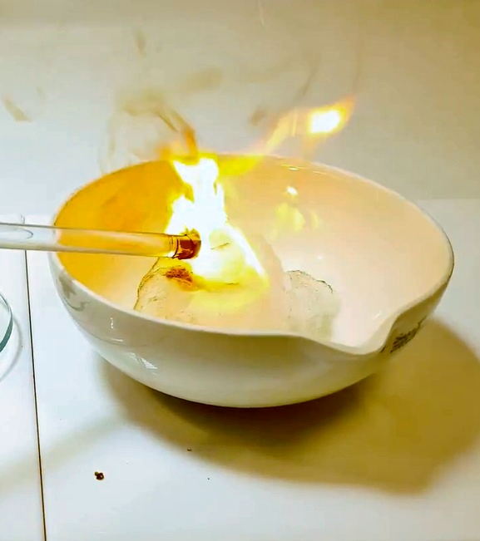
Introduction
A glass rod is dipped first into the concentrated sulfuric(VI) acid and then into solid potassium manganate(VII). The demonstrator then touches a small piece of cotton wool with the end of the glass rod that has the mixture on it. The cotton wool immediately bursts into flame.
The reaction can be made a little more spectacular if the cotton wool is first soaked in ethanol.

You will need
Goggles (BS EN166 3) | Glass rod
Cotton wool | Sulphuric acid (conc)
Potassium manganate VII (crystals) | Evaporating dish (or mat or watch glass)
Ethanol (optional) | Heat-resistant mat(s)

Preparation
- Demonstrator should wear goggles (to BS EN166 3)
- A few cm³ of concentrated sulphuric acid should be placed in a container that will allow the glass rod to dip into (a watch glass is ideal)
- Place 1-2 spatulas of potassium manganate VII crystals on another watch glass.
- Place the cotton wool in an evaporating dish (or on a heatproof mat or on another watch glass). If desired, moisten with 2-3 cm³ of ethanol.
- Students should be at least 3 m away and wearing eye protection.

The demonstration
- Dip a clean glass rod into the concentrated sulfuric(VI) acid, then into the potassium manganate(VII)
- Then, quickly, touch the cotton wool.
The cotton wool will immediately burst into flame.
- To extinguish the flame, place a second heat resistant mat over the evaporating basin.

Safety

Manganese VII oxide is an extremely powerful oxidiser and is unstable, exploding above 55°C.
At this scale, the experiment is safe but do not be tempted to try to scale it up.
Under no circumstances should the sulphuric acid and potassium manganate VII be mixed in any way other than that described.

What is happening?
As soon as the acid comes into contact with the KMnO4, small amounts of Mn₂O₇ are produced.
Initially the sulphuric acid acts as an acid, protonating the MnO^{4–} ion to form HMnO₄.
The HMnO₄, once formed, is extremely unstable and undergoes dehydration in a second reaction with sulphuric acid to form the required Mn₂O₇.
2HMnO₄ → Mn₂O₇ + H₂O
The Mn₂O₇, a drop of dark green oil, forms in situ on the end of the glass rod.
As soon as it comes into contact with the cotton wool, it aggressively oxidises the cotton wool causing it to ignite and burn rapidly. The compound is particularly unstable at room temperature and it is likely that some of the reaction seen is as a result of its own decomposition.
The products are MnO₂ and O₂ but Ozone (O₃) is also produced, giving a strong smell to the substance. It is thought to be the ozone that causes the spontaneous ignition of the cotton wool.

It is the responsibility of teachers doing this demonstration to carry out an appropriate risk assessment.

