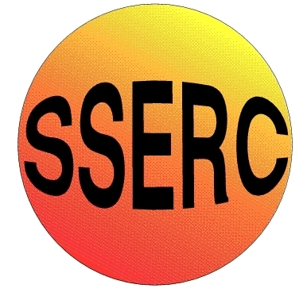
SSERC Risk Assessment (revised version November 2009)
(based on HSE ‘5 steps to risk assessment’)

2 Pitreavie Court, South Pitreavie Business Park, Dunfermline KY11 8UB
tel : 01383 626070 fax : 01383 842793
e-mail : sts@sserc.org.uk web : www.sserc.org.uk

Activity assessed | Belousov-Zhabotinskii reaction
Date of assessment | 8/20/2018
Date of review (Step 5)
School
Department

Step 1 | Step 2 | Step 3 |  | Step 4
List Significant hazards here: | Who might be harmed and how? | What are you already doing? | What further action is needed? | Action by whom? | Action by when? | Done
Potassium bromate is (and sodium bromated probably is) a carcinogen as well as being toxic if ingested and oxidizing.  Malonic acid and iron II sulphate are harmful and an irritant  6M H₂S0₄ is corrosive  1,10 phenanthroline is toxic if ingested  Reaction mixture gives off bromine.  Reaction mixture is corrosive, due to sulphuric acid, and carcinogenic, due to the bromate. | Teacher/technician preparing solutions by inhalation or splashes.  Teacher/technician preparing solutions by inhalation or splashes.  Teacher/technician preparing/using solution by splashes.  Teacher/technician preparing solutions by inhalation or splashes.  Teacher/technician or bystanders preparing solutions by inhalation  Teacher/technician carrying out reaction or clearing away by splashes. | Wear goggles (BS EN166 3) and gloves. Avoid raising dust. Keep away from combustible materials  Wear eye protection. Avoid raising dust.  Wear goggles (BS EN166 3) or a face shield for diluting concentrated acid and follow appropriate guidance. Wear goggles (BS EN166 3) when using solution.  Wear goggles (BS EN166 3) and gloves. Avoid raising dust.  The amount of bromine released is small. Work in a well-ventilated laboratory or in a fume cupboard.  Wear goggles (BS EN 166 3) and gloves.

Description of activity:

To carry out the demonstration place about 5 cm³ of the bromate in a beaker and add 1 cm³ each of the bromide, malonic acid and sulphuric acid..
The mixture will go yellow because of bromine production. Swirl the beaker until the yellow colour completely disappears. Then add 1 or 2 cm³of E (the ferroin indicator solution), and swirl to mix. Pour the mixture into a Petri dish.
Initially red in colour, let the solution stand. After a while, tiny blue spots will start to appear. Each spot will slowly expand, eventually producing a series of concentric rings. The reaction may continue for half an hour, or even longer.

Additional comments:

This reaction looks particularly good when the pertri dish with the mixture is placed on an overhead projector and the image projected on a screen.

