Specification for the development of art work to
be displayed within SSERC HQ.

SSERC has secured the tenure of a third building within it’s Dunfermline base. This building will support the following functions:

- Ground floor – large open plan STEM learning area dedicated to early years and primary professional learning
- Upper floor – large formal and informal digital learning space.
- Upper floor – CEO office and Board room.

(a plan of the new building is attached)

We are looking to work in partnership with a school(s) to develop some art work for the following areas:

- Area 1 Main reception area of the new building - see pictures and upper floor plan attached
- Area 2 New CEO and Board rooms – see pictures and upper floor plan attached
- Area 3 The open space on the upper floor including stairwell from ground to upper floor - e pictures and upper floor plan attached
- Area 4 We are also looking for some artwork to replace current artwork in our other two buildings.

Ideally the art work for areas 2, 3 and 4 will be hangable.
The art work for areas 1 and possibly 3 could be permanent and applied directly onto the surface of the walls.
3D/Sculpture work could also feature, as could digital images as we will be installing a projector which will allow us to beam images directly onto the wall space from the upper stairwell wall to the lower stairwell wall in the new building.

Given that the core functions of SSERC relate to science, technology, engineering and mathematics (STEM), we are looking for artwork which has a STEM theme.

We would be interested in receiving an outline plan/proposal from interested schools which could be considered. Those selected will then be invited to SSERC HQ to view the new building – pre-restructuring – as part of the finalisation process.

Submission should be sent to: alastair.macgregor@sserc.scot

Please do not hesitate to make contact if you require additional information: alastair.macgregor@sserc.scot

Images of areas available for artwork

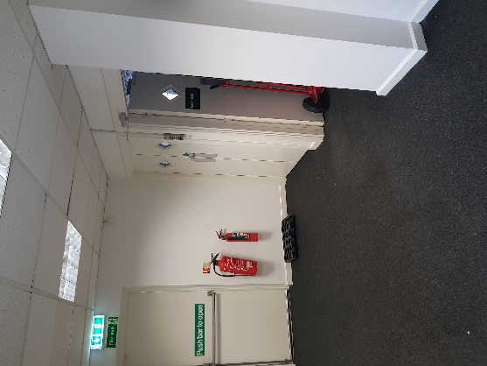
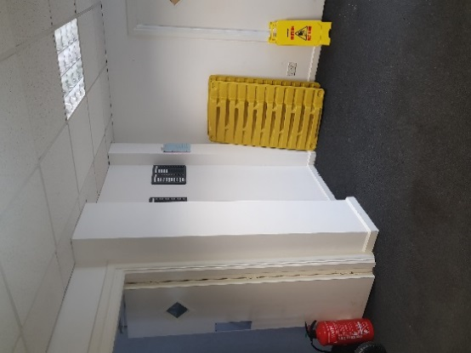
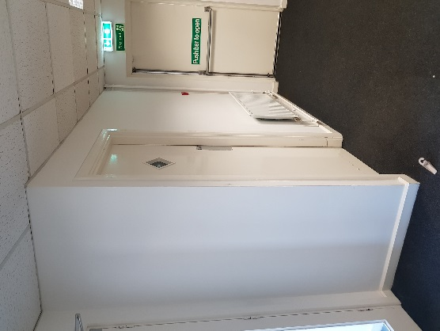

Downstairs entrance area which leads to upper floor stairs | Downstairs entrance area – left and entrance to STEM Learning space | Downstairs entrance area

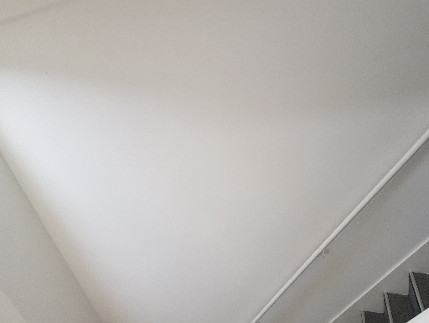
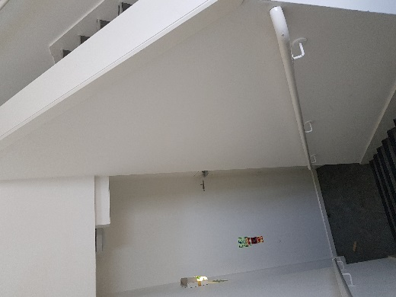
Note: all images are as the building is now – prior to any restructuring and refurbishment work.

Lower stairwell leading upstairs | Upper stairwell leading upstairs
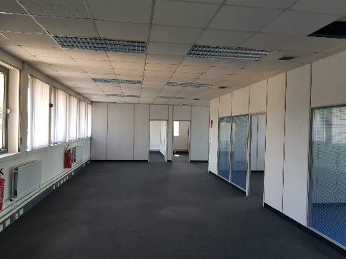
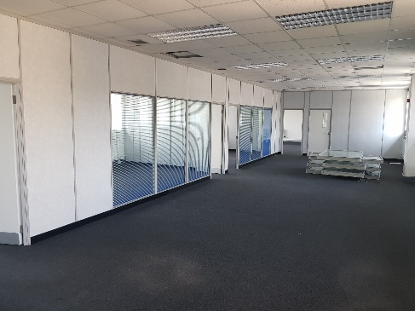

Upper floor – glass partitions will be solid walls with glass doors | Upper floor. CEO and Board room at rear. Some restructuring – see plan
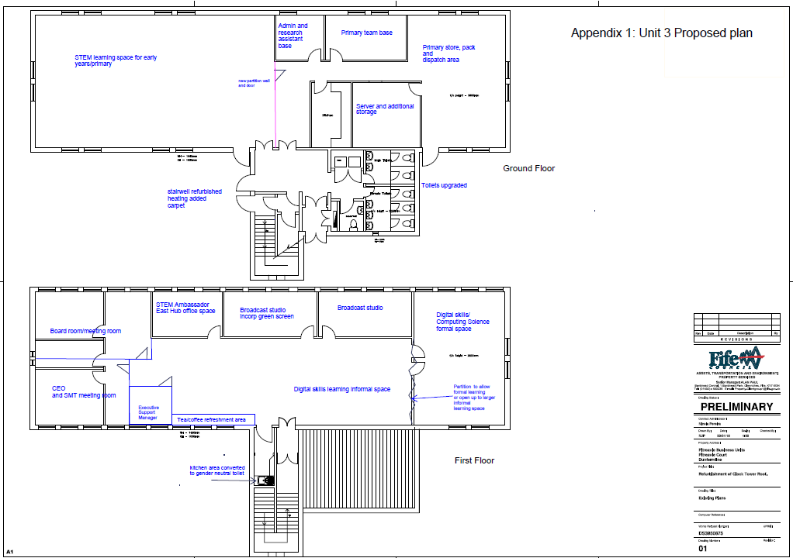
Outline Plan for new building
AREA 3
AREA 2
AREA 1

