Newton’s Thought Experiment – Investigations
Two investigations into factors affecting the range of a cannon ball in a “Newton’s Thought Experiment” were carried out.
The two investigations were–
- Horizontal range versus horizontal velocity
- Horizontal range versus launch height
Theory
According to projectile theory, in the absence of air resistance,
Range = horizontal velocity x time of flight

If the ball always falls through the same height throughout the investigation, its time of flight will always be the same.
A graph of range (y axis) versus horizontal velocity should be a straight line.

The equation that links the range of an object that is launched horizontally to the height it falls through is not covered at National 5 Physics. It is:
$$range=horizontal velocity x \text{√}\left(\frac{2 x height}{g}\right)$$
As there is a square root in the equation, a graph of range (y axis) versus height, for a constant horizontal velocity, should be a curve.

Methods for finding range
Three methods were used to find horizontal range – video, apps (which involved analysing video) and carbon paper. A sheet of carbon paper placed over a sheet of ordinary A4 was the most straightforward way of finding range. The A4 sheet was moved until, for a given height or velocity, the projectile landed on it. The carbon paper was then placed over the sheet and the run repeated three times before measurements were taken. The carbon paper leaves marks on the A4 sheet where the ball landed.

If using video, open the video using Quicktime not Windows Media Player. Quicktime allows the user to step through the video frame by frame using the left / right arrow keys, making it much easier to identify the spot where the projectile hits the ground. There has to be some object in the video frame, such as a metre stick, to give a sense of scale or to allow direct measurement. It must lie in the plane of motion. Projecting the video on to a screen will give better results.
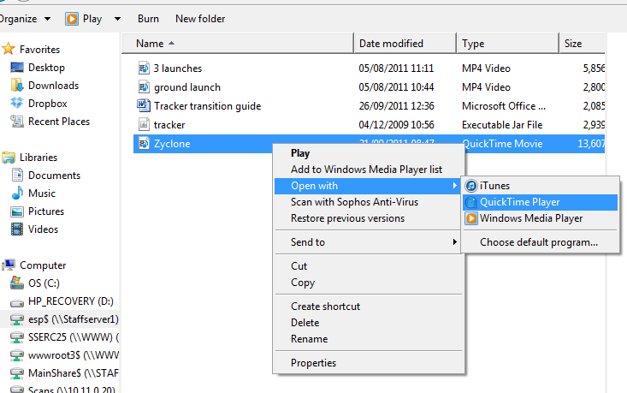
To open a video using Quicktime (if Quicktime is not the default video player):
Right-click on the video file.
Choose Open with...
Choose QuickTime Player.

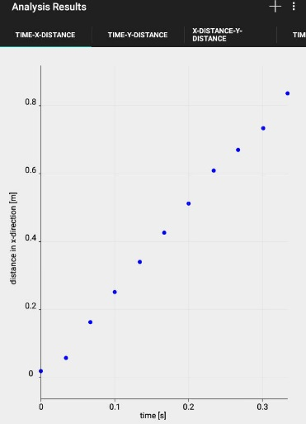
A number of apps exist that allow video footage to be taken and later analysed. Again, an object of known length must be place in the plane of motion to allow for calibration. The apps below allow the motion of an object to be followed (and its position plotted) by clicking / touching the image of the object in each video frame. The apps can produce a variety of graphs, for example horizontal displacement versus time.
Guides on using the apps are available on SSERC’s website. See:
http://tinyurl.com/physics-apps (Android / iOS)
http://tinyurl.com/SSERC-motion (PC / Mac / Linux)
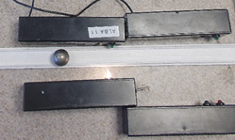

For a ramp, a piece of plastic conduit cover was used. This flexible track, used to cover channels carrying network cabling, was a good width for a ball bearing to run down. Experiments with “Hot Wheels” tracks were less successful. If cars were used, they tended to tumble in mid-air. If ball bearings were used on the wider Hot Wheels track, they tended to go from side to side.

Range versus Horizontal Velocity
Whilst it is possible to get horizontal velocity from the apps that could also be used to determine range, this proved not to be ideal. Moving objects on videos tend to be blurred, and the uncertainty involved in marking the object can translate into an unacceptable inaccuracy when the app uses this data to calculate velocity. It proved to be better to use a pair of light gates of known separation, connected to a timer. If using a TSA-type timer, set to Gap Time. The diameter of the ball bearing used was too small to use a single light gate. At N5 level, the following strategy may be the most appropriate regarding averaging results:
- Release the ball from a known height.
- Find the velocity and range.
- Repeat, releasing the ball from the same height two more times. Assume velocity is unchanged.
Some experimenters may prefer that velocity is measured each time and then averaged. Others may appreciate this simplification.
Results are shown below.
 | Range (m)
Horizontal velocity (ms⁻¹) | Try 1 | Try 2 | Try 3
0.77 | 0.315 | 0.319 | 0.322
1.15 | 0.480 | 0.475 | 0.484
1.41 | 0.598 | 0.585 | 0.591
1.64 | 0.690 | 0.683 | 0.675
1.84 | 0.763 | 0.776 | 0.764
2.01 | 0.843 | 0.838 | 0.846
2.20 | 0.918 | 0.916 | 0.920

Range versus Launch Height
The same launch ramp set up was used for this experiment. Varying the launch height by raising or lowering the end of the ramp would be difficult to do without affecting other variables such as the geometry of the track. As a result, this investigation was carried out by raising or lowering the landing area. Once again, carbon paper was used over a white sheet of paper. With no carbon paper in place, the sheet of white paper was placed on top of a stack of lab trays. The ball was released from a known position on the track and the “landing site” moved until the ball landed on the paper. The carbon paper was then placed above the white paper and three sets of readings taken for this height. Height was then altered by changing the number of trays. The experiment was then carried out with this new height difference, making sure that the ball was released from the same position on the ramp as before. Thus, horizontal velocity was kept constant for each run.
Results are shown below.

 | Range (m)
Height (m) | Try 1 | Try 2 | Try 3
0.22 | 0.46 | 0.44 | 0.45
0.39 | 0.59 | 0.59 | 0.59
0.55 | 0.70 | 0.70 | 0.70
0.72 | 0.80 | 0.80 | 0.80
0.91 | 0.89 | 0.88 | 0.89

