Newton’s Thought Experiment
Physicist Isaac Newton was born more than 300 years before the first man-made object orbited the Earth. He still managed to work out that orbiting was possible. He did this by carrying out a “thought experiment”. A thought experiment is an experiment that is impossible to do. You can only think about what would happen if it was possible. This can still be very useful.
Newton had studied the force of gravity and its effects on falling objects.
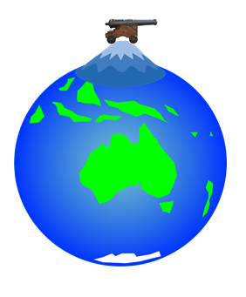
Newton imagined a cannon on top of a very high mountain. When the cannon is fired, the force of gravity on the cannon ball causes it to fall towards the Earth. The distance it travels before hitting the Earth depends on a number of factors. One is the curvature of the Earth. If the Earth’s surface was flat, the cannon ball would not travel so far before hitting the earth.

What other factors might affect the range (horizontal displacement) of the cannon ball?

If the cannon ball is fired with a greater horizontal velocity, it will travel further before reaching the surface. If it is fired with a great enough horizontal velocity it will miss the ground and travel all the way back to where it started. It will continue to orbit the earth. Faster still and it could shoot off into space.
Newton’s experiment would have been impossible to carry out because:
- There is no mountain high enough on earth;
- There was no cannon capable of launching a ball at a high enough speed to make the ball orbit;
- Air resistance would affect the ball’s motion.

Launching a ball
In the lab, factors affecting the ball’s range (the horizontal distance it travels before hitting the ground) can be investigated.
One way of launching a ball is to let it run down a track and off the end as shown below.
Range
Ball
Ramp

A “Hot Wheels” track set could also be used, though the cars sometimes tumble in mid air.
Measuring range
As the ball or car will not stop dead when it hits the ground, judging where it lands could be difficult.
Sheets of paper could be placed on the floor and covered with carbon paper. When the ball lands on the carbon paper, it causes a mark to be made on the white paper underneath.
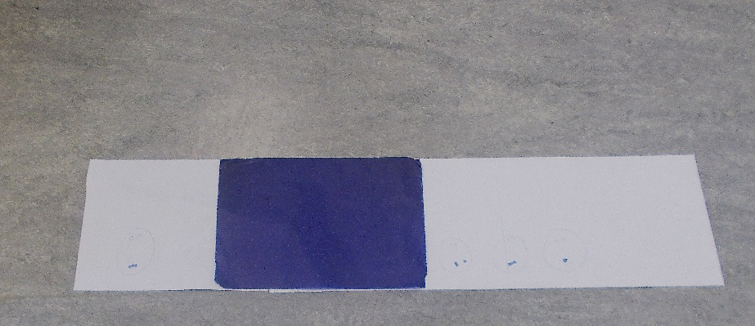

Another technique is to video the flight of the ball. If an object of known length, for example a ruler, is included in the video, a measurement of the range can be estimated by stepping through the video a frame at a time until the ball is seen to hit the ground. The ruler must be in the same plane that the ball is moving in. In other words, not behind, in front of or at an angle to the ball’s flight path.

Some computer programmes and apps allow the tracking of motion. Guides on using them are available from the SSERC website. They can plot various graphs. Some of the graphs will allow you to find the range.
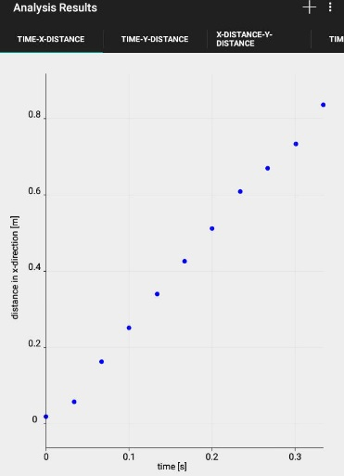
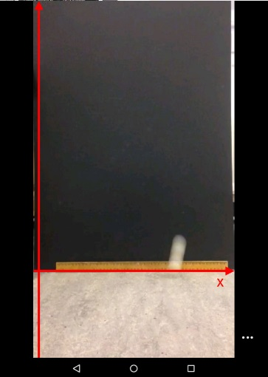
Look for:
- Tracker (PC, Mac)
- Vernier Video Analysis (iPad)
- Trackit! (Android)
- Vidanalysis (Android)

Launch velocity investigation
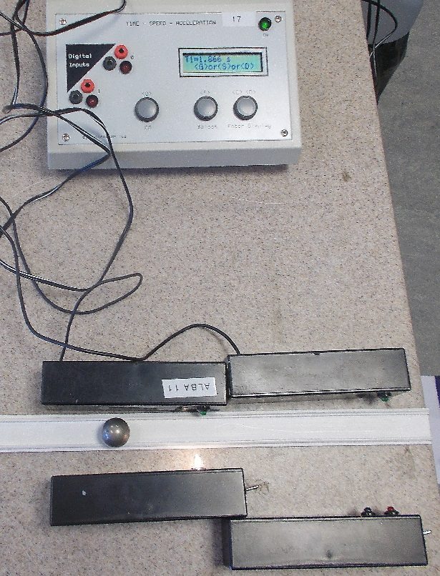
If you are investigating the effect on range of horizontal launch velocity, velocity could also be measured using a suitable app. Another method is to use two light gates and a timer.
Example method
In the following experiment, a ball bearing was used. It was released from various points on a ramp. Horizontal velocity was found by measuring the time to travel between two light gates. The separation between the light gates was also measured and velocity found from separation divided by time.
velocity = separation of light gates
time on timer

The carbon paper method was used to find range.

In this experiment, it was important that the height of the launch point above the ground was the same each time. Since horizontal velocity does not affect the time for the ball to fall, the time of flight should be constant each time the experiment is carried out.

Launch height investigation
The second investigation varied the launch height above ground and investigated the effect of this on range. This time, the experiment was carried out so that the ball always left the end of the ramp with the same horizontal velocity. Since the ball will be in flight for longer if the height is greater, the range should increase as height is increased.
Example method
The ball bearing was always released from the same point on the ramp so that the launch velocity would be the same. The carbon paper method was again used to find range. The main difficulty in this investigation was to vary the launch height without affecting the launch ramp. In the end, rather than change the height of the ramp above the ground, a landing board was raised or lowered.

