Catalase Activity in Immobilised Yeast

Teacher / Technician Guide

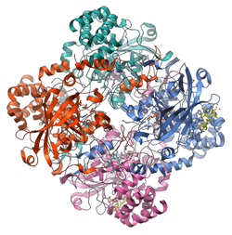
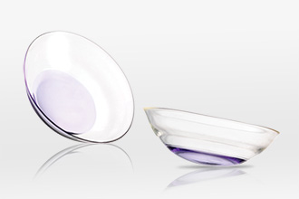
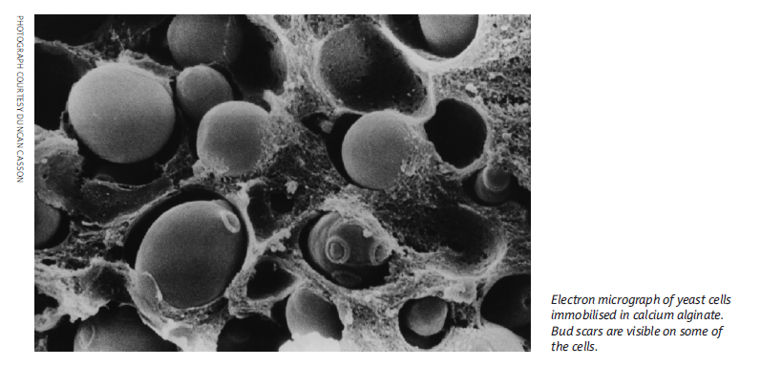

Please note - this activity has been developed by SSERC. No endorsement by SQA is implied.

National 5
Biology

Photo: Wikipedia, GDFL

Higher Physics Topical Investigation Skin Cancer—Prevention and Cure

2

Investigation Brief
Suntan creams stop harmful UV radiation reaching the skin. Manufacturers’ products are rated with a Sun Protection Factor (SPF). Suntan creams can have SPF values from 6 to over 50.
UV radiation monitors normally measure irradiance in output intensity per unit area. Thus, a typical low intensity UV lamp may emit approximately 10 mWcm^{-2.}
The aim of this investigation is to determine the effect of various suntan creams on the transmission of UV radiation. In particular, the relationship between SPF and absorption should be found.

Investigation Notes
UV lamps can be harmful. Make sure that you read the safety leaflet which is supplied with the UV lamp. Some cheap UV monitors do not measure the irradiance of UV radiation. Rather, they give an indication of UV index. It is possible to undertake this investigation with such a monitor, but results will be less reliable and accurate. UV radiation does not pass through many transparent materials (including glass). However, UV transparent acrylics are readily available.
3

National 5 Biology

Catalase activity in immobilised yeast

Teacher / Technician Guide

Curriculum links

This activity can be used to:
- provide evidence for the assignment at National 5 Biology
- provide an opportunity to study the distribution of enzymes from a range of sources

Background information

The Course Specification for National 5 Biology lists the following:

Proteins

- The variety of protein shapes and functions arises from the sequence of amino acids. Proteins have many functions such as structural, enzymes, hormones, antibodies and receptors.

- Enzymes function as biological catalysts and are made by all living cells. They speed up cellular reactions and are unchanged in the process. The shape of the active site of an enzyme molecule is complementary to its specific substrate(s). Enzyme action results in product(s). Enzymes can be involved in degradation and synthesis reactions. Examples should relate enzymes to their specific substrate(s) and product(s).
- Each enzyme is most active in its optimum conditions. Enzymes and other proteins can be affected by temperature and pH. Enzymes can be denatured, resulting in a change in their shape which will affect the rate of reaction.

Why are enzymes important in biological systems?
(A shortened version of this section appears in the Student Guide)

Let’s think about sugar. The conversion of sucrose to CO₂ and H₂O is, from a thermodynamic point of view, a favourable process. Additionally, there is a significant quantity of energy within sucrose and provided this energy can be released in a controlled way it can be utilised to drive the many reactions which take place in living systems.

Of course, you can store a bag of sugar for a long time and there will be little or no change in its composition. So, how do we, as functioning organisms, convert sucrose to CO₂ and H₂O and release the energy in that process? The answer to that conundrum is through the action of enzymes. Through the intervention of enzymes sucrose is converted into energy within the body in a matter of seconds.

Enzymes are macromolecules that act as catalysts. In general, enzymes are proteins (some RNA molecules can also function as enzymes but at this curriculum level these can be ignored). The study of enzymes is an important part of biological sciences curricula.

Measurement of enzymes and their activity continues to be an area where much elegant practical work is possible. Our belief is that practical work involving enzymes, as far as possible, should:

- be robust
- involve cheap (and readily available) substrates and enzymes
- be versatile and offer opportunities for investigative work
- be reliable
- allow students to extract enzymes from ‘living things’
- incorporate an assay that is simple to follow
- produce results in short timescales
- offer opportunities for kinetic studies.

Few enzyme systems meet all the above criteria but one which continues to be widely used in schools is the breakdown of hydrogen peroxide by catalase. Catalase is a common enzyme found in nearly all living organisms exposed to oxygen. Catalase is involved in the breakdown of hydrogen peroxide into water and oxygen:

2H₂O₂ 2H₂O + O₂

In the absence of catalase, hydrogen peroxide would become involved in oxidative damage and the production of reactive oxygen species. Consequently, catalase is crucial in protecting the cell from these potentially damaging species. It should be noted that catalase has one of the highest turnover numbers of all enzymes; each catalase molecule being capable of converting several million molecules of hydrogen peroxide molecules to water and oxygen each second [1]. From this we might infer that removal of hydrogen peroxide is a vital process.

A number of factors are known to affect the rate of enzyme-controlled reactions including:

- temperature
- pH
- substrate concentration.

Each of the above factors can be easily investigated with the protocol described below.

Commercial uses of catalase [2]

Catalase is sometimes used in the food industry for removing hydrogen peroxide from milk prior to cheese production. Another use is in food wrappers where it prevents food from oxidising. Catalase is also used in the textile industry, removing hydrogen peroxide from fabrics to make sure the material is peroxide-free. A minor use is in contact lens hygiene - a few lens-cleaning products disinfect the lens using a hydrogen peroxide solution; a solution containing catalase is then used to decompose the hydrogen peroxide before the lens is used again.

Measuring catalase activity

Several years ago, a simple method for measuring catalase activity was published [3] based on previous work by Delpech [4]. More recently Bryer [5, 6] immobilised yeast suspensions thereby producing ‘yeast balls’ and she used these in solutions of hydrogen peroxide to test for catalase activity. In principle the advantages of such an approach include:

- consistent numbers of yeast cells can be trapped / immobilised
- the number of yeast cells in a single yeast ball can be estimated using a haemocytometer
- varying the concentration of the yeast cells in the stock solution is straightforward and immobilised balls with varying numbers of yeast cells can be produced.
- the opportunities for investigations are increased.

The experiments which follow are, then, largely based on Bryer’s work [5,6] but we have adapted them to use the same apparatus as we would utilise for producing immobilised algae [7].

Materials required  - Dried yeast (2.5 g)  - Sodium alginate solution (2% w/v)  - CaCl₂ solution (2% w/v)  - Syringe (Gilson, 10 cm³ or similar - see Figure 1) to contain alginate/yeast mixture  - Tea strainer  - Distilled water (room temperature)  - Cold (fridge) distilled water  - Stock solution of hydrogen peroxide (10 vol)  - Measuring cylinders (25 cm³)  - Disposable pipettes (3 cm³) | 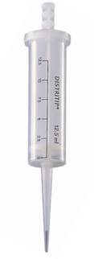  Figure 1. Gilson syringe (available from Griffin Education).

Preparing sodium alginate solution: Sodium alginate takes quite some time to dissolve and solutions are best prepared the day before experiments are planned. Dissolving, using a magnetic stirrer, may take up to 16 hours. Heating the alginate can lead to depolymerisation and is not recommended. After preparation alginate solutions can be stored in the fridge for about one week.

The basic activity involves the preparation of immobilised yeast shown schematically here:

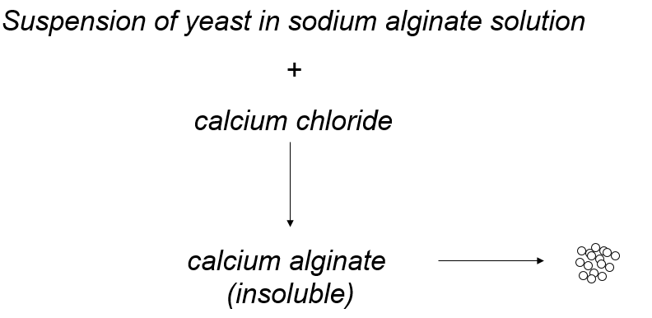

Experimental protocol  - Prepare a 10% stock solution of yeast by adding 2.5 g of yeast to a bottle which contains 25 cm³ of distilled water.  - Dispense 2 cm³ of this stock yeast solution into a clean bottle.  - Shake the yeast and add it to another bottle which contains 2 cm³ of sodium alginate solution (2%). Give this mixture a good shake.  - Place about 30 cm³ of 2% CaCl₂ solution into a plastic cup or beaker.  - Clamp the barrel of your syringe about 20 cm above the top of your plastic cup containing CaCl₂ solution (see Figure 2).  - Making sure that you have thoroughly mixed the solution prepared in 3 above, pour the yeast/alginate mixture into the syringe.  - Once all the liquid has flowed from the syringe leave the newly formed beads for about 5 min. Transfer them to a tea strainer and wash them (gently!) with cold tap water for about 1 min. Give them a final rinse with distilled water. The beads can be stored in distilled water until use. | 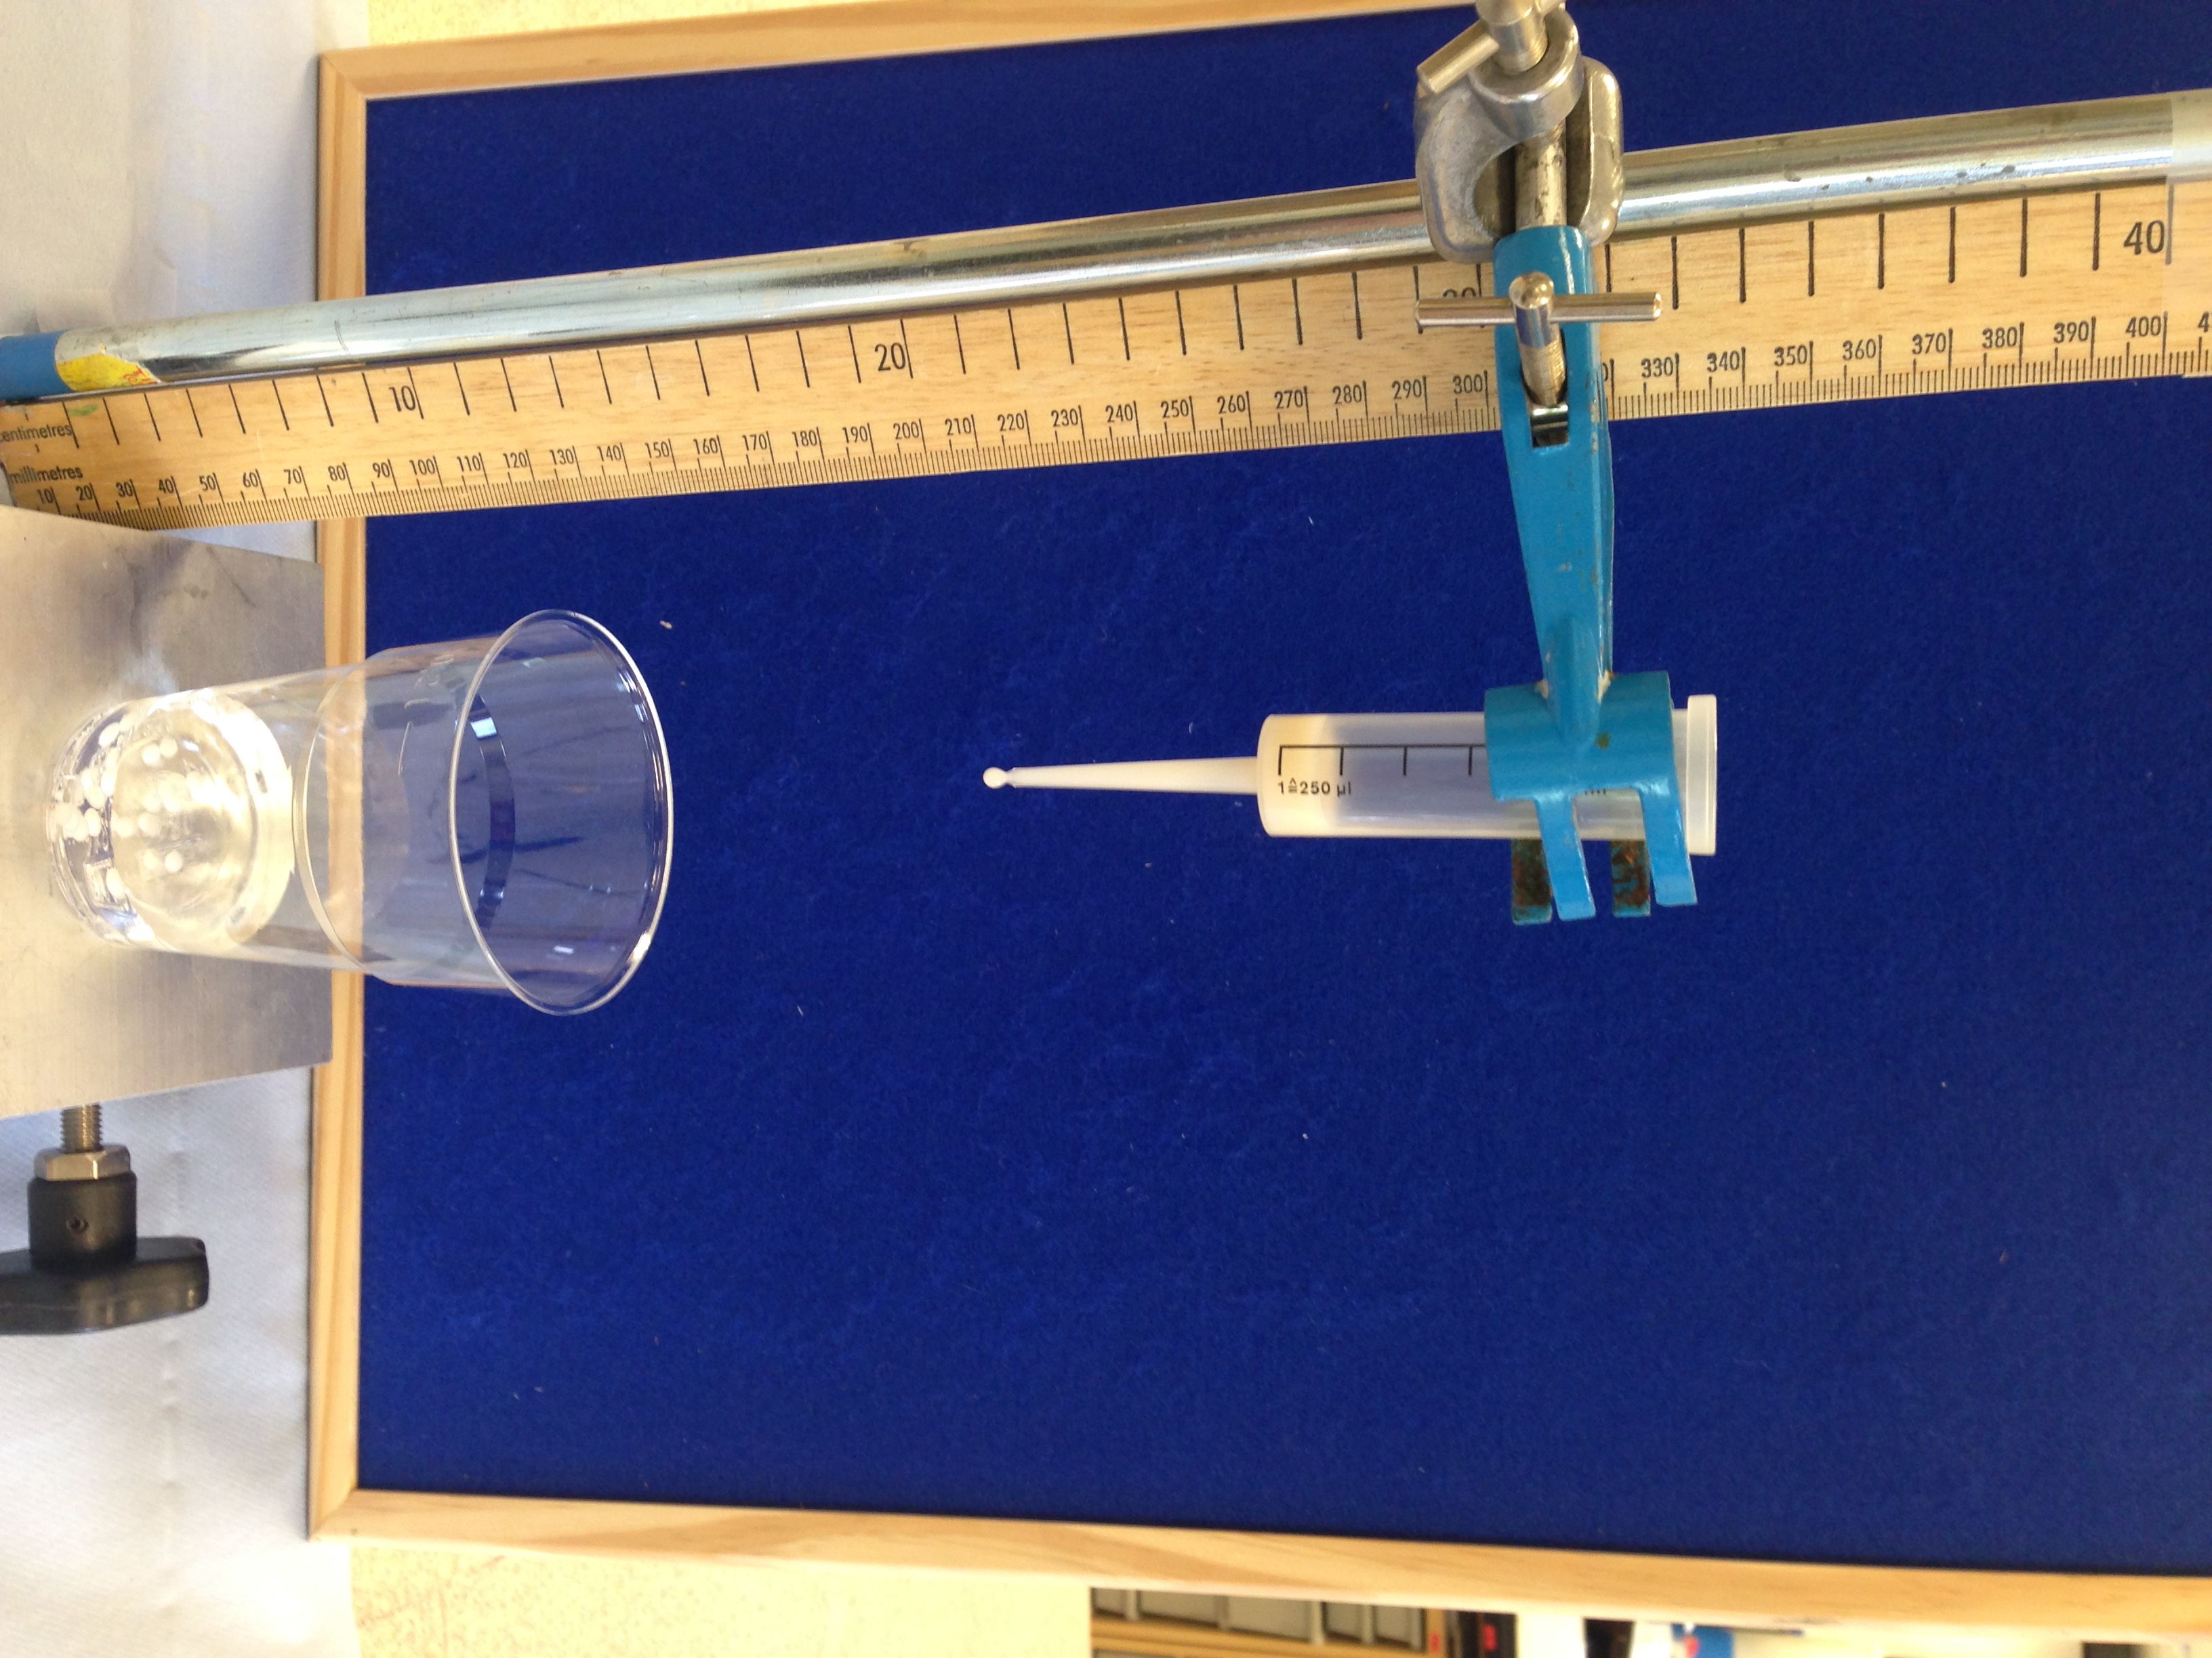  Figure 2. Experimental set-up for producing immobilised yeast.

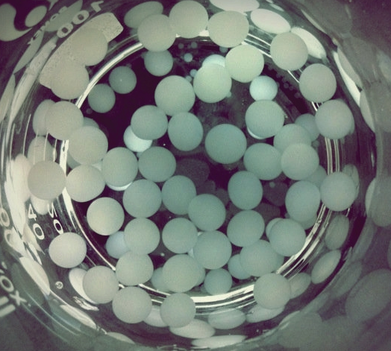  Figure 3. Immobilised yeast beads in distilled water | - Put 2.5 cm³ of the stock solution of hydrogen peroxide into a measuring cylinder (25 cm³) and add distilled water until the final volume is 25 cm³.  - Add 1 bead of the immobilised yeast, immediately start the timer and time how long it takes before it rises to the surface (the bead will probably sink to the bottom of the cylinder before rising to the surface). Repeat (3-5 measurements are recommended).
At this stage a number of possible variables can be investigated - concentration of hydrogen peroxide, temperature, pH etc. Other sources of catalase can be utilised - for example extracts from a range of fruits and vegetables can be prepared and tested for catalase activity [8].

Health and Safety

General health and safety advice on working with enzymes is available [9].

References

- Wikipedia (2018), Catalase - available at https://en.wikipedia.org/wiki/Catalase (accessed 18th May 2018).

- National Centre for Biotechnology Education (2016), Enzymes for Education: Catalase. Available at http://www.ncbe.reading.ac.uk/MATERIALS/Enzymes/catazyme.html (accessed 18th May 2018).

- SSERC (2010), Effervescent Enzymes, SSERC Bulletin, 234, 9-10.

- Delpech, R. (2003) Microscale investigations with catalase – available at: http://www.saps.org.uk/secondary/teaching-resources/293-student-sheet-24-microscale-investigations-with-catalase (accessed 18th May 2018).

- Bryer. P.J. (2016), A twist on measuring catalase, Science Teacher, 83, 69-73.

- Bryer, P.J. (2016), Exploring Catalase and Invertase Activity Using Sodium Alginate-Encapsulated Yeast (Yeast Spheres), J. Microbiol. Biol. Educ., 17, 490-491 - available at http://www.asmscience.org/content/journal/jmbe/10.1128/jmbe.v17i3.1180 (accessed 18th May 2018).

- Immobilised algae – laboratory protocol. Available at: http://info.sserc.org.uk/biology-2/biology-resources/biology-national-4/n5-cell-biology/3400-photosynthesis (accessed 18th May 2018).

- SSERC (2016), Hydrogen peroxide and immobilised yeast, SSERC Bulletin, 258, 10-13.

- ASE Health & Safety Group (2016), Topics in Safety, Topic 20: Working with enzymes. Available at http://www.ncbe.reading.ac.uk/SAFETY/PDF/EnzymeSafety.pdf (accessed 18th May 2018).

Possible websites / resources for Catalase activity in immobilised yeast

- BBC Bitesize (first broadcast May 2012), Enzyme and active sites. Available at https://www.bbc.com/education/clips/z87r87h (accessed 23 May 2018).

- Newman, T. (2018) Enzymes: How they work and what they do. In Medical news Today. Available at https://www.medicalnewstoday.com/articles/319704.php (accessed 23 May 2018).

- Novozymes website. What are enzymes? Available at https://www.novozymes.com/en/biology (accessed 23 May 2018).

- Microscale investigations of catalase activity in plant extracts. Available at http://www.nuffieldfoundation.org/practical-biology/microscale-investigations-catalase-activity-plant-extracts (accessed 23 May 2018).

- Investigating an enzyme-controlled reaction: catalase and hydrogen peroxide concentration. Available at http://www.nuffieldfoundation.org/practical-biology/investigating-enzyme-controlled-reaction-catalase-and-hydrogen-peroxide-concentrat (accessed 23 May 2018).

Other syringe systems are available – see When every drop counts… SSERC Bulletin (2017), 259, 17.

