Limiting Factors in Photosynthesis

Teacher / Technician Guide

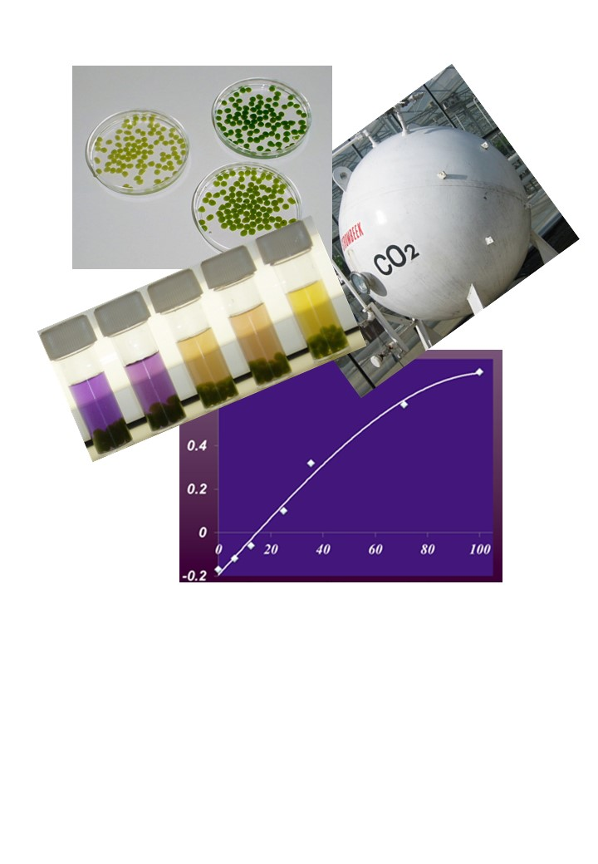

National 5
Biology

Photo: Wikipedia, GDFL

Higher Physics Topical Investigation Skin Cancer—Prevention and Cure

2

Investigation Brief
Suntan creams stop harmful UV radiation reaching the skin. Manufacturers’ products are rated with a Sun Protection Factor (SPF). Suntan creams can have SPF values from 6 to over 50.
UV radiation monitors normally measure irradiance in output intensity per unit area. Thus, a typical low intensity UV lamp may emit approximately 10 mWcm^{-2.}
The aim of this investigation is to determine the effect of various suntan creams on the transmission of UV radiation. In particular, the relationship between SPF and absorption should be found.

Investigation Notes
UV lamps can be harmful. Make sure that you read the safety leaflet which is supplied with the UV lamp. Some cheap UV monitors do not measure the irradiance of UV radiation. Rather, they give an indication of UV index. It is possible to undertake this investigation with such a monitor, but results will be less reliable and accurate. UV radiation does not pass through many transparent materials (including glass). However, UV transparent acrylics are readily available.
3

National 5 Biology

Limiting factors in photosynthesis

Teacher / Technician Guide

Curriculum links

This activity can be used to:
- provide evidence for the assignment at National 5 Biology
- provide an opportunity to study the relationship between light intensity and the rate of photosynthesis

Background information
By 2050 we will have to address the effects of several challenges including:

- the growth in the world’s population from its current (2017) level of 7.2 billion (7,200,000,000) to a predicted total of 9.7 billion (9,700,000,000) by the year 2050 – an increase of some 35%
- the demand for a more varied and higher quality diet which will require greater resources to ensure its delivery
- competition for land, water and energy is set to rise at a time when the need for us to reduce greenhouse gas levels in the atmosphere is increasingly becoming important.
- the effects of climate change will become more noticeable.

There are no simple solutions to any of the items above and to tackle the problems which we face will require that governments from across the globe work together. In terms of providing more food it seems likely that, at best, we can expect only a small (less than 10%) increase in the amount of land available for agricultural use. To feed the anticipated 35% increase in the world’s population we need to make some dramatic improvements. One area which may be important is to see how we might increase the efficiency of photosynthesis in plants used for food. To achieve this, we need to understand what factors affect the rate of photosynthesis in plants.

Photosynthesis can be described as a set of reactions through which plants produce sugars which in turn they use to produce energy which fuels their metabolism and growth. Often the process of photosynthesis is described by the following reaction:

Light + H₂O + CO₂ (sugars)

Plants obtain carbon dioxide from 2 major sources (i) directly from the atmosphere or (ii) from water. Generally, plants which grow on land obtain water through their roots whereas those plants which live in water can directly absorb it from their surroundings.

The factors known to affect the rate of photosynthesis include:

- Light intensity
- Temperature
- Carbon dioxide concentration

Classically the variation of factors is as shown in Figure 1.

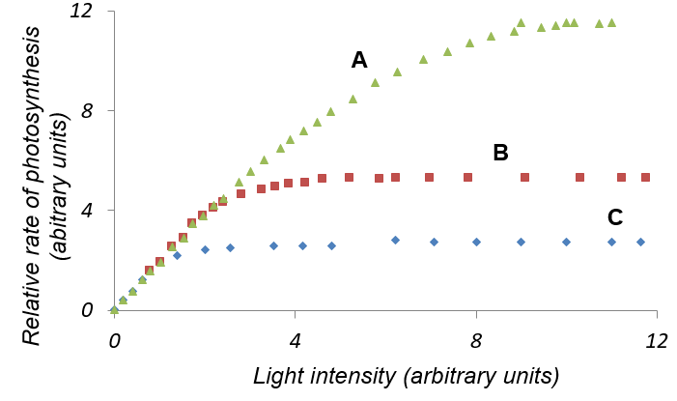
Figure 1. Effect of external factors on the rate of photosynthesis in Chlorella (plot adapted from [1]).
A - Effect of light intensity at 25ºC, 0.04% CO₂
B - Effect of light intensity at 15ºC, 0.04% CO₂
C - Effect of light intensity at 25ºC, 0.01% CO₂

The interpretation [1] of the plots in Figure 1 can be summarised as:
- At ‘low’ light intensities the rate of photosynthesis increases linearly as a function of light intensity.
- At higher light intensities the rate of photosynthesis is limited by the available CO₂ concentration and temperature.

Effect of light intensity
For ease of convenience, many schools opt to use the well-established technique involving immobilisation of algae [2] for which a kit and supporting documentation are available from the National Centre for Biotechnology Education (NCBE) [3]. In terms of investigating limiting factors, the most common experiment which is undertaken is the measurement of the effect of light intensity on the rate of photosynthesis. Using immobilised algae this is a relatively straightforward experiment to set up. Briefly, you put immobilised algae in a suitable vessel containing hydrogencarbonate indicator and place the samples in front of a light source. As CO₂ is removed from solution (and the solution becomes less acidic) the indicator will change colour and the rate of colour change can be conveniently measured using a colorimeter. Reducing the light intensity (as shown schematically in Figure 2) can be readily achieved simply by moving samples away from the light source.
Figure 2. Reducing the light intensity in photosynthesis experiments

There are some drawbacks with this method which are worth highlighting here:

- Light intensity does not fall linearly as the samples are moved away from the lamp. The inverse-square law applies and this can be a challenging concept for learners to take into account when planning experiments.
- It is important to minimise the effects of stray room lights on your samples especially those which are distant from the lamp source.
- Inadvertent shading of samples can occur unless samples are placed correctly.
- Since temperature can also affect the rate of photosynthesis any heating effects from the light source must be minimised.

An alternative way of reducing light intensity is to use so-called neutral density filters (shown schematically in Figure 3).
Figure 3. Using a neutral density filter to reduce light intensity in photosynthesis experiments

Neutral density filters are available from a number of suppliers – e.g. Lee Filters (www.leefilters.com/) who have a number of distributors throughout the UK (e.g. Black Light in Edinburgh [http://www.black-light.com/], 0131 551 2337). It is possible that your colleagues in the Drama department will have a range of suitable filters since neutral density filters are often marketed as photographic stop filters and used in lighting rigs for stage productions. Essentially a neutral density filter is designed to reduce light intensity by a given amount across all wavelengths. The filters which are available from Lee Filters include:

Lee Filters Number | Light transmitted (%)
298 | 71.0
209 | 50.0
210 | 25.0
211 | 12.5
299 | 6.25

There is no need to buy a complete set of filters. A single layer of filter Lee Filter 298 will notionally allow 71% of light to pass through. A single layer of filter 298 combined with a single layer of filter 209 would allow (0.71 x 50%) = 36% of the light to be transmitted; other filter combinations can be made.

The experimental set-up shown in Figure 4 shows how the effects of light intensity might be measured and the advantages using of neutral density filters are apparent. All samples are equidistant from the lamp, any heating effects from the lamp will affect all samples equally, room lighting complications are reduced, and the effects of shading are removed.

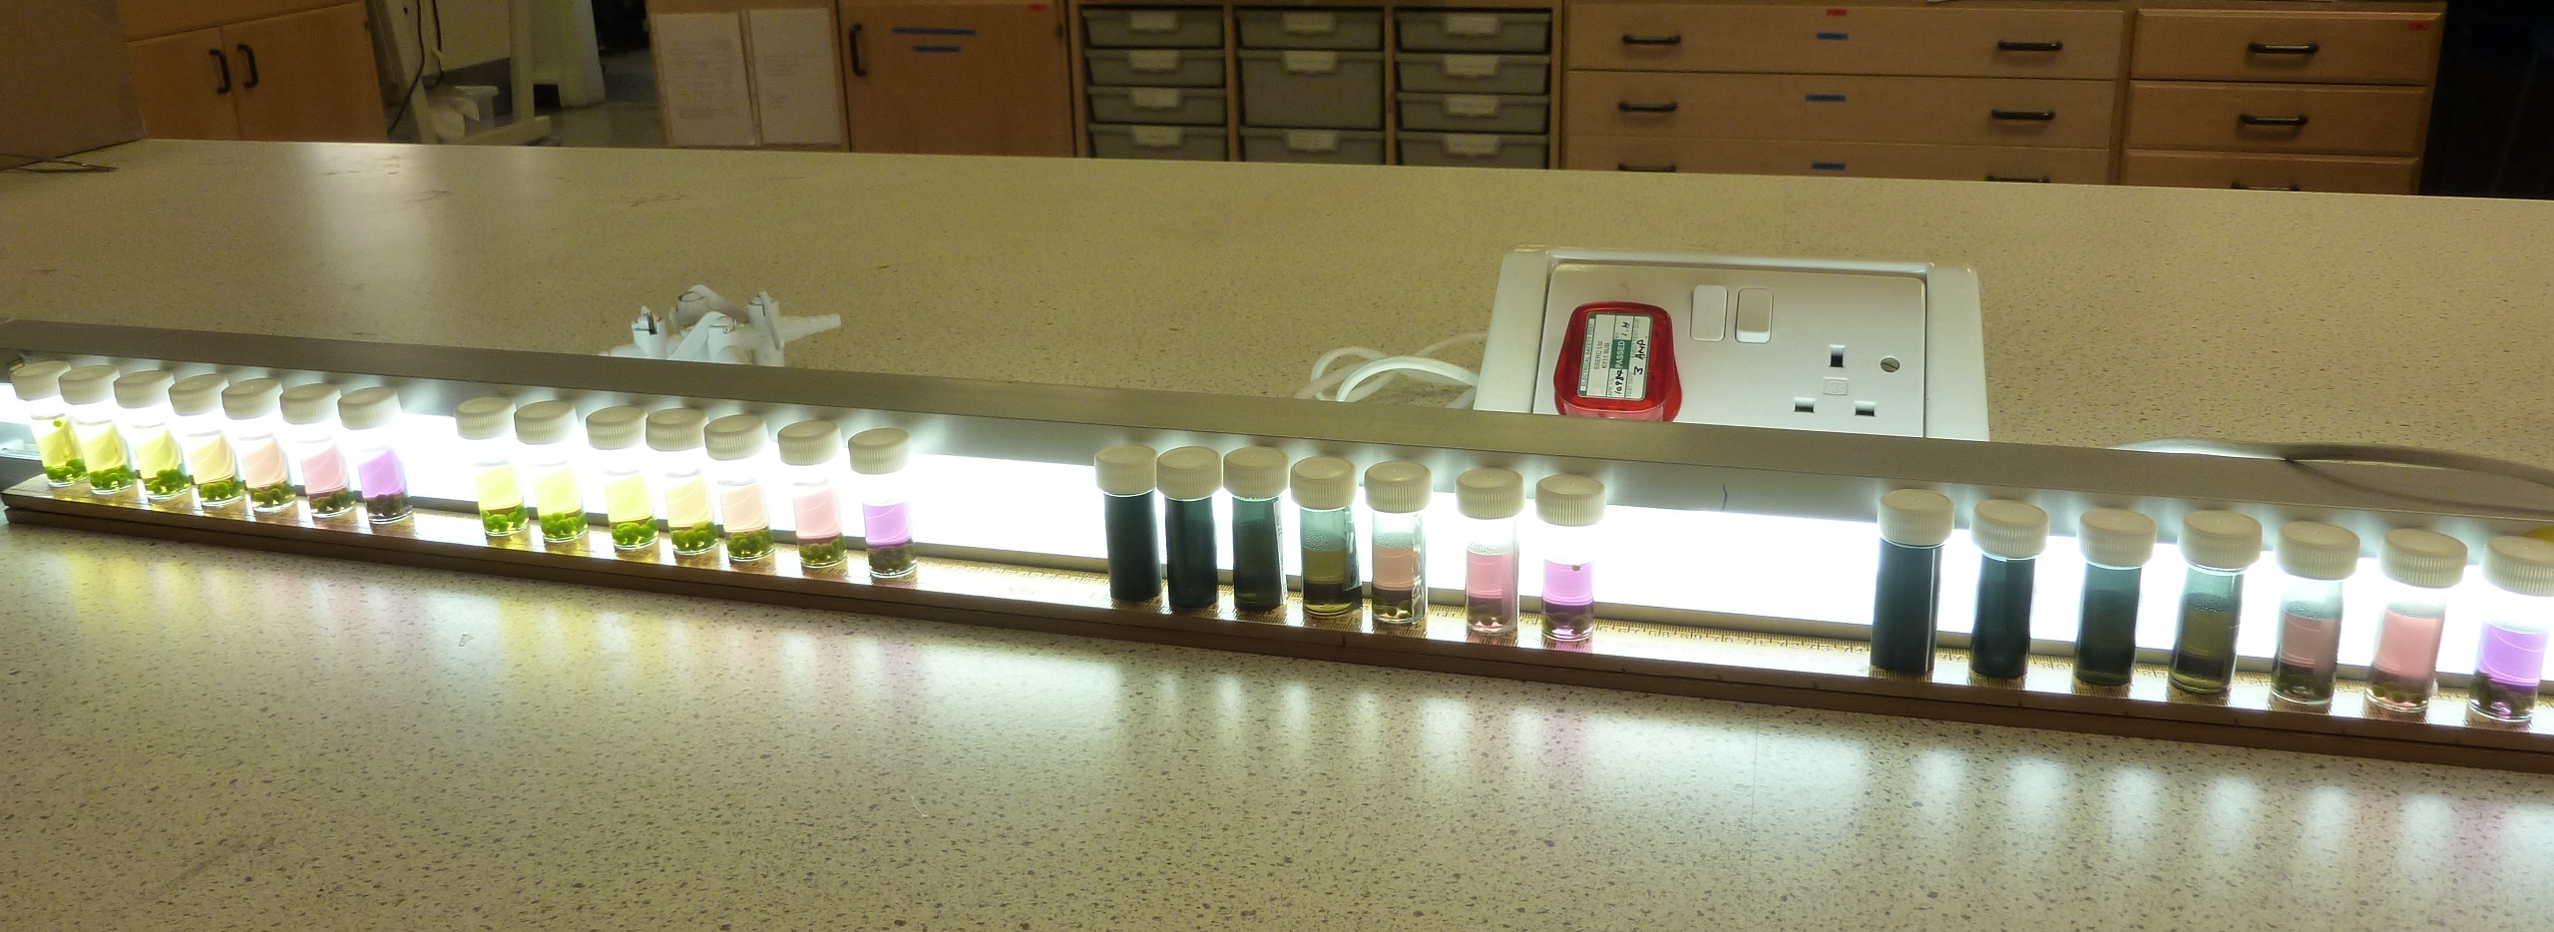

Figure 4. An experimental set-up allowing for measurement of the effects of light intensity on the rate of photosynthesis. Bijou bottles containing immobilised algae are exposed to light from a fluorescent tube; light intensity is altered by the addition of a suitable filter.

Materials required
Many of the materials required for this practical are included in the NCBE-SAPS photosynthesis kit [3]. At the time of writing (June 2017) the kit costs £71 plus VAT; some items in the kit are re-usable.

Preparing the algal culture: This needs to be done 3 - 4 weeks beforehand. Alternatively, it can be prepared earlier and 100 cm³ sub-cultures stored in the fridge for several months before required. Reproduced below are aspects of instructions that are available on the NCBE website (http://www.ncbe.reading.ac.uk/MATERIALS/Plant%20science/PDF/PhotosynthTG.pdf):
You will need:
- A clear, colourless plastic lemonade (or similar) bottle (2 dm³).
- Aquarium air pump.
- Aquarium airline tubing and airstone or glass sparger.
- Cotton wool or foam, ideally non-absorbent, for closing the top of the bottle.
- Low-temperature lighting, e.g., 18 W low-energy bulbs (equivalent to 100 W), ideally double-walled (x 2).
- Algal enrichment medium (1 dm³):
- Add 1.5 g of the enrichment medium to 1 dm³ of distilled water in a 2 dm³ lemonade bottle and shake to dissolve. Some residual powder will settle out; this is normal and it will be utilised by the algae as the soluble nutrients are depleted.
- Inoculate the bottle with the algae.
- Insert an airline to aerate the culture with an air. This will provide extra dissolved carbon dioxide and keep the algae and nutrients circulating.
- Stopper the bottle loosely with cotton wool or a foam bung. Continuously illuminate the culture with a bright light while it is growing. Small fluorescent strip lights or 18 W low-energy lamps give good results. The best results are obtained when extraneous light in the laboratory is minimised.

Preparing hydrogencarbonate indicator. It is recommended that schools prepare their own indicator since those which are available commercially often vary in quality. To make a concentrated stock of indicator (10 times the concentration required for experiments with algae) use the following protocol:
- dissolve cresol red (0.1 g) and thymol blue (0.2 g) in ethanol (IDA, 20 cm³)
- dissolve sodium hydrogencarbonate (0.85 g) in freshly boiled distilled water (200 cm³)
- add the solution of cresol red and thymol to the distilled water and make to 1 dm³ with freshly boiled distilled water.

For use in experiments:
- dilute the indicator (use 1 part indicator to 9 parts freshly boiled distilled water) prepared above
- adjust the pH to approximately 7.4
- aerate the solution prior to use.

Preparing sodium alginate solution: Sodium alginate takes quite some time to dissolve and solutions are best prepared the day before experiments are planned. Dissolving, using a magnetic stirrer, may take up to 16 hours. Heating the alginate can lead to depolymerisation and is not recommended. Alginate solutions can be stored in the fridge for about one week.

Preparing apparatus: Due to the sensitive nature of hydrogencarbonate indicator all apparatus used must be clean. Ideally, syringes, beakers, Bijou bottles and cuvettes should be flushed with a little orange hydrogencarbonate indicator. Any pieces of apparatus changing the colour of the indicator should be replaced.

Equipment List (per group)

- Bijou containing concentrated algal suspension (3 cm³)  - Bijou containing sodium alginate solution (3%, 3 cm³)  - 8 empty Bijou bottles  - stand + clamp  - disposable plastic cup  - solution of CaCl₂ (2%, 30 cm³)  - syringe (10 cm³) to contain alginate/algae mixture (see Figure 5)  - tea strainer  - disposable syringe (5 cm³) or pipette  - hydrogencarbonate indicator solution (~ 40 cm³)  - marker pen  - distilled water  - tea spoon / tweezers (plastic)  - neutral density filters:  - 71% (x 2), 50% (x 2), 25%, 12.5%, 6.25%  - black filter  - cuvette | 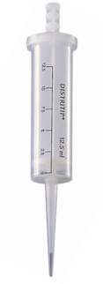  Figure 5. Gilson syringe (available from Griffin Education).

Materials to be shared
- Light source (e.g. fluorescent tube, microscope lamps of same wattage, sunny windowsill)
- Colorimeter

Additional Notes

Depending on the time available it may not be possible to complete the various protocols in a single lesson. If this is the case then samples can be kept for colorimeter reading at later times provided that:

- Hydrogencarbonate indicator is removed from the immobilised algae once the lamp is switched off (failure to do this will mean that as the algae respire colour changes will be reversed).
- When removing hydrogencarbonate indicator in step (i) above it is important to make sure that no carbon dioxide is inadvertently added during the process. We recommend using disposable pipettes from which air has been removed prior to their insertion into the bottles containing immobilised alga/indicator.
- Samples can be kept in the fridge in sealed containers until it is convenient to measure their absorbance.

References
- Hall, D.O. and Rao, K.K. (1999) Photosynthesis, 6th Edition, Cambridge University Press, pp. 24-26.
- Eldridge, D. (2004) A novel approach to photosynthesis practicals, School Science Review, 85, 37-45. (Copies of this paper can be downloaded from the NCBE website - http://www.ncbe.reading.ac.uk/MATERIALS/Plant%20science/PDF/SSR_Eldridge.pdf).
- NCBE (2013), NCBE-SAPS Photosynthesis kit. Available at: http://www.ncbe.reading.ac.uk/MATERIALS/Plant%20science/photosynkit.html.

Possible websites / resources for Limiting Factors in Photosynthesis activity

- Marsh, C., Simms, J., Stevenson, C., Torrance, J. and Fullarton, J. (2013), National 5 Biology with Answers, Hodder Gibson.

- Moffat, G. and Dickson, B. (2013), How to Pass, National 5 Biology, Hodder Gibson.

- Cook, M. and Thornhill, F. (2013), National 5 Biology (Bright RED Study Guides), Bright Red Publishing.

- BBC Bitesize Science - http://www.bbc.co.uk/schools/gcsebitesize/science/add_aqa/photosynthesis/photosynthesisrev1.shtml (accessed 12th June 2017).

- Rate of photosynthesis: limiting factors - http://www.rsc.org/learn-chemistry/content/filerepository/CMP/00/001/068/Rate%20of%20photosynthesis%20limiting%20factors.pdf (accessed 12th June 2017).

- The SSERC website has a range of activities related to the use of immobilised algae. Detailed protocols and associated activities can be accessed via http://www.sserc.org.uk/biology-2/biology-resources/biology-national-4/n5-cell-biology/3400-photosynthesis and http://www.sserc.org.uk/biology-2/biology-resources/higher-biology-revised/sustainability-a-interdependence/3747-the-science-of-food-production-2. Data sets are also available via http://www.sserc.org.uk/higher-biology-revised (accessed 12th June 2017).

- ‘Algal balls' - Photosynthesis using algae wrapped in jelly balls’ - http://www.saps.org.uk/secondary/teaching-resources/235-student-sheet-23-photosynthesis-using-algae-wrapped-in-jelly-balls (accessed 12th June 2017). Follow the links to SAPS - Photosynthesis with Algal Balls - Teachers notes to see sample data using the protocol outlined in this document.

Data taken from http://www.worldometers.info/world-population/#table-forecast – accessed June 12th 2017
Other syringe systems are available – see When every drop counts… SSERC Bulletin (2017), 259, 17.

