Limiting Factors in Photosynthesis

Student Guide

National 5
Biology
Photo: Wikipedia, GDFL

Higher Physics Topical Investigation Skin Cancer—Prevention and Cure

2

Investigation Brief
Suntan creams stop harmful UV radiation reaching the skin. Manufacturers’ products are rated with a Sun Protection Factor (SPF). Suntan creams can have SPF values from 6 to over 50.
UV radiation monitors normally measure irradiance in output intensity per unit area. Thus, a typical low intensity UV lamp may emit approximately 10 mWcm^{-2.}
The aim of this investigation is to determine the effect of various suntan creams on the transmission of UV radiation. In particular, the relationship between SPF and absorption should be found.

Investigation Notes
UV lamps can be harmful. Make sure that you read the safety leaflet which is supplied with the UV lamp. Some cheap UV monitors do not measure the irradiance of UV radiation. Rather, they give an indication of UV index. It is possible to undertake this investigation with such a monitor, but results will be less reliable and accurate. UV radiation does not pass through many transparent materials (including glass). However, UV transparent acrylics are readily available.
3

Limiting Factors in Photosynthesis

Student Activity Guide

By 2050 we will have to address the effects of several challenges including:

- the growth in the world’s population from its current (2017) level of 7.2 billion (7,200,000,000) to a predicted total of 9.7 billion (9,700,000,000) by the year 2050 – an increase of some 35%.
- the demand for a more varied and higher quality diet which will require greater resources to ensure its delivery
- competition for land, water and energy is set to rise at a time when the need for us to reduce greenhouse gas levels in the atmosphere is increasingly becoming important.
- the effects of climate change will become more noticeable.

There are no simple solutions to any of the items above and to tackle the problems which we face will require that governments from across the globe work together. In terms of providing more food it seems likely that, at best, we can expect only a small (less than 10%) increase in the amount of land available for agricultural use. To feed the anticipated 35% increase in the world’s population we need to make some dramatic improvements. One area which may be important is to see how we might increase the efficiency of photosynthesis in plants used for food.

To achieve this, we need to understand what factors affect the rate of photosynthesis in plants. There are a number of methods that can be used to investigate these factors..
Your teacher will be able to advise which method would be most appropriate depending on the equipment which is available to you.

Method 1 – using neutral density filters

- You are provided with two small bottles, one containing a concentrated solution of Scenedesmus quadricauda (a green alga) and the other a solution of sodium alginate. | 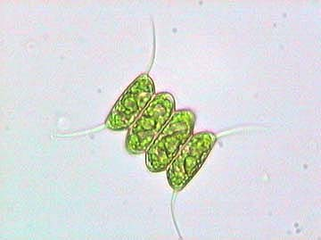  Scenedesmus quadricauda (see link for source of image)

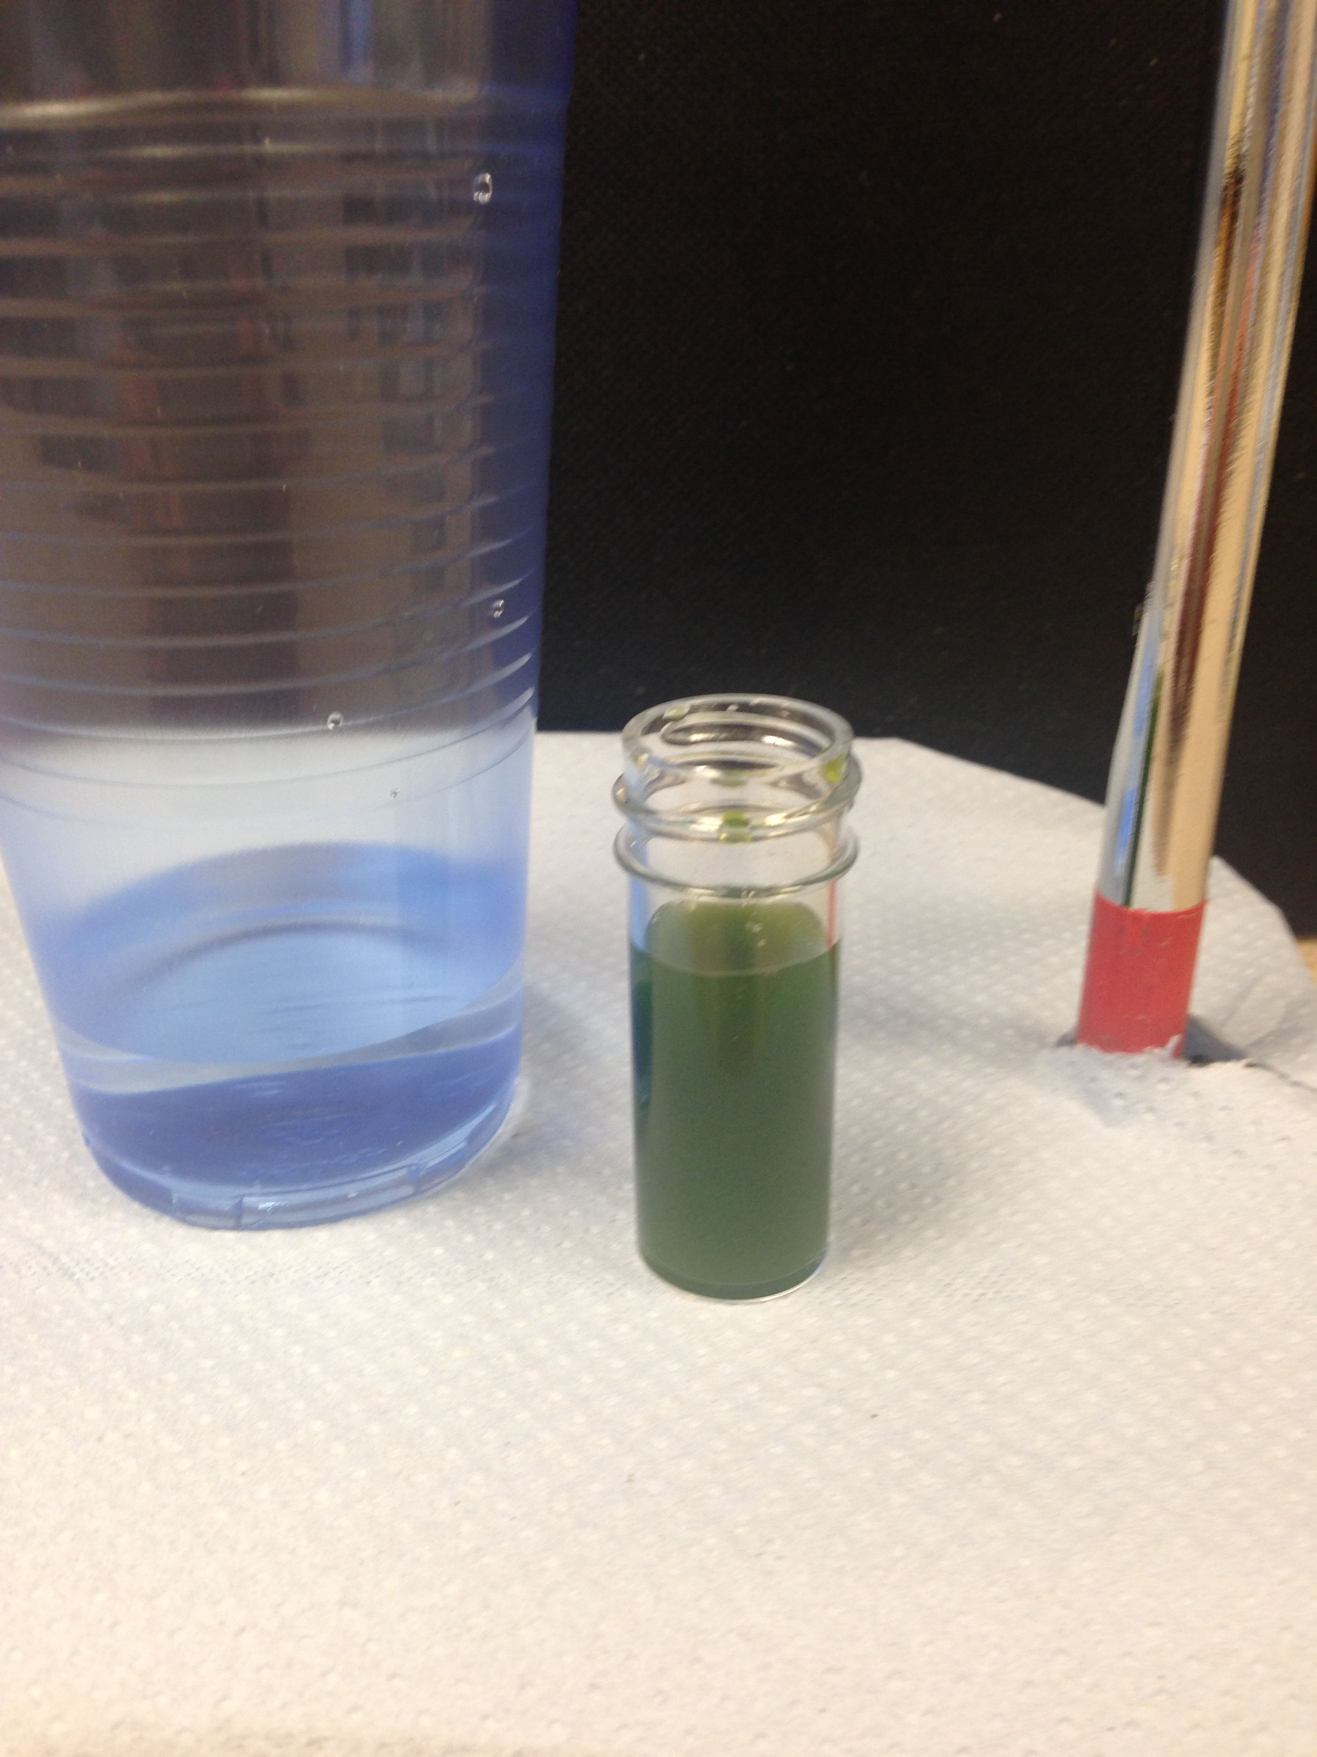 | - Shake the Scenedesmus quadricauda and add it to the sodium alginate solution.  - Place 30 cm³ of calcium chloride (CaCl₂) solution into a plastic cup.
- Clamp the barrel of your syringe (you will not need the plunger) so that it is 20 cm above the top of your plastic cup.  - Making sure that you have thoroughly mixed the solution prepared in step 2 above, pour the algae/alginate mixture into the syringe. |  | 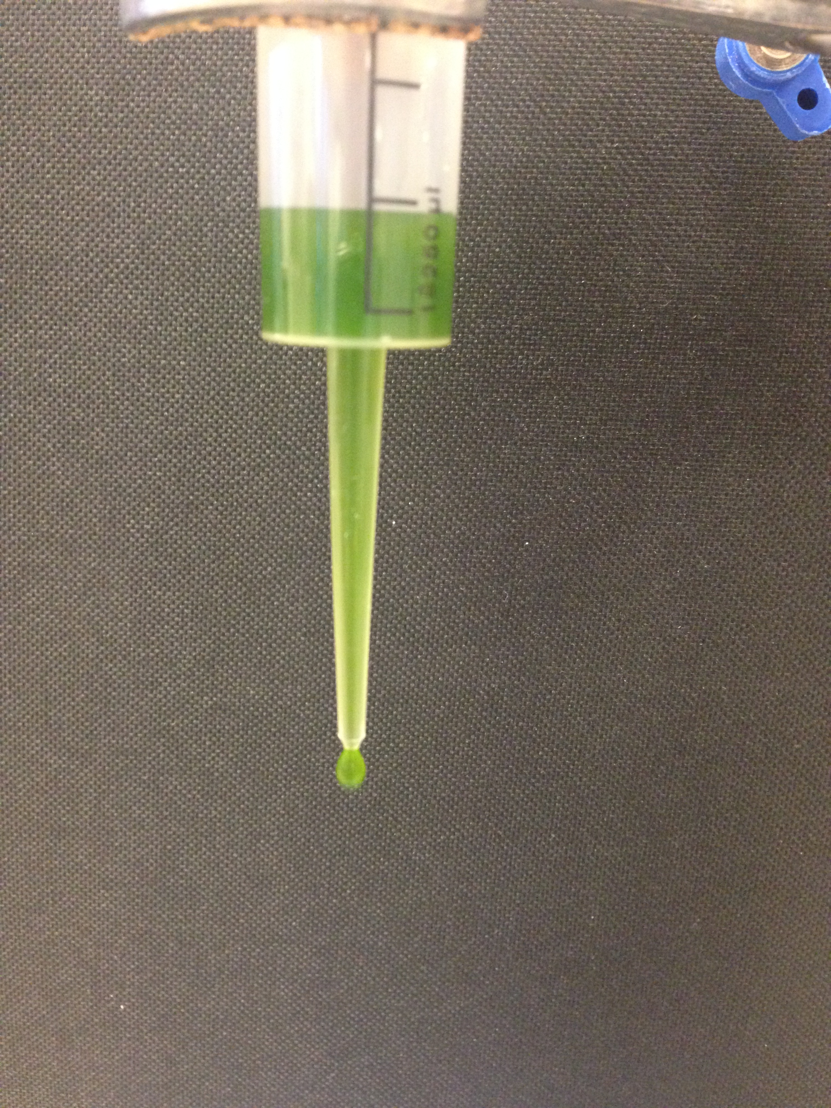

- As the algae/alginate mixture flows into the CaCl₂ solution you should see that small spherical beads of immobilised algae are formed.  - Once all of the liquid has flowed from the syringe leave the newly formed beads for 5 min. Transfer them to a tea strainer and wash them (gently!) with cold tap water for 1 min. Give them a final rinse with distilled water. | 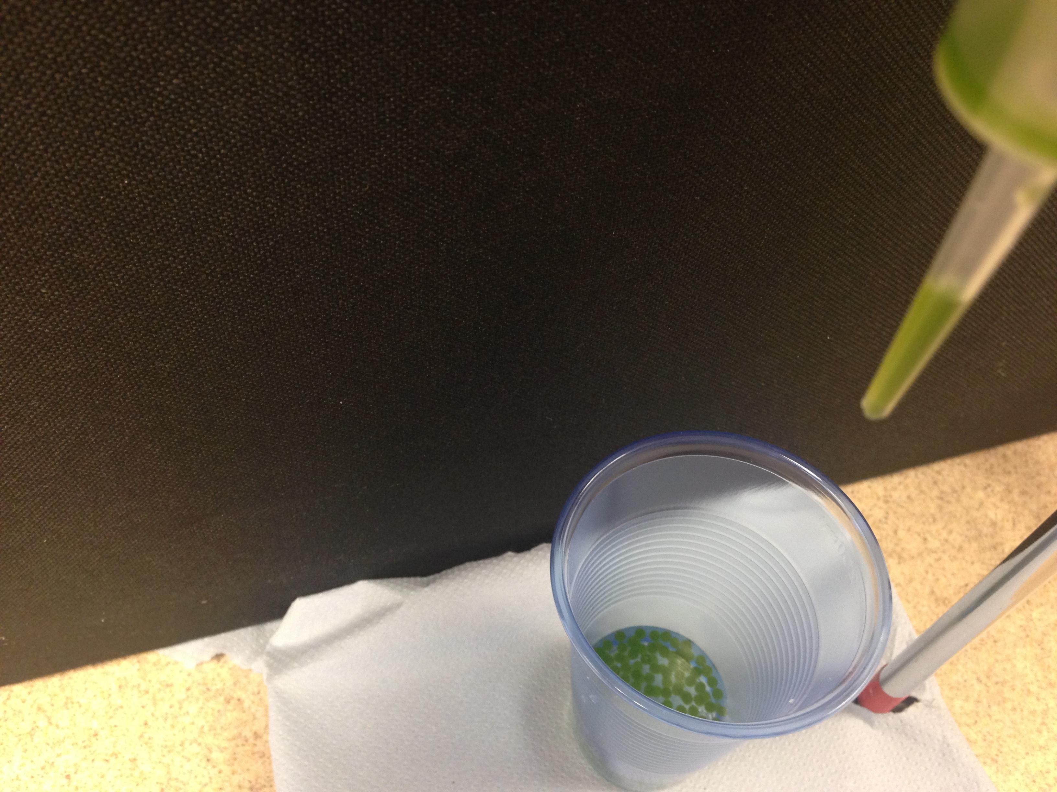

- Line up 8 empty Bijou bottles. Rinse the first bottle with approximately 2 - 3 cm³ of hydrogen carbonate indicator and transfer the indicator to the second bottle. Repeat this process until all bottles have been rinsed.

- Repeat step 8 twice more, then discard the indicator.

- Transfer 15 algal balls into each of the 8 Bijou bottles.

- Using a syringe add 4 cm³ of hydrogen carbonate indicator to each Bijou bottle. You will need to keep some hydrogen carbonate indicator for use in step 18 below.

- You will be provided with a range of neutral density filters. These filters should be cut and taped so that they fit over your Bijou bottles. Some filters are shown in the table below:

Filter Number | Light transmitted (%)
298 | 71.0
209 | 50.0
210 | 25.0
211 | 12.5
299 | 6.25
Black paper | 0.00

You should also be provided with an additional piece of filter which will allow 71% of light to be transmitted as well as another piece of filter which will allow 50% of light to be transmitted.

- Place each of the pre-formed filter sleeves around 6 of the Bijou bottles and leave 1 bottle without a filter (this sample will receive all of the light).

- For the remaining bottle wrap both the extra pieces of 71% filter and 50% filter. This will provide you with a combination which will allow 35.5%% of light to be transmitted.
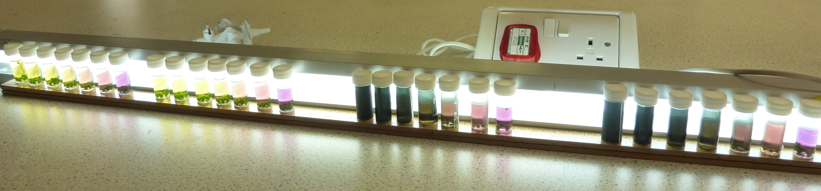 | - Place all your bottles in front of one of the fluorescent tubes making sure that all samples are close to, and the same distance from, the lamp.

- Leave the samples in front of the lamp for a period of 90 - 120 min.

- Thoroughly mix the contents of each Bijou bottle.

Please note – your teacher will advise you as to whether samples need to be stored prior to step 18.

- Turn on your colorimeter and set the wavelength to be 580 nm. If using a colorimeter which has a diode as the light source use the green diode. Rinse out a cuvette with distilled water and then add about 3 cm³ of distilled water. Use this cuvette to zero the colorimeter. Now rinse out the cuvette with some hydrogen carbonate indicator and discard the solution. Add approximately 3 cm³ of hydrogen carbonate indicator (you kept some in step 11….!) to the cuvette and measure and record the absorbance.

- Discard the hydrogen carbonate indicator from the cuvette and gently pour into the cuvette the hydrogen carbonate indicator from the Bijou which received 0% of the light. Avoid transferring any of the immobilised algal beads into the cuvette. Measure and record the absorbance.

- Using the same cuvette measure and record the absorbance of each of the solutions in the remaining 7 Bijou bottles (it is best to measure solutions in the sequence lowest light intensity highest light intensity).

Method 2 – Moving samples away from the light source

- You are provided with two small bottles, one containing a concentrated solution of Scenedesmus quadricauda (a green alga) and the other a solution of sodium alginate. | Scenedesmus quadricauda (see link for source of image)

- Shake the Scenedesmus quadricauda and add it to the sodium alginate solution.
- Place 30 cm³ of calcium chloride (CaCl₂) solution into a plastic cup.

- Clamp the barrel of your syringe (you will not need the plunger) so that it is 20 cm above the top of your plastic cup.

- Making sure that you have thoroughly mixed the solution prepared in step 2 above, pour the algae/alginate mixture into the syringe.

- As the algae/alginate mixture flows into the CaCl₂ solution you should see that small spherical beads of immobilised algae are formed.
- Once all of the liquid has flowed from the syringe leave the newly formed beads for 5 min. Transfer them to a tea strainer and wash them (gently!) with cold tap water for 1 min. Give them a final rinse with distilled water.

- Line up 8 empty Bijou bottles. Rinse the first bottle with approximately 2 - 3 cm³ of hydrogen carbonate indicator and transfer the indicator to the second bottle. Repeat this process until all bottles have been rinsed.

- Repeat step 8 twice more, then discard the indicator.

- Transfer 15 algal balls into each of the 8 Bijou bottles.

- Using a syringe add 4 cm³ of hydrogen carbonate indicator to each Bijou bottle. You will need to keep some hydrogen carbonate indicator for use in step 15 below.

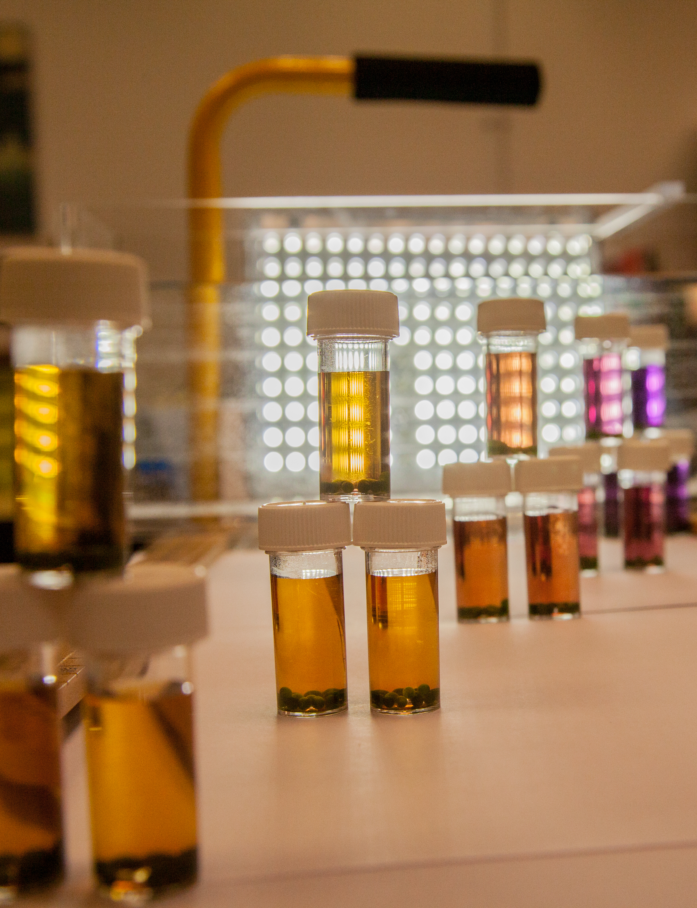 | - Place all 8 bottles in front of your lamp in a similar arrangement to that shown opposite. (You may need to place a container of water between the Bijou bottles and the lamp to make sure your samples do not get too warm).  - Leave the samples in front of the lamp for a period of 90 - 120 min.  - Thoroughly mix the contents of each Bijou bottle.

Please note – your teacher will advise you as to whether samples need to be stored prior to step 15.

- Turn on your colorimeter and set the wavelength to be 580 nm. If using a colorimeter which has a diode as the light source use the green diode. Rinse out a cuvette with distilled water and then add about 3 cm³ of distilled water. Use this cuvette to zero the colorimeter. Now rinse out the cuvette with some hydrogen carbonate indicator and discard the solution. Add approximately 3 cm³ of hydrogen carbonate indicator (you kept some in step 11….!) to the cuvette and measure and record the absorbance.

- Discard the hydrogen carbonate indicator from the cuvette and gently pour into the cuvette the hydrogen carbonate indicator from the Bijou which received 0% of the light. Avoid transferring any of the immobilised algal beads into the cuvette. Measure and record the absorbance. Using the same cuvette, measure and record the absorbance of each of the solutions in the remaining 7 Bijou bottles (it is best to measure solutions in the sequence lowest light intensity highest light intensity).

Method 3 – Varying temperature

In the previous methods 1 and 2 the light intensity was changed either by using so-called neutral density filters or by changing the distance of the light source from your samples. An alternative experiment is to change the temperature at which your samples undergo photosynthesis.
- You are provided with two small bottles, one containing a concentrated solution of Scenedesmus quadricauda (a green alga) and the other a solution of sodium alginate. | Scenedesmus quadricauda (see link for source of image)

- Shake the Scenedesmus quadricauda and add it to the sodium alginate solution.
- Place 30 cm³ of calcium chloride (CaCl₂) solution into a plastic cup.

- Clamp the barrel of your syringe (you will not need the plunger) so that it is 20 cm above the top of your plastic cup.

- Making sure that you have thoroughly mixed the solution prepared in step 2 above, pour the algae/alginate mixture into the syringe.

- As the algae/alginate mixture flows into the CaCl₂ solution you should see that small spherical beads of immobilised algae are formed.
- Once all of the liquid has flowed from the syringe leave the newly formed beads for 5 min. Transfer them to a tea strainer and wash them (gently!) with cold tap water for 1 min. Give them a final rinse with distilled water.

- Line up 8 empty Bijou bottles. Rinse the first bottle with approximately 2 - 3 cm³ of hydrogen carbonate indicator and transfer the indicator to the second bottle. Repeat this process until all bottles have been rinsed.

- Repeat step 8 twice more, then discard the indicator.

- Transfer 15 algal balls into each of the 8 Bijou bottles.

- Using a syringe add 4 cm³ of hydrogen carbonate indicator to 2 of the Bijou bottle. Make sure the lids are on tightly. You will need to keep some hydrogen carbonate indicator for use in step 16 below.

- Add approximately 2 cm³ of distilled water to the remaining bottles containing algae and place them in a fridge.

- Float the 2 bottles of algae prepared in step 11 above in a water bath (we suggest a starting temperature of 20ºC). Carefully fix a lamp (it is very important that the lamp / water bath arrangement is checked by your teacher before you plug in the lamp and switch it on) above the water bath.

- Leave the samples under the lamp for a period of 120 min.

- Thoroughly mix the contents of each Bijou bottle.

Please note – your teacher will advise you as to whether samples need to be stored prior to step 16.

- Turn on your colorimeter and set the wavelength to be 580 nm. If using a colorimeter which has a diode as the light source use the green diode. Rinse out a cuvette with distilled water and then add about 3 cm³ of distilled water. Use this cuvette to zero the colorimeter. Now rinse out the cuvette with some hydrogen carbonate indicator and discard the solution. Add approximately 3 cm³ of hydrogen carbonate indicator (you kept some in step 11….!) to the cuvette and measure and record the absorbance.

- Discard the hydrogen carbonate indicator from the cuvette and gently pour into the cuvette the hydrogen carbonate indicator from one of the Bijou bottles from step 15. Avoid transferring any of the immobilised algal beads into the cuvette. Measure and record the absorbance. Using the same cuvette, measure and record the absorbance of the other solution prepared in step 15.

- Take 2 of your bottles from the fridge, pour off the distilled water and repeat steps 11-17 (step 12 can be ignored) but raise the temperature by 5ºC.

- You can use the remaining 4 samples in the fridge to make measurements at two further temperatures.

