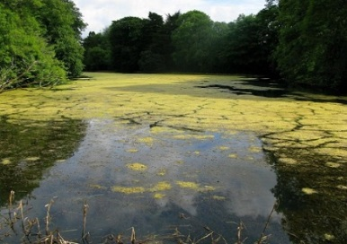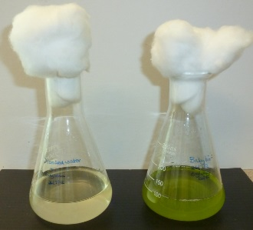

**National 5**

**Biology**

*Fertiliser and the growth of algae*

Student guide



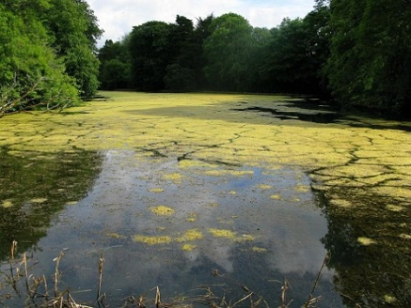

**Fertilisers and the growth of algae**

**Student Activity Guide**

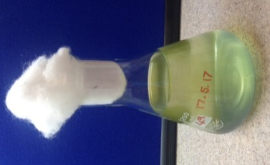

Many species of algae live in fresh water habitats. The addition of fertiliser to the water can promote the growth of these algal populations which has subsequent effects harmful to the ecosystem. It is possible to culture single-celled algae in the lab and to use houseplant fertiliser to influence the growth of the population. The growth of the population over time can be estimated in several ways by, for example -

* Using a colorimeter to measure absorbance of a sample of the culture. Absorbance, in this case, is a measure of the extent to which a beam of light of particular wavelength is scattered by the algae as it passes through the culture. The greater the absorbance, the greater the number of algae.
* Estimating the size of the population by counting algae using a haemocytometer.

It is also possible to compare algal populations by observing them in a ‘hanging drop’ using a light microscope.

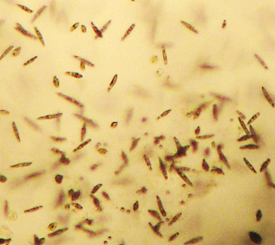

*Euglena gracilis* cultured in plant fertiliser

***Fertiliser Concentration and the Growth of Algae***

**Materials**:

* 50 cm3 measuring cylinder
* 4 x 250 cm3 conical flask
* Cotton wool
* Distilled water
* 1 x 5 cm3 syringe
* Baby BioTM (or other suitable liquid plant fertiliser)
* Colorimeter
* 8 x cuvette
* 9 x 1 cm3 plastic pipette
* Discard jar
* A stock culture of algae
* Marker pen

**Method**

**Setting up the algal cultures**

1. Label the conical flasks:

Flask 1 – Distilled water; Flask 2 – Distilled water and 0.25 cm3 fertiliser;

Flask 3 – Distilled water and 0.5 cm3 fertiliser. Flask 4 – Distilled water and

0.75 cm3 fertiliser.

1. Put 250 cm3 of distilled water into each flask.
2. Using a plastic pipette put 0.25 cm3 of fertiliser into Flask 2; 0.5 cm3 of fertiliser into Flask 3 and 0.75 cm3 of fertiliser into Flask 4.
3. Label 4 cuvettes: 1,2,3,4.
4. Using a fresh plastic pipette for each flask, transfer 3 cm3 of liquid from each flask into the appropriate cuvette, i.e. 3 cm3 from Flask 1 to cuvette 1 and so on. These ‘control cuvettes’ will be required to ‘zero’ the colorimeter each time you take readings over the next 10 – 14 days. So, they will be frozen between readings to prevent any bacteria growing in them.
5. Using the syringe add 5 cm3 of the stock algal culture to each flask and swirl the flasks to mix the contents. Place the syringe in the discard jar.
6. Now follow the instructions for making the first colorimeter readings of the cultures in flasks 1 – 4.

***Fertiliser Type and the Growth of Algae***

**Materials**:

* 50 cm3 measuring cylinder
* 4 x 250 cm3 conical flask
* Cotton wool
* Distilled water
* 1 x 5 cm3 syringe
* 3 different house plant fertilisers
* Colorimeter
* 8 x cuvette
* 11 x 1 cm3 plastic pipette
* Discard jar
* A stock culture of algae
* Marker pen

**Method**

**Setting up the algal cultures**

1. Label the conical flasks:

Flask 1 – Distilled water; Flask 2 – Distilled water and fertiliser 1.

Flask 3 – Distilled water and fertiliser 2. Flask 4 – Distilled water

and fertiliser 3.

1. Put 250 cm3 of distilled water into each flask.
2. Using a fresh plastic pipette for each fertiliser, put 0.5 cm3 of fertiliser 1 into Flask 2; 0.5 cm3 of fertiliser 2 into Flask 3 and 0.5 cm3 of fertiliser 3 into Flask 4.
3. Label 4 cuvettes: 1,2,3,4.
4. Using a fresh plastic pipette for each flask, transfer 3 cm3 of liquid from each flask into the appropriate cuvette, i.e. 3 cm3 from Flask 1 to cuvette 1 and so on. These ‘control cuvettes’ will be required to ‘zero’ the colorimeter each time you take readings over the next 10 – 14 days. So, they will be frozen between readings to prevent any bacteria growing in them.
5. Using the syringe add 5 cm3 of the stock algal culture to each flask and swirl the flasks to mix the contents. Place the syringe in the discard jar.
6. Now follow the instructions for making the first colorimeter readings of the cultures in flasks 1 – 4.

**Comparing the algal populations using a colorimeter**

1. Set the colorimeter to read absorbance at 665 nm.
2. Use control cuvette 1 to calibrate the colorimeter for Flask 1 (665 nm). Retain the control cuvette for use with the colorimeter readings you will take over the next 10 – 14 days. Freeze the cuvette and its contents between measurements.
3. Gently swirl Flask 1 to mix the contents and, using a clean pipette, transfer 3 cm3 algal suspension into a clean cuvette. Place the pipette in the discard jar.
4. Place the cuvette in the colorimeter, read and record the absorbance. Empty the cuvette back into Flask 1. Place the used cuvette in the discard jar.
5. Repeat steps 1 – 4 using control cuvette 2 and Flask 2.
6. Repeat steps 1 – 4 using control cuvette 3 and Flask 3.
7. Repeat steps 1 – 4 using control cuvette 4 and Flask 4.

You will repeat this process regularly over a period of 10 – 14 for days and use absorbance as an indication of the size of each of the algal populations. The greater the absorbance, the greater the number of algaepresent in the suspension*.*

You may also note a change in colour of the suspensions as time goes on.

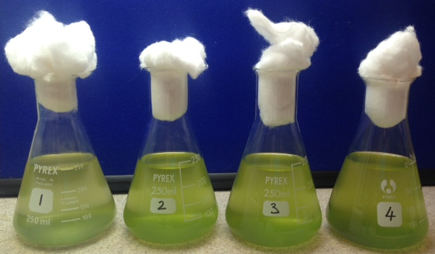

**Comparing algal populations by observing hanging drops of the cultures**

In this activity you will make a hanging drop of each culture and observe the algae using a microscope. (See Preparing a Hanging Drop Help Card)

**Preparing a Hanging Drop HELP CARD**

**Materials**

Microscope Lens tissue

Pipette Blu-takTM

Paper towels Two glass slides

You may wish to practise steps 4 and 5 using a drop of water before preparing a hanging drop of algal suspension.

**Method**

1. Clean two glass slides by rubbing each of them gently with a piece of lens tissue. Do not throw away the lens tissue.
2. Stick two small pieces of blu-takTM on one slide, about 2 cm apart.
3. Gently swirl the flask to mix the contents. Using a pipette, draw up some of the algal suspension.
4. Place a single drop of the liquid from the pipette in the middle of the second glass slide.
5. Working as quickly as you can, turn the slide over so that the drop hangs down from the slide.
6. Place the slide over the first slide and stick it down on the blu-takTM.
7. The hanging drop should hang between the two slides without touching the bottom one.
8. You are now ready to observe the algae under the microscope. Start with the x10 objective lens.
9. When you are finished observing the algae, the pipettes and slides should be placed in a discard jar.

*Counting cells using a disposable haemocytometer*

* 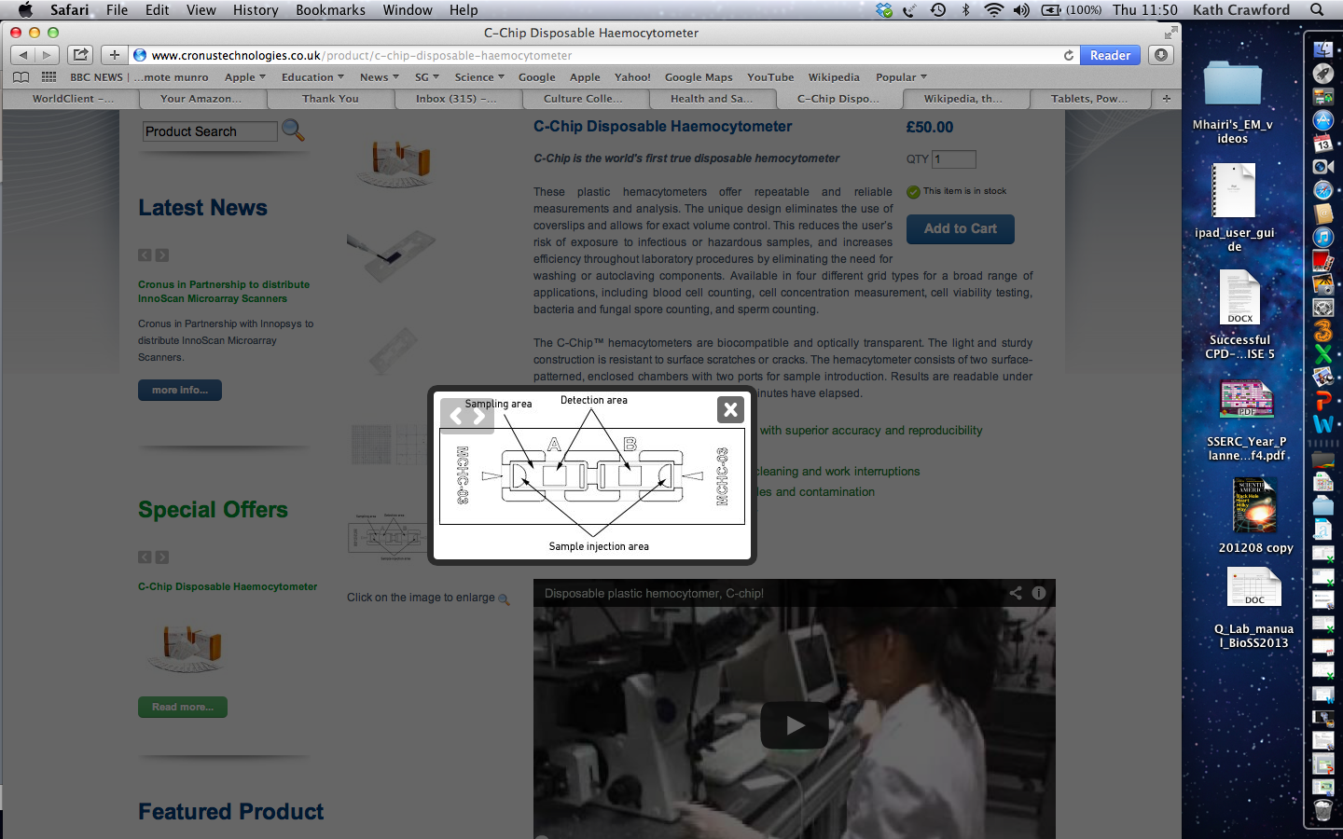“Finding your way round the haemocytometer”
* Identify sample injection area
* Look at grids in the detection area with the naked eye
* Observe one detection area at x40 and identify the central grid
* 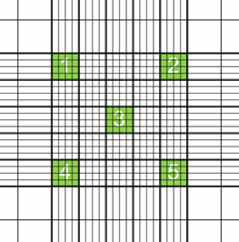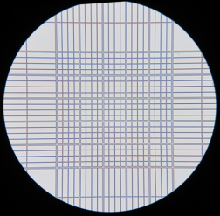Observe at x100 and identify ‘sample’ squares
* 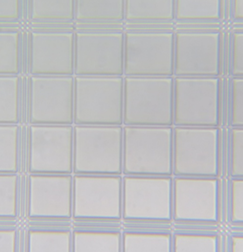At x400, find the top left and right, central and bottom left and right sample squares.

*Notice the boundary lines*

* Practise moving the haemocytometer around to find the sample squares.
* 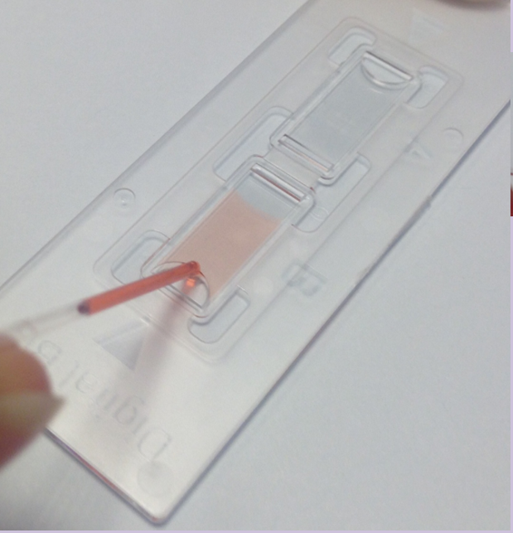Use a coloured dye to practise loading the haemocytometer using a capillary tube (load one sample injection area).
* Load the other sample injection area of the haemocytometer with algal suspension
* Observe at x40, x100 and x400
* Check that you can find the sample squares at x400
* 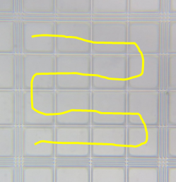Counting the cells
* Count systematically
* *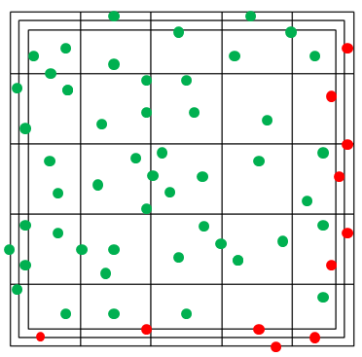Count all the cells within the sample square and those touching the top and left boundary lines (). Don’t count those touching the bottom and right boundary lines ().*

1. Count the cells in all 5 sample squares

Square 1 ___________ Square 2 ___________

Square 3 ___________

Square 4 ___________ Square 5 ___________

**

**Estimating the number of cells**

