Complying with Pressure Regulations in school science departments
School science departments are likely to own apparatus covered by the Pressure Systems Safety Regulations (PSSR). Quoting HSE,
“The aim of PSSR is to prevent serious injury from the hazard of stored energy (pressure) as a result of the failure of a pressure system or one of its component parts.”
Devices covered by this legislation that may be used in schools include:
- Model steam engines (e.g. Mamod, Wilesco)
- Pressure cookers
- Autoclaves (see particular issues with thermostatically controlled autoclaves).
These must be safety checked annually against a Written Scheme of Examination (WSE). Any WSE has to be certified as suitable for your particular piece of equipment. There is a subtlety here. You may own a Mamod steam engine that is the same as a thousand other Mamod steam engines but the WSE for your engine has to be certified as being appropriate for your actual engine and not identical Mamod engines. Only a suitably experienced engineer can certify.
Non-thermostatically controlled equipment
For model steam engines, pressure cookers and autoclaves that are not thermostatically controlled, there are two routes you can go down. You can employ an outside company to examine your pressure systems. Alternatively, a competent person in your school or local authority can examine them, provided they have a certified written scheme of examination. Whilst many teachers and technicians in Scotland will be either capable of carrying out examinations or being able to do so after training, it is unlikely that there will be somebody local who can certify the WSE. If you are currently inspecting pressure systems in house, it is likely that you are using a scheme of examination that has not been certified. HSE will not accept this. Fortunately, there is a simple, cost-effective solution.
SSERC and our sister organisation CLEAPSS have been working with a company called LMP who have extensive experience in this field. LMP have come up with a protocol that does not necessitate an engineer visiting your premises. In order to receive a certified WSE, schools need to do the following:
- Take clear photographs of every piece of equipment that comes under PSSR. Even if you have six identical pressure cookers, photograph them all, making sure each has a unique identifier, for example a clearly visible code number or a coloured mark.
- Send the photos to LMP, clearly cross-referenced to a list of the equipment shown. The list should show the make, model and unique identifier.
- Include a statement that none of the equipment has been modified.
Provided that LMP is familiar with the equipment shown, you will be sent a WSE for each piece of apparatus. If you have three identical steam engines, you will still receive 3 WSEs, one for each. This is why it is important that identical items are in some way uniquely identifiable. You will need to have your WSEs recertified every 5 years. LMP has a robust database and can work with you to ensure you keep on top of this. Note that the purpose of the photographs is to enable LMP to certify that a WSE is suitable for your equipment. LMP are not using the photographs to judge the equipment or to examine it remotely.
LMP will invoice you for £10 per WSE issued. As these will be valid for a further 4 years, this is a very cost-effective solution.

Thermostatically controlled autoclaves
Thermostatically controlled autoclaves such as the Prestige Medical (figure 1) present another issue. The thermostat circuitry should ensure that the temperature is controlled so that pressure never rises to the level at which the safety valve operates. The safety valve can therefore only be checked by disconnecting the temperature regulating circuitry or by removing the valve and using calibrated test equipment. Neither of these can realistically be carried out by school or local authority staff.
This leaves you with the following options:
- Return your autoclave to the manufacturer for checking.

or

- Employ a company to test your device. Make sure that the check they carry out on the valve involves one of the methods above. It is not sufficient to simply check that its components move freely.
or
- Send your autoclave to LMP for testing and certification. This will cost £100 per unit.
or
- If you have more than 6 autoclaves or if your local authority can arrange for a number of autoclaves to be taken to a central location, it should prove cost-effective for you to contact LMP so that they can send an engineer out to test a batch.

LMP can be contacted on:
LMP Technical Services
Rockleigh Court,
17 Rock Rd,
Finedon,
Wellingborough
NN9 5EL, UK

Telephone: 01933 683810
e-mail: peter@lmp.co.uk, copying in Steve@lmp.co.uk

We are, of course, happy to hear from other companies who could offer this service.
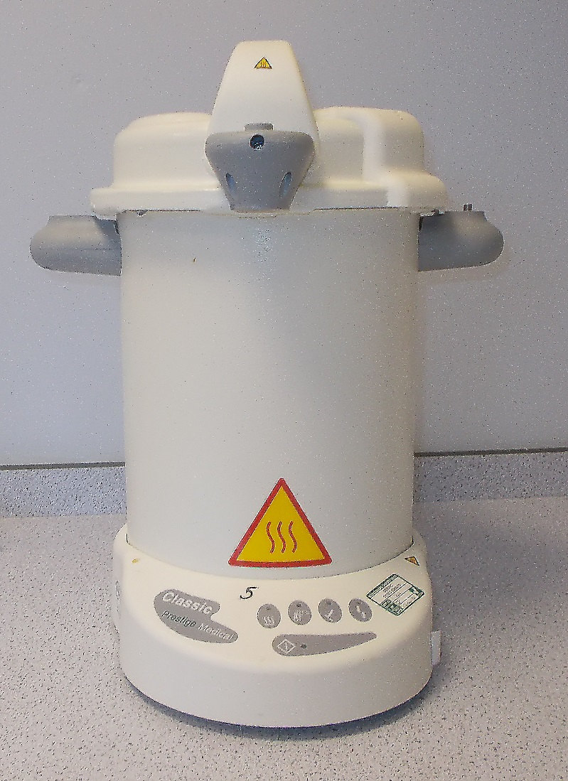
Figure 1 – thermostatically controlled autoclave. Note the unique identifier (numeral 5) written on it.

