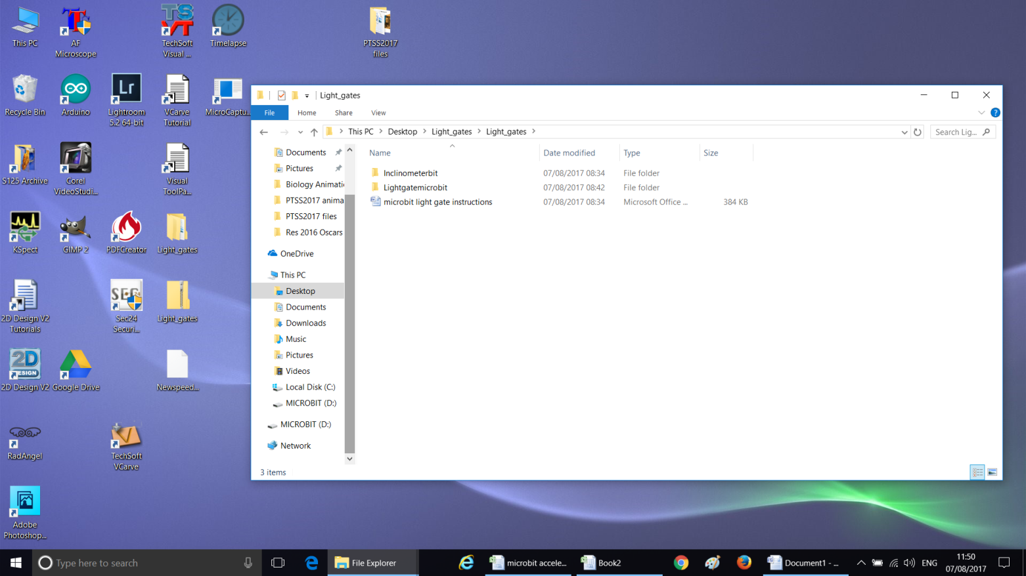

Download zipped folder from [www.sserc.org.uk](http://www.sserc.org.uk). Extract files and open extracted folder.

Plug the micro:bit into a USB socket on your computer.

Locate chosen program (hex file version). Drag and copy to MICROBIT(D:) (the drive may not be D:)

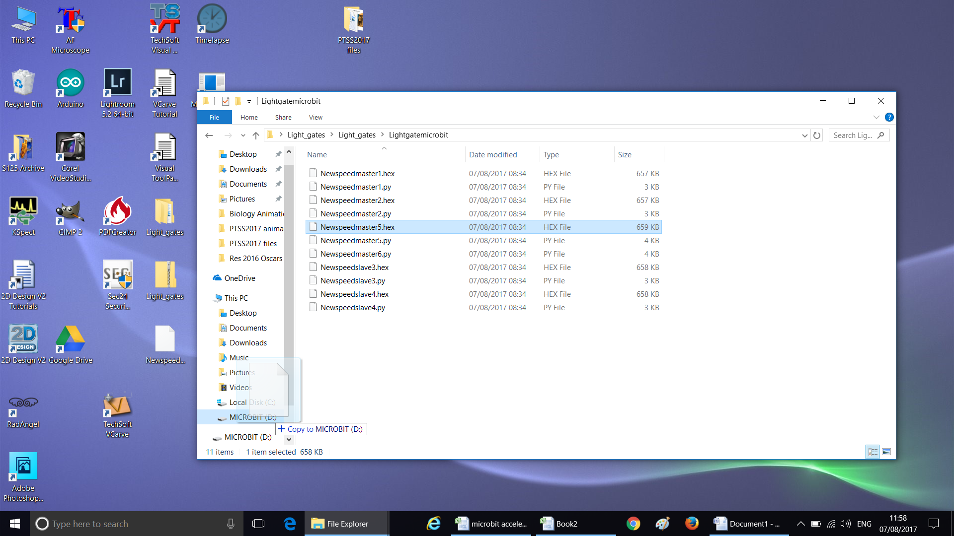

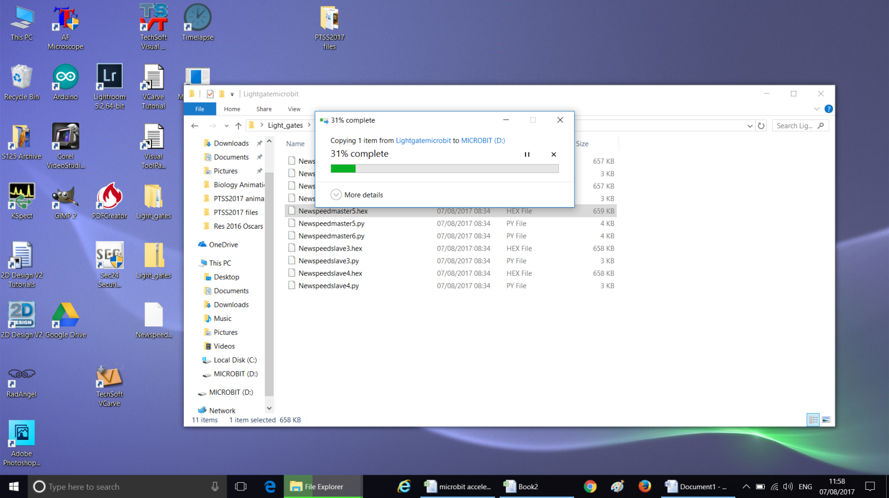

Once copying is complete, micro:bit is ready to use..

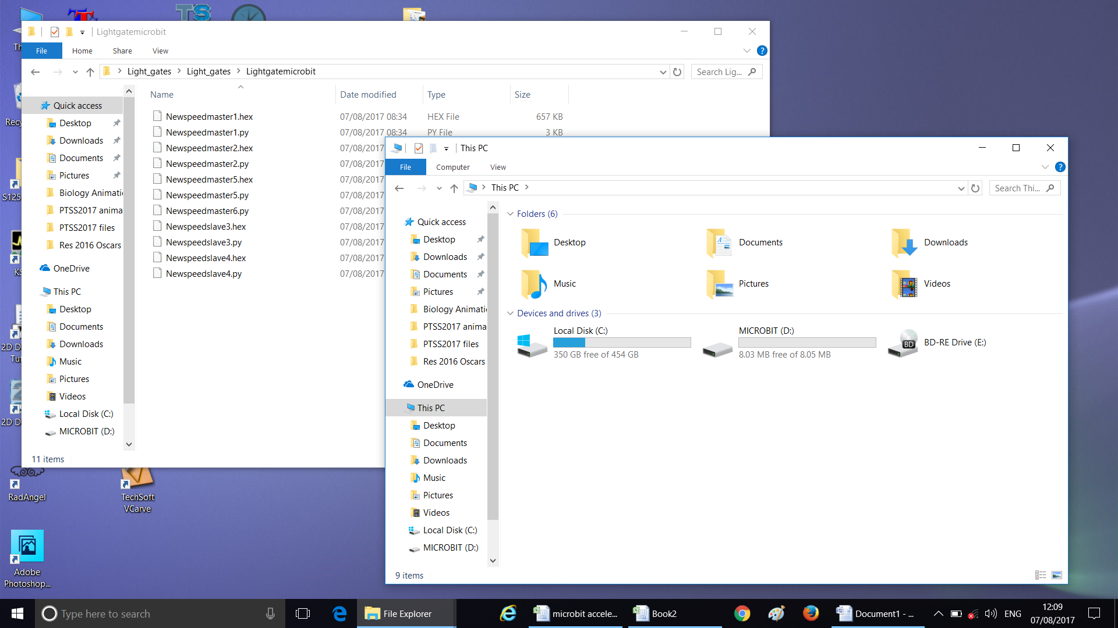

Alternatively, open the Light_gates folder and This PC simultaneously and drag the appropriate file.

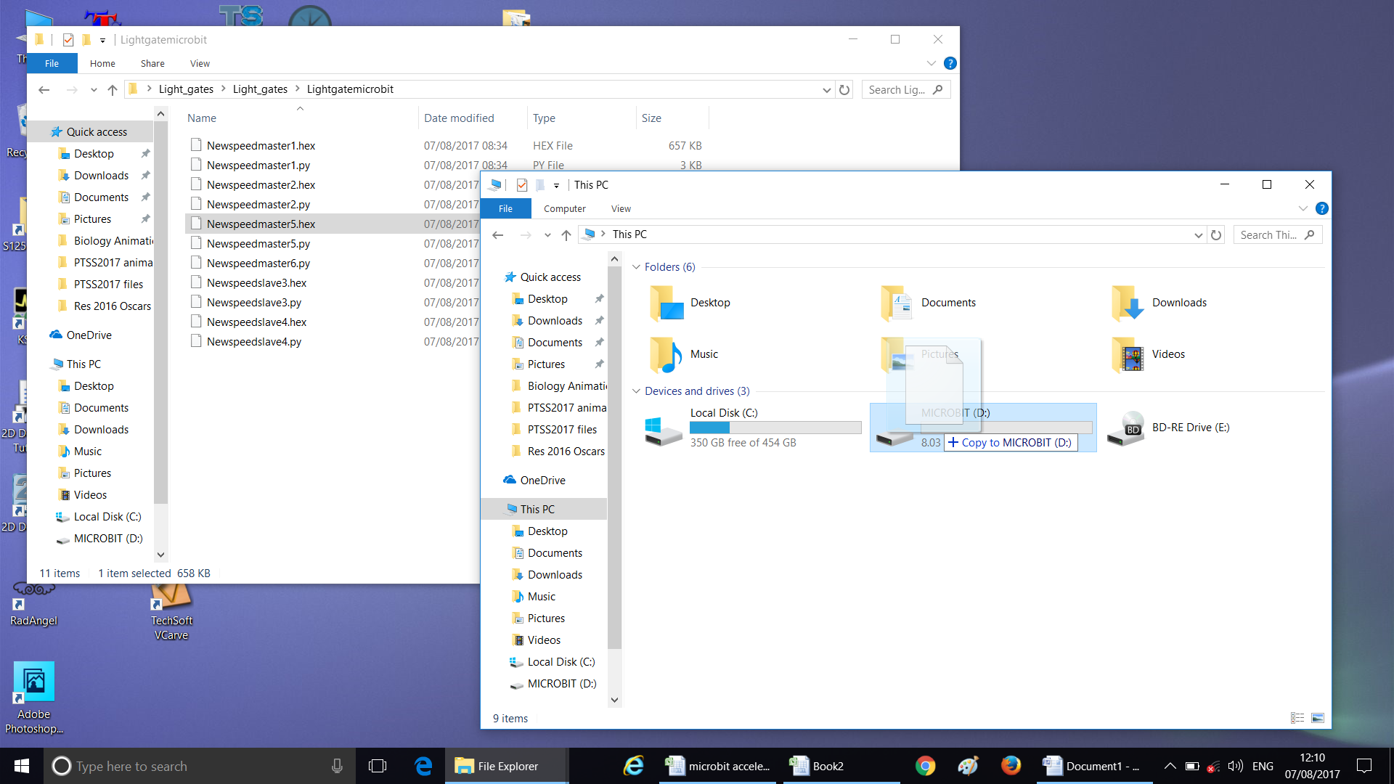

Drag hex file from Light_gates and copy to MICROBIT(D:)

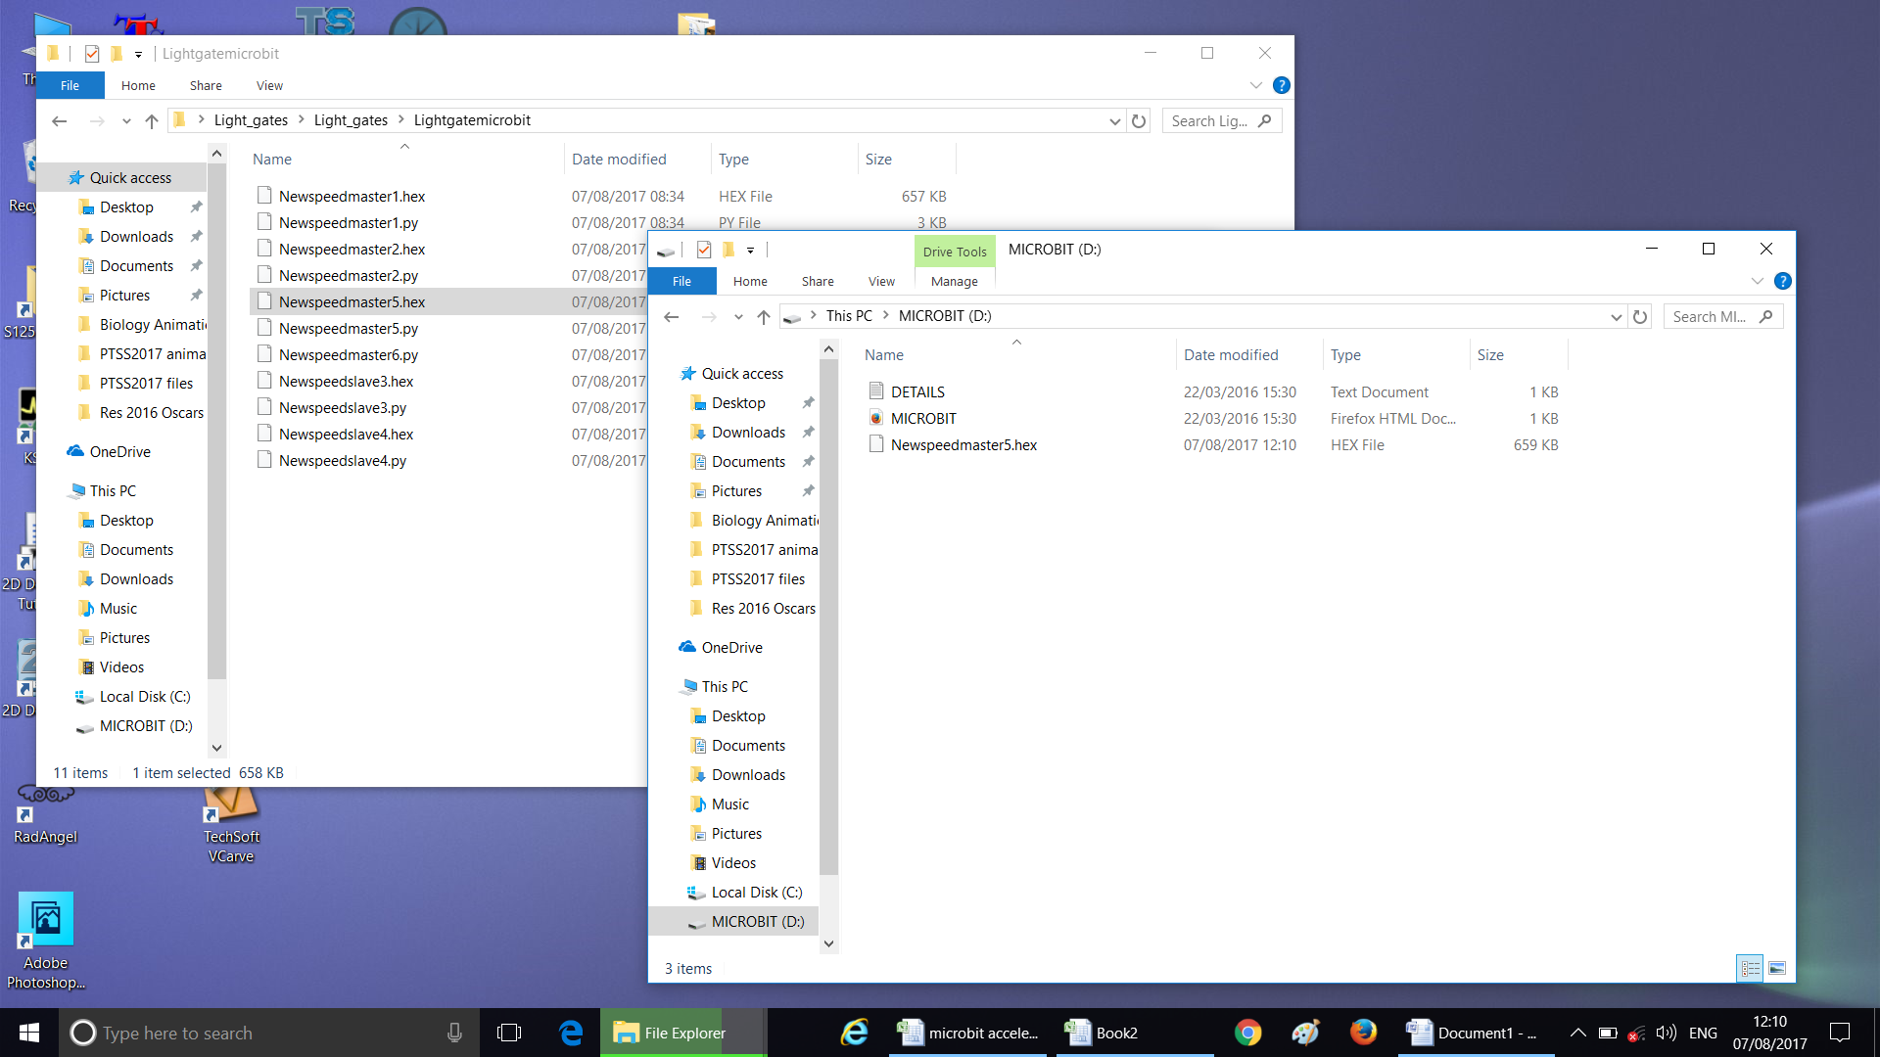

Microbit is ready to use.