Using a volumetric flask
Introduction
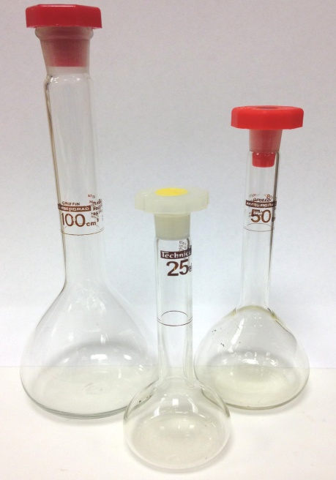
Making solutions is an essential skill in chemistry. When accuracy is required (eg, for analytical work), a volumetric flask is used.
Stock solutions for qualitative work do not have to be made up in a volumetric flask. A measuring cylinder or a graduated jug will do.
Volumetric flasks are usually pear-shaped, with a flat bottom and can be made of glass or plastic. They have a narrow neck with a ring marked on which accurately marks a specific volume.
As is the case for pipettes and burettes, volumetric flasks are precision pieces of glassware. Grade ‘B’ is quite sufficient for school work.
Safety
There are no particular safety issues to do with the use of volumetric flasks. However, your solution may be hazardous. To determine the level of protection, and any other precautions, consult the appropriate entry in the Hazardous Chemicals Database.

Method
- Weigh the solid accurately to at least 2 decimal places (using the technique described earlier).
You can weigh it out into a weighboat as described or, alternatively, weigh it directly into a clean beaker that you will use to make the solution up in.
- If you are using a weighboat, add the solid to a clean beaker and then wash any remaining solids out of the weighboat with distilled/deionised water (or whatever solvent you are) into the beaker using a wash bottle (or use a pasteur pipette).
- Add about a quarter of the final volume of distilled/deionised water (or other solvent) that you require. (If you are making up 100 cm³, add about 25 cm³).
- Stir carefully with a glass rod until the solid dissolves, taking care to avoid splashing. Aside from any safety issues, splashing means that you have lost some of your solution so the final concentration will be slightly out.
If your solid will not dissolve in this amount of liquid, which is possible if you are making up quite a concentrated solution, use more than a quarter of the final volume but you will need to adjust the volumes used in the next steps.
- Once it has dissolved, pour the solution, using the stirring rod as a guide, into the volumetric flask. Use a funnel to make sure you don’t spill any.
- Add about another quarter of the final volume of solvent (25 cm³ in the example here) to the now empty beaker. Stir well to dissolve any remaining drops of the solution you have transferred to the flask. Carefully add this solution to the volumetric flask.
- Repeat this process with another quarter of the final volume of solvent. This way you should manage to ensure that the entire weighed chemical is transferred to the flask.
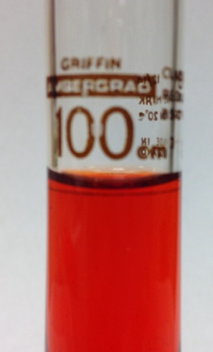
- Using a wash bottle or a pasteur pipette, rinse the stirring rod and funnel. Ensure that all the washings go into the volumetric flask.
- Now add more solvent to the volumetric flask. Stop when the liquid level is about 2 cm below the graduation mark.
- Hold the flask at eye level and then add more water (drop-wise) using the wash bottle or a 3 cm³ plastic dropper pipette until the bottom of the meniscus is level with the graduation mark.
- Add the stopper, hold firmly and invert the flask several times to make sure the solution is thoroughly mixed. Label the flask as appropriate.

