Filling and using a pipette
Introduction
Use of a pipette is essential for delivering accurate volumes of liquid and carrying out volumetric analysis.
There are two types of pipette you will come across:
a. Volumetric pipette. These are calibrated with a single line to measure out a fixed volume of solution, most commonly 5, 10, 20 and 25 cm³.
b. Graduated pipette: these too come in different sizes but instead of a single line they have a range of graduations. They commonly come in 1, 2, 5 and 10 cm³ sizes and are useful for measuring out intermediate, or varying, volumes of liquid.
As is the case for burettes, pipettes too are subject to National and International standards. ‘B’ standard pipettes are sufficiently accurate for school work.
The use of different types of pipette filler is described.
Safety measures
To determine the level of protection, and any other precautions, consult the appropriate entry in the Hazardous Chemicals Database.
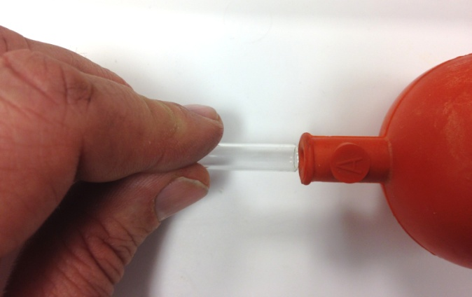
In years gone by, pipettes were frequently filled by sucking up the liquid with suction from the mouth. This is not safe and you should not do it. Pipettes should only be filled using a pipette filler.
Fitting the pipette to the filler must be carried out with care. If not there is a danger that the glass will break and cause serious injury.
Hold the pipette close to the top and carefully insert it into the filler by pushing gently. This is the same for all types of pipette fillers.

Method
A. Using a rubber bulb filler
(see diagram on the next page)
- Hold the pipette at the top and carefully insert it into the rubber bulb filler (push gently while twisting slightly).
- Pinch the valve at the top (marked A) and squeeze the bulb to expel all the air inside.
- Place the tip of the pipette in the solution and squeeze the valve below the bulb (marked B). The liquid should rise up the pipette. Make sure the tip of the pipette remains in the liquid otherwise air bubbles are sucked up and the liquid can be pulled into the filler bulb, which will contaminate it.
- When the level of liquid is a cm or so above the graduation mark on the pipette, release valve B.
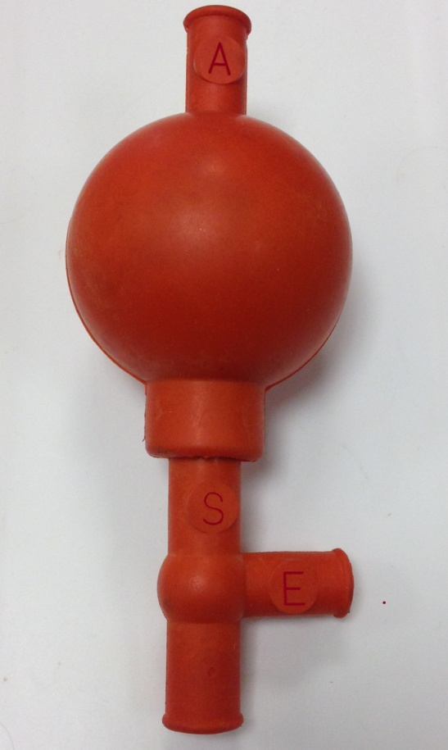
- Holding the graduation mark at eye level, gently squeeze the valve on the side arm (marked E) to lower the liquid level. Lower the liquid until the bottom of the meniscus is level with the graduation mark.
- Carefully move the pipette to the flask or beaker you are putting it in and firmly squeeze valve E to allow the liquid to drain from the pipette.
You will need practice to be able to do this accurately.

B. Filling the pipette using a Pi-pump
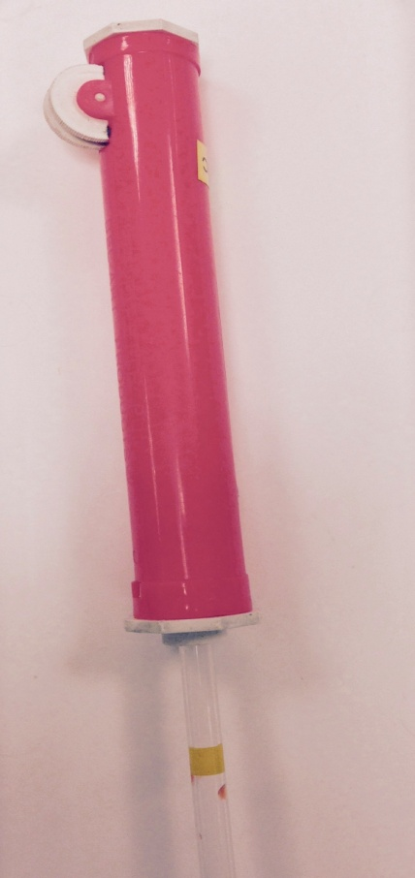
This sort of pump is easier to use as it just has the one control but there can be issues with ‘slippage’.
- Hold the pipette at the top and carefully insert it into the Pi-pump by pushing gently and twisting slightly.
- Place the tip of the pipette in the solution. Use the thumbwheel to raise the level of liquid to a cm or so above the graduation mark on the pipette. Ensure the tip of the pipette remains in the liquid otherwise air bubbles are sucked up and the liquid can be pulled into the filler bulb, which will contaminate it.
- Holding the graduation mark at eye level, lower the liquid by gently turning the wheel until the bottom of the meniscus is level with the graduation mark.
- Carefully move the pipette to the flask or beaker you are putting it in and expel the liquid using the release lever valve.
- Do not use the wheel to force the liquid out. Volumetric pipettes are calibrated to allow for the small amount that is left due to surface tension. Pushing this out will reduce accuracy.

C. Filling the pipette using a syringe
If you don’t have any pipette fillers, all is not lost. It is possible to use a syringe.
- Choose a syringe of a greater volume than the volume of your pipette.
- Attach the syringe to the top of the pipette with a short length of silicone tubing.
- Place the tip of the pipette in the solution. Raise the barrel of the syringe to raise the level of liquid to a cm or so above the graduation mark on the pipette.
- Quickly remove the rubber tubing (with the syringe still attached) and slip your forefinger (or thumb) over the top of the pipette. (You should manage to do this while the level is still above the mark. If not, re-attach the syringe, pull up the liquid again, to a higher level this time, and have another go.
- Holding the graduation mark on the pipette at eye level, gently adjust the pressure of your forefinger (or thumb) on the pipette. You should be able to reach a point at which the seal is sufficiently loose to let the liquid flow out slowly enough that you can control it. (This takes practice) . Lower the liquid until the bottom of the meniscus is level with the graduation mark.
- Carefully move the pipette to the flask or beaker you are putting it in and expel the liquid from the pipette by releasing your finger/thumb.
- Do not blow out the liquid. Volumetric pipettes are calibrated to allow for the small amount that is left due to surface tension. Pushing this out will reduce accuracy.

Cleaning
If solutions have accidently been sucked into the filler, they should not be placed back in a storage drawer.
The fillers can be rinsed in pure water to remove any reagents that might affect the materials.
Rubber bulb fillers should be allowed to dry fully open, not squeezed shut.

Aliquot
An aliquot is a term used for a sample taken from a larger amount of liquid. The term is commonly used in titrations to describe the volume of reagent you place in the flask or beaker below the burette, usually using a pipette. So for instance, in an acid/base titration you might refer to using 25 cm³ aliquots of sodium hydroxide. This tells the reader that for each run you used the same sample size, 25 cm³, in the flask.

