Filling and using a burette
Introduction
When carrying out volumetric analysis, it is essential to be able accurately to measure out volumes of liquids.
For most purposes in the laboratory, it is quite sufficient to simply use a measuring cylinder/jug but when doing accurate volumetric work a higher level of precision is required.
In the laboratory, this will be done using pipettes, burettes or volumetric flasks, depending on the precise nature of the task. It is important to learn the correct handling and use of the apparatus. This technique needs patience and regular practice by both the teacher and the student.
The burette is a precision and delicate instrument and subject to National and International standards which are engraved on the glass. ‘B’ standard burettes are sufficiently accurate for school work. 50 cm³ burettes are the most common but 25 cm³ burettes are also available, and, being shorter, they can be and easier to handle for younger/shorter pupils.
Safety measures
If you are filling the burette with a liquid that is corrosive, irritant, toxic etc, eye protection will be needed. To determine the level of protection, and any other precautions, consult the appropriate entry in the Hazardous Chemicals Database.
Method
Burettes must be held vertically upright in a clamp. Care should be taken, though, as they are fragile (and relatively expensive, pieces of equipment.
The best things to use are wooden burette stands or specialised burette holders but many schools will not have these.
If possible, bare metal clamps should not be used: the burette can be easily crushed as the jaws are tightened. A better option, in the absence of a more specialised holder, is using clamps with rubber-coated jaws. However, if there is no alternative, bare metal clamps can be used quite successfully as long as sufficient care is taken.
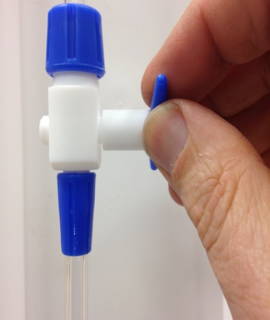
- Make sure the tap is closed (this usually means having the tap at right angles to the column).
- Clamp the burette about two/thirds down its length. Make sure the burette is vertical in both directions (side to side and front to back). For all but the tallest students, the top will probably be above eye level which will make it difficult to fill accurately.
- If this is the case, lower it by standing it on a stool or even the floor.
- Place a small plastic funnel in the top of the burette and a beaker below the burette.
- Add a few cm³ of the solution to be used. Open the tap and let some of the solution drain out through the jet into the beaker used for waste solution. (the object is to ensure that there are no air bubbles trapped. These will usually appear in the jet, below the tap. If there are, open the tap fully and tap the jet gently with a finger. If this doesn’t work at first, add more liquid and repeat until they are gone).
- Fill the burette to a few cm above the zero mark. Remove the funnel (it might hold a few drops of liquid which, if they drip into the burette, will affect the readings).
- You will need to take the reading at eye level so you may well need to move the burette. In order to aid visibility, it is a good idea to have a piece of paper behind it. A simple method is to make two cuts in a piece of paper and slip them over the burette so the paper is held in place.
- Turn the tap, letting the solution fall into the beaker, until the bottom of the meniscus just touches the graduations. You need to know exactly what the value is but it does not have to be zero. (You can determine volume by subtraction in exactly the same way as you do for mass when weighing).
- Wipe off any drops of liquid hanging off the end of the jet with a paper towel.

Handling the burette
When carrying out your titration, you need to make sure that the contents of the flask are mixing well, especially when the end point of your reaction is near. The best way to do this is to hold the tap with the one hand and use the other to swirl the conical flask to make sure the contents are mixed.
It is important not to pull on the tap as it can become loose and leak, or even come out altogether. The best option is to turn it while applying a slight inward pressure.
Handedness
It is possible to get right-handed or left-handed burettes. These will have the tap on the right or left side while you are looking at the markings. This can make a difference to ease of use. If possible, get burettes with markings on both sides as they can be used with equal ease by all.

