“Quickfit” apparatus
Much organic chemistry work involves the need to connect various pieces of apparatus together, a flask and a condenser for distillation for instance. This can be done simply by using corks and bungs but the best way is to use a set of glassware with ground glass joints.
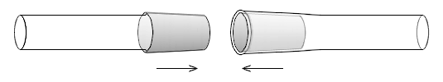
(Image CC BY-SA 3.0, https://commons.wikimedia.org/w/index.php?curid=667208)
This is generally known as Quickfit glassware, although Quickfit is simply a brand name for the first, and best known, brand (a bit like Hoover becoming synonymous with vacuum cleaners).
Quickfit apparatus is made from borosilicate glass which has a high resistance to thermal shock and is thus suitable for various heating processes. There are several advantages of using Quickfit apparatus:
- It is quicker to put together. You simply push the ground glass joints together with a slight twist and they are held quite firmly.
- There is no contamination of the chemicals by contact of liquids or vapours with cork or rubber stoppers.
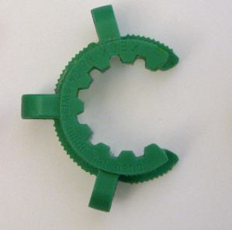
- A variety of different procedures can be carried out with just a few pieces of apparatus, joined together in different ways if need be, leading to efficient use of equipment.
- The wider glass tubing used for the connections between the apparatus means that risks from suck-back and blockages are reduced.
- It is possible to get clips that fit over the joints (see right) which help hold them together and prevent the apparatus coming apart.
The main drawback of Quickfit glassware, however is the cost. It is expensive and so needs careful looking after.

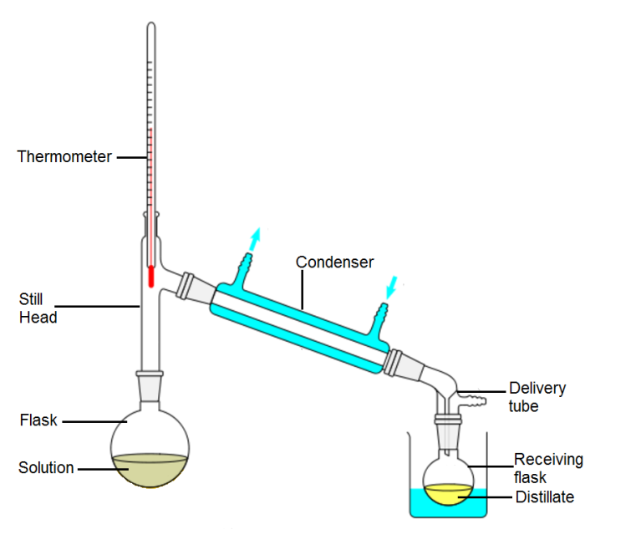
How to assemble your quickfit apparatus
- Make sure you have all the pieces you need, and that the joints are the right size.
There are several different size joints so this might be a problem. If you find some of them are incompatible sizes and you can’t get ones that do fit, you will need to use step up/down adaptors.
As an example, we’ll describe setting up the distillation apparatus shown in the diagram to the right..
- Decide on your heat source (Bunsen burner, heating mantle etc), put it in place and place your clamp in position in/over it.
Use a clamp, fixed round the neck of the flask, to hold the flask in the right place.
NB you must use clamps to support your apparatus. The myth that giving your glassware a ¼ turn will hold it firm is just that – a myth. An unsupported flask can fall off and spill potentially hazardous contents.
- Connect the next piece of apparatus. In this case a stillhead.
- Next connect the condenser –
The stillhead is light enough to not need any support but the heavier condenser should be supported by a second clamp fixed round the middle of the tube.
- Attach the delivery tube to the end of the condenser – if you are using it. (They are useful but not essential)
- Attach the collecting flask to the bottom of the delivery tube – again, if this is being used. In any case, make sure the collecting flask/beaker is positioned at the right height and held in the right fashion (in an ice bath perhaps)
- Take a thermometer adaptor and carefully insert the thermometer through the valve. Attach the thermometer connector to the top of the stillhead and make sure the bulb is level with the mouth of the condenser. If it is not, take it off and adjust the position. Do not try pushing the thermometer through the connector while it is attached to the apparatus.
- Once you are satisfied your apparatus is properly connected together, connect the condenser to the water supply and turn it on, pour the reagents into the flask and plug in the heater.
- If you have clips, place them over the joints to hold them firm – the wider part of the clip goes over the lower part of the joint.
- Start your reaction.
- When it is over, allow to cool for a few minutes and remove your product. As soon as the rest of the apparatus is cool enough to handle, disassemble all the joints to make sure they don’t stick.
Maintenance
The ground glass joints are precision made and, if looked after, will provide a tight fit for years.
They must, however be kept clean and free of dust, grit and other solids (residue left by the evaporation of solutions for instance).
Generally speaking, there is no need to apply any grease to the joints, though that might be needed for vacuum distillation or other procedures at reduced pressure. Likewise, if it is anticipated that salt solutions or alkalis might come into contact with the joints, then a very thin smear of grease may be applied. (This should be done by technicians rather than left to pupils as they have a tendency to apply too much which can be difficult to clean off).
(Use Apiezon grease, L, M or N or silicone vacuum grease. Not anything else).

Seized joints
Sometimes you find that two pieces of apparatus are stuck together and it seems impossible to separate them.
The first thing to point out is that ‘prevention is better than cure’.
Always separate your pieces of quickfit apparatus immediately after carrying out the reaction – as soon as it is cool enough to handle.
- If you failed to do this then there are a few things that you can try..
- Soak the joint in hot water, or run it under a very hot tap, and then try to twist gently. If twisting does nothing, tap gently with a piece of wood – or tap it gently on the bench. (You can use a hairdryer to heat instead of you prefer).
- Set the joint upright and place some glycerol at the junction to penetrate into the joint.

What you need
A basic set of quickfit glassware should contain:
a 50 ml pear-shaped flask with a ground glass stopper | 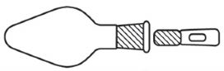
a stillhead | 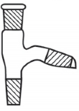
a condenser

a receiver adaptor
a separating funnel fitted with a ground socket and a 14/23 cone below the stopcock
a screw-capped adaptor for a thermometer

Additions – the more pieces of glassware you have, the greater the variety of processes you can carry out but each school will need to decide what its priorities are and thus what pieces of glassware they need to buy next.

