Making crystals
Crystals are structures formed from a regular repeated pattern of connected atoms or molecules. Growing crystals is a very popular activity in science lessons, ranging in complexity from simple crystal growth commonly encountered in primary schools , to more complex crystal formation such as growing crystals in gels.
In order to grow a crystal you need a concentrated solution with as much solute as you can dissolve (a saturated solution).
Sometimes nucleation (the formation of a ‘start point’ for crystal growth) can occur simply through the interactions between the solute particles in the solution (called unassisted nucleation), but sometimes it's better to provided a sort of meeting place for solute particles to aggregate (assisted nucleation). A rough surface tends to be more attractive for nucleation than a smooth surface. As an example, a crystal is more likely to start forming on a rough piece of string than on the smooth side of a glass.

Making a Saturated Solution
When you have decided what sort of crystals you want to grow, you will need to look up their solubility. When you have found out how much solid will dissolve in your volume of water, add that much (and a little more) and stir to dissolve.
You may also find that heating the solution will help things along. The increased movement of the particles will speed up the dissolving process. In addition, many solutes are more soluble in a hot solvent that a cold one.
If you do heat your solution to get it to dissolve, let it cool before using it.
An example for Alum (potassium aluminium sulphate)
Alum is very soluble at high temperatures (94 g in 100 g of water at 80 °C) but much less so at room temperature (12 g in 100 g of water at 20 °C).
To prepare a working solution, dissolve the salt in warm water (about 50°C) at a rate of 40 g per 100 cm³. Cover the solution and allow to cool to room temperature. This solution is now supersaturated.
Seed this solution with a pinch of tiny crystals and leave it in the closed vessel for two to three days, shaking occasionally, to become saturated at room temperature. Pour off the clear saturated solution into another vessel, with a lid.
This saturated solution is now ready to grow crystals in.

Growing a Seed Crystal
If you are trying to grow a larger single crystal, you will need to obtain a seed crystal.
There are two ways of getting your seed crystal:
1.
- Pour a small amount of your saturated solution onto a plate, petri dish, evaporating basin and leave it to evaporate. You can take the crystals formed on the bottom to use as seeds.
- Select the crystal you want to use as a seed and tie it onto a nylon fishing line (too smooth to be attractive to crystals, so your seed can grow without competition),
- Suspend the crystal in a clean container with saturated solution, and just leave your crystal to grow. Cover the container with filter paper (paper towel or coffee filter will be fine). Don't seal it with a lid – if you do, there will be no evaporation of the solvent and the solute will not be concentrated and so will not deposit on the seed crystal.
- Pour the liquid into a clean container if you see crystals growing on the container.

2.
- Pour saturated solution into a very smooth container (like a glass jar) and dangle a rough object (like a piece of string) into the liquid. Small crystals will start to grow on the string, which can be used as seed crystals.
- Once you have a seed crystal on a string, pour the liquid into a clean container (otherwise crystals will eventually grow on the glass and compete with your crystal),
- Remove any other crystals from the string – unless you want to grow several – and suspend the string in the liquid. As before, cover the container with a filter paper or paper towel etc.
- Pour the liquid into a clean container whenever you see crystals growing on the container.

In both cases, try not to warm the solutions. A warmer solution will evaporate faster but the crystals formed will be smaller.
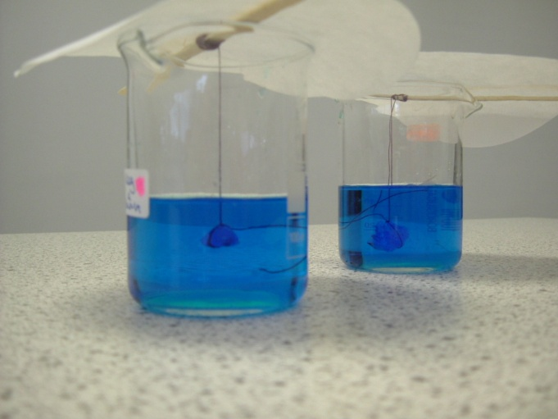
Growing a bigger crystal
Once you have your seed crystal, attach it to a length of thread and dangle it in a saturated solution.
As the water from the solution slowly evaporates, more solid will be deposited on the crystal and it will grow.

Sodium silicate, the crystal (chemical) garden and silicate gels

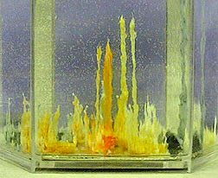
An interesting variation on crystal growing is the crystal garden, which involves the growth of coloured silicates in the laboratory. As well as crystal growth, this links into Earth Science as the formation of molten silicates in the Earth’s mantle involves the reaction of silicon dioxide with metal oxides at extremely high temperatures.
In brief, seed crystals of different metal salts are dropped into a solution of sodium silicate (also known as water glass).
Safety
The sodium silicate solution is strongly alkaline so eye protection and gloves should be worm. Some of the metal salts may also be hazardous – check the appropriate entries in the Hazardous Chemicals Database.
Growing your garden
Wear eye protection and consider wearing disposable nitrile gloves.
- Pour the prepared sodium silicate solution into a 600 ml beaker (a large jar is also suitable)
- Place the jar where you are intending to grow the crystals, cover it with a watch glass (or sheet of plain glass and allow the liquid to settle. (Once you have added your crystals, it is better not to move the container so any moving should be done at this stage.)
- Now add small (eg, rice-grain size) crystals of various metal salts. Some possible ones are:
manganese II sulphate
copper II sulphate
chromium III chloride,
iron II sulfate
iron III chloride,
cobalt II chloride*,
tin II chloride,
aluminium sulphate
nickel II sulphate*
* be careful as nickel, cobalt compounds are carcinogenic.
Other anions should work too so don’t worry if you have, say, cobalt nitrate rather than chloride.
- Leave the container undisturbed for several days.
- Label the container IRRITANT.

Making sodium silicate solution
A – from concentrate
Wear eye protection.
Add commercial sodium silicate to pure water in a ratio of 1+3
Pour into a labelled bottle. Although the solution is classified as low hazard but it is strongly alkaline so exercise caution.

B – From the solid
Wear eye protection and consider wearing disposable nitrile gloves.
- For 500 cm³, add 40 g of sodium silicate to a large beaker or coffee jar beaker and add 250 cm³ of pure water.
- Add a magnetic stirrer bar and place the mixture on a hotplate/stirrer.
- Keep the temperature at about 45 °C until the solid appears to dissolve.
- Filter through Whatman No.1 filter paper.
- Pour into a labelled bottle. Although the solution is classified as low hazard but it is strongly alkaline so exercise caution.

Growing crystals in gels
It is possible to grow crystals in gels. This method has some advantages over others:
- as they are supported gently in the gel matrix, their shape is not affected by the container they are grown in.
- crystals can be observed in all stages of growth
- it is possible to get crystals with different shapes and sizes just by changing the growth conditions
- it is simple and inexpensive.
The gels
Most commonly this is done in silica gel but it can be done quite successfully in other gels such as gelatin or agar.
Method
there are various different methods but the simplest is just using a test tube or boiling tube.
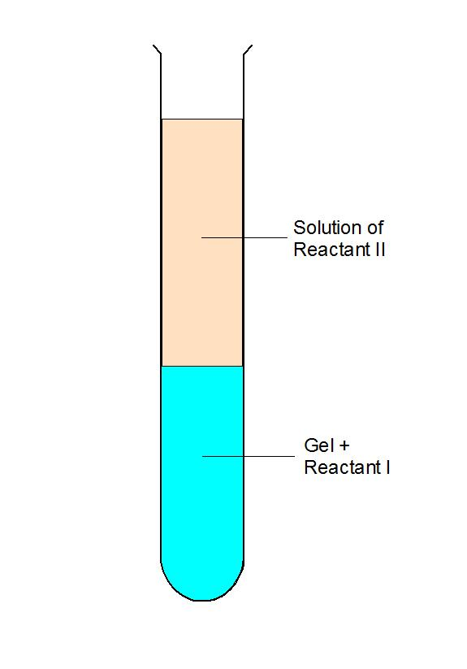
- dissolve one of your reactants in your gel solution.
(For gelatin or agar it is easier to dissolve it in the liquid and then use that solution to make the gel. This is also useful if you are making silica gel from scratch but if you are diluting the commercial product you will just have to dissolve it in the solution. In this case take care not to stir too vigorously as this will create bubbles in your gel.
- Carefully pour your gel into a test tube and leave it to set
- Dissolve your second reactant in a suitable solvent – usually water.
- pour the second reactant on top of the now solidified gel
- Stopper (or otherwise seal) the tube and leave it to grow the crystals.

The reactants
There is a wide variety of crystals that can be grown this way. A few examples are:

Crystals | A | B
Lead II iodide | 6 parts silica gel (diluted 6x with water), mixed with 1 part of 1M ethanoic acid with 4.5% potassium iodide. | A few cm³ of 25% lead nitrate in distilled water.
Copper | 6 parts silica gel (diluted 6x with water), mixed with 1 part of 1M ethanoic acid with 2 % copper II chloride | Clean an iron nail (or paper clip) and insert it part way into the gel.  Cover with 1 M sodium chloride solution.
Calcium carbonate | 6 parts silica gel (diluted 6x with water), mixed with 1 part of 1M ethanoic acid with 2 % calcium chloride-6-water | Cover with 1 M sodium carbonate solution.
Lead | 6 parts silica gel (diluted 6x with water), mixed with 1 part of 1M ethanoic acid with 5 % calcium chloride-6-water | Clean a piece of zinc and insert it part way into the gel.  Cover with distilled water..

Recrystallising
Recrystallisation is a technique used to purify chemicals.
After an organic synthesis or an extraction, it is quite likely that you will not have a pure substance but a mixture of your desired chemical mixed with some contaminants.
One way of getting a pure sample is to recrystallise from a suitable solvent.
The impure substance is dissolved in as small an amount of the solvent as possible.
The important thing is that your desired compound must have a different solubility in the solvent than the impurities.
The process works best if when some of the substances have a markedly different solubility when heated. If your desired substance becomes much more soluble when heated while the impurities don’t, you can dissolve the mixture in a small amount of hot solvent. As it cools, your product will crystallise out of solution and can be removed.
The impurities are excluded from the crystal structure as they form so they are pure crystals of your product.
Here is a description of the process from the RSC. (It is actually for recrystallising crude aspirin but is described in usefully general terms)
- Shake your sample with the solvent and warm to dissolve
The product dissolves only in the hot solvent. Soluble impurities also dissolve, but there should not be so many impurities that the solution is saturated. Insoluble impurities stay in suspension
- Filter the solution hot. Use a Buchner funnel and pump to make sure that the solution does not cool too much while it is being filtered. Throw away the residue.
Insoluble impurities stay on the filter paper, soluble impurities and the product stay in solution and are found in the filtrate.
- Allow the solution to cool slowly. If no crystals appear, add a single crystal as a ‘seed’ or stir vigorously for a few minutes. (If still no crystals appear you have probably added too much solvent!)
The product becomes less soluble as the mixture cools and eventually crystallises. Soluble impurities are less concentrated so they stay in the solution. (NB if the mixture is cooled too quickly solvent can become trapped in the crystals and is difficult to remove.)
- Filter the solution cold. Use a Buchner funnel and pump. Keep the residue.
The crystals are separated from the solvent which still contains soluble impurities, leaving the product contaminated only with solvent in which is dissolved a small amount of soluble impurity.
- Wash the residue with a small amount of cold solvent.
Contaminated solvent passes through the funnel, leaving only product and pure solvent on the filter paper. Warm solvent would dissolve a significant amount of product and it would pass through the filter paper.
- Dry the product on a watch glass, either at room temperature or in an oven
Because the solvent is pure it leaves no residue apart from the product

