Heating substances
An important part of many chemical processes is heating. Heating a reaction mixture will speed up the reaction rate of many reactions and overcome the activation energy and allow others to take place.
In needs, however, to be done safely. There are numerous methods of heating substances

Bunsen burner
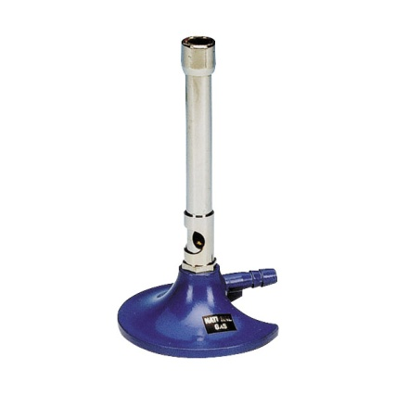
this tends to be the first port of call in a chemistry laboratory. The Bunsen burner is a convenient way to apply heat in a variety of situations.
The flame can be adjusted to a luminous yellow when not being used which makes them safer as it gives added visibility. This flame is not suitable for heating things though as it deposits too much soot.
Drawbacks
- As a naked flame, it should not be used when heating any flammable substances
- They are quite powerful sources of heat so there is a risk of heating delicate substances too much or heating too rapidly. Smaller, ‘semi-micro’ Bunsen burners are available that are less prone to this problem.

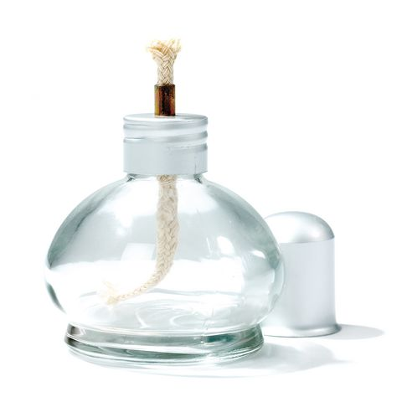
Other burners
spirit burners
These work by means of a wick drawing up methylated spirits (usually). They are not as hot as Bunsen burners but can still reach several hundred degrees celsius. The flame also is smaller in size. They are often used in microscale chemistry.
Drawbacks
- The small flame is not suitable for heating large volumes – it would simply take too long.
- The presence of a reservoir of flammable liquid is a potential hazard if they get knocked over.
- As a naked flame, it should not be used when heating any flammable substances

Mini gas burners
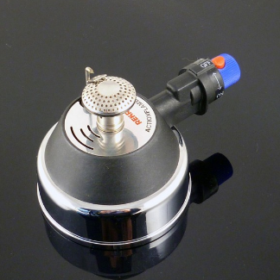
These are available from a few suppliers and use butane gas as a fuel, provided by the canisters used for refilling cigarette lighters.
They are solid and stable and while they don’t provide quite the heat that a Bunsen burner will, they provide more than a spirit burner. Each refill lasts for about 40 minutes of continuous burning.
Drawbacks
- As a naked flame, it should not be used when heating any flammable substances
NB. Camping gas stoves, or similar devices with small canisters of butane are not suitable for use in the laboratory.
candles/tealights
These are occasionally used but are not really suitable in a lab.
Drawbacks
- dirty flame will deposit soot on glassware.
- candles, though not tealights, tend to be unstable and hence a fire risk
- As a naked flame, it should not be used when heating any flammable substances
- Although the flame is quite hot, it is not very large and so, like the spirit burner, is not suitable for heating more than small quantities.

Hotplates
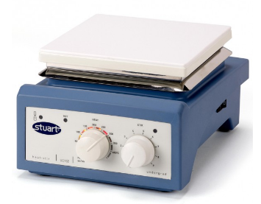
These are suitable devices for heating many substances and have the advantage of being able to be set at a particular temperature to keep the substance at.
Domestic hotplates can be used in some circumstances (perhaps for heating water in primary science) but are no substitute for a proper laboratory hotplate.
Many hotplates are combined with magnetic stirrers – this is invaluable and there seems little point to us in getting one without this facility. Many will also have a thread to attach a clamp stand to hold apparatus steady, again, a sensible addition.
Most laboratory hotplates claim to go up to about 300 °C but in our experience the generally struggle to get over about 250 °C.
Drawbacks
- Can be slow to heat up – particularly if larger volumes of liquid are being used.

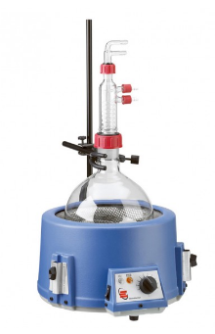
Electrothemal mantles
These are designed for heating smallish flasks, usually of organic liquids, safely. They provide a gentle, uniform heat for laboratory flasks. They are commonly used for distillation set ups and are particularly suitable for round bottom vessels.
They should be used where distillation (or reflux) of a flammable liquid is involved.
Drawbacks
- Tend to be limited in the size of flasks they can take – though it is possible to buy ones especially for larger or smaller flasks.
- Only really suited to round-bottom or pear-shaped flasks.

Water baths
Water baths are ideal for keeping reaction vessels at a constant, relatively low temperature (below 100 °C obviously), and also for ensuring an even distribution of heat. They are used extensively in biology but are also useful in chemistry for heating some flammable liquids safely.
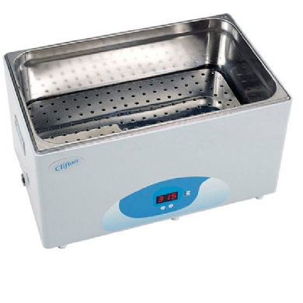
A temporary water bath - can be made simply by heating a beaker of water, using a Bunsen burner or pouring boiling water in from a kettle, and then using this hot water to heat up ethanol, propanone or some other flammable solvent (once the Bunsen burner has been switched off).
This is fine for short experiments but the water in the ‘bath’ will obviously cool down.
A permanent water bath - will be needed for longer activities.. This is a rectangular tank that can be filled with water, which contains a heater and a thermostat which can be set to keep the water at a specified temperature.
Drawbacks
- Temperature limited to 100°C

Oil baths
The principle of an oil bath is exactly the same as that of a water bath.
In this case, however, oil is used instead of water and this allows for greater temperatures to be reached.
Most commonly, the container of oil is placed on a hotplate to heat up.
Drawbacks
- Outside if container gets covered in oil

Sand bath
Again, the principle is the same. A container of sand is heated and the substance to be heated is inserted into it, in a suitable container. Like the water and oil baths, this provides a steady, even heat.
Most commonly, the tray of sand is placed on a hotplate to heat up.
Drawbacks
- Can take a long time to heat up, As sand is a poor conductor, temperatures can be much greater as you go down into it.

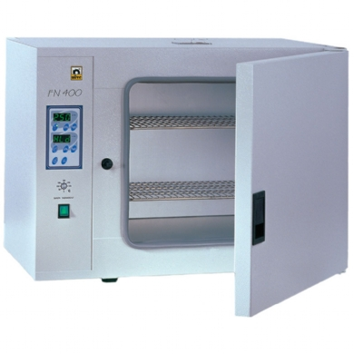
Laboratory ovens
These are useful for a variety of purposes such as drying soil samples, ensuring primary standards are properly dried before making up solutions, sterilising glassware etc.
Drawbacks
- Expensive

