Flame Tests
Flame tests are an important part of qualitative analysis in chemistry. In particular, they are a way to test for the presence of a variety of metal ions. Many metal ions colour a flame with a characteristic colour. To be more accurate, an emission spectrum is taken which will show characteristic lines associated with each element but most commonly in schools the colour is simply judged by eye.
The procedure is simple:
A small amount of the substance is introduced into a colourless flame. This will produce the flame colour.
There are various methods to carry this out.

Using a metal loop
A small loop of nichrome wire on a handle is used (like an inoculating loop used in microbiology).
- Dip a clean flame test loop in the sample. This can be a solution or a solid – in the latter case, the wire should be damp so that some grains attach to it.
- Hold the flame test loop at the edge of a Bunsen burner flame
- Observe the changed colour of the flame,
It gives a colour but the flame colour does not last very long.

Using a soaked splint
An alternative is to soak wooden splints in the salt solutions to be used. When these are held in the flame, the solution vapourises and colours the flame
- Take a splint that has been soaked in your solution for several hours (ideally overnight)
- Hold it in the outer part of the Bunsen flame
- Observe the changed colour of the flame,
This has the advantage that the splint has absorbed a larger amount of liquid than can be held on the loop so the flame colour lasts significantly longer. After a while, though, parts of the splint dry out and start to burn which colours the flame yellow, masking the colour from the metal ions.

Using an atomiser spray
This is another good method. The solutions are placed into small atomiser sprays and these are simply sprayed into the flame.
- Take your chosen atomiser bottle
- Hold it at least 30 cm from the flame, not pointing at the base.
- Spray a few ‘puffs’ of droplets into the flame and observe the colour.
There is no need to make solutions in flammable ethanol (as is sometimes seen on the internet), 1 M or so aqueous solutions work perfectly well. Be wary of getting too close and having the spray blow out the Bunsen burner – it is best to start off further away and work closer as needed.
It is best if the atomisers are washed out after each session – they can then be stored separately and normal lids put on the bottles of solutions – this is especially the case for copper as it will react with and ruin the spring.

Using the Bunsen air intake
Another method, which is very useful if you want the colour to persist for a while. perhaps to take readings with a spectrophotometer.
The method works by creating an aerosol in the solution. This can be done in two main ways – creating effervescence in the solution or bubbling air through it. There are various methods
Method A (i)
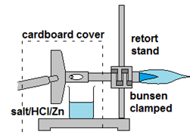
- The Bunsen burner is clamped on its side, as shown.
- A cardboard cover might be helpful to prevent air-currents blowing the mist away from the intake.
- The salt is placed in a small beaker with some zinc granules.
- The beaker is placed beneath the air hole of the Bunsen burner, as shown and hydrochloric acid is then added (2 M or more to get a good rate of bubbling)
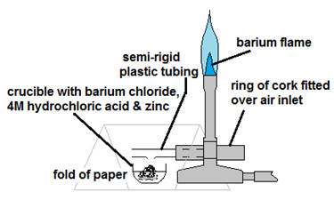
- The acid/zinc mixture produces hydrogen bubbles which cause droplets to be sent up past the air intake of the Bunsen. Some of it is taken in with the air and will colour the flame for as long as the effervescence continues.

Method A (ii)
A similar version is shown here. This time there is a connection made over the air hole to try to maximise the amount of mist that goes in to the flame.
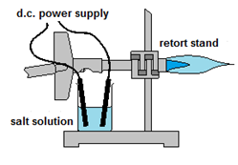
Method B
An alternative to using zinc/acid to create the droplets.
- The Bunsen burner is clamped on its side, as shown.
- A beaker containing the solution is placed below the air hole.
- Electrodes are placed in the solution, connected to a DC transformer.
- When the power is turned on, if the current is sufficient, the bubbles coming off at least one of the electrodes will make a mist that is drawn up into the air intake as before.
Method C
Another variation, using an aquarium pump this time.
Again the Bunsen burner is clamped on its side – as is the case for the others, it does not need to be at 90° but it does need to allow the beaker to fit close to the underside of the air vent.
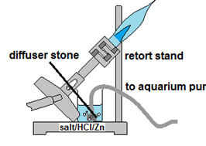
Take a length of narrow piping to fit an aquarium pump and place an aerating ‘diffuser stone’ on the end. This ensures that lots of small bubbles are produced which will be more effective at creating a mist.
Place the stone in a beaker containing the solution you are testing.
Attach the other end of the tube to the aquarium pump
Place the beaker beneath the air hole, as shown, and turn on the pump.
While it will work with a plain solution, more effective results are obtained if this is combined with the zinc/acid method as outlined in A (i).

Methanol flame colours
This is a different method in that it allows the flame to burn for a significant amount of time. Care should be taken as the methanol is extremely flammable (ethanol can be used instead but it is less effective)
Details of the method (and a risk assessment) can be found here (http://www.sserc.org.uk/index.php/chemistry-demonstrations/chemistry-demonstrations/3213-flame-colours)
- A spatulaful (about 1g) of solid salts are placed in a series of crucibles (or watch glasses).
- 3 cm³ of methanol is put on top of each sample.
- the methanol is then lit.
- After a few seconds, each flame gets hot enough to vapourise enough solid to colour the flame. The result is a rainbow of colours all at the same time.
