Filtration
Filtration is a process used to remove an insoluble solid material from a solution. The solid could be the required product or an impurity or an additive such as a drying agent.
The mixture is poured onto a filter, usually a filter paper, that acts like a sieve and allows the passage of liquid, the filtrate, while the solid, the residue, collects in the filter.

Simple filtration
Sometimes known as gravity filtration, this is the most common method of filtration.
Gravity filtration uses a plastic or glass funnel with a stem and filter paper.
Filter paper can have pore sizes ranging from small to large to permit slow to fast filtering.
Folding the paper
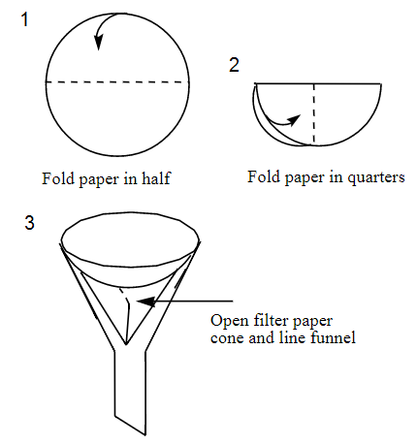
There are two ways of folding filter paper:
1) the ‘normal’ way
- Fold the paper in half, then, without opening it, fold again so it is in quarters. (see diagram 1&2)
- Now form it into a cone with three thicknesses of the paper on one-half of the cone and one thickness on the other.
- Put the cone into the funnel (you may need to wet it to get it to stay in place).
2) Fluted folding
The steps to flute the filter paper are shown.
- Fold the paper in half.
- Open it, turn 90° and fold in half again.
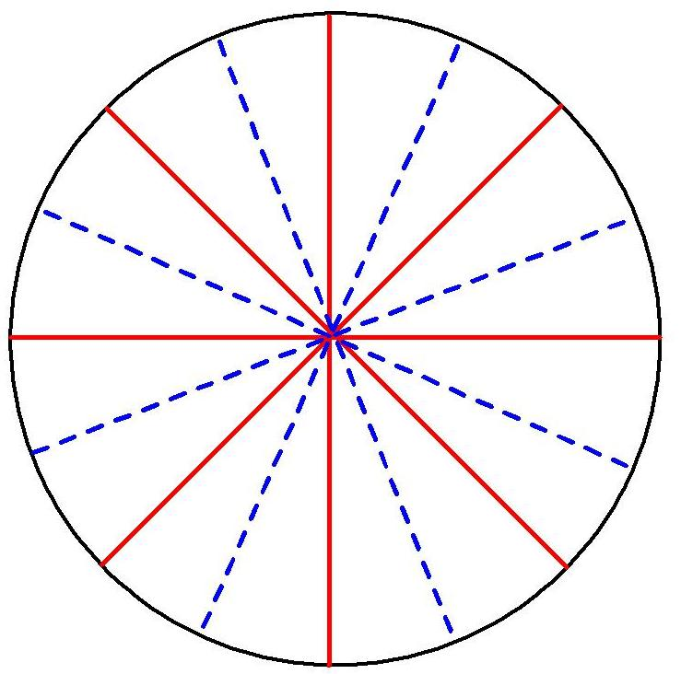
- Open again and make two more folds between the ones you have just made. These are the ones shown in blue on the diagram.
- Now turn the paper the other way up and make a new fold in half, between two of the folds you have just made.
- Open up and continue in exactly the same way you did for the first set of folds. These are the ones shown in red on the diagram.
- Now pleat your folded filter paper by folding each segment in the opposite direction to its neighbours, like an accordion, firming the folds.
When opened out the complete fan-like fluted paper results.

Fluting the filter paper maximises the rate at which the liquid may flow through the filter paper by increasing the surface area and by allowing air to enter the flask along its sides to permit rapid pressure equalisation
Carrying out the filtration
- Place the funnel into a beaker and wet the filter paper completely with the solvent (or solvents) in the mixture to be filtered. This step makes the filter paper stick to the funnel walls preventing solid from escaping.
- Sit the funnel in the neck of a conical flask.
If you are filtering into a beaker, you will need to support the funnel with a clamp (or ring). Placing the funnel so the stem rests against the side of the beaker can help prevent splattering.
- Before filtering, allow most of the solid in the mixture to settle.
- Pour the supernatant liquid (the liquid standing over the solid in a mixture) through the filter first.
This will allow the initial part of the filtration to proceed faster and may prevent clogging of the filter by the solid.
- Scrape the solid onto the filter with a rubber policeman or spatula.
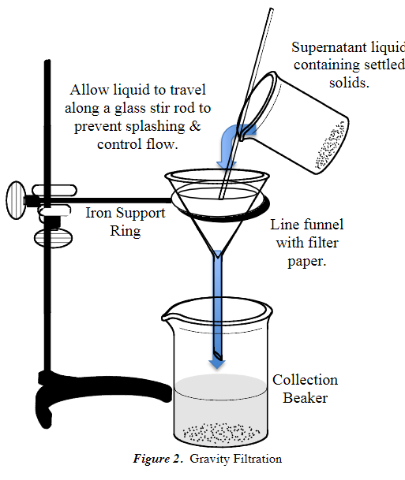
- Rinse the spatula, and beaker and pour the washings into the filter funnel.
- If the remaining solid residue is to be washed, rinse with three small portions (a few milliliters each) of an appropriate solvent.
- If the solid is to be saved, remove the filter paper carefully and place it on a watch glass to dry.
Caution: Wet filter paper tears easily.

Hot filtration
Sometimes during a gravity filtration, crystals can start to grow in the filter funnel and may block the funnel, stopping filtration.
This problem can be avoided by using a hot filtration where the whole filtration apparatus is heated in order to prevent the solution from cooling significantly. The hot filtration process is best carried out using a fluted filter paper and a stemless filter funnel. Having a stemless funnel means that there is less chance of the solution cooling in the stem and possibly crystallising out there.
- Support the stemless filter funnel on a clamp (or an iron ring) if it is at all insecure (see the lower picture).
- Place your solution to be filtered on a hotplate and make sure it is at the right temperature – your filtration set-up should be next to the hotplate so it doesn’t cool down during th process.
- Put your filter paper in the funnel – it is probably best to use the fluted method of folding as that allows for a faster flow and so reduces the chance of crystals forming in the paper and blocking it.
- pour a small amount of the solution into the filter and return the rest to the hotplate.
- Keep adding it in small portions until the process is complete.
- If crystals start to form in the paper or in the filter funnel, then the receiving flask containing a few drops of pure solvent with the funnel and paper in place should be heated on a steam bath (or a hot plate) and the entire filtration procedure carried out in this way at a higher temperature. Hot solvent may be added to remove any crystals appearing in the filter paper.
If pressure builds up in the flask due to the presence of hot vapours, the filtering action will slow down or even stop. The use of the fluted paper reduces this problem but may not stop it entirely. If this does cause the flow to stop, a small piece of wire or paper may be inserted between funnel and the neck of the flask to prevent the formation of a seal and consequent pressure build-up.
It is best not to use metal tongs or a test-tube holder to hold the hot flask flask while pouring the liquid since it is too easy to drop the flask. If you don’t have a purpose made flask holder, you can make a simple one from a piece of paper towel folded into a strip and pinched around the neck of the flask.
There is a good video on fluting filter paper and hot filtration here - http://www.rsc.org/learn-chemistry/resource/res00001066/hot-filtration?cmpid=CMP00001932#!cmpid=CMP00001932
Testing the filtrate
Sometimes the filtrate is tested to determine if a product or reactant has or has not passed through the filter. The test depends on what is being separated.
For example: All barium ions (Ba²⁺ ) should have removed from solution by the formation of the precipitateBaSO₄. To check this a few drops of Na₂SO₄ solution can be added to a small portion of the filtrate. If no BaSO₄ precipitate forms, the filtration was successful. If a precipitate forms, additional precipitating reagents (sulphate solution in this case) must be added to the filtrate and the resulting mixture must be filtered again.

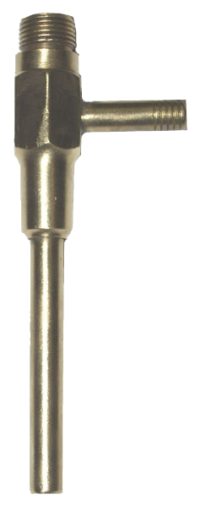
Vacuum (or Suction) Filtration
Vacuum filtration uses a Buchner funnel and a water-powered vacuum pump, also known as an aspirator.
A Buchner funnel is a flat bottomed, porous, circular porcelain bowl with a short stem. The stem is fitted with a rubber stopper and inserted in the mouth of a side arm filter flask.
An aspirator pump is a device that fixes to the tap and water flows through it into the sink. It has a side arm which has a rubber hose attached to it and this is connected to the filtration apparatus, providing the vacuum.
(The design of the path of the water causes a reduction in pressure at the point where the side arm joins and this creates the suction. It is known as the Venturi effect if you want to look up the details.)
Make sure the tubing you are using is heavy enough to prevent pinching or collapsing under external atmospheric pressure.

- It is important that the apparatus be clamped since it is very easily tipped over usually resulting in loss of the sample
- Place a circular filter paper, in the bottom of the funnel.
it must be large enough to cover all the holes in the bottom but small enough that it can sit flat without being folded up the sides.
- Wet the paper with the appropriate solvent to create a seal before starting the filtration.
- Attach the hose from the vacuum pump to the side arm of the filter flask. This creates the suction that pulls liquid through the filter and filter paper.
- Turn on the flow of water to create the suction. You may need to press gently on the funnel to start with just to help establish the seal.
- Swirl the mixture to be filtered and quickly pour it all into the funnel.
- If required, wash out the flask/beaker with more solvent and add it to the funnel.
- If required, wash the residue with clean solvent.
- Switch off the vacuum
- Disconnect the apparatus and take your filtrate or residue.
DO NOT pull off the funnel while the system is still under vacuum! Water could flash back into the collection flask or the filter paper could be damaged resulting in the loss of filtered solid.
If smaller quantities are to be filtered, you can use a Hirsch funnel and a small filter paper instead.
The filter flask can be replaced with a side-arm .test tube. Again, the tube should be clamped and the vacuum applied at the side arm using the thick walled vacuum tubing.

Microscale filtration
This can be done in several ways using disposable glass or plastic pasteur pipettetes*, or syringes.
* If using a plastic pipette, you will need to cut off the bulb using a pair of scissors.
Method 1
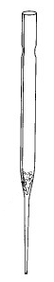
- Insert a small piece of cotton into the top of a Pasteur pipette and push it down to the beginning of the lower constriction in the pipette.
The cotton plug can be pushed down with a long thin object such as a glass stirring rod, a splint or a piece of wire.
It is important that enough cotton is used to collect all the solid being filtered; however, the amount used should not be so large that the flow rate through the pipette is too slow.
In some cases, such as when filtering a strongly acidic mixture or when performing a very rapid filtration, it may be better to use glass wool in place of the cotton, even though it is not quite as good as a filtering aid.
- Clamp the filtering pipette so that the filtrate will drain into an appropriate container.
- Transfer the mixture to be filtered to the filtering pipette (this is best done with another Pasteur pipette)
- Allow the filtrate to drip through and be collected.
If the volume of the mixture being filtered is less than 1-2 cm³, rinse the filter and plug with a small amount of solvent after the last of the filtrate has passed through the filter.
If desired, the rate of filtration can be increased by gently applying pressure to the top of the pipette using a pipette bulb.
Method 1a
If a syringe is being used it is possible, if desired, to speed up the process by applying pressure with the plunger.
- Set up the syringe in the same way as the Pasteur pipette described above.
- After putting the mixture in to be filtered, fit the plunger into the top of the barrel and apply gentle pressure to speed the flow of the filtrate.
Be careful not to push too hard as you might force some of the solid through the wool.

Method 2
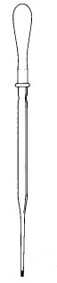
- Loosely shape a tiny piece of cotton into a ball.
- Push this into the bottom of the pipette using a wire with a diameter slightly smaller than the inside diameter of the narrow end of the pipette. (from the outside, not the inside of the barrel).
If it is difficult to push the cotton into the tip, you've probably used too much cotton.
- Squeeze gently to expel the air.
- Dip the tip of the pipette in the solution to be filtered and release.
- The expanding bulb creates suction which will pull the liquid up into the pipette through the cotton wool.
- Remove the plug of cotton wool and expel the filtrate into a suitable container.
With this procedure, small amounts of solid will be captured by the cotton and the clean filtrate will be in the barrel of the pipette.
This method also works with a syringe – indeed it is possible to get greater pressure this way.
The method is exactly the same as above only start off with the barrel of the syringe fully inserted and pull it out to draw up the liquid through the cotton wool
Do not pull too hard or you might such the ball of wool right into the syringe.

