Distillation
Distillation is an important technique that allows you to separate mixtures of substances that have different boiling points.
The mixture is heated to a temperature at which one of the components will vapourise (or vapourise significantly more than the others) and the vapour is cooled back into a liquid by a condenser.
As usual, there are various ways to carry this out.

Simple distillation
While distillation usually requires more complex glassware, it can be done quite simply as shown in the diagram below.
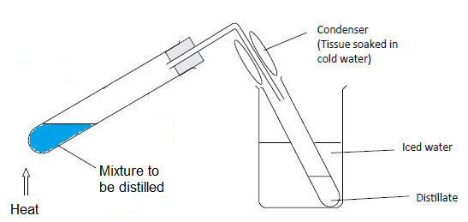
- Put a small amount of your mixture in a boiling tube and add a couple of anti-bump granules
- Fit a delivery tube and bung in the top
- Hold the boiling tube at an angle in a clamp
- Wrap some damp tissue paper round the delivery tube, to cool it a little more
- Place a test tube, for collecting the distillate, in a beaker of ice or iced/water and position it so that the delivery tube goes well down into it.
- Heat the bottom of the boiling tube gently. It is very easy to overheat the liquid so it boils too vigorously which will cause it to overflow down the delivery tube.
You should hold the Bunsen burner in your hand (by the base!) and play it backwards and forwards over the bottom of the tube.
- Once you see signs of boiling, be even more careful, keep taking the heat away and allowing the bubbling to die down a little before giving it another few seconds.
- The vapour will go up and into the delivery tube where contact with the cooled sides of the tube cause it to condense and trickle down into the test tube.
- After a short time, the hot vapour will heat up the glass so little condensation occurs here but there will still be a significant amount happening in the tube that is being cooled by the ice.
This is not an efficient process, in that quite a lot of vapour escapes, but it can allow for the collection of small quantities of distillate quite easily.
NB Heating with a Bunsen burner is only suitable for a non-flammable solvent such as water. For flammables like ethanol or propanone, the heating is best carried out in a water bath.

‘Standard’ distillation
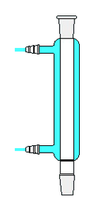
This is the ‘normal’ method of distillation that is carried out in the classroom. The principle is exactly the same as for simple distillation but a specialised condenser is used so as to be able to capture all of the vapours that evaporate, making it a much more efficient process.
Condensers
There are various different types of condenser but the one most commonly encountered is the Leibig condenser. In this device, the glass delivery tube is surrounded by another tube which can be filled with cold water. The condenser is connected to the cold tap so water is constantly flowing in and out and this keeps the walls of the delivery tube cold enough for the fumes to condense and trickle down to be collected.
While it is possible to use bungs or corks and glass tubing, it is much preferable to use ‘quickfit’ type glassware.
All the components have ground glass fittings which allow them to fit snugly together with no leakage. They come in different sizes but adaptors are available to step up or down.
Although quickfit joints are firm, they are not strong enough to support any load on their own. A flask attached to a still head, for instance must be supported by a separate clamp or it is likely to fall off and spill potentially hazardous substances.
Clips are available to help hold the apparatus together. These are a good idea but are not a substitute for holding any load (as above) – though the load from a 25 cm³ receiving flask should not be a problem.
Heating
Aqueous solutions can be heated, carefully, with a Bunsen burner but anything flammable should be heated by another method. Most commonly a water/oil or sand bath or a heating mantle or hotplate. (See Heating Substances)
Method
The apparatus is set up (more or less) as in the diagram below. 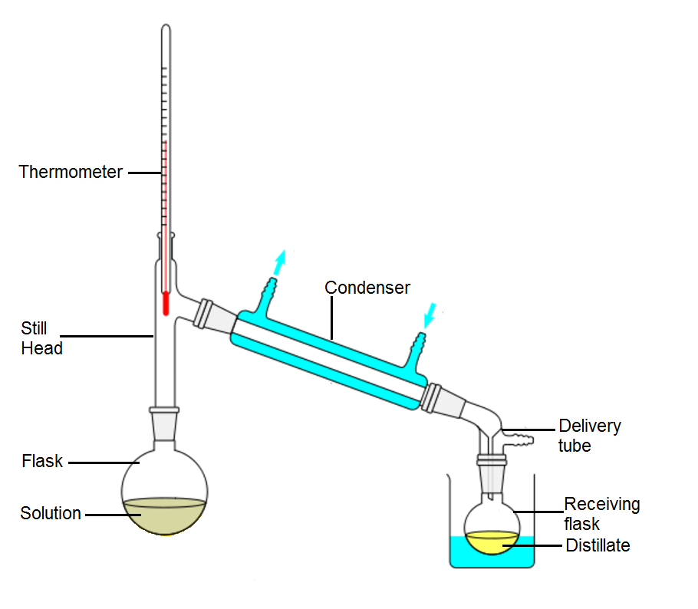
For most distillation the delivery tube is likely to be optional or, if used, it will be a much simpler type. The one shown has an adaptor for vacuum distillation.
- Set up the apparatus as shown in the diagram
- connect the water so that cold water flows in at the bottom and out at the top. Be careful not to turn on the water too forcefully as it might force the hose off and spray all round the lab!
- Make sure that the flask and the condenser are both supported by clamps. Make sure the height of the apparatus is suitable so that you can fit whatever heating apparatus you are using under the flask.
- Disconnect the flask and put the solution to be distilled in it along wiht a few anti-bump granules. Don’t over fill – no more than about half wat.
- Replace the flask in the apparatus and make sure the joits are tight. Put clips on if you are using them.
- Make sure the water is switched on to the condenser.
- Heat the solution. If using a Bunsen burner, be careful not to overheat it. (be particularly careful as you get close to the boiling point.
After a while you will start to see condensation on the inside walls of the condenser.
- Keep an eye on the thermometer. Its positioning will let you know what substance is coming over.
For instance. If you are distilling ethanol from home made wine, initially you will get some other components coming over such as volatile esters and aldehydes. When the temperature gets up to about 78°C you will be getting ethanol* and once the temperature rises above that you will be getting more and more water.
* In fact you get an azeotropic mixture of 95.6% ethanol and 4.4% water but the principle still holds.
- When you have sufficient distillate or the temperature rises to the point at which you think no more of your desired product is coming over. Stop heating.

Fractional distillation
‘Normal’ distillation isn't good enough to do an efficient job of separating liquids with boiling points that are relatively close together. To separate these, we use a technique called fractional distillation.
Fractional distillation is similar to standard distillation initially. The difference comes in that there is an extra piece of apparatus placed between the flask and the condenser – a fractionating column.
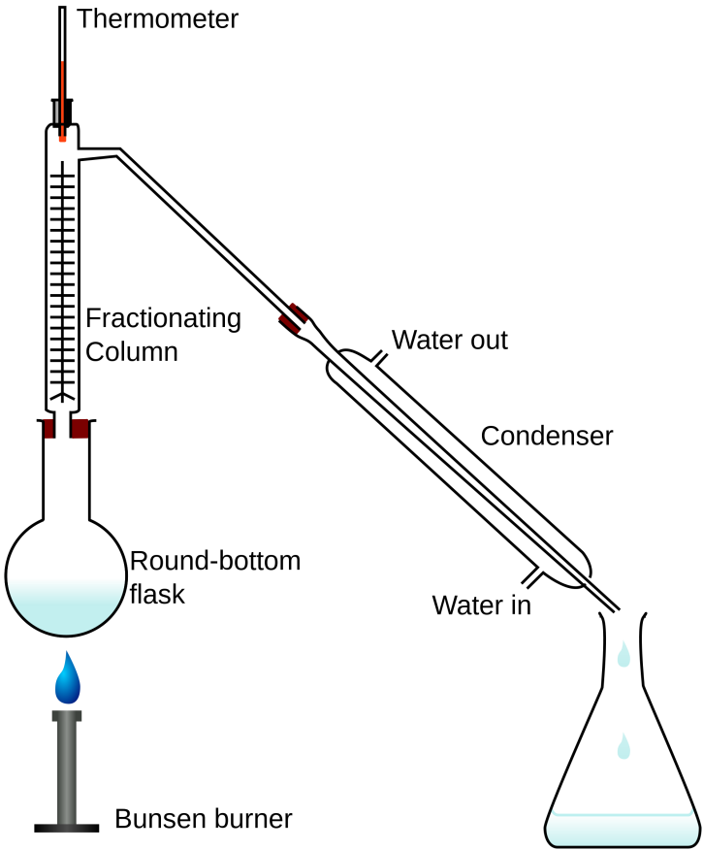
This is where the separation takes place.
As the vapour from the boiling mixture enters the fractionating column it begins to cool and condense and drip back into the flask. The least volatile liquid tends to condense The lower boiling more volatile blue liquid gets further up the column. As the process continues, the fractionating column gradually heats up from the bottom so the vapours get higher each time before condensing and falling back. During this process, the more volatile components get further up more rapidly.
Fractionating columns help to separate the mixture by helping the mixed vapors to cool, condense, and vaporize. With each condensation-vaporization cycle, the vapors are enriched in a certain component. A larger surface area allows more cycles, improving separation. This is why fractionating columns are packed with glass beads or projections that give a larger surface area for this to take place.
When the temperature at the top of the column reaches the boiling point of the lowest boiling component, that component will then distil over into the condenser. The higher boiling liquids, are still condensing and running back into the flask mixture. Thus they are separated.
The method is exactly the same as described for simple distillation.
This time, it is more important to keep an eye on the thermometer as that allows you to know when the different components are coming over and collect them in different tubes.
In industry, a version of this process is widely used, particularly for separating the components of crude oil. Instead of allowing the temperature to gradually increase to take off different components, though, a constant temperature gradient is maintained and there is a series of vents that tap the fumes at different points in the column (different temperatures) instead.
eg
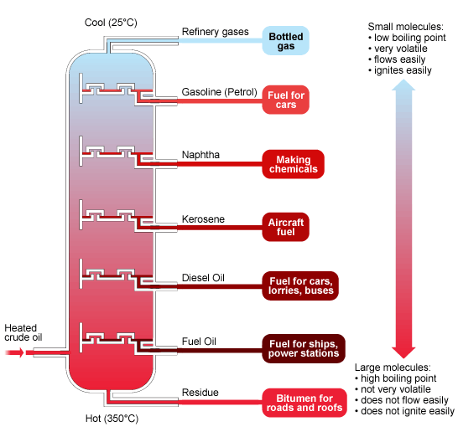
(image © BBC (http://www.bbc.co.uk/schools/gcsebitesize/science/aqa_pre_2011/rocks/fuelsrev3.shtm)

Vacuum distillation
It is often preferable, if possible, to distil things under reduced pressure, a process known as vacuum distillation.
The advantage of this is that it allows liquids to boil at a lower temperature. This can be important if trying to distil fragile molecules that might decompose if heated too much.
The process is, again, almost identical to Normal distillation.
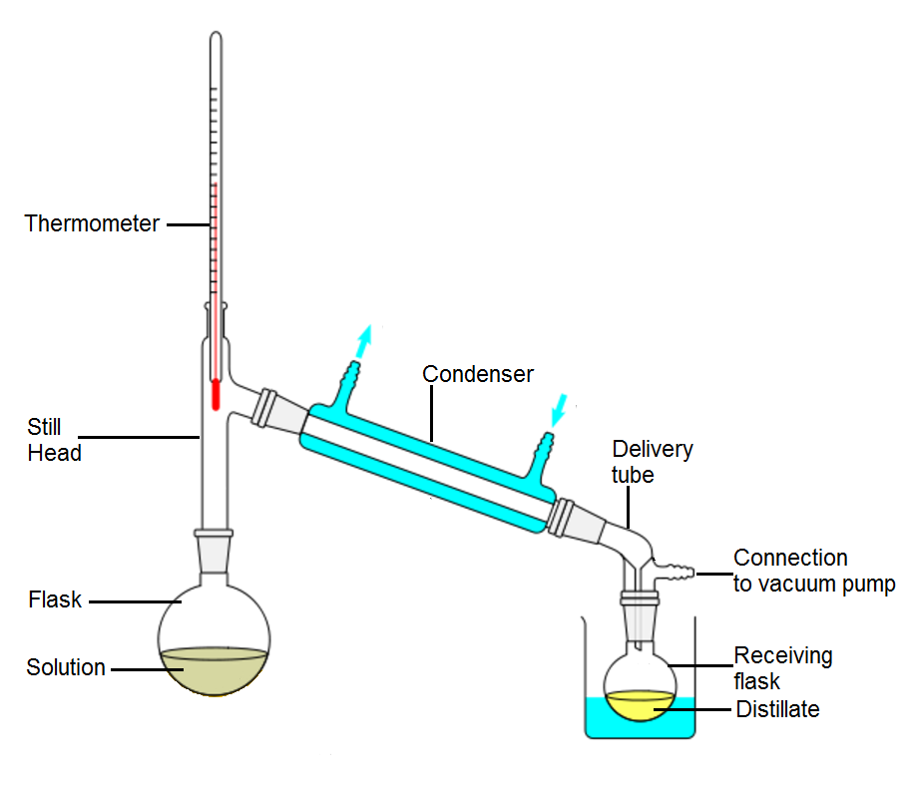
- Set up all the apparatus as shown above.
- The delivery tube will need to connect to the receiving flask by a ground glass joint.
- Start off as described under ‘normal’ distillation (steps 1 – 6).
- Once all is set, connect the tube from a vacuum pump (usually an aspirator type (see vacuum filtration for details) and switch on the tap/pump.
- All the ground glass joints should be airtight so as the air is sucked out from the delivery tube, the pressure should drop in the whole of the apparatus.
- Now, as before, heat gently until condensate starts to come over.
- When you have finished, Do Not disconnect the flask until the vacuum pump has been switched off.
This process too can be adapted for fractional distillation using a fractionating column.

Steam Distillation
This is a technique often used for extracting volatile oils from plant matter. Steam passed into the plant matter has the effect of depressing the boiling point of the scented compounds. These valuable substances then volatilize and are carried to the condenser in the flow of steam.
When a mixture of two practically immiscible liquids is boiling, each constituent independently exerts its own vapour pressure as if the other one were not present. As the mixture is heated, the vapour pressure of each component increases independently. Consequently, the vapour pressure of the whole system increases. Boiling begins when the total vapour pressures of the two immiscible liquids just exceeds the atmospheric pressure.
“In this way, many organic compounds insoluble in water can be purified at a temperature well below the point at which decomposition occurs. For example, the boiling point of bromobenzene is 156 °C and the boiling point of water is 100 °C, but a mixture of the two boils at 95 °C. Thus, bromobenzene can be easily distilled at a temperature 61 °C below its normal boiling point”. (Source: Wikipedia (2016))
Again, this has simple and more complex versions.
Simple steam distillation
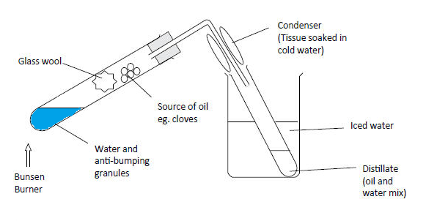
- The water is heated to produce steam – care is needed to ensure it dies not bubble too vigorously and froth up.
- The steam passes up through the plant material, cloves, orange zest etc, causing some of the essential oils to volatilise.
- The mixture passes up into the delivery tube, condenses and is collected in the flask.
As in other forms of simple distillation, this is not a very efficient process but it should be sufficient to see a few drops of essential oils collect.
One pot steam distillation
In this method, the steam is generated in a mixture of water and plant material and the boiling carries over the essential oil as before.
In practice, it is exactly the same as the ‘normal’ distillation process described earlier. The only difference is that the mixture to be distilled is a mixture of water and the oil-containing material – orange zest, cloves etc.
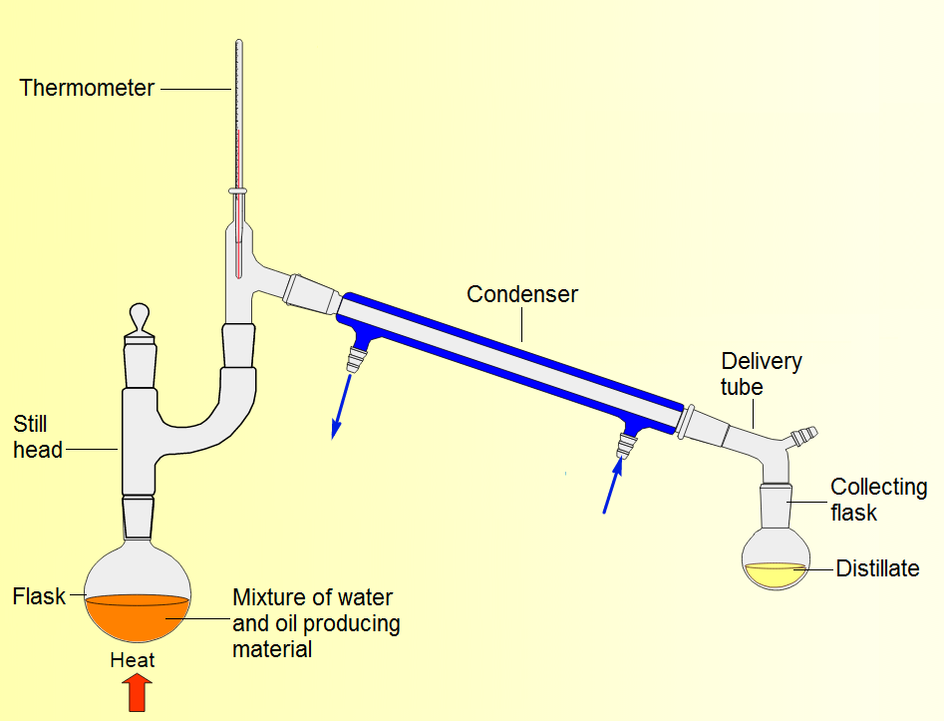
Image adapted from Reading University material (https://www.reading.ac.uk/web/FILES/chemistry/Limonene.pdf)
Follow the method described in ‘normal’ distillation, above.
There is no need for the delivery tube to have an adaptor for vacuum distillation – unless you are doing this at lower pressure, in which case proceed in the same way as for vacuum distillation.
Be careful when boiling it as pectins and other organics in some plant materials can cause frothing which may spill over into the condenser.

Two pot steam distillation
In this case the steam is generated in a separate reaction vessel and passed through the plant material in another flask.
This way, the water can be boiled as vigorously as you like without any issues of frothing.
The plant material also needs to be heated though great care needs to be taken not to burn it if you are using a Bunsen burner.
This is the most effective method but it is rather fiddly and very equipment heavy so may not be suitable in a class situation.
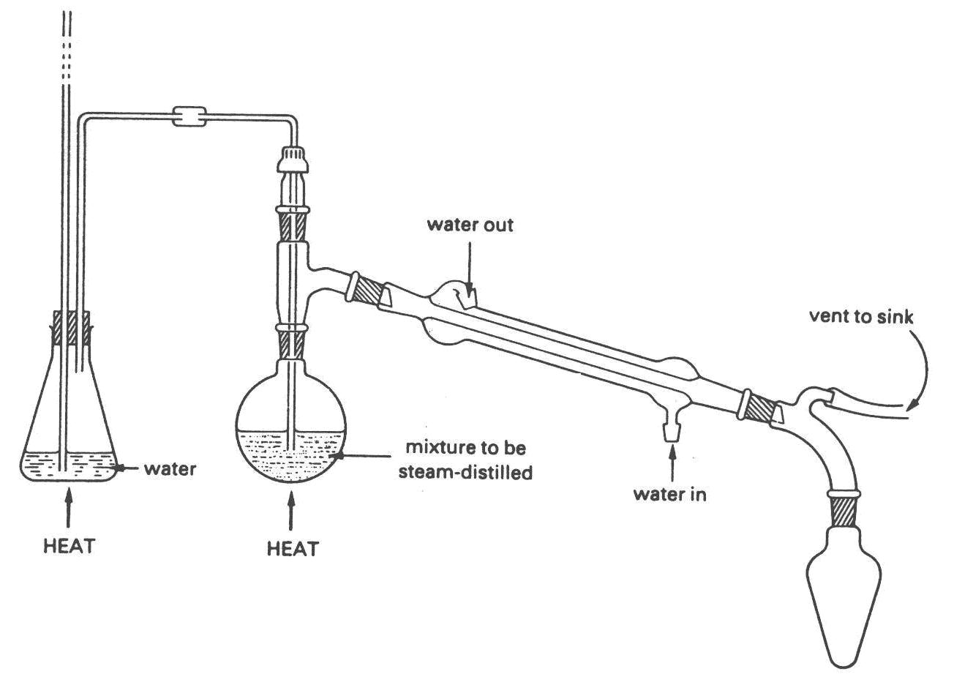
ice cold water
plant material

- Set up the apparatus as shown. (There is no real need for the vent to the sink).
- Start heating the flask with the water in so that it comes to the boil.
- Once the steam starts coming over, start gently heating the plant material
Make sure you do this very gently so as not to burn the plant material.
- Continue until you think you have extracted sufficient essential oil.

