Colorimetry

Colorimetry is, put simply, the measurement of colour.

While you can see with your eyes if water is cloudy or clear, or if it is coloured, it is not possible to get an accurate measurement of just how intense a colour is or how cloudy a solution may be. (although the human eye is actually a lot better than you might think)

## Colorimeters

A colorimeter is a device that passes light of a particular “wavelength” through a sample. Using a detector, the colorimeter can measure how much of the light has been absorbed by the sample. The amount of light absorbed by the sample is related to the concentration of the chemical of interest. This way it is possible to get numerical values for the amount of light and given such data, there is much more that can be done.

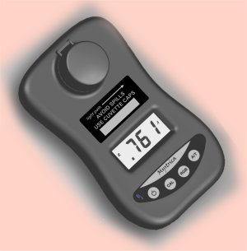There are many different colorimeters on the market.

The one we use most commonly is the Mystrica colorimeter – because that is very inexpensive but still manages to be robust and accurate (SSERC has put a class set into each local authority that can be borrowed by schools).

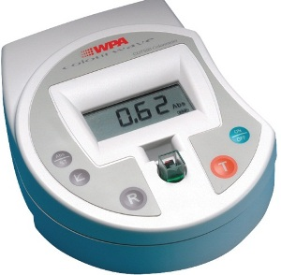The other ones we have a set of here are the more expensive WPA ones.

They have the advantage of a wider range of colour filters which can be an advantage in some experiments.

We should point out that these are just two models and we make no claims about them being superior to others on the market. There are many other good products available.

## Visual colorimetry

This is the simplest and cheapest method – as it needs no equipment at all!

1. Make up a range of standard solutions of different concentrations
2. Line up your standard solutions.
3. hold the tube with your solution of unknown concentration against the row of tubes and move it along until you reach the one it is closest to.
4. Make a note of the concentrations on each side and estimate what the intermediate concentration is.

eg. Here is a row of copper sulphate solutions with an unknown on the left. The label on the bottle gives a misleading colour but look at the lower part of the sample (marked with an arrow)

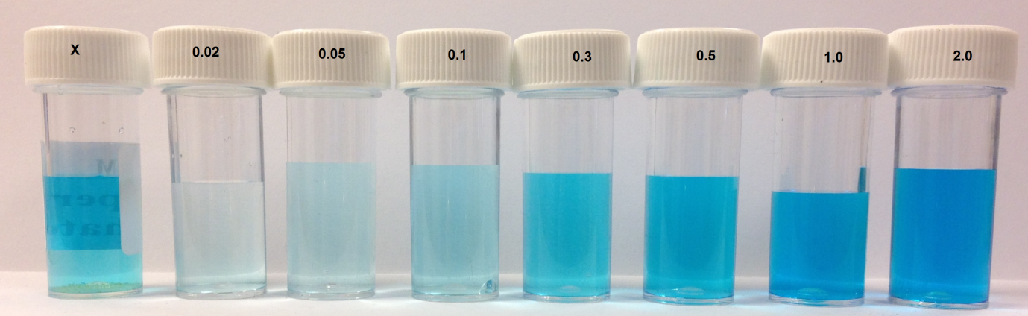

It is not possible to move it along so it is a bit harder but it seems to me that the colour is closest to that of the 0.3 M sample.

In fact it is 0.25 M.

## Using a colorimeter

**Cuvettes**

In order to take a reading of a sample in a colorimeter, it is normal to place the solution in a cuvette. These are small, rectangular containers, usually plastic, that sit in the slot in the top of the colorimeter.

The reason for using cuvettes is that when comparing solutions, it is important to bear in mind that the length of the path through the liquid will affect how much light is absorbed – that’s why it gets darker as you go deeper into the ocean.

Cuvettes have, mainly, a standard, 1 cm path length which allows for a fair comparison between samples.

**Types of cuvettes**

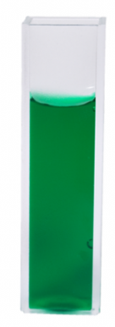**1. Standard**

These are made of polycarbonate and have two main designs

- all 4 sides transparent

- 2 sides frosted or ridged. The idea is that these are the sides you hold, so you don’t get fingerprints on the clear sides. You need to make sure you put them in the colorimeter the right way round though.

They hold about 4 cm3 of solution when filled to the brim but do not put more than about 3 cm3 in to avoid spillage.

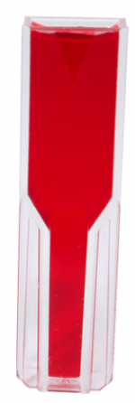**2. Semi-micro**

These are also made of polycarbonate but the bottom is narrower (on 2 sides).

This means that a smaller volume of liquid can be used while still retaining the 1 cm path length.

Again, it is important to insert these the right way round in the colorimeter.

**3. Glass cuvettes**

These come in the same designs as 1 & 2 above but are made of glass (obviously).

The reason for this is that some solvents will attack or even dissolve the polycarbonate so it is impossible to use the normal plastic cuvettes for them – propanone for example.

They are more expensive and, being glass, likely to break so it is best to use the plastic ones where possible.

**4, Quartz cuvettes**

Not so much used in colorimeters but in spectrophotometers, if you want to work in the uv spectrum neither glass nor polycarbonate will do as they are both opaque to wavelengths below about 370 nm. In these cases, quartz cuvettes are the only option – but they are too expensive for normal usage.

All the cuvettes have lids available. It is a good idea to use them if you can, to protect the colorimeter from spillage.

**Absorbance and transmittance**

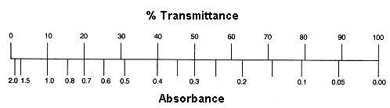You have a choice of taking readings of either absorbance or transmittance.

These two values are related but not exactly the same.

(Diagram taken from Sheffield Hallam university <http://teaching.shu.ac.uk/hwb/chemistry/tutorials/molspec/beers1.htm> )

So, if all the light passes through a solution without any absorption, then absorbance is zero, and percent transmittance is 100%. If all the light is absorbed, then percent transmittance is zero, and absorbance is infinite.

As you can see from the graphs above, it is preferable most of the time to measure absorbance as that has a simple, linear relationship with concentration.

If you have accidentally recorded transmittance instead, there is no need to repeat the readings. transmission and absorbance are related by the following equation

a = 2 – log10 T%

**Using a colorimeter**

The precise methods will differ from machine to machine but this is the general sequence of steps.

1. Switch on your colorimeter and select the right filter/light source.

*The mystrica gives you a choice of red, green or blue, the WPA offers 7 different wavelengths, while higher end machines will allow an infinite variation within the range.*

1. Look to see the direction of the beam so you know which way to insert your cuvette – unless it is one with all 4 sides equally transparent.
2. Zero your colorimeter against a reference sample, called a ‘blank’. This should be the solvent that your solutions are in. You may need to re-zero your colorimeter fairly frequently for accurate results.
3. Prepare cuvettes of your test solutions.

*With a standard cuvette you will need no more than 3 cm3 at most. If you over fill, you have a greater chance of spilling solution into the machine which can cause damage to an expensive piece of equipment. If possible, it is best to use a lid.*

1. Make sure there are no air bubbles clinging to the sides of the cuvette or other marks that may interfere with the readings.
2. Insert your cuvette in the slot in the colorimeter, making sure it is the right way is there are any frosted sides.
3. Take the reading.

For accurate work, it is best to prepare 3 (or more) samples of each solution and average the reading.