Chromatography
Chromatography is a set of related laboratory techniques for the separation of mixtures of soluble substances.
The types of chromatography that are commonly encountered in schools are:
- paper chromatography
- thin-layer chromatography
- column chromatography
- flash chromatography

How chromatography works
All forms of chromatography work by exploiting different interactions between the substances to be separated and the two components of the chromatography setup.
The stationary phase – this does not move and the liquids pass through it. (In ordinary paper chromatography, the paper is the stationary phase.)
The mobile phase – this is the fluid that moves through the stationary phase (like the water through filter paper)
The different components of the mixture travel at different speeds, because they interact differently with the stationary phase, causing them to separate.
Development
When separating out mixtures of inks, it is easy to see where the different spots are. Many substances which are separated are colourless. In this case, the chromatogram needs to be developed before you can see them. This can be done either by irradiating with uv or by chemical development eg using ninhydrin for locating amino acids.

Paper chromatography
This is a familiar technique in schools.
A mixture most commonly of dyes (often an ink) is place on some filter paper and a solvent is allowed to run up/along the paper carrying the different dyes different distances.
Chromatography paper
There are various different grades of chromatography paper. They differ mainly in the thickness and flow-rate – chemically they are all cellulose-based so will interact with any solutes in the same way. They do, however, have different densities and fibre characteristics.
It is possible to carry out simple chromatography using filter paper, or even coffee filters, but if you want to get decent, quantitative results of Rf values then you need a decent quality chromatography paper.

Chromatography tank
A chromatography tank is simple the container in which the chromatography process takes place.
It is possible to purchase expensive, purpose-made tanks for this but there is not much need in a school context. A large beaker (600 cm³ or larger is fine). As long as you have some way of covering the top to keep the atmosphere saturated with vapour, all will be fine – this is easier with a tank but not too great a challenge using a beaker.
The instructions below are for running a chromatogram with about 8 samples on in a 600 cm³ beaker. It is possible to use a narrower piece of paper and run one or two samples it in a test tube or boiling tube. Likewise a smaller beaker could be used with a shorter piece of paper – though there would be less separation. The principles are exactly the same.

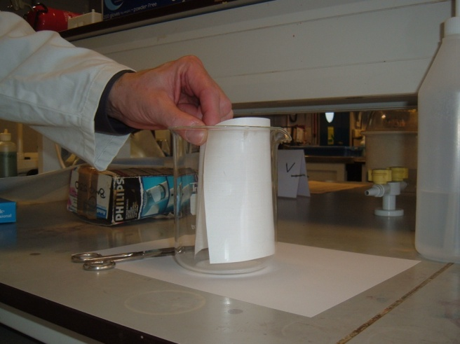
Preparing the chromatography paper
- Take the sheet of chromatography paper. Cut the paper so that if fits into the container without touching the sides
- Using a ruler, draw a light pencil line across the paper about 2 cm from the bottom of the sheet (see diagram below)
- Draw dots or crosses along this line 2 cm apart (see diagram below)
- Mark numbers at the top, above each dot, so you can identify which sample is which.
- Most commonly you will have one or more unlnowns and one or more standards for comparison.
1 2 3 4 sample 5 6 7 8
Dots or crosses 2cm apart
Pencil line 2cm up
Spotting the chromatography paper
- Using a capillary tube, apply a small spot of the unknown mixture on the pencil line. (The colour spot should not exceed about 0.4 cm in diameter.)
Leave it to dry. (It is necessary to allow the spot to dry between applications of colour in order to keep it small in size.)
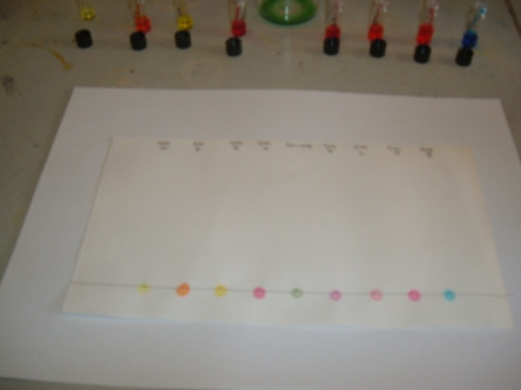
If the spot seems to be too small or too light in colour, you can make it darker by applying a second spot of colour (or more) directly on top of the dry first one.
- Spot the paper with each of the other samples and references, allowing about 2.0 cm minimum distances between each different spot.
- Remember to mark which is which!

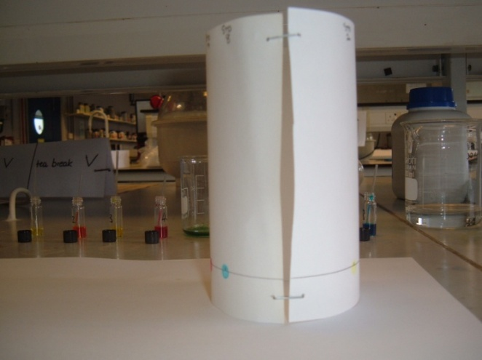
Preparing the solvents
- Add your solvent to a clean 600 cm³ beaker, to a depth of about 0.5 cm (this will require approximately 25 cm³ of solution).
- Bend the spotted chromatography paper into a cylindrical shape, butt the ends together (do not overlap the ends) and staple them as shown.
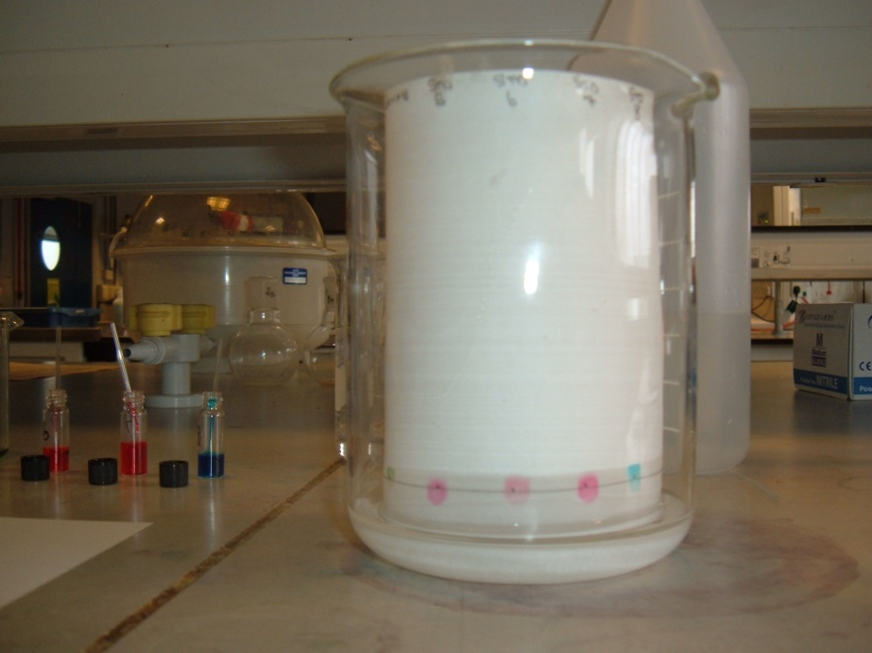
Running the chromatogram
- Place the chromatography paper into the beaker making sure that the spots of dye are NOT below the solution level and that the paper is NOT touching the sides of the beaker.
Important – make sure the spots you have made are ABOVE the level of the solution

- Cover the beaker a watch glass. (or some clingfilm) (See diagram below)
The reason for covering the container is to make sure that the atmosphere in the beaker is saturated with solvent vapour. Saturating the atmosphere in the beaker with vapour stops the solvent from evaporating as it rises up the paper.
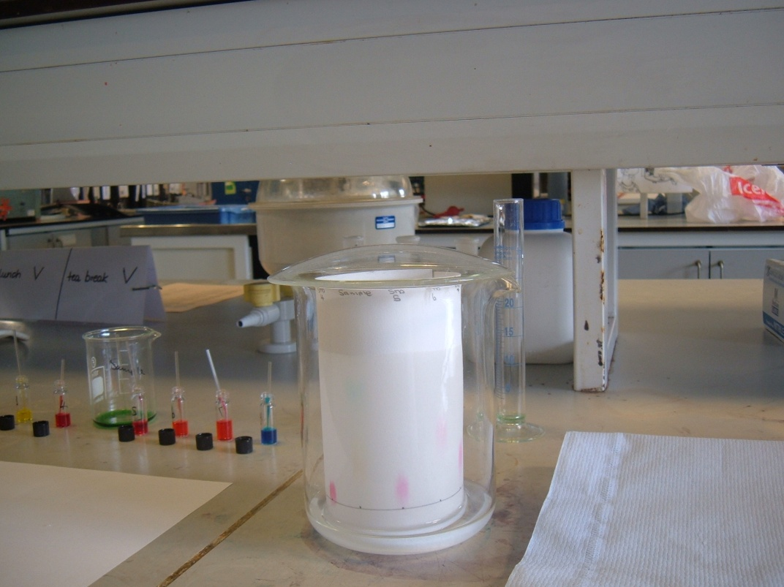

Watchglass covering beaker

- Allow the solvent to move up the paper to within about 1 cm of the top. This can take half an hour or more.
- When it is finished, remove from the tank and immediately mark the position the solvent reached (the solvent front). Some solvents evaporate very fast and the solvent front will probably not be visible once dried.

Thin-Layer chromatography
This technique is exactly the same as paper chromatography except that instead of paper as the stationary phase, the solvent runs through a thin layer (hence the name) of solid material that has been deposited on a thin metal or plastic sheet.
The most common stationary phases are silica (silicon dioxide) and alumina (aluminium oxide).
It has various advantages over paper chromatography. It is faster and will produce clearer separation and more reproducible results. It also needs smaller amounts of sample. As the plated are more robust than paper, they can be treated more harshly, if needed, to develop the spots.
It is possible to make your own TLC plates but it is preferable to buy them ready made as these give more consistent results. A box of TLC plates is not cheap but you can economise by cutting them to smaller sizes. Indeed, it is possible to carry out TLC on a microscale which uses only a very small piece.
The technique in principle is very similar to that for paper chromatography.
- Put a pencil line 1cm from the bottom of the TLC strip.
- Using a capillary tube, place a spot of your sample on the line (you want the spot to be as small as possible).
A standard capillary tube may well be too large. If too much solute gets on the plate, any spots will tend to be blurred. If this is the case, draw the capillary tube out into a finer point by putting it into a Bunsen flame and pulling it out to a thinner tube. (You will only need to heat it for a few seconds). Then break off to get your finer capillary.
- Repeat with other samples/references if desired.
- Place a small amount of solvent in the bottom of your ‘tank’ (to about ½ cm in depth)
- Place the TLC strip so the bottom is in the solvent. Cover the ‘tank’ and leave to run.
- Once the solvent front has travelled to near the top of the TLC plate, remove it from the ‘tank’ and immediately mark the position of the solvent front with a pencil – before the solvent evaporates and you can’t see it.
- Allow the TLC plate to dry.
The image to the right shows a TLC plate of photosynthetic pigments.

Column Chromatography
Column chromatography works on the same principle. The mixture is washed down a column filled with a permeable solid. The different dyes move through the column at different speeds and so come out of the bottom at different times. The advantage of this is that you can get samples of your separated dyes to do further work on. Thus it is a preparative as well as an analytical technique – indeed it is widely used in industry to isolate and purify substances.
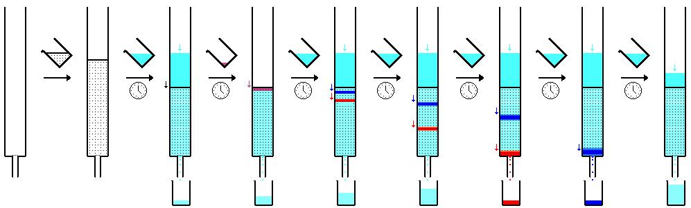
By quantockgoblin - Own work, Public Domain, https://commons.wikimedia.org/w/index.php?curid=1603838
The stationary phase
As with TLC, is most commonly silica or alumina although any solid or gel can be used. One of the advantages of this technique is that it is possible to use very specific solids that will interact with specific components of the mixture to separate them more efficiently. You can, however, also use cheaply available materials like cornflour or talcum powder.
The column
It is possible to use any tube that can be packed with solid. Simple glass tubing is fine but you do need to be careful that the column does not fall out of the bottom! A way round this is to use a glass pasteur pipette: a small plug of cotton or mineral wool in the bottom will prevent any problems like this.
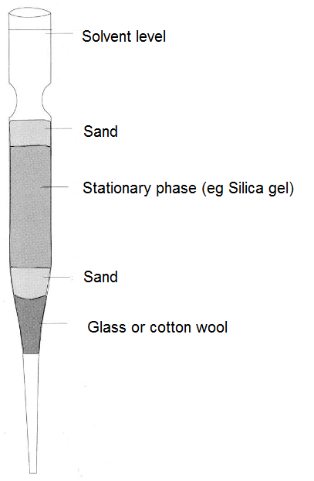
- Insert a small plug of glass/mineral wool into the neck of a glass pipette and pack it gently, but firmly in the bottom end.
- Covered it with a thin layer of sand.
- Now add your chosen stationary phase. Tap the side of the pipette with a pencil to make sure the material settles properly without air pockets.
- At this stage, you can store the column for later use
- Before use, place your column vertically in a clamp and wash it with one volume of your eluting solvent to settle and prepare it.
- When the solvent is about 0.5 cm or less above the top of the stationary phase, add a few drops of your mixture
- Once the mixture has reached to just below the surface, carefully add another thin layer of sand on top of the column.
- Carefully add more solvent
- Keep adding solvent as the level drops. Do not let the column dry out.
- You can make this less onerous if you attach a length of tubing to the top of the pipette and fill that with the solvent – as well as giving you more solvent to run through between refills, it will increase the pressure and mean that the column runs faster.
- If you are separating a mixture of coloured dyes, it will be possible to simply watch them as they proceed down the column and then collect them individually at the bottom.
- If, however, you are separating colourless substances, the best tactic is to collect set amounts of eluted solvent. For instance, if you collect 1 cm³ samples, you can then test each one to see where the desired substance actually is.

Flash chromatography
Flash chromatography is very similar to column chromatography.
In fact the only difference is that pressure is applied to the solvent to force it through the stationary phase. This makes the process much faster, hence the term ‘flash’.
There are a couple of ways to do this:
Method A
The most straightforward way to do this is to set up the apparatus for column chromatography as above.
To apply the pressure, you will need a syringe and a length of silicone tubing that will fit over the top of the column.
Follow steps 1 – 8 above
- Once you have added the first batch of eluting solvent, make sure the barrel of the syringe is pulled out and then attach the syringe to the top of the column with the silicone tubing
- Now press on the plunger. This in turn applies pressure to the top of the solvent, forcing it through the column.
Watch out for:
The column running dry – you will need to keep removing the syringe and tubing to add more solvent.
The tube popping off. If you push too hard, the pressure will force
- Collect your samples as described in 11 & 12 above.
Method B – Syringe chromatography
It is possible to carry out the whole process in a syringe – using the barrel as the column and the plunger to apply pressure.
Details are given on the SSERC website here
http://www.sserc.org.uk/index.php/national-4/nature-s-chemistry-n4/1130-subject-areas/chemistry/chemistry-national-4/nature-s-chemistry-n4/3052-flash-chromatography
in brief though:
You can use any size syringe but 5 cm³ ones seem a good compromise.
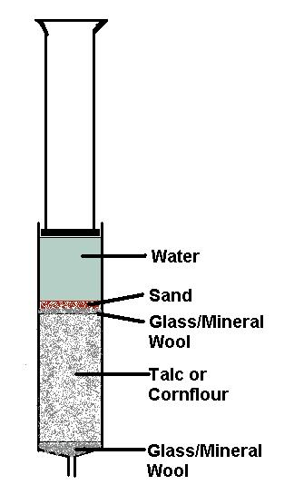
- Put a plug of glass or mineral wool in the bottom of the syringe barrel and firm down.
- Put a thin layer of sand on top
- Pack the barrel with your stationary phase. Tap the side of the barrel to get it to fall into place. You can also use the plunger to push it down.
(You can now run solvent through and continue as before or alternatively, run it as a dry column, as described below)
- Add a few drops of your mixture to the top of the column.
- Put another thin layer of sand on top.
- Carefully add solvent to very near the top – but not quite to the rim.
- Insert the plunger of the syringe and apply pressure.

Some reagents for chromatography
Solvent = the eluting solvent that is used to run the column
Locator = the reagent needed to make the chemicals visible on a paper/TLC chromatogram
Many of thees solvent mixtures (and other substances) are hazardous. Consult the Hazardous Chemicals Section of the SSERC website for safety information.

For | solvent | locator
Amino acids | Butan-1-ol, glacial ethanoic acid, water; 6:1:2 by volume. eyes. | Apply ninhydrin and heat in an oven at 110 °C or with a hairdryer.
Analgesics, eg, aspirin, paracetamol | Ethyl ethanoate, hexane, ethanoic acid; 10:9:1 by volume. | UV light, Dragendorff reagent or iodine vapour.
Anthocyanins (plant pigments) | 100 ml 50% aqueous methanol solution with 1 ml of glacial ethanoic acid or  1 ml concentrated hydrochloric acid in 100 ml ethanol/IDA | Natural colour. (The components are light sensitive so run the chromatograms in the dark if possible and quickly note or photograph the results.)
Inks from Biro pens | Butan-1-ol, ethanol, water; 3:1:1 by volume (The addition of a few drops of 880 ammonia is said to produce a better chromatogram). | Natural colour
Chlorophyll | Propanone, petroleum spirit (100-120°C); 1 : 9 by volume  or  cyclohexane, propanone, ethoxyethane; 2:1:1 by volume. | Natural colour of dyes and UV light. (The components are light sensitive so the results should be noted or photographed quickly.)
Lipstick | 3-Methylbutan-1-ol, propanone and water; 2:1:9 by volume. | Natural colour
Metal ions | Propanone, hydrochloric acid (conc), Distilled water; 17:2:1 by volume. | Use conc ammonia solution followed by 0.1% dithio-oxamide (rubeanic acid).
Products from nitration of methyl benzoate | Ethoxyethane, pet ether (80/100 °C); 1:9 by volume. | UV light.
Sugars | Ethyl ethanoate, pyridine, water, 8:2:1 by volume. | Dab Benedict’s solution on the chromatogram and dry in an oven at 110 °C.

