Arculus Method
The Arculus method is a common arrangement of equipment used for passing steam over magnesium and for the cracking hydrocarbons or alcohols. (As shown below)
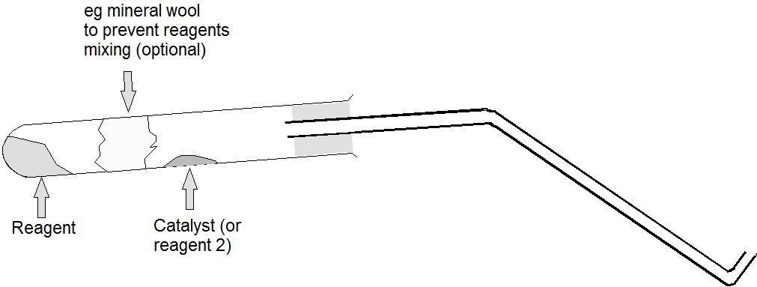
Solid reagents can simply be placed in the bottom of the tube.
Liquid reagents are absorbed onto an inert medium. Ceramic or glass wool is usually used by scrunched up filter paper is just as effective and in fact has a bigger capacity of absorbing liquids. It will only char when all the water or other liquid has been driven off; clearly there is no advantage in heating further. It is not suitable, however, for oxidising or corrosive reagents.
Higher up the tube is placed the other reagent or catalyst.
The tube is placed almost horizontally so as to stop the reagents mixing. For safety, depending on the reaction, it can be a good idea to have a plug of glass or mineral wool between them
This method can be used for:
1) Reaction of metals with steam – water is absorbed onto the ceramic wool or filter paper and the metal is placed higher up the tube.
2) Reaction of metals with oxygen – potassium manganate VII is placed at the bottom of the tube and the metals are placed part-way up as before.
3) Dehydration of alcohols – ethanol (or other small chain alcohols can be absorbed onto mineral wool / filter paper at the bottom and passed over how aluminium oxide to dehydrate them to alkenes.
4) Cracking of liquid paraffin – similarly to the above. Liquid paraffin is absorbed at the bottom and aluminium oxide is used higher up as a catalyst.

