Anodising

Introduction
Anodising is a process used to increase the thickness of the natural oxide layer on the surface of metal parts. In concept it is similar to electroplating in that it involves passing an electric current through a solution which results in a layer being deposited on one of the electrodes.
It is called anodizing because the part to be treated forms the anode electrode of an electrical circuit.
Anodizing increases resistance to corrosion and wear, and provides better adhesion for paint primers and glues than does bare metal.
It can also be used for various cosmetic effects, producing a coloured appearence on the metal that is more resistant to corrosion than any paint would be, either with thick porous coatings that can absorb dyes or with thin transparent coatings that add interference effects to reflected light.
In the school setting, there are two variations that can be easily carried out.
1. Anodising aluminium – this involved the thickening of the oxide layer and can then be followed by absorbing dyes into this oxide layer to give a tough, coloured coating.
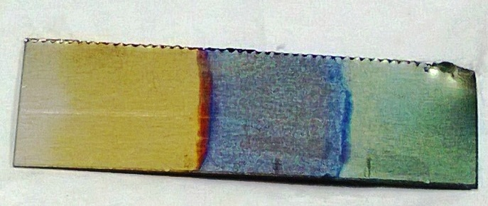
2. Anodising titanium. – this is more expensive (due to the titanium) but of interest. The oxide layer itself produced colours due to interference effects from the thickness of the layer. This in turn is controlled by the voltage. So changing the voltage will give you a different colour coating.

Preparation
The metals
Aluminium
It is best to use aluminium sheet from chemical suppliers or aluminium takeaway food containers as both of these produced good results. Cooking foil is too thin and fragile. Aluminium drinks cans, although plentiful and ‘free’ are not recommended since they have internal and external coatings. These are very difficult to remove and they inhibit the anodising process.
Cut the aluminium to the required size and shape – leave a small ‘tag’ to attach the crocodile clip to.
Clean and de-grease both sides of the aluminium strips by immersing in a beaker of ethanol (IMS is fine) for 1 minute. Then remove and wash with distilled water.
Titanium
Unlike aluminium, titanium is not in general usage so will have to be bought. Due to its cost, it is sensible to cut the pieces into smaller ones for the anodising. Titanium sheet is tough so you will need some fairly solid shears to do it.
Cut your shape from the piece of titanium – leaving a small ‘tag’ where the crocodile clip can be attached. Smooth any sharp edges with a file
Clean both sides of the piece of titanium with brasso (or other metal polish) using paper towel.
The solution
Aluminium is usually anodised in a bath of 1M sulphuric acid. This is corrosive and the electolysis produces a mist of sulphuric acid droplets so the solution should be covered to prevent this escaping and being breathed in – or the process should be carried out in a fume cupboard.
Titanium can be anodised using diet coke, which has no such problems) though if you wish it is possible to use 1M phosphoric acid which should be treated as the sulphuric acid above.
The circuit
Connect up the circuit with a DC power supply (or batteries).
The object to be anodised should be connected to the positive terminal
For the Cathode (negative electrode) use a scrap piece of metal immersed in the solution. Aluminium is probably easiest anything non-rusting should work. The immersed surface area of the cathode should be greater than that of the anode
For aluminium, you will need a supply at about 15 V
For Titanium, you can use different voltages to get different colours – 10, 20 and 30 V are good choices (9, 18 and 27 if you are using batteries)
Important note: once you go up in voltage and add another colour (e.g. pink over blue), you can't go back to a colour at a lower voltage.
Switch on and leave:
aluminium for about 20 – 30 minutes
titanium for 5 – 15 minutes. (Though for the titanium you will see the colour developing and can judge as you go along)

