Food Chemistry
Amino acids in soy sauce
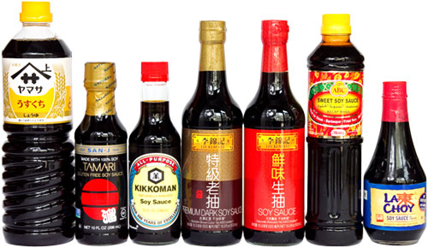
CfE Level 3
I can differentiate between pure substances and mixtures in common use and can select appropriate physical methods for separating mixtures into their components.
SCN 3-16a
CfE Higher – Nature’s Chemistry
Proteins
Chemistry in Society
Chemical analysis
Introduction
Soy sauce is made from a fermented paste of boiled soybeans, roasted grain, brine, and particular varieties of Aspergillus fungus.[3] After fermentation, the paste is pressed, producing a liquid, which is the soy sauce, and a solid by product, which is often used as animal feed. Soy sauce is a traditional ingredient in East and Southeast Asian cuisines, where it is used in cooking and as a condiment.
Soy sauce has a distinct yet basic taste of umami, due to naturally occurring free glutamates.
Some brands of soy sauce are made from acid-hydrolyzed soy protein instead of brewed with a traditional culture. This takes about three days. Although they have a different flavour, aroma, and texture when compared to traditionally fermented brewed soy sauces, they have a longer shelf life and are usually made for this reason. The clear plastic packets of dark sauce common with Chinese-style take-out food typically use this sort of product.
Both the fermentation and the acid hydrolysis result in some of the protein being broken down into peptides and further into individual amino acids. The exact composition will vary from product to product; typically being high in Valine, Tryptophan, Lysine, and Histidine.
It is possible to separate these amino acids using thin layer chromatography.
Thin layer chromatography (TLC) like other forms of chromatography separates substances according to their solubilities and how they react with the material the plate is made of (usually silica or alumina). TLC uses a thin layer of silica or alumina (hence the name, on a plastic backing. The advantage of TLC over other forms of chromatography is that it can be carried out quite quickly and gives good separation.
You will need
Soy sauce(s)* | Chromatography solvent**
Chromatography tank*** | Access to hairdryer
Access to hotplate | Ninhydrin solution (use in fume cupboard)
TLC plates | ****Capillary tube for spotting.

* You can use as many different ones as you like. Some may have only 2 different amino acids you can find, others will have quite a few more.
** There are several solvents that you can use. The most effective seems to be 4 parts butan-1-ol : 1 part glacial ethanoic acid : 2 parts water. (Other recipes are given at the end)
*** You do not need a bespoke chromatography tank. You can use anyting from a beaker to a glass vial to a test tube. As long as you can put a lid on to prevent evaporation and manage to support the TLC plate, it should be fine. You can cut the plates to size with scissors.
**** Most capillary tubes (unless they are specifically for this) are too wide and give far too large a spot. You can easily make your own by simply softening a glass tube in a Bunsen burner flame and pulling apart to get a thin tube.
Procedure:
- Prepare the solvent mixture according to the recipe.
- Place a small amount of solvent in the bottom of your container
- Cut your TLC plate to size (if needed). Lightly mark a pencil line 0.5 – 1 cm from the bottom
- Make sure you only handle the TLC plate by the edges. There are amino acids in your sweat that may mess up your plate if you are not careful)
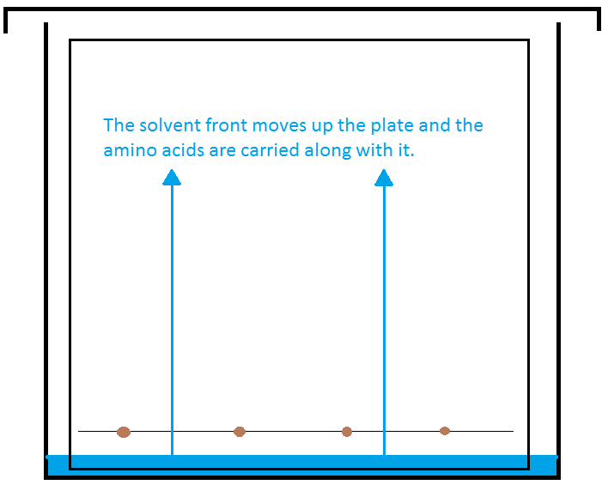

- Using a capillary tube (see above) place small spots (only 2 mm or so in diameter) of the different soy sauces at intervals along the line on the plate. If you are using a test tube or vial, you may only have room for one spot; in which case use several different plates if you are investigating more than one – or of you are using pure amino acids for analysis.
- Once dried. Place the TLC plate in the solvent. The level of solvent must be below the level of your spot.
- Cover the chromatography tank and leave to allow the solvent to rise up the plate and separate the pigments.

- When the solvent front has reached a reasonable height, remove the plate from the tank and immediately mark the position of the front lightly with a pencil.
- Dry your TLC plate with a hairdryer.
- Go to the fume cupboard and either spray or dip your plate with the ninhydrin solution.
- Let your plate dry (you can speed this up with the hairdryer if you wish). then place it on the hotplate at about 60 – 70°C. Within a few seconds spots will appear. Leave the TLC plate on the hotplate for about a minute or so, until you don’t think any more development will take place.
- Examine your plate.
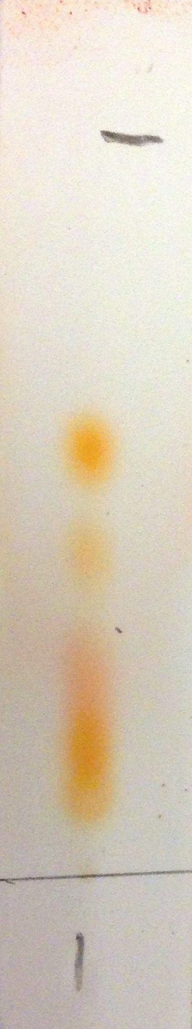
Here is an example obtained at SSERC using the method described above and Amoy brand light soy sauce.
Solvent
front
Starting point
Amino acid spots
?
You can clearly see 4 distinct spots and there may be a fifth (marked with a ?) though this might be merely an overlap between the two neighbouring ones.

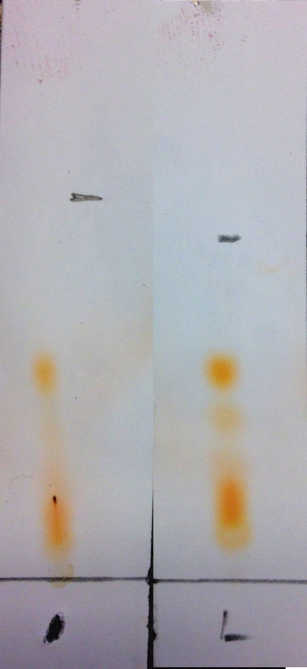
Here is another example of Amoy Dark and Light soy sauces. (Dark on the left).
Here you can see that they do not have the same amino acid composition; the dark version seem to have fewer – or at least significantly less of some.
You can also see the dark spot from the colouring.

Extensions
- Compare different Soy Sauces.
  - Is there a difference between dark and light sauces (and possibly other types?)
  - Is there a difference between Chinese and Japanese Sauces?
  - How much variation is there between brands?
  - What is the difference between hydrolysed and naturally fermented soy sauces?
- Analyse the amino acids by comparing with pure acids.

Technician’s Guide

Each group will need
Soy sauce(s)* | Chromatography solvent**
Chromatography tank*** | Access to hairdryer
Access to hotplate | Ninhydrin solution (use in fume cupboard)
TLC plate(s) | ****Capillary tube for spotting.

* You can use as many different ones as you like. Some may have only 2 different amino acids you can find, others will have quite a few more.
** There are several solvents that you can use. The most effective seems to be 4 parts butan-1-ol : 1 part glacial ethanoic acid : 2 parts water. (Other recipes are given at the end)
*** You do not need a bespoke chromatography tank. You can use anything from a beaker to a glass vial to a test tube. As long as you can put a lid on to prevent evaporation and manage to support the TLC plate, it should be fine. You can cut the plates to size with scissors.
**** Most capillary tubes (unless they are specifically for this) are too wide and give far too large a spot. You can easily make your own by simply softening a glass tube in a Bunsen burner flame and pulling apart to get a thin tube.

