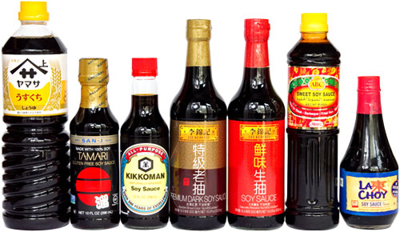
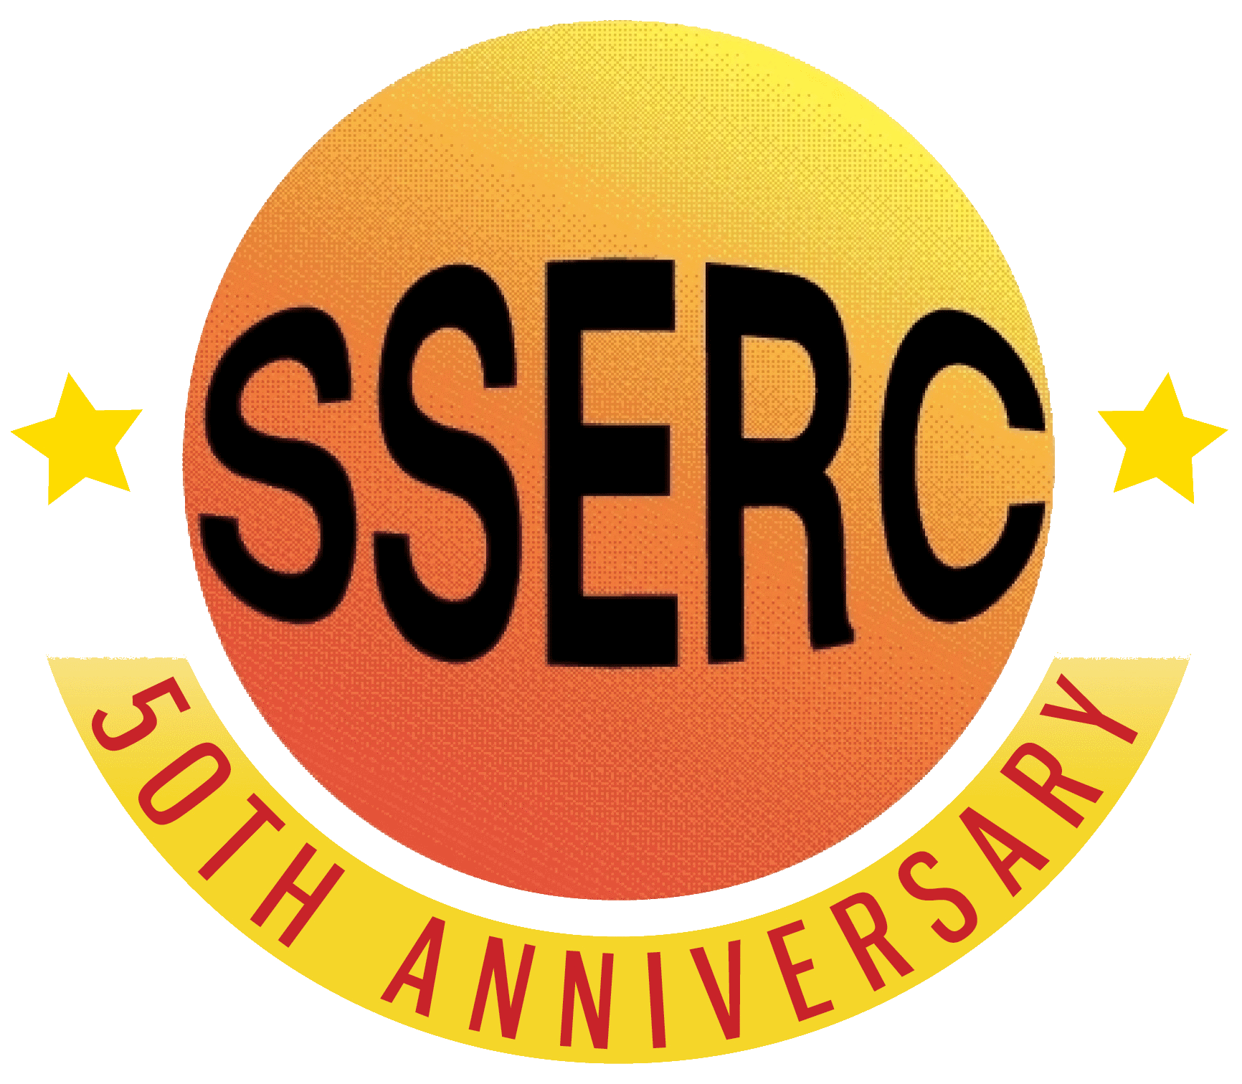
Introduction
You have probably all tasted soy sauce. But have you ever wondered what it is and what it is made of?
Soy sauce is made, unsurprisingly, from soya beans. They are crushed and fermented by a special type of mould and then the juice is pressed out. This is the sauce.
Some brands of soy sauce are made from soy protein that is hydrolysed with acid instead of being fermented. This is faster and, although they taste different from the traditional types, they have a longer shelf life and are usually made for this reason. The clear plastic packets of dark sauce common with Chinese-style takeaway food typically use this sort of product.
Both the fermentation and the acid hydrolysis result in some of the protein being broken down into peptides and further into individual amino acids. The exact composition varies from product to product.
It is possible to separate these amino acids using thin layer chromatography.
Thin layer chromatography (TLC) like other forms of chromatography separates substances according to their solubilities and how they react with the material the plate is made of (usually silica or alumina). TLC uses a thin layer of silica or alumina (hence the name, on a plastic backing. The advantage of TLC over other forms of chromatography is that it can be carried out quite quickly and gives good separation.
You will need
Soy sauce(s)* | Chromatography solvent**
Chromatography tank*** | Access to hairdryer
Access to hotplate | Ninhydrin solution (use in fume cupboard)
TLC plates | ****Capillary tube for spotting.

* You can use as many different ones as you like. Some may have only 2 different amino acids you can find, others will have quite a few more.
** There are several solvents that you can use. The most effective seems to be 4 parts butan-1-ol : 1 part glacial ethanoic acid : 2 parts water. (Other recipes are given at the end)
*** You do not need a bespoke chromatography tank. You can use anyting from a beaker to a glass vial to a test tube. As long as you can put a lid on to prevent evaporation and manage to support the TLC plate, it should be fine. You can cut the plates to size with scissors.
**** Most capillary tubes (unless they are specifically for this) are too wide and give far too large a spot. You can easily make your own by simply softening a glass tube in a Bunsen burner flame and pulling apart to get a thin tube.

To do:
- Prepare the solvent mixture according to the recipe.
- Place a small amount of solvent in the bottom of your container
- Cut your TLC plate to size (if needed). Lightly mark a pencil line 0.5 – 1 cm from the bottom
- Make sure you only handle the TLC plate by the edges. There are amino acids in your sweat that may mess up your plate if you are not careful)
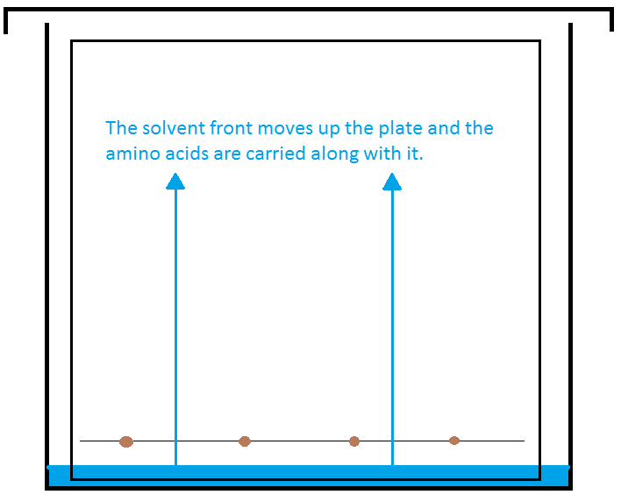

- Using a capillary tube (see above) place small spots (only 2 mm or so in diameter) of the different soy sauces at intervals along the line on the plate. If you are using a test tube or vial, you may only have room for one spot; in which case use several different plates if you are investigating more than one – or of you are using pure amino acids for analysis.
- Once dried. Place the TLC plate in the solvent. The level of solvent must be below the level of your spot.
- Cover the chromatography tank and leave to allow the solvent to rise up the plate and separate the pigments.

- When the solvent front has reached a reasonable height, remove the plate from the tank and immediately mark the position of the front lightly with a pencil.
- Dry your TLC plate with a hairdryer.
- Go to the fume cupboard and either spray or dip your plate with the ninhydrin solution.
- Let your plate dry (you can speed this up with the hairdryer if you wish). then place it on the hotplate at about 60 – 70°C. Within a few seconds spots will appear. Leave the TLC plate on the hotplate for about a minute or so, until you don’t think any more development will take place.
- Examine your plate.

Investigations
- Compare different Soy Sauces.
  - Is there a difference between dark and light sauces (and possibly other types?)
  - Is there a difference between Chinese and Japanese Sauces?
  - How much variation is there between brands?
  - What is the difference between hydrolysed and naturally fermented soy sauces?
- Analyse the amino acids by comparing with pure acids.

