Food Chemistry
Oxidative Rancidity
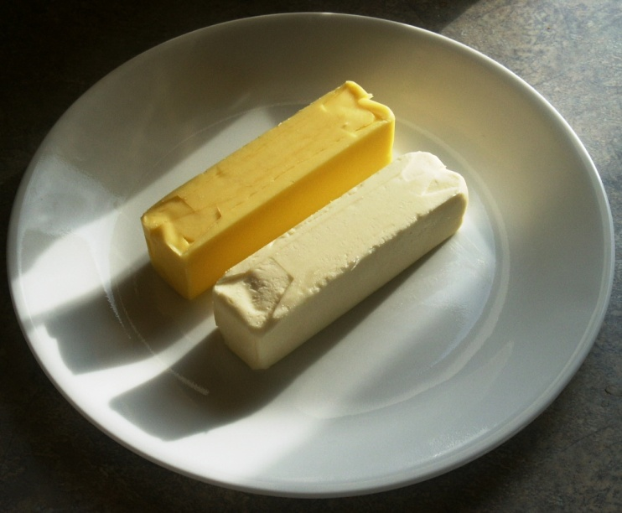

CfE Level 3
Through experimentation, I can identify indicators of chemical reactions having occurred. I can describe ways of controlling the rate of reactions and can relate my findings to the world around me.
SCN 3-19a
CfE Higher – Nature’s Chemistry
Oxidation of food
Introduction
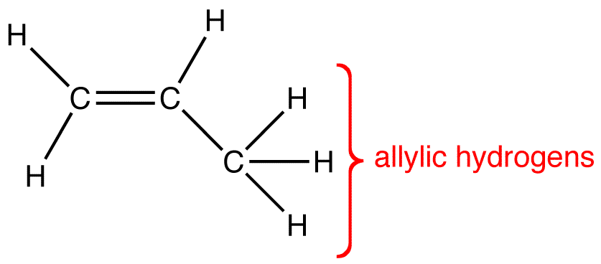
Because of their chemical structure, unsaturated fats and oils are subject to oxidative breakdown, so-called oxidative rancidity. This reaction is a free radical chain reaction that involves abstraction of relative allylic hydrogen from the fatty acid chain followed by a series of reaction with oxygen, rearrangements, and chain cleavage to produce odiferous compounds.
Allylic hydrogen atoms are those atached to an allylic carbon atom. An allylic carbon atom is one attached to another carbon which in turn is attached to another carbon – this time with a double bond.

In this experiment, β-carotene is used as a marker of fat rancidity reactions.
Lipid oxidation
Phases of lipid oxidation
The overall mechanism of lipid oxidation consists of three phases:
- initiation, the formation of free radicals;
RH + O2 R· + ·OH or R· + O2 · + ROO·
- propagation, the free-radical chain reactions

ROO· + RH R· + ROOH or ROOH RO· + HO·
- termination, the formation of nonradical products.
R· + R· RR or R· + ROO· ROOR or ROO· + ROO· ROOR + O2
Where RH is any unsaturated fatty acid;
R· is a free radical formed by removing a labile hydrogen from a carbon atom adjacent to a double bond;
ROOH is a hydroperoxide, one of the major initial oxidation products that decompose to form compounds responsible for off-flavors and odors.
Such secondary products include hexanal, pentanal, and malonaldehyde.
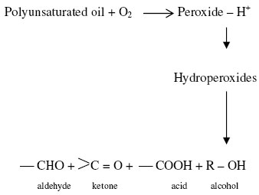

The important lipids involved in oxidation are the unsaturated fatty acid moieties such as oleic, linoleic, and linolenic.
The rate of oxidation of these fatty acids increases with the degree of unsaturation.
- Oleic – standard rate set as 1
- Linoleic – 10 times faster than oleic
- Linolenic – 100 times than oleic

Once formed, hydroperoxides may break down through a number of mechanisms. A common breakdown scheme is called dismutation. In this reaction a hydroperoxide reacts with another molecule or radical to form two new compounds. Since the reaction RH + O2 free radicals, is thermodynamically difficult (activation energy of about 150 kj/mol), the production of the first few radicals necessary to start the propagation reaction normally must occur by some catalytic means such as hydroperoxide decomposition, light and heat exposure and metal catalysis.
Preventing oxidation
The most common method, not surprisingly, is using antioxidants.
Antioxidants function by interfering with the chain reaction. If the number of free radicals can be kept low enough, oxidation will not occur. The following is a model for the type of compound that can function effectively as an antioxidant. In order to function well as an antioxidant a molecule must:
- React with free radicals more rapidly than the free radicals react with lipid.
- The products of the reaction with free radicals must not be pro-oxidant.
- The molecule must be lipid soluble.
The free radicals formed by conjugated molecules can exist in many resonant structures as shown below:
Alternatives to antioxidants:
- Elimination of oxygen
  - packaging under nitrogen;
  - packaging in vacuum;
  - packaging with an oxygen scavenger
- Elimination of the sensitive substrate
  - replacement of polyunsaturated oils with less unsaturated oils, such as olive oil or palm oil, that are more stable
- Decreasing the rate of oxidation
  - storage at low temperatures;
  - storage in the dark;
  - use of fats and oils that contain low levels of oxidation promoters (eg. oxidized products and heavy metals);
  - use of ingredients that are naturally rich in antioxidants
For the biologists!
In eukaryotic organisms, ROS are mainly generated during the normal respiration process involving oxygen, oxidases and electron transports in mitochondria or endoplasmic reticulum.

The experiment
The objective of this exercise is to study factors (light, temperature, antioxidants, prooxidants) that affect rancidity of fats.

You will need
Rendered port fat (Lard*) – 50 g | Carotene – 10 mg
Hexane or cyclohexane – 1 cm³ | Filter papers – 7 cm diameter discs
Petri dishes with filter paper discs | 0.01 % CuSO₄ – 25 ml
0.001% BHA – 25 ml | 0.5% haemoglobin – 25 ml
Saturated salt solution – 25 ml | Turnip greens extract – 80 ml
Green onion tops extract – 80 ml | White potatoes extract – 80 ml

* You can’t use commercial lard for this easily because it has antioxidants added to it for preservation. Use the fat from cooking bacon or sausages or any other meat. If lard is to be used, it will need to be left for longer.
Complications: If the group or groups doing this experiment also have other experiment assigned, this one should be started first due to the length of time that must be allowed for oxidation reaction to take place.
Experiment 1 (environmental conditions)
Procedure
- Dissolve 10 mg carotene in a little hexane or cyclohexane (about 1 cm³ should be enough)
- Melt 50 g of rendered pork fat (lard). When it is melted, add the carotene and mix.
- Using forceps, dip small filter papers (7 cm in diameter) in the melted fat and allow to drain for 20 seconds. Transfer to petri dishes and treat as follows.
  - Cover the dish and stored in the dark at room temperature
  - Cover the dish and store in the light (direct sunlight if possible)
  - Cover the dish and store in the refrigerator
  - Cover the dish and store in an incubator at 60°C
Experiment 2 (antioxidants and prooxidants)
- Prepare filter paper discs as in Experiment A
- for these experiments, saturate small filter discs with test solutions (see below); place several disc of each test solution on a filter paper saturated with carotene-lard mixture. Invert the bottom of the petri dish containing the papers over the petri top containing water, using a separate petri dish for each variation. Store dishes in an incubator at 40°C. Solution to be tested include:
  - Water control
  - Dilute copper solution (0.01% CuSO₄)
  - Dilute haemoglobin solution (0.5%)
  - Commercial antioxidant (0.001% BHA)
  - Saturated salt solution
  - Extracts prepared by heating 20 g chopped vegetable (turnip greens, green onion tops, white potato peel) with 80 ml H₂O to the boiling point. Decant and cool before using.
On cannot visualise fats going rancid. Carotene, which is a highly unsaturated hydrocarbon similar in structure to a fatty acid, turns from bright orange to colourless as it oxidises. There, the rate of bleaching observable with the carotene can be used as an index to the rate of oxidative rancidity of the fat. Compare the treatments for their influence on oxidative rancidity as determined by the rate of bleaching. Compare the odour of fat in bleached vs. non-bleached paper. Outline the events (with reactions) that occur as fats undergo oxidative rancidity. Discuss the results of each treatment using this outline.
Taken from: The Food Chemistry Laboratory – Connie M Weaver and James R Daniel

Health & Safety
All the reagents are of low hazard.

