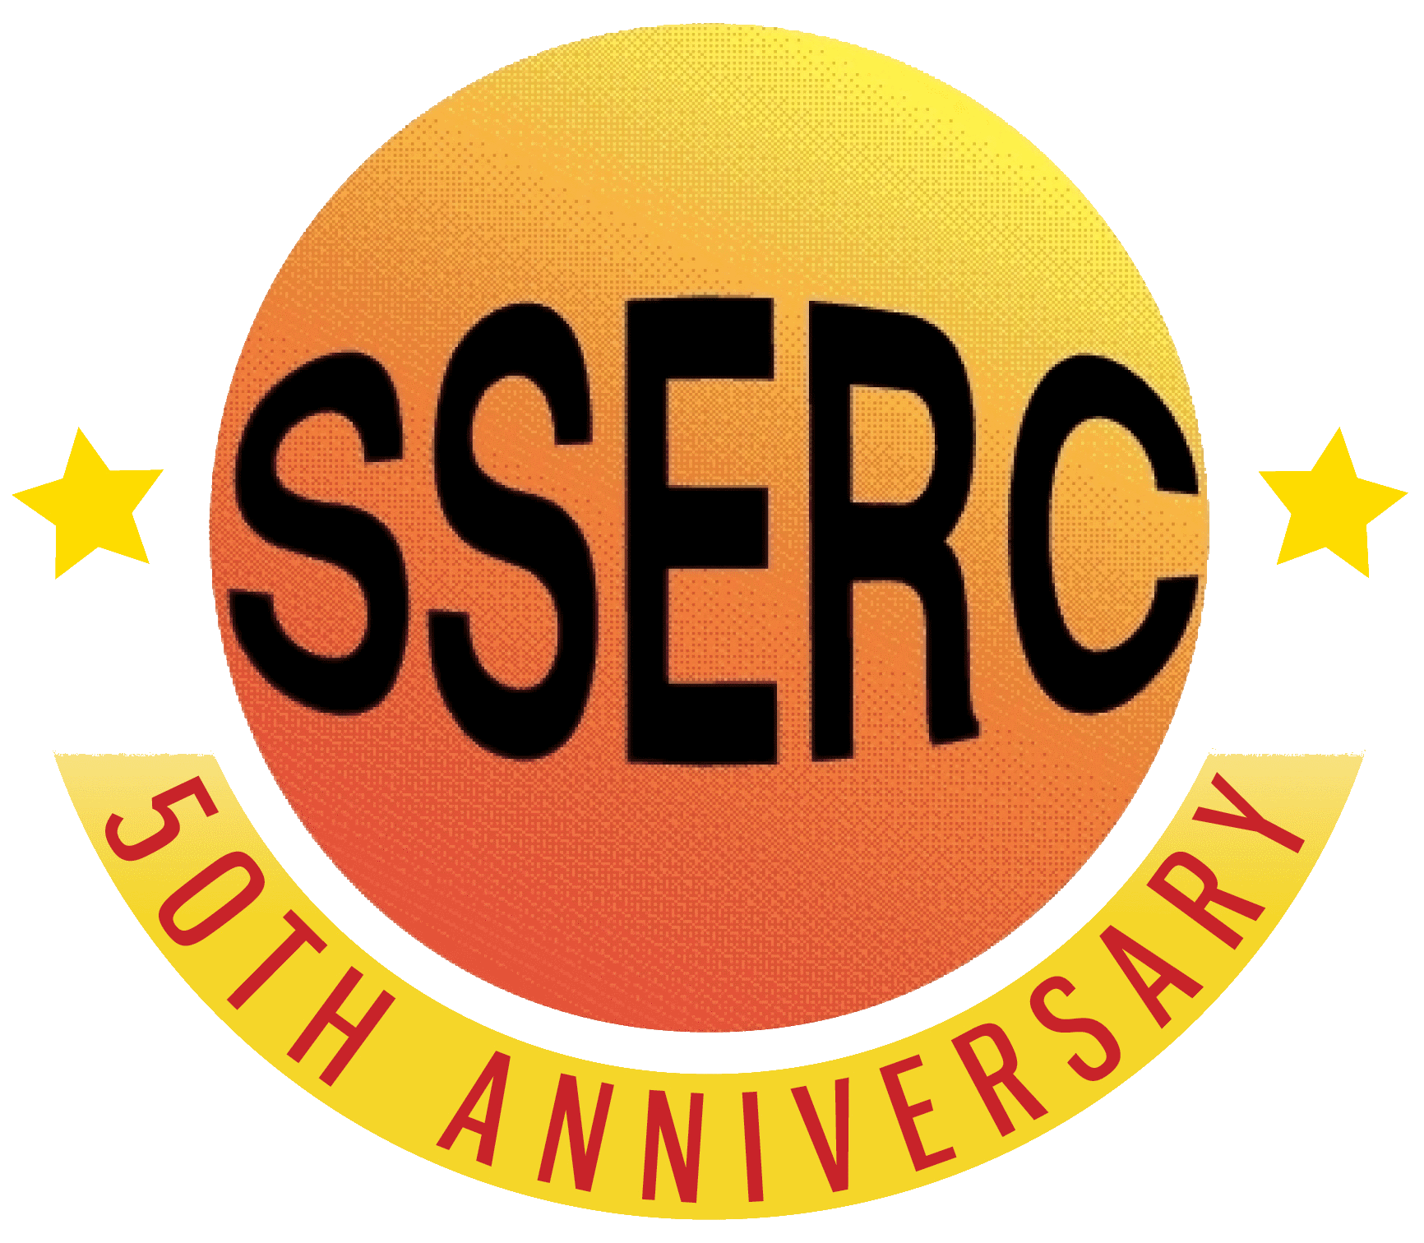

Food Chemistry
Oxidative Rancidity
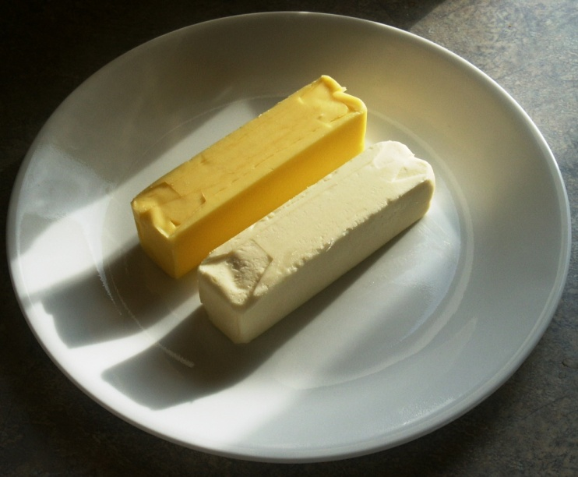

Introduction
Because of their chemical structure, unsaturated fats and oils are subject to oxidative breakdown, called ‘oxidative rancidity’. This reaction is a free radical chain reaction that involves abstraction of a hydrogen from the fatty acid chain followed by a series of reaction with oxygen, rearrangements, and chain cleavage to produce unpleasant smelling compounds. These make the fat smell unappetising – rancid. In this experiment, carotene is used as a marker of fat rancidity reactions.
In this investigation you will study factors (light, temperature, antioxidants, prooxidants) that affect rancidity of fats.

You will need
Rendered port fat (Lard*) – 50 g | Carotene – 10 mg
Hexane or cyclohexane – 1 cm³ | Filter papers – 7 cm diameter discs
Petri dishes with filter paper discs | 0.01 % CuSO₄ – 25 ml
0.001% BHA – 25 ml | 0.5% haemoglobin – 25 ml
Saturated salt solution – 25 ml | Turnip greens extract – 80 ml
Green onion tops extract – 80 ml | White potatoes extract – 80 ml
* You can’t use commercial lard for this easily because it has antioxidants added to it for preservation. Use the fat from cooking bacon or sausages or any other meat. If lard is to be used, it will need to be left for longer.
Complications: If the group or groups doing this experiment also have other experiment assigned, this one should be started first due to the length of time that must be allowed for oxidation reaction to take place.
Experiment 1 (environmental conditions)
Procedure
- Dissolve 10 mg carotene in a little hexane or cyclohexane (about 1 cm³ should be enough)
- Melt 50 g of rendered pork fat (lard). When it is melted, add the carotene and mix.
- Using forceps, dip small filter papers (7 cm in diameter) in the melted fat and allow to drain for 20 seconds. Transfer to petri dishes and treat as follows.
  - Cover the dish and stored in the dark at room temperature
  - Cover the dish and store in the light (direct sunlight if possible)
  - Cover the dish and store in the refrigerator
  - Cover the dish and store in an incubator at 60°C
Experiment 2 (antioxidants and prooxidants)
- Prepare filter paper discs as in Experiment A
- for these experiments, saturate small filter discs with test solutions (see below); place several disc of each test solution on a filter paper saturated with carotene-lard mixture. Invert the bottom of the petri dish containing the papers over the petri top containing water, using a separate petri dish for each variation. Store dishes in an incubator at 40°C. Solution to be tested include:
  - Water control
  - Dilute copper solution (0.01% CuSO₄)
  - Dilute haemoglobin solution (0.5%)
  - Commercial antioxidant (0.001% BHA)
  - Saturated salt solution
  - Extracts prepared by heating 20 g chopped vegetable (turnip greens, green onion tops, white potato peel) with 80 ml H₂O to the boiling point. Decant and cool before using.
On cannot visualise fats going rancid. Carotene, which is a highly unsaturated hydrocarbon similar in structure to a fatty acid, turns from bright orange to colourless as it oxidises. There, the rate of bleaching observable with the carotene can be used as an index to the rate of oxidative rancidity of the fat. Compare the treatments for their influence on oxidative rancidity as determined by the rate of bleaching. Compare the odour of fat in bleached vs. non-bleached paper. Outline the events (with reactions) that occur as fats undergo oxidative rancidity. Discuss the results of each treatment using this outline.
Taken from: The Food Chemistry Laboratory – Connie M Weaver and James R Daniel

Health & Safety
All the reagents are of low hazard.

