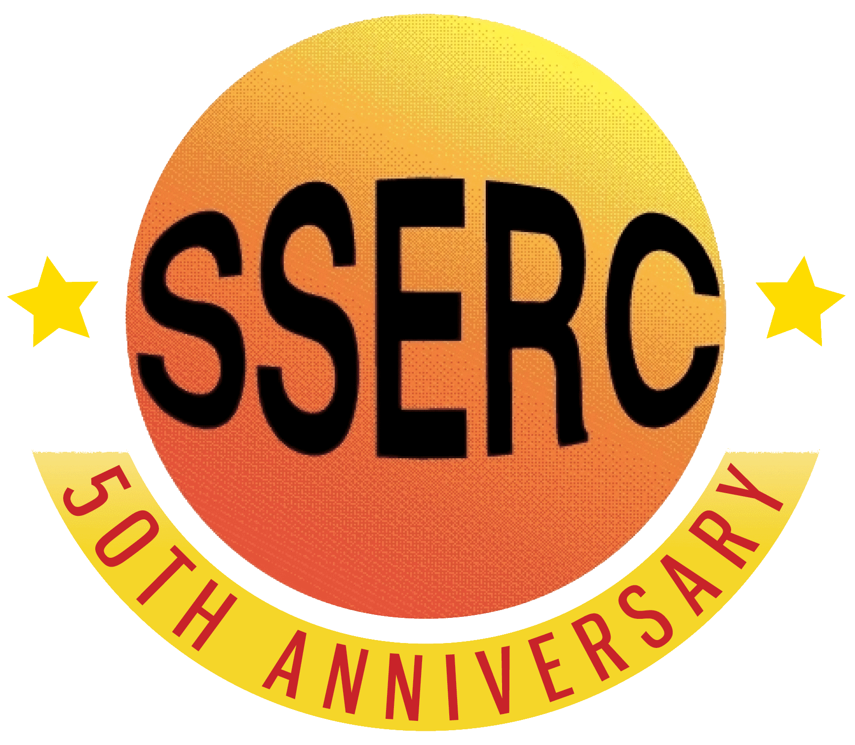

Food Chemistry
Maillard reaction

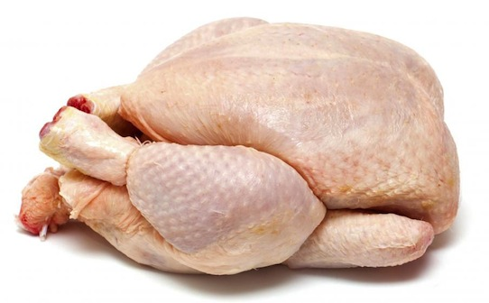
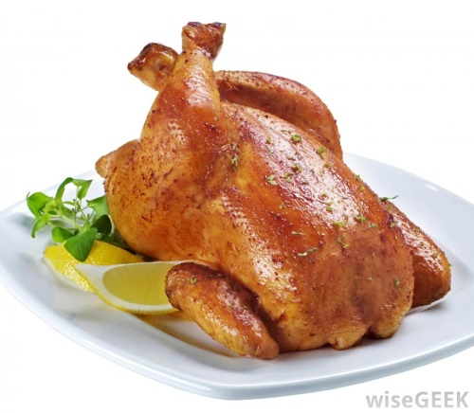

Introduction
Under certain conditions, reducing sugars may react with compounds bearing a free amino group and undergo a sequence of reactions known collectively as the Maillard reaction. The compounds formed add colour and aroma to foods. They are responsible for the browning of toast, the colour of coffee and the colour and aroma of roast meats.
In this investigation you will look at some of the reactions between sugars and amino acids.

You will need
D-glucose | L-Amino acids (6 or so different ones)
Test tubes | Boiling water bath
Sodium carbonate* | Aluminium foil
Access to a 2dp balance | spatula

* the Maillard reaction occurs more rapidly in alkaline conditions so the sodium carbonate is added to speed things up.
Procedure
- To 0.05 g of d-glucose in a test tube add 0.05 g of an amino acid
- Add 1.0 ml of distilled water. Mix thoroughly. Cover the top with aluminium foil.
- Repeat for all your other amino acids
- Smell each mixture and record any sensations.
- Place a piece of heavy aluminium foil over each test tube top and heat the solutions in a water bath at 100°C. You will rapidly start to see some of the tubes develpping a yellow-brown colour. L
- Leave the tubes in the water bath for 10 – 15 minutes. Remove them and allow to cool a little. Then examine them.
Your results
Qualitative
- Record the odour sensations for each solution (e.g. chocolate-like, potato-like, popcorn-like).
- Record the colour as 0 = none, 1 = light yellow, 2 = deep yellow, 3 = brown.

Quantitative
- Dilute your solutions to 5 cm³ with distilled water.*
- Transfer 3 cm³ of each sample to a cuvette and use a colorimeter to determine their absorbance at 400 nm. (Blue LED on the mystrica colorimeter)
* some of them, such as arginine and lysine may need to be diluted more, possibly quite a lot more.

Health & Safety
All the reagents are of low hazard.

