Food Chemistry
Enzymic Browning

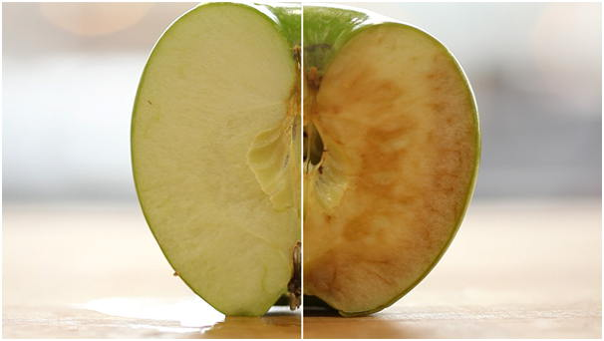

CfE Level 3
Through experimentation, I can identify indicators of chemical reactions having occurred. I can describe ways of controlling the rate of reactions and can relate my findings to the world around me.
SCN 3-19a
CfE Higher – Nature’s Chemistry
Proteins
Introduction
Some plant tissues contain phenolics associated with their cell walls. Some of these also contain polyphenoloxidase (PPO), an enzyme that will convert the phenolic to a quinone, which will eventually be transformed into a brown melanin pigment. This reaction is generally undesirable when it occurs in tissues of fruits such as apple, banana, or pear. It is thus important to know how to control this browning reaction.
Fruit and vegetables have health benefits for consumers, due to their content of fibre, vitamins and antioxidant compounds. However, for the antioxidant compounds many changes occur during harvesting, preparation (fresh-cut fruits) and storage of these fruits. Thus, preservation against oxidation in food during processing and storage has become an increasing priority in the food industry. In fact, oxidation is the second most important cause of food deterioration after that caused by microbiological contamination.
One of the main oxidative reactions is enzymatic browning. This involves two oxidoreductase enzymes: polyphenoloxidase (PPO) and peroxydase (POD).
PPO catalyzes two reactions;
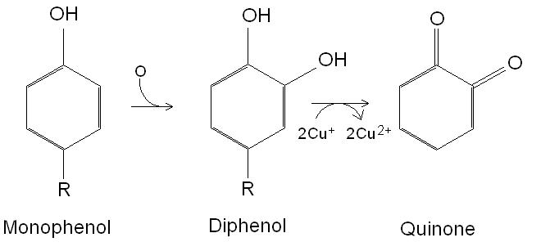
The first, a hydroxylation of monophenols to diphenols, is relatively slow and results in colourless products.
The second, the oxidation of diphenols to quinones, is rapid and gives coloured products.
Because the substrates involved in these reactions are located in the vacuoles while enzymes are in the cytoplasm; the reactions can take place only if they are mixed and in the presence of oxygen (i.e. when you cut a piece of fruit or vegetable).
To avoid this off-putting browning, various methods have been developed. The role of these methods is either to inactivate polyphenol oxidase (PPO) or to avoid contact between the enzyme and its substrate, either by adding antioxidants or by maintaining the structural integrity of the food.
Mitigation strategies
- Chemical treatments
  - Using antioxidants but is dependent on pH, water activity (aw), temperature, light and composition of the atmosphere
  - Chelation treatments - the presence of a substance capable of binding divalent cations present in the medium reduces the enzymatic activity of PPO (requires copper ions to be active)
  - Agents of firmness – like calcium salts – these strengthen the cellular walls and slows down the rate of oxidation
  - Acidifying agents – PPO is inactivated at 3 pH or lower
- Physical treatments
  - Blanching – mild heat inactivation of the protein through thermal degradation of the enzyme proteins
    - Water, steam and microwave blanching is expressed throughout the literature – depends on product and type of processing needed.
  - Freezing – this reduces the water activity which is required for enzymic reactions
  - Modified atmospheric packaging – oxygen is essential for this type of reaction and therefore the removal of it will inhibit the enzymic reaction, this is a well-used method of packaging for the food industry.
- Coatings
  - Usually with gums – inhibit the Using chemicals or physical methods to inhibit oxygen exposure by coatings or films – not industrially feasible (currently)
- Other methods
  - Pressure – like High Pressure Processing – inactivate enzymes through pressure
  - Electricity and light – new techniques that inhibit or inactivate enzymes.

Some common examples of enzyme browning
Avocado – guacamole | 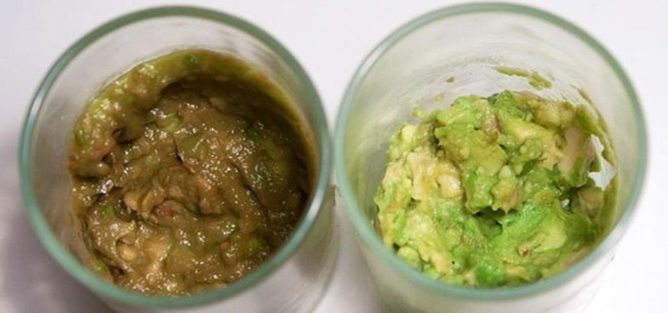
Don’t keep your bananas by any other fruit – acetylene speeds up the ripening process (which is an enzyme browning reaction). | 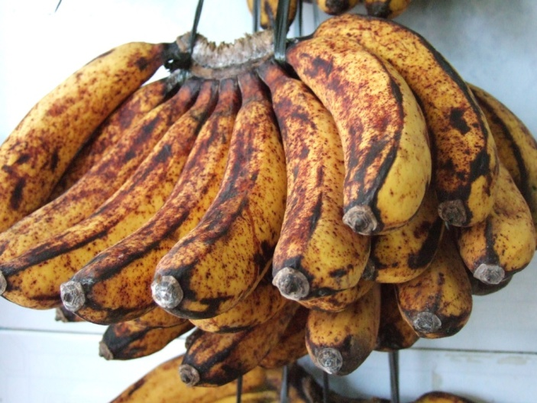
Potatoes that go brown – enzymes again! | 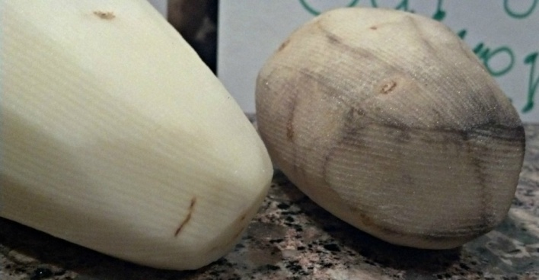

The experiment
The objective of this investigation is to assess the effect of various treatments on enzymatic discolouration of apples.
You will need
1 bramley apple* | 60 cm³ 1% thiourea (1g in 100 cm³ )
60 cm³ 0.02% Ascorbic acid solution (0.1g in 500 cm³ ) | 60 cm³ 0.02% Sodium sulphite (0.1g in 500 cm³)
60 cm³ 0.2% Dipotassium phosphate (0.2g in 100 cm³ ) | 60 cm³ 0.02% copper sulphate solution.
Small knife for chopping the apple | 60 cm³ distilled/deionised water.
Small sieve (tea strainer) | Blender (small ‘stick’ type)
Colorimeter & cuvettes | Access to 1dp balance
1 x 400 cm³ beaker** | 4 x 100cm³ beakers (or plastic cups)
* Other apples or pears could be investigated but Bramley apples (sold as cooking apples) go brown quicker than any others we tried.
** or whatever size will allow the head of your blender to reach the bottom.

Procedure
- Prepare all the solutions and label the beakers in advance It is important to work quickly once the apple tissue is cut until the slices are placed into solution.
- Roughly peel part of the apple (just to get at the flesh)
- Cut some thin slices off the apple, placing them into a weigh-boat on the balance until you have about 20g. Quickly chop them into small pieces and put them into the beaker with thiourea in.
- Do the same and put another 20g into the ascorbic acid solution.
- Repeat again and put into distilled water
- Repeat once more and put in the copper sulphate solution.
- For the final sample, place into sodium sulphite solution and start timing.
- After 45 seconds, pour the sodium sulphite solution away through a sieve and put the apple pieces into the potassium phosphate solution.
- Leave the solutions for about 30 minutes.
- At the end of the 30 minutes, examine the solutions and compare the colours.

Extension – looking more quantitatively at the results.
- Blend the contents of each beaker. Pour it, liquid and all into the larger beaker, blend for 15-30 s and then pour it back into the original beaker. Repeat for all solutions.
If you don’t have access to a blender, you can either try to crush the apple in a pentle and mortar or just use the liquid the apple has been sitting in without any further processing.
- Place the sieve over a beaker and pour the first solution into it. When it stops dripping, transfer 2-3 cm³ into a cuvette and read the absorbance in a colorimeter at about 475 nm (Blue LED for the Mystrica)

Adapted from: The Food Chemistry Laboratory – Connie M Weaver and James R Daniel
http://eujournal.org/index.php/esj/article/viewFile/1963/1905

Technician’s Guide
Each group will need
1 bramley apple* | 60 cm³ 1% thiourea (1g in 100 cm³ )
60 cm³ 0.02% Ascorbic acid solution (0.1g in 500 cm³ ) | 60 cm³ 0.02% Sodium sulphite (0.1g in 500 cm³)
60 cm³ 0.2% Dipotassium phosphate (0.2g in 100 cm³ ) | 60 cm³ 0.02% copper sulphate solution.
Small knife for chopping the apple | 60 cm³ distilled/deionised water.
Small sieve (tea strainer) | Blender (small ‘stick’ type)
Colorimeter & cuvettes | Access to 1dp balance
1 x 400 cm³ beaker** | 4 x 100cm³ beakers (or plastic cups)

* Other apples or pears could be investigated but Bramley apples (sold as cooking apples) go brown quicker than any others we tried.
** or whatever size will allow the head of your blender to reach the bottom.
For the basic activity, pupils will simply look qualitatively at the colour of the apple.
In the extension, they use a colorimeter to try to get some quantitative data.

