Food Chemistry
Enzymic Browning

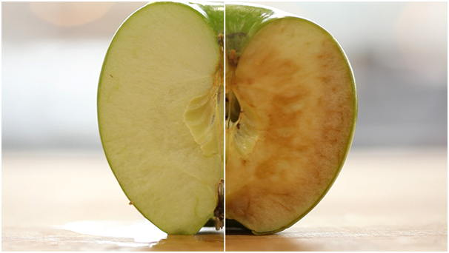

Introduction
You will know that if you take a bite out of an apple and then cut it, where you have bitten into it will soon go brown. This is because of enzyme catalysed reactions that turn polyphenols into coloured melanins. Browning of fruit and vegetables makes them look less appetising so the food industry tries to reduce this as far as possible.
The objective of this investigation is to assess the effect of various treatments on enzymatic discolouration of apples.
You will need
1 bramley apple* | 60 cm³ 1% thiourea (1g in 100 cm³ )
60 cm³ 0.02% Ascorbic acid solution (0.1g in 500 cm³ ) | 60 cm³ 0.02% Sodium sulphite (0.1g in 500 cm³)
60 cm³ 0.2% Dipotassium phosphate (0.2g in 100 cm³ ) | 60 cm³ 0.02% copper sulphate solution.
Small knife for chopping the apple | 60 cm³ distilled/deionised water.
Small sieve (tea strainer) | Blender (small ‘stick’ type)
Colorimeter & cuvettes | Access to 1dp balance
1 x 400 cm³ beaker** | 4 x 100cm³ beakers (or plastic cups)
* Other apples or pears could be investigated but Bramley apples (sold as cooking apples) go brown quicker than any others we tried.
** or whatever size will allow the head of your blender to reach the bottom.

Procedure
- Prepare all the solutions and label the beakers in advance It is important to work quickly once the apple tissue is cut until the slices are placed into solution.
- Roughly peel part of the apple (just to get at the flesh)
- Cut some thin slices off the apple, placing them into a weigh-boat on the balance until you have about 20g. Quickly chop them into small pieces and put them into the beaker with thiourea in.
- Do the same and put another 20g into the ascorbic acid solution.
- Repeat again and put into distilled water
- Repeat once more and put in the copper sulphate solution.
- For the final sample, place into sodium sulphite solution and start timing.
- After 45 seconds, pour the sodium sulphite solution away through a sieve and put the apple pieces into the potassium phosphate solution.
- Leave the solutions for about 30 minutes.
- At the end of the 30 minutes, blend the contents of each beaker. Pour it, liquid and all into the larger beaker, blend for 15-30 s and then pour it back into the original beaker. Repeat for all 4 solutions.
If you don’t have access to a blender, you can either try to crush the apple in a pentle and mortar or just use the liquid the apple has been sitting in without any further processing.
- Place the sieve over a beaker and pour the first solution into it. When it stops dripping, transfer 2-3 cm³ into a cuvette and read the absorbance in a colorimeter at about 475 nm (Blue LED for the Mystrica)

Health & Safety
Care is needed when chopping but the chemicals are at a low enough concentration as to render them of low hazard.

