Food Chemistry
Emulsions

CfE Level 3
I can differentiate between pure substances and mixtures in common use and can select appropriate physical methods for separating mixtures into their components.
SCN 3-16a
CfE Higher – Nature’s Chemistry
Soaps, Detergents and Emulsions
Introduction
Emulsions are a sub-class of a group of materials called colloids. Some of the main types are shown below.
Dispersion Medium | Dispersed Phase | Type of colloid | Example
Gas | Liquid | Aerosol | Turbo Tango  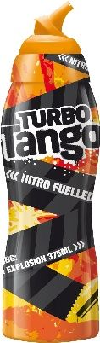
Gas | Solid | Aerosol | Smoke used in smoking foods
Liquid | Gas | Foam | Whipped cream  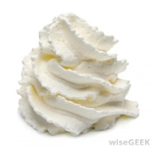
Liquid | Liquid | Emulsion | Mayonnaise,
Liquid | Solid | Sol | Blood  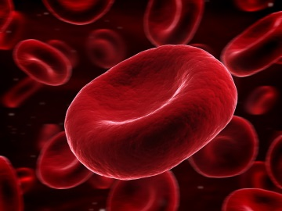

Solid | Gas | Foam | Meringues  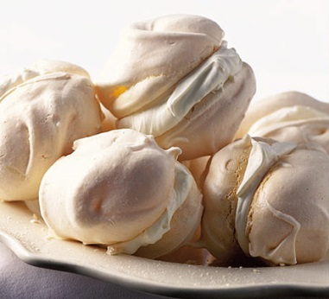
Solid | Liquid | Gel | Jelly, Cheese, Jam
Solid | Solid | Solid Sol | Chocolate chip cookie  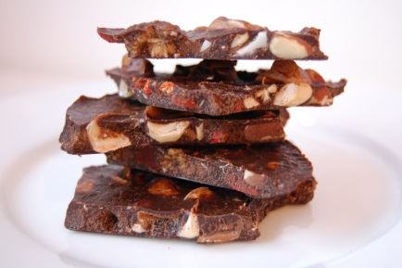

An emulsion is a particular subgroup of colloids: a mixture of two fluids such as oil and water. The mixing to form the emulsion is achieved by breaking up the molecules in both substances into very fine, small droplets in order to keep the combination from separating. Emulsions may be temporary (they separate in a few minutes) or permanent (remaining blended for months or longer).
There are several common foods that are classed as emulsions: milk, margarine, ice cream, mayonnaise, salad dressings, sausages, and sauces like béarnaise and hollandaise. When packaged and manufactured on a larger scale, most of these foods need emulsifiers to stabilise the mixture and keep the different ingredients from becoming separated. Lecithin is a common emulsifier that is naturally found in soy oil. Egg yolks are another example of an emulsifier; they contain lecithin and cholesterol, which makes them a great binder for sauces like mayonnaise.
In an emulsion, you have small bubbles of one liquid suspended in another. The bubbles ‘want’ to join with each other and eventually more and more join up and the two liquids separate completely - this is what happens with a simple oil and vinegar dressing.
Emulsifiers are similar to detergents in that they have two ends, a hydrophilic and a hydrophobic one, allowing them to bind to lipids and to aqueous solutions. The emulsifier adsorbs to the surface and lowers the interfacial tension. Emulsifiers also cause repulsive forces between droplets and stop them approaching one another and coalescing. Thus the emulsifier stabilises the mixture by interacting with both phases - both the oil and the water. This makes the edges of the bubbles stable and less likely to attract each other.
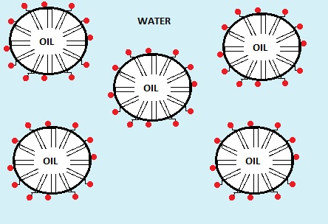
(Image taken from the Huffington Post)
In order to work effectively, the emulsifiers need to coat the particles of the ‘minoroty, component and these should be as small as possible. In the kitchen (or the laboratory) this can be achieved by vigorous beating or whisking, or using a hand mixer. There is often something of an art to the process, however, using an emulsifier correctly in a sauce or mixture requires adding the ingredients in the proper order, and often at a specific temperature.
Common emulsifiers in foods include proteins, gums, and various fatty acids. The same elements that are often good emulsifiers also are used in other ways in foods, such as keeping bread from going stale, reducing the amount of cocoa butter in chocolate which also reduces calories, and can help cakes stick less to the side of the pan.
Of particular interest to biochemists, phospholipids are robust emulsifiers and are commonly used within the food, paint and other manufacturing industries.

The experiment
The objective of this exercise is to demonstrate the effectiveness of various substances as emulsifying agents.
You will need
Sudan Red (or tomato puree) | Vegetable oil
Small screw cap ‘universal’ bottles or test tubes with bungs | Egg yolk – 2 cm³
Microscope slides (dimple) | Mustard – 2 g
Detergent (washing-up liquid) 2 cm³ | timer
Test tubes or small beakers
Polyoxyethylene sorbitan (Tween 40) – 5 ml* | Sucrose ester (Ryoto sugar ester S-170, HLB 1) – 2 g*
Sucrose ester (Ryoto sugar ester S-170, HLB 15) – 2 g* | Access to a Microscope

* if possible. If these are not available, you can try some other households materials to see if they work as emulsifiers.
Preparation
If you have sudan red, use this to colour the oil. If not, it is possible to use the lycopene and β-carotene from tomato puree.
To colour the oil, put 10g of tomato puree into a bottle or jar (with a lid).
Add 100 – 200 cm³ of oil
Shake vigorously and allow to settle.
Decant of the clear oil layer which is now stained orange.
Procedure
Part one – Oil/Water or Water/oil emulsion
- Prepare 2 samples as follows in screw cap tubes of test tubes with stoppers.
Tube A: 1 cm³ oil and 9 cm³ water
Tube B: 1 cm³ water and 9 cm³ oil.
- Cap the tubes and shake vigorously for 1 minutes.
- Start the timer
- Examine a sample of each emulsion under the microscope, keeping an eye on the tube.
- Record how long it takes the two layers to separate in each emulsion

Part 2 – Emulsifying agents
- Prepare tubes for as many of the emulsifiers as you have, according to the table below. (For example, Lecithin is dissolved in the oil before it is mixed with the water whereas egg yolk is dissolved in the water before the mixing).
- Cap each tube and shake vigorously for 1 minute.
- Put the tubes down and start the timer. How long does it take the emulsions to settle out now?

Tube Number | Emulsifier | Oil (ml) | Water (ml) | Liquid for dissolving emulsifier
Oil / Water (O/W) emulsions
1 | Control (no emulsifier) | 2 | 8 | -
2 | mustard – 0.5 g | 2 | 8 | Oil
3 | Egg yolk - 0.5 cm³ | 2 | 8 | Water
4 | Detergent (eg washing up liquid) – 0.5 cm³ | 2 | 8 | Water
5 | Bile – 0.5 g | 2 | 8 | Water
6 | Polyoxyethylene sorbitan monopalmitate (Tween 40) – 0.5 g | 2 | 8 | Oil
7 | Sucrose ester (HLB 1) – 0.5 g | 2 | 8 | Water
8 | Sucrose ester (HLB 15) – 0.5 g | 2 | 8 | Water
Water / Oil (W/O) emulsions
9 | Control (no emulsifier) | 8 | 2 | -
10 | Mustard – 0.5 g | 8 | 2 | Oil
11 | Egg yolk - 0.5 cm³ | 8 | 2 | Water
12 | Detergent (eg washing up liquid) – 0.5 cm³ | 8 | 2 | Water
13 | Bile – 0.5 g | 8 | 2 | Water
14 | Polyoxyethylene sorbitan monopalmitate (Tween 40) – 0.5 g | 8 | 2 | Oil
15 | Sucrose ester (HLB 1) – 0.5 g | 8 | 2 | Water
16 | Sucrose ester (HLB 15) – 0.5 g | 8 | 2 | Water

Health & Safety
All the reagents are of low hazard.

Adapted from: The Food Chemistry Laboratory – Connie M Weaver and James R Daniel

Technician’s guide
Preparation
Colouring the oil
If you have sudan red, use this to colour the oil. If not, it is possible to use the lycopene and β-carotene from tomato puree.
To colour the oil, put 10g of tomato puree into a bottle or jar (with a lid).
Add 100 – 200 cm³ of oil
Shake vigorously and allow to settle.
Decant of the clear oil layer which is now stained orange.
Experiment 1
Each group will need
Coloured vegetable oil | Water
2 x Small screw cap ‘universal’ bottles or test tubes with bungs | Microscope slides (dimple)
Access to a Microscope*

* Alternatively, this could be set up as a demonstration.
Experiment 2
Each group will need
Egg yolk – 2 cm³ | Mustard – 2 g
Detergent (washing-up liquid) 2 cm³ | Any other emulsifiers to test
4 (or more) Small screw cap ‘universal’ bottles or test tubes with bungs | timer
Polyoxyethylene sorbitan (Tween 40) – 5 ml* | Sucrose ester (Ryoto sugar ester S-170, HLB 1) – 2 g*
Sucrose ester (Ryoto sugar ester S-170, HLB 15) – 2 g*
* if possible. If these are not available, you can try some other households materials to see if they work as emulsifiers.

