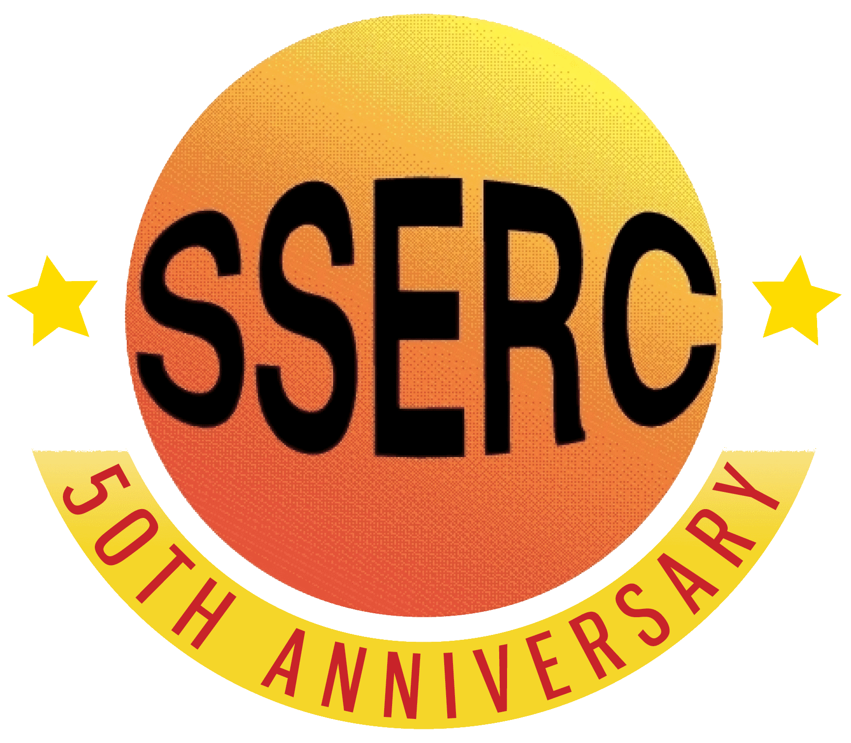

Food Chemistry
Emulsions

Introduction
An emulsion is a mixture of two fluids such as oil and water that is achieved by breaking up the molecules in both substances into very fine, small droplets in order to keep the combination from separating.
There are several common foods that are considered emulsions: milk, margarine, ice cream, mayonnaise, salad dressings, and sauces like béarnaise and hollandaise. When packaged and manufactured on a larger scale, most of these foods need emulsifiers to stabilise the mixture and keep the different ingredients from becoming separated.
In this investigation you will look at emulsion formation and at the effectiveness of various substances as emulsifying agents..

You will need
Coloured vegetable oil | Access to a Microscope
Small screw cap ‘universal’ bottles or test tubes with bungs | Egg yolk – 2 cm³
Microscope slides (dimple) | Mustard – 2 g
Detergent (washing-up liquid) 2 cm³ | timer
Polyoxyethylene sorbitan (Tween 40) – 5 ml* | Sucrose ester (Ryoto sugar ester S-170, HLB 1) – 2 g*
Sucrose ester (Ryoto sugar ester S-170, HLB 15) – 2 g*
* these are commercial emulsifiers that you might not have access to. If these are not available, you can try some other households materials to see if they work as emulsifiers.
Procedure
Part one – Oil/Water or Water/oil emulsion
- Prepare 2 samples as follows in screw cap tubes of test tubes with stoppers.
Tube A: 1 cm³ oil and 9 cm³ water
Tube B: 1 cm³ water and 9 cm³ oil.
- Cap the tubes and shake vigorously for 1 minutes.
- Start the timer
- Examine a sample of each emulsion under the microscope, keeping an eye on the tube.
- Record how long it takes the two layers to separate in each emulsion

Part 2 – Emulsifying agents
- Prepare tubes for as many of the emulsifiers as you have, according to the table below. (For example, Lecithin is dissolved in the oil before it is mixed with the water whereas egg yolk is dissolved in the water before the mixing).
- Cap each tube and shake vigorously for 1 minute.
- Put the tubes down and start the timer. How long does it take the emulsions to settle out now?

Tube Number | Emulsifier | Oil (ml) | Water (ml) | Liquid for dissolving emulsifier
Oil / Water (O/W) emulsions
1 | Control (no emulsifier) | 2 | 8 | -
2 | mustard – 0.5 g | 2 | 8 | Oil
3 | Egg yolk - 0.5 cm³ | 2 | 8 | Water
4 | Detergent (eg washing up liquid) – 0.5 cm³ | 2 | 8 | Water
5 | Bile – 0.5 g | 2 | 8 | Water
6 | Polyoxyethylene sorbitan monopalmitate (Tween 40) – 0.5 g | 2 | 8 | Oil
7 | Sucrose ester (HLB 1) – 0.5 g | 2 | 8 | Water
8 | Sucrose ester (HLB 15) – 0.5 g | 2 | 8 | Water
Water / Oil (W/O) emulsions
9 | Control (no emulsifier) | 8 | 2 | -
10 | Mustard – 0.5 g | 8 | 2 | Oil
11 | Egg yolk - 0.5 cm³ | 8 | 2 | Water
12 | Detergent (eg washing up liquid) – 0.5 cm³ | 8 | 2 | Water
13 | Bile – 0.5 g | 8 | 2 | Water
14 | Polyoxyethylene sorbitan monopalmitate (Tween 40) – 0.5 g | 8 | 2 | Oil
15 | Sucrose ester (HLB 1) – 0.5 g | 8 | 2 | Water
16 | Sucrose ester (HLB 15) – 0.5 g | 8 | 2 | Water

Health & Safety
All the reagents are of low hazard.

