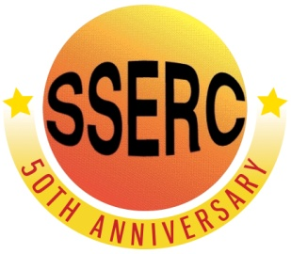
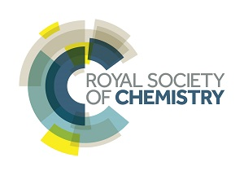
Simple Chemical Reactions
pH of the Planet

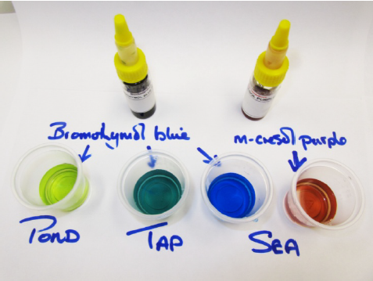
Background

National 4
Chemical changes and structure
Acids and alkalis

Chemistry in society
Chemical analysis

CfE Advanced Higher (with adaptation)
Inorganic and physical chemistry
Indicators

One of the most important factors affecting water quality is its pH.
This simple activity uses two different indicators to allow you to test the pH of water between pH 6.0 and pH 8.8.

You will need

Water samples | Bromothymol blue indicator
m-cresol purple indicator | Test tubes or other containers
Pasteur pipettes (unless indicator are in dropping bottles) | Colour charts
Universal indicator solution*

Preparation
- Water samples: The water samples can be collected in plastic drink bottles (1.5 L will be plenty). If samples need to be kept they should be stored in a refrigerator, allowed to come to room temperature before use, and used promptly after opening. Collect the water sample as close to the time the class will be carrying out the measurements as possible.
- Bromothymol blue
  - Dissolve 0.1 g of bromothymol blue in 16 mL of 0.01 M NaOH.
  - When dissolved, slowly add 234 mL of water (distilled if possible).
  - Store at room temperature.
- m-Cresol purple
  - Dissolve 0.1 g of m-Cresol purple in 26 mL of 0.01 M NaOH.
  - When dissolved, slowly add 224 mL of water (distilled if possible).
  - Store at room temperature.

* Universal indicator might be needed if any water samples are outside the pH 6.0 – 8.8 range.

The Experiment
- Put a few cm³ of the first water sample into two test tubes.
- add a few drops of bromothymol blue to the first tube and of m-cresol purple to the second.
- Compare the colours to the chart and record the pH.
- Repeat with your other water samples. Make sure you add the same number of drops of indicator. (If you are re-using the same tubes, make sure they are thoroughly rinsed with distilled water between samples.

Safety
The solids are not classified as hazardous but take care not to inhale dusts.
Be careful if the sodium hydroxide solution is being prepared from solid or a stronger solution. The 0.01 M solution is of low hazard.
The indicator solutions are of low hazard.
It is the responsibility of teachers doing this demonstration to carry out an appropriate risk assessment.

Interpreting pH values
pH values obtained in the activity need to be interpreted cautiously because there is a natural variability due to differing light levels and temperatures and artifacts of the different measuring techniques. In the case of freshwater sources the natural variability is quite large, commonly between 6.5 and 8.0. Marine waters usually are buffered and have a smaller range in pH variation, between 8.1 and 8.4.
Temperature changes cause changes in the pH of sample solutions and of pH sensors. Although these changes remain small if the temperature remains close to 20-25oC, bigger variation is to be expected with more extreme temperatures.
For natural waters, the pH also changes during the day due to the living material in the water. Respiration of organisms produces carbon dioxide which lowers the pH of the sample. In daylight the pH increases because the photosynthesizing organisms reduce the levels of carbon dioxide.
The geology of the area can also affect the pH of the local water. The presence of limestone can raise the pH considerably. In the case of the oceans, the limestone and other sources of calcium carbonate contribute to the normal ocean pH of 8.3, but the additional carbon dioxide in the atmosphere due to climate change is partially dissolving in the ocean decreasing the pH (by very small amounts).
Indicator Colour Chart
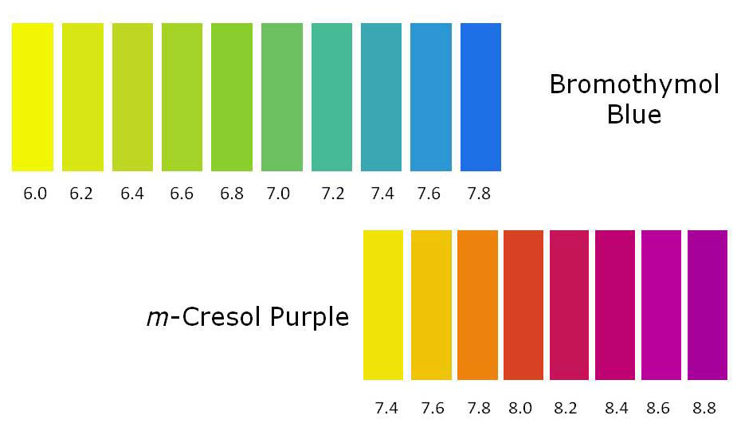

Table of RGB Indicator Colours
Different printers (and monitors) render colours differently. The table below gives the RGB values for each so you can be sure it is correct.

