|  |
| --- |
| Chemical Demonstrations |
| The **real** reactivity of  Aluminium |

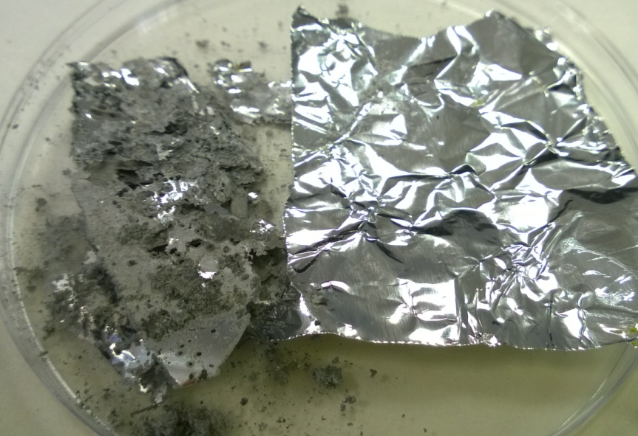

This reaction can be applied to curriculum for excellence.

*Through experimentation, I can identify indicators of chemical reactions having occurred ...*

SCN 3-19a

N4 – Chemistry in Society

*The properties of Metals and Alloys*

**Introduction**

Aluminium does not react very well with the oxygen in the air but it is in fact quite a reactive metal. The reason it does not react is that is has already reacted, but the aluminium oxide has formed in a thin, tightly bonded layer that protects the aluminium foil from further attack. This aluminium oxide layer is so thin that is it not noticeable.

It is possible to remove this layer with mercury II chloride and watch the aluminium reacting rapidly with the oxygen in the air.

**You will need**

|  |  |
| --- | --- |
| Mercury II chloride solution (0.5M - saturated) | Aluminium foil |
| Forceps | Beaker or other container. |

**What you Do**

1. Pour some of the mercury chloride solution into a container (petri dish, beaker, evaporating basin).
2. Using forceps, take a piece of aluminium foil, approximately 5 x 5 cm, and dip it into the solution.
3. Keep it in there for about 30 seconds then remove, allowing the few drips to fall off into the solution.
4. Place the foil into a watch glass (or on a heat proof mat.
5. Over the next few minutes, a white layer will appear on the aluminium surface and the foil slowly disintegrates into a fine powder.

**Safety**

Wear eye protection Wear gloves

Do not pour the mercury chloride solution down the sink. Just pour it back into the bottle and keep for next time. (Alternatively dispose of as recommended on the SSERC website).

Do not put the aluminium in a waste bin until you are sure the reaction has finished – the heat could ignite any paper there.

**It is the responsibility of teachers doing this demonstration to carry out an appropriate risk assessment.**