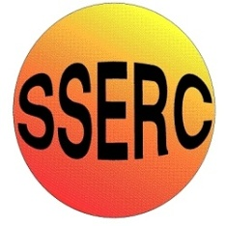

|  |
| --- |
| Chemical Demonstrations  This reaction can be applied to curriculum for excellence.  *Through experimentation, I can identify indicators of chemical reactions having occurred ...*  SCN 3-19a  N3 – Nature’s Chemistry  *- Fuels and energy*  CfE Higher – Nature’s chemistry  *- Esters, fats and oils* |
| Chip Pan Fire |

**You will need**

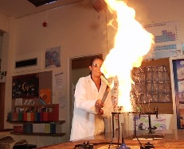

|  |  |
| --- | --- |
| Face shield | Heat-resistant gloves |
| Crucible (25 mm diameter), nickel or steel | Pipeclay triangle to support crucible |
| Tripod | Bunsen burner |
| Heat resistant mats | Safety screens |
| A small square of hardboard or aluminium (or other solid, non-flammable material). | Test-tube, fixed securely to end of 1 metre pole (metre rule will do) |
| 3cm3 cooking oil | 5cm3 of water (in the test tube) |
| *The class will require eye protection* |  |

**Preparation**

* Teacher should wear face shield and heat resistant gloves.
* Class should wear eye protection and must be kept not less than 4 metres back.
* Safety screens must be positioned and secured to protect both students and the demonstrator.
* The experiment must not be carried out below a light fitting.

1. Wedge the nickel crucible firmly and upright in the pipe-clay triangle on the tripod. It must not tip over when the flame is smothered by the demonstrator. (The wires of the triangle may need to be bent over the tripod to hold it steady).

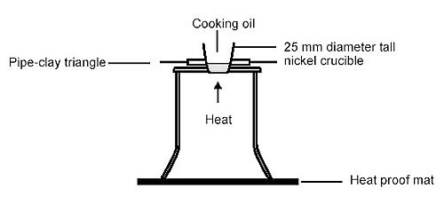

1. Protect the demonstration bench from hot burning fat by covering with an array of heat resistant mats.
2. Arrange safety screens and secure in place so they protect both demonstrator and the class.
3. The test-tube should be held firmly, e.g. in a test-tube holder, and strapped to the end of a long pole so that the tube will not fall off when engulfed in flame during the demonstration.

**The demonstration**

1. Place about 5 cm3 of water in the test-tube ready for use during the demonstration.
2. Pour 3 cm3 of cooking oil into the crucible and place a lighted Bunsen burner beneath it.
3. Once the oil catches fire, switch off the gas supply to the Bunsen burner and extinguish the flame by placing a small square of hardboard or aluminium over the crucible to simulate placing a tray over a burning chip pan to remove the oxygen from the fire.
4. Explain that a damp tea-towel would also extinguish the fat-pan fire. In this demonstration this method is unsuitable, as it could knock the apparatus off the tripod, but for a real fat-pan fire it is a good method.
5. Remove the square and light the Bunsen burner again until the cooking oil re-ignites.
6. Switch off the gas supply to the Bunsen burner, and holding the pole with the test-tube containing water attached at arm’s length, add the water to the burning oil. This will cause a ball of fire to rise about a metre, effectively demonstrating the hazard of attempting to put out a fat-pan fire with water.

The demonstration is improved if this is done twice: the first time, use the hardboard etc to put out the fire properly, then re-light it and add the water, as described.

## Safety

This demonstration can be extremely hazardous unless the procedures laid out above a strictly followed. In addition to the precautions above:

* the demonstration must NOT be done in a fume cupboard.
* the quantities prescribed must NOT be exceeded; do NOT be tempted to use more cooking oil.
* a squat crucible must NOT be used as it ejects the hot fat sideways.
* a porcelain crucible is NOT safe as it is liable to break.
* Although it is commonly suggested that this sort of fire should be put out using a damp cloth, it is not a good idea to attempt this as there is a definite chance that the crucible will be knocked over.

**What is happening?**

In order to burn, oil needs to be close to or at its boiling point, around 220°C. (This will vary depending on the oil).

When the water is added, it sinks to the bottom as it is more dense than the oil. It then turns to steam, as the temperature is far about boiling point (100°C). The steam erupts out from under the burning oil, carrying it along too. As the burning oil is spread out into smaller droplets and mixes with the air, it burns much faster, hence the fireball.

As well as being used for teaching about fire in general, this demonstration can be linked to the more general aspects of assessing risks and taking action to reduce risks to themselves and others.

Chip pan fires cause about one in five of all accidental house fires in the UK each year. As well as the damage they can cause to people’s homes, these fires are also the most common cause of fire-related injuries to people, injuring around 4,000 people every year.

**It is the responsibility of teachers doing this demonstration to carry out an appropriate risk assessment.**

# What you will do

## Before the demonstration:

1. Ensure that the atomiser bottles are trigger operated, with a piston rather than a scent spray pump where a rubber bulb is squeezed. This will prevent any possibility of the flame flashing back into the container if using alcoholic solutions.
2. Alternatively, use aqueous solutions of the salts in the bottles.
3. Make a saturated solution of each salt in about 10 cm3 of water. Only a few mg of each is required.
4. Place each solution in an atomiser bottle and label it accordingly.

## The demonstration:

1. Place a large sheet of card on the bench and the wall behind the experiment – it can get messy!
2. Put the Bunsen burner on a half blue flame.
3. Take the atomiser bottle with the solution of the metal salt and spray it through the flame.

NOTE take care to direct the spray away from yourself and the audience.

## Salts to try:

|  |  |
| --- | --- |
| Compound | Flame colour |
| sodium chloride |  |
| lithium iodide |  |
| potassium chloride |  |
| barium chloride |  |
| strontium nitrate |  |
| calcium chloride |  |
| copper sulphate |  |