Chemical Demonstrations
Superconducting galvanic cells
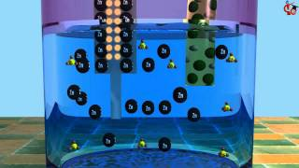
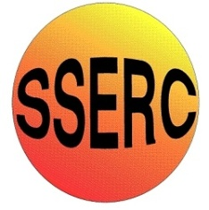
This reaction can be applied to curriculum for excellence.
Through experimentation, I can identify indicators of chemical reactions having occurred ...
SCN 3-19a
N4 – Chemistry in Society
The properties of Metals and Alloys

Introduction
Magnesium will only react slowly with water, iron even more slowly.
It is possible, however, to get the two of them to react much more rapidly, though not with water with salt solution (any salt, it just needs to be an electrolyte.
You will need
magnesium ribbon | Steel wool
sodium chloride solution (10% or so) | Test tubes and test tube rack

What you Do
- Pour some of the salt solution into each of three test tubes
- Place some magnesium ribbon into the first tube and some steel wool into the second one. You might see the odd bubble but nothing much.
- Take another piece of magnesium ribbon and clean it with some steel wool
- Take another piece of steel wool and wrap it around the magnesium ribbon in a spiral fashion. Try to get as much of the steel wool in contact with the magnesium as possible.
- Drop this piece of magnesium ribbon into the third test tube. It will soon start to bubble vigorously.

Safety
Aside from the flammability of magnesium and the possibility of cuts from the magnesium ribbon, this is a low hazard activity.

What is happening?
This is a simpler example of the chemistry behind some flameless ration heaters used by the military.
When placed in an electrolyte, each bit of magnesium and iron becomes a tiny battery. But because the magnesium and iron particles are in contact, they become lots of tiny short-circuited batteries, which quickly burn out, producing heat in a process the patent holders call "Supercorroding Galvanic Cells".
In the ration heaters, powdered iron, magnesium and salt are mixed together and adding water is enough to get the reaction to work rapidly. Sadly from a classroom perspective, it needs nanoparticles (or at least very, very fine powder to work.
This version does, however, show the principle.
Extension
1. weigh the steel wool and the magnesium ribbon before the experiment.
2. After the experiment, wash the assembly, separate out the two metals and dry them (use a hairdryer as the steel wool will rust if you leave it to dry on its own)
3. Weigh them again. The iron should be the same while the magnesium has lost mass – showing that it is working as a sacrificial anode.
It is the responsibility of teachers doing this demonstration to carry out an appropriate risk assessment.

