Chemical Demonstrations
Ghost Metal

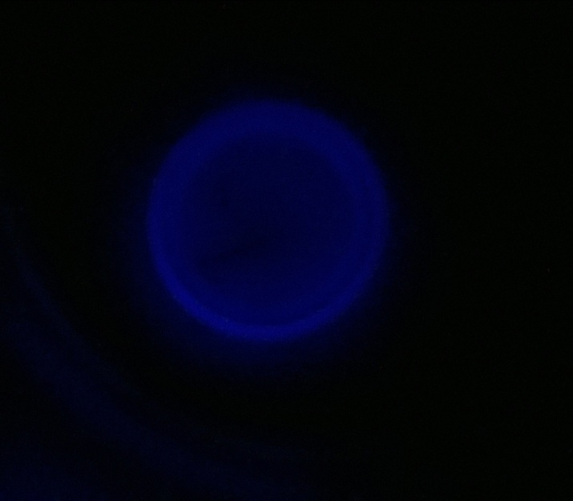
Higher (CfE) –
Chemistry in Society
Oxidising or reducing agents
Introduction
A great little demo of chemiluminescence taken from the NurdRage website - (If you haven't been there, you should)
It is based on the simple luminol reaction with copper ions and peroxide. In this case, though, the copper ions are produced in situ by the action of ammonia on copper coins (or pieces of wire). To prevent the solution just ending up a luminous blue, EDTA is added that chelates the free copper ions. The end result is that you get a blue glow around the copper but not elsewhere.
You will need
1 x 500 cm³ flask / beaker/bottle | 5% ammonia solution
3% hydrogen peroxide solution (10 vol) | Luminal (5-Amino-2,3-dihydro-  1,4-phthalazinedione)
Sodium EDTA (sodium ethylenediaminetetraacetate) | Copper coins /wire/sheet
Petri dish or beaker

To Do
Preparation
a. Take 8 cm³ of .880 ammonia and make up to 50 cm³.
b. Take 0.5 cm³ of 100 vol H₂O₂ and make up to 5cm3 (or use 5 cm³ of 10 vol)
c. Weigh out 0.05g of luminol and 0.15g of NaEDTA
Dissolve the luminal and EDTA in the ammonia solution.
Add the hydrogen peroxide
Dilute the mixture to 500 cm³.
The demonstration
a. Pour some of the solution into a beaker or petri dish.
b. Place your copper objects in.
c. Turn off the light
You will notice a blue glow around the copper where copper ions leach into the solution and interact with the luminal. If you nudge the mixture, the glow increases temporarily as more copper ions come into solution but this then drops down as they are chelated by the EDTA.

Safety
Concentrated ammonia and hydrogen peroxide are both corrosive and should be handled wearing goggles and gloves.
.880 ammonia gives off toxic fumes and the dilution should be carried out in a fume cupboard.
The concentrated solution is irritant but once diluted to 500 cm³ it is of low hazard.

What is happening?
In this reaction, a small amount of luminol (3-aminophthalhydrazide or 5-amino-2,3-dihydro- 1,4-phthalazinedione) is dissolved in a basic aqueous solution, which also contains a small amount of copper(II) sulphate. To this solution is added a solution of a mild oxidizing agent, which is 0.3% hydrogen peroxide in the demonstration below. (Bleach is also used in some recipes as the oxidizing agent.) The reaction is believed to occur by the following mechanism:
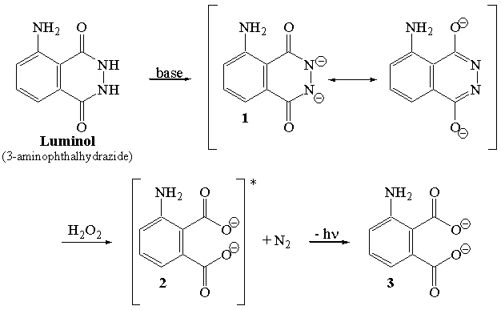
The luminol is converted by the basic solution into the resonance-stabilized dianion 1, which is oxidized by the hydrogen peroxide into the dicarboxylate ion 2, accompanied by the loss of molecular nitrogen, N₂. When the molecule 2 is formed, it is in an excited (higher energy) electronic state, and sheds its "extra" energy by emitting a photon of light (hν), allowing the molecule to go to its ground state form (3).
In aqueous solution, the luminol oxidation is catalyzed by the presence of a metal ion, such as iron(II) or copper(II).
In this reaction the metallic copper reacts with the ammonia, and oxygen from the hydrogen peroxide, to produce a tetramino copper ²⁺ complex. The Copper ²⁺ then catalyses the oxidation of luminal.
More specifically, the copper catalyses the first step, the formation of the dicarboxylate ion.
(Details from Angelo State University, San Angelo, Texas, USA - http://www.angelo.edu/faculty/kboudrea/demos/luminol/luminol.htm)

