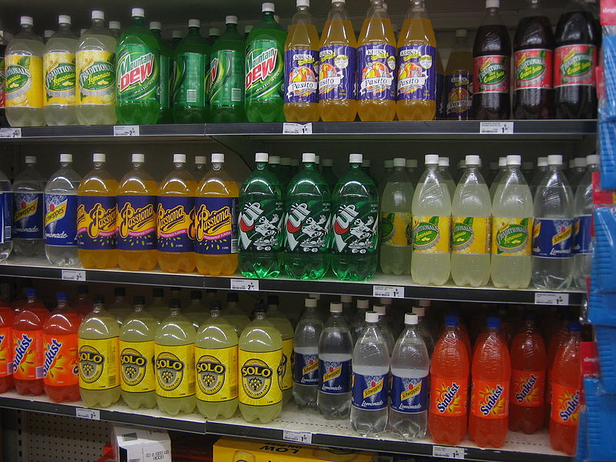
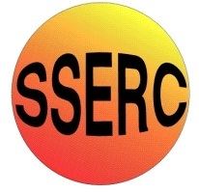
INTRODUCTION
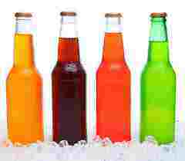
Artificial food colours are added to many foods to make them look tastier and more appealing..
Most of us are familiar with their use in sweets, and soft drinks, but fewer people are aware of their widespread use in foods such as sauces, cheese, butter, and various prepared foods.
This experiment involves the use of Solid-phase extraction (SPE).
This is a separation process by which compounds that are dissolved or suspended in a liquid mixture are separated from other compounds in the mixture according to their physical and chemical properties.
Analytical laboratories use solid phase extraction to concentrate and purify samples for analysis, which is what you will be doing.
This particular form of SPE uses reverse phase chromatography.
Reversed phase separations involve a polar or moderately polar mobile phase, in this case water as we are using an aqueous solution, and a nonpolar stationary phase.
The analytes of interest, in this case the colourings, are typically mid- to nonpolar.
Binding of organic compounds from polar solutions onto these SPE materials is due primarily to the attractive forces between the carbon-hydrogen bonds in the analyte and the functional groups on the silica surface. These nonpolar-nonpolar attractive forces are commonly called van der Waals forces: or dispersion forces.
Once the compound has attached to the column, we use a nonpolar solvent to disrupt the forces that bind the compound to the packing and thus elute it for analysis.

Extraction of Synthetic Colours From Food
You will need
2 x 25 cm³ measuring cylinders | Stirring rod
2 x boiling tubes | Cartridge with syringe attachment*
Test tube rack | Tetrabutylammonium bisulphate 0.007M
Ethanol (IDA) | Tetrabutylammonium bisulphate 0.7M
* The cartridge looks like the barrel of a syringe with a white layer about 1cm thick at the bottom. You will also need an adaptor. This is a small, plastic device that fits tightly into the top of the barrel of the cartridge. On the top is a small hole where the end of a syringe fits, also quite tightly.
The idea of having such a tight fit is that it allows you to apply pressure to the liquid going through the column using the top syringe.

Once you have got your syringe fixed in the top of the adaptor, which is in the cartridge, DO NOT pull the plunger out. ALWAYS take the syringe out of the adaptor first. If you don’t it will damage the filter bed in the cartridge and it will not work properly.

A) PREPARING THE SOFT DRINK
- Measure 20mls of the soft drink using a measuring cylinder and put it into the small 100ml beaker.
- Add 2-3 drops of the 0.7M TBAB (THE SMALL VIAL) into the beaker containing the soft drink.
- Mix using the glass rod.
- Your soft drink is now ready to extract the colour.

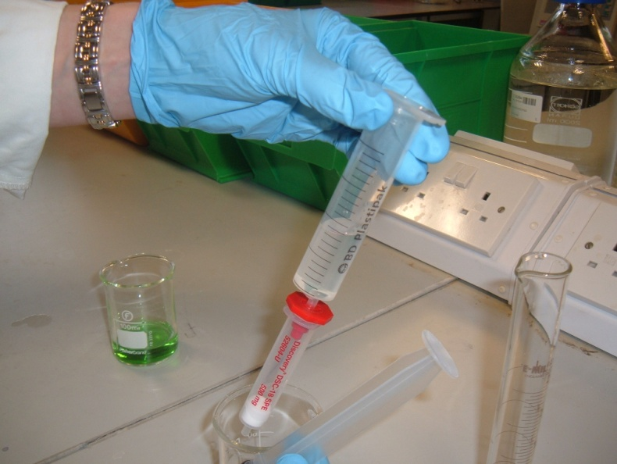
B) PRIMING THE CARTRIDGE
- Take the cartridge and fix the adaptor in the top so it is tight.
The adaptor remains in this position for the whole of the experiment.
- Remove the plunger from the 10 cm³ syringe.
- Push the syringe body into the top of the adaptor so it, too, is snug.
- Sit the assembly in the top of a boiling tube.
- Use a measuring cylinder to measure out 10 cm³ ethanol and pour it into the top of the syringe.
- Now place the plunger into the syringe
- Using the plunger, depress gently into the syringe expelling the used ethanol into the boiling tube below.
- Remove the syringe WITH THE PLUNGER STILL IN from the adaptor.
- You can now remove the plunger from the syringe.
- Put the syringe, minus the plunger, back into the adaptor.
- Using a clean measuring cylinder measure out 10 cm³ of the 0.007M TBAB and pour this into the top of the syringe.
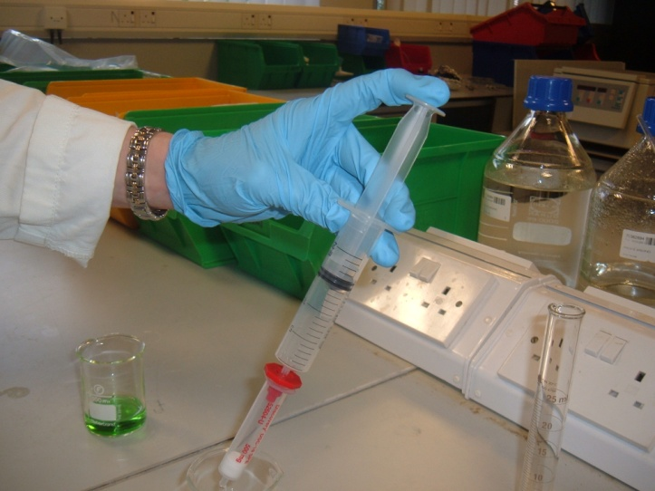
- Using the plunger, depress gently into the syringe expelling the used 0.007M TBAB into the boiling tube, as you did with the ethanol.
YOU HAVE PRIMED THE CARTRIDGE AND IT IS READY TO EXTRACT YOUR COLOUR FROM THE SOFT DRINK
Remove the syringe from the adaptor again and then remove the plunger from the syringe.
Once again, reattach the syringe battle to the adaptor.

C) EXTRACTING THE COLOUR FROM THE SOFT DRINK
- Carefully pour 10 cm³ of your pre-prepared coloured soft drink (20 cm³ of soft drink plus 2-3 drops of 0.007m TBAB) into the syringe barrel.
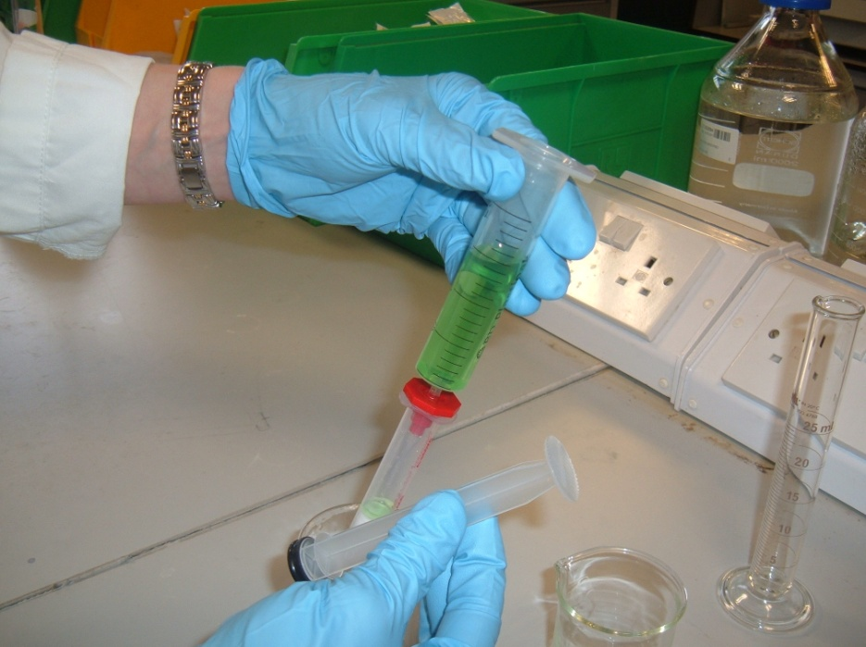
20 cm³ of soft drink plus 2-3 drops of 0.007m TBAB

- Put in the plunger, push gently into the syringe, expelling the soft drink into the test tube below.
- Remove the syringe from the adaptor, then take out the plunger and re-attach the barrel again. Put the second batch of drink in the top of the syringe and push that through as before.
- Remove the syringe and then take out the plunger before putting the syringe barrel back in the adaptor.
REMEMBER TO REMOVE THE SYRINGE FROM THE RED ATTACHMENT BEFORE REMOVING THE PLUNGER.
YOUR EXTRACTED COLOUR IS NOW ON THE CARTRIDGE.

D) CLEANING THE COLOUR ON THE CARTRIDGE
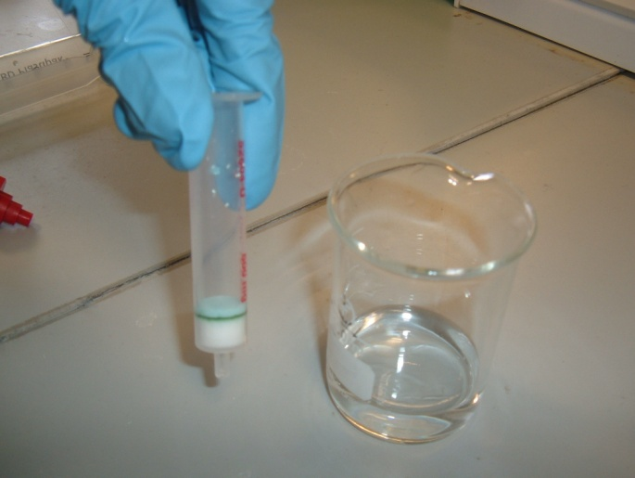
- Ensure the syringe barrel is fixed to the adaptor.
- Sit it in the top of a boiling tube.
- Use the measuring cylinder to measure out 10 cm³ of the 0.007M TBAB and pour it into the top of the syringe.
- Put in the plunger and push down gently on the syringe expelling the used 0.007M TBAB into the boiling tube below.
- Remove the syringe from the adaptor and now remove the plunger from the syringe
YOUR COLOUR ON THE CARTRIDGE IS NOW CLEAN

E) TAKING THE EXTRACTED COLOUR OFF THE CARTRIDGE
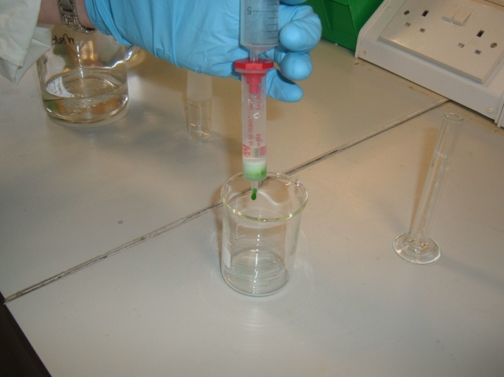
- You will need a CLEAN boiling tube.
- Sit the cartridge (with the adaptor fixed in the top of it) in the top of the boiling tube.
- Measure 2 cm³ of ethanol using a pipette, syringe or measuring cylinder and pour it into the top of the syringe.
- Put in the plunger and push down gently on the syringe, expelling the extracted colour into the boiling tube beneath.*
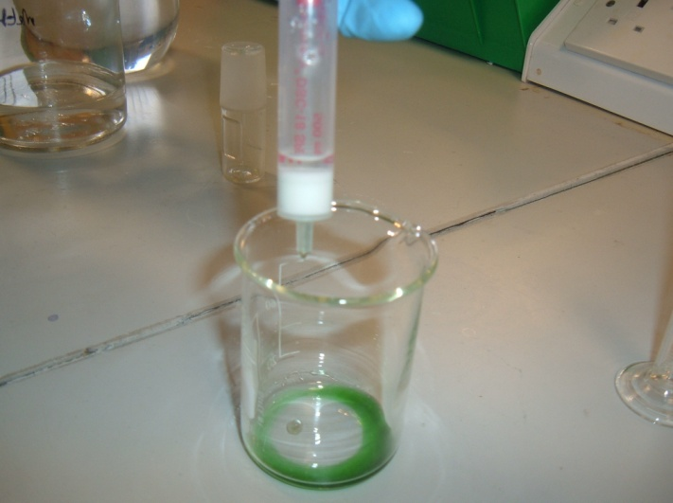
THE EXTRACTED COLOUR IS IN THE BEAKER AND IS READY TO BE ANALYSED.
* To get the most concentrated colour, watch the flow of the ethanol carefully and don’t collect the first few drops as they will be colourless. Equally, you can stop collecting before the whole 2 cm³ is through as the extract gets paler near the end.

