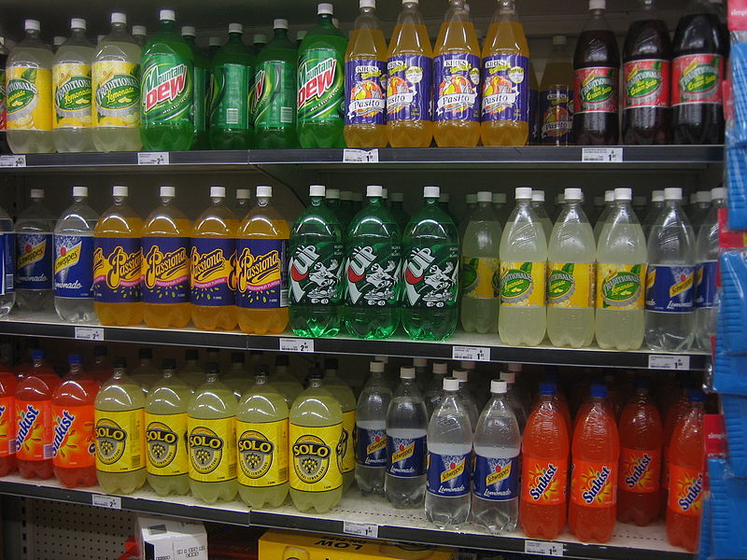
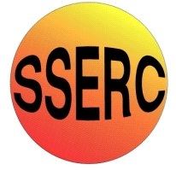
Introduction
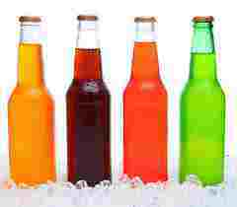
Artificial food colours are added to many foods to make them look tastier and more appealing..
Most of us are familiar with their use in sweets, and soft drinks, but fewer people are aware of their widespread use in foods such as sauces, cheese, butter, and various prepared foods.
This experiment involves a specific type of chromatography – Reverse Phase Separation to remove the colourants from drinks. The concentrated colourants can then be analysed by other chromatographic methods.

Links to the curriculum.
SCN 3 16a - I can differentiate between pure substances and mixtures in common use and can select appropriate physical methods for separating mixtures into their components.
SCN 3 17b I can participate in practical activities to extract useful substances from natural resources.
N4 Chemistry in Society – Chemical Analysis (Chromatography is specifically mentioned)
N5 Chemistry in Society – Chemical Analysis (Chromatography is not specifically mentioned but is not ruled out)
CfE Higher Chemistry in Society – Chemical Analysis (Extensive coverage of chromatography)
CfE Higher Chemical Changes and Structure – Structure and bonding (Extensive coverage of the Van de Waals and dispersion forces underlying this technique)

How chromatography works
All forms of chromatography work by exploiting different interactions between the dyes and the two components of the chromatography setup.
The stationary phase – this does not move and the liquids pass through it. (In ordinary paper chromatography, the paper is the stationary phase.)
The mobile phase – this is the fluid that moves through the stationary phase (like the water through filter paper)
Paper chromatography is a familiar technique in schools. A mixture of dyes (often an ink) is place on some filter paper and a solvent is allowed to run up/along the paper carrying the different dyes different distances.
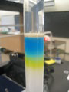
Column chromatography works on the same principle. The ‘ink’ is washed down a column filled with a permeable solid. The different dyes move through the column at different speeds and so come out of the bottom at different times. The advantage of this is that you can get samples of your separated dyes to do further work on.
The ability to show separate dyes in separate containers can show how this technique can recover the constituent parts – a task which is a little more difficult with paper chromatography.

This experiment involves the use of Solid-phase extraction (SPE). a particular type of column chromatography
This is a separation process by which compounds that are dissolved or suspended in a liquid mixture are separated from other compounds in the mixture according to their physical and chemical properties.
Analytical laboratories use solid phase extraction (SPE) to concentrate and purify samples for analysis, which is what you will be doing.
This particular form of SPE uses reverse phase chromatography.
Reversed phase separations involve a polar or moderately polar mobile phase, in this case water as we are using an aqueous solution, and a nonpolar stationary phase.
The analytes of interest, in this case the colourings, are typically mid- to nonpolar.
Binding of organic compounds from polar solutions onto these SPE materials is due primarily to the attractive forces between the carbon-hydrogen bonds in the analyte and the functional groups on the silica surface. These nonpolar-nonpolar attractive forces are commonly called van der Waals forces: or dispersion forces.
Once the compound has attached to the column, we use a nonpolar solvent to disrupt the forces that bind the compound to the packing and thus elute it for analysis.
(A diagram of the process is shown on the next page)
Ion pair chromatography
Developed by Dr. Gordon Schill in 1973, ion pair chromatography relies upon the addition of ionic compounds to the mobile phase to promote the formation of ion pairs with charged analytes.
These reagents are comprised of an alkyl chain with an ionizable terminus.
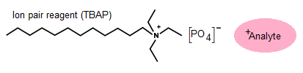
When used with reversed-phase chromatography, ion pair reagents can be used to selectively increase the retention of charged analytes.
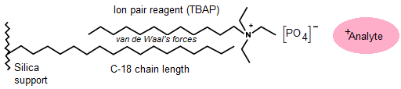
In this particular experiment, tetrabutylammonium bisulphate is used to increase the interactions with the dyestuffs and thus increase both the amount and specificity their extraction from the drink. The diagrams above show tetrabutylammonium phosphate. There is a variety of TBA compounds and, we would assume, any of them will work for this. SSERC has tested the phosphate, bisulphate and hydroxide.
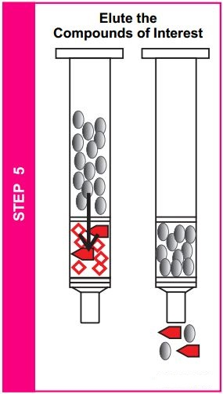
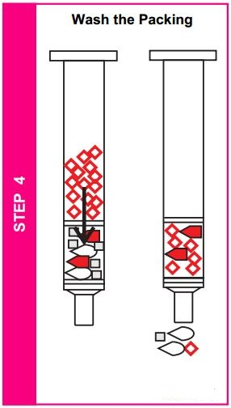
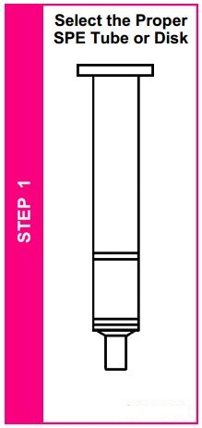
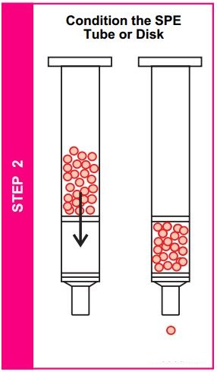
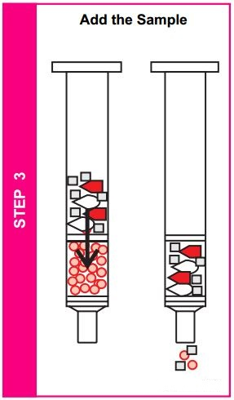
Diagrams taken from Supelco bulletin 910 (Supelco is a subsidiary of Sigma Aldrich)
Now wash out the compounds you want, in this case the colours, using ethanol.
Washing with the TBAP will remove the chemicals in the mixture that have not bound to the bed.
Your sample of drink will contain all sorts of chemicals, only some of which you want.
Wash first with ethanol (IDA) and then the TBAP solution

Setting the Scene
The investigation here is set up as an exercise in forensic science.
The pupils analyse one (or more) drink samples for the presence of banned additives. They then draw up a report which they present to the ‘Sherriff’s Court’.
One possible way of running this would be as follows.
1) Introductory lesson
Discussion of the importance of analysis and of the role of the Scientific Services labs.
Revision (probably) of chromatography. And a short experiment – probably chromatography of some food dyes.
Description of the problem and allocation of groups and roles.
The problem – It has been suggested that a certain manufacturer is using illegal food additives in their soft drinks. Your job is to analyse the drinks and try to determine if this is indeed so.
2) Extraction of Colours
One (or more) drinks will have to be ‘spiked’ with some artificial colour eg tartrazine (see next page)
Depending on time either get each group to carry out extractions of 3 or 4 different drinks or get each group to extract a colour from one drink and then they can pool the results for the chromatography.
If the latter route is followed, it should be possible to carry out the chromatography in the same lesson. If they are extracting colours from several drinks, the colours will need to be kept until the next time.
3) Analysis of results
Run the chromatogram (if it has not already been run) and then measure the distance and calculate the rf values. Compare these to the reference samples.
Write a brief report about the content of the drink(s)
4) Presentation of results
Groups could present their finding at the ‘Sherriff Court’ set up and answer questions relating to their decisions. They should be prepared to ask other groups appropriate questions
*For the writing and presentation of the report, it could be helpful to work in association with the English department or Modern Studies for the court set up.
5) Discussion activity relating to food additives in general.
Preparing the drinks
There are some colourings that, while permitted in some foods, are not allowed in soft drinks. This includes azo dyes such as tartrazine (E102) and Allura Red (E129).
Fortunately for us, because they are still permitted in many foods, it is still possible to get hold of them. A good source is the colourings that can be found in Chinese supermarkets.
For the purposes of testing a ‘new’ drink. Obtain a clear lemonade and add one of the dyes. Enough to give a decent colour. If you add too much, it will be difficult to get the SPE cartridges clean – although they will still work.

The experiments
Each group will need
2 x 25 cm³ measuring cylinders | Stirring rod
2 x boiling tubes | Cartridge with syringe attachment*
Test tube rack | Tetrabutylammonium bisulphate 0.007M
Ethanol (IDA) | Tetrabutylammonium bisulphate 0.7M
* The cartridge looks like the barrel of a syringe with a white layer about 1cm thick at the bottom. You will also need an adaptor. This is a small, plastic device that fits tightly into the top of the barrel of the cartridge. On the top is a small hole where the end of a syringe fits, also quite tightly.
The idea of having such a tight fit is that it allows you to apply pressure to the liquid going through the column using the top syringe.

Once you have got your syringe fixed in the top of the adaptor, which is in the cartridge, DO NOT pull the plunger out. ALWAYS take the syringe out of the adaptor first. If you don’t it will damage the filter bed in the cartridge and it will not work properly.

A) PREPARING THE SOFT DRINK
- Measure 20mls of the soft drink using a measuring cylinder and put it into the small 100ml beaker.
- Add 2-3 drops of the 0.7M TBAP (THE SMALL VIAL) into the beaker containing the soft drink.
- Mix using the glass rod.
- Your soft drink is now ready to extract the colour.
Given that soft drinks nowadays do not contain certain ‘artificial’ colours, you will need to ‘spike’ a sample with a ‘banned’ colour such as tartrazine E102)
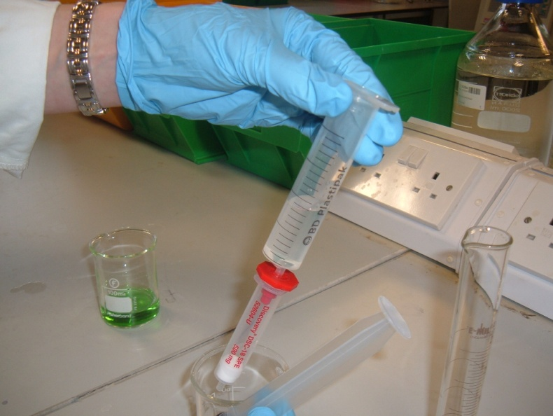
B) PRIMING THE CARTRIDGE
- Take the cartridge and fix the adaptor in the top so it is tight. (The adaptor is red in the picture)
The adaptor remains in this position for the whole of the experiment.
- Push the syringe into the top of the adaptor so it, too, is snug.
- Sit the assembly in the top of a boiling tube.
- Use a measuring cylinder to measure out 10 cm³ ethanol and pour it into the top of the syringe.
- Now place the plunger into the syringe
- Using the plunger, depress gently into the syringe expelling the used ethanol into the boiling tube below.
- Remove the syringe WITH THE PLUNGER STILL IN from the adaptor.
- You can now remove the plunger from the syringe.
- Put the syringe, minus the plunger, back into the adaptor.
- Using a clean measuring cylinder measure out 10 cm³ of the 0.007M TBAP and pour this into the top of the syringe.
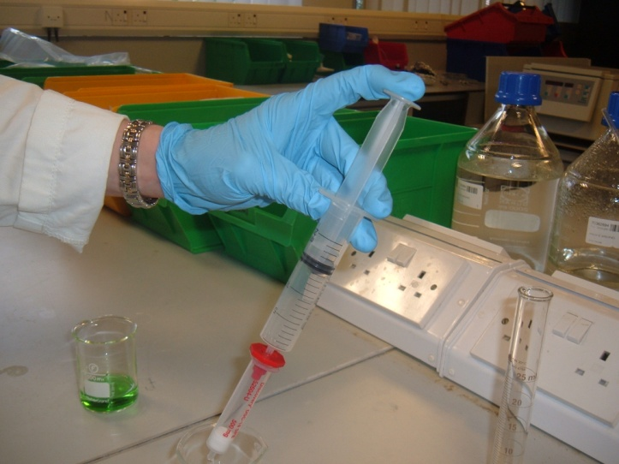
- Using the plunger, depress gently into the syringe expelling the used 0.007M TBAP into the boiling tube, as you did with the ethanol.
YOU HAVE PRIMED THE CARTRIDGE AND IT IS READY TO EXTRACT YOUR COLOUR FROM THE SOFT DRINK
Remove the syringe from the adaptor again and then remove the plunger from the syringe.
Once again, reattach the syringe battle to the adaptor.

C) EXTRACTING THE COLOUR FROM THE SOFT DRINK
- Carefully pour 10 cm³ of your pre-prepared coloured soft drink (20 cm³ of soft drink plus 2-3 drops of 0.007m TBAP) into the syringe barrel.
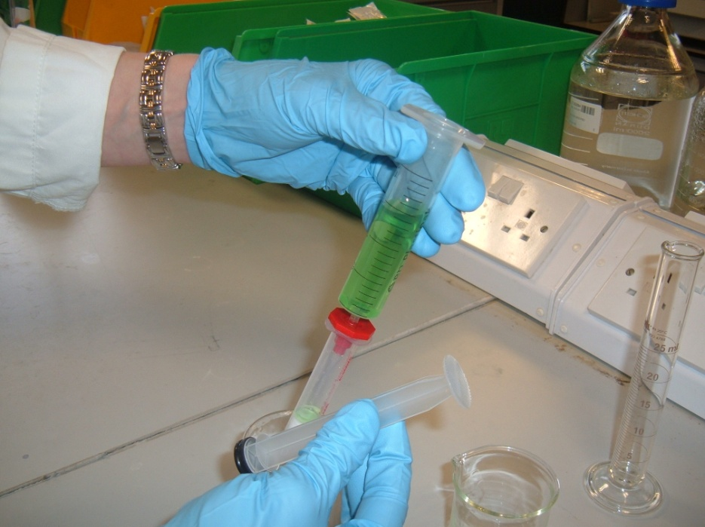
20 cm³ of soft drink plus 2-3 drops of 0.007m TBAP

- Put in the plunger, push gently into the syringe, expelling the soft drink into the test tube below.
- Remove the syringe from the adaptor, then take out the plunger and re-attach the barrel again. Put the second batch of drink in the top of the syringe and push that through as before.
- Remove the syringe and then take out the plunger before putting the syringe barrel back in the adaptor.
REMEMBER TO REMOVE THE SYRINGE FROM THE RED ATTACHMENT BEFORE REMOVING THE PLUNGER.
YOUR EXTRACTED COLOUR IS NOW ON THE CARTRIDGE.

D) CLEANING THE COLOUR ON THE CARTRIDGE
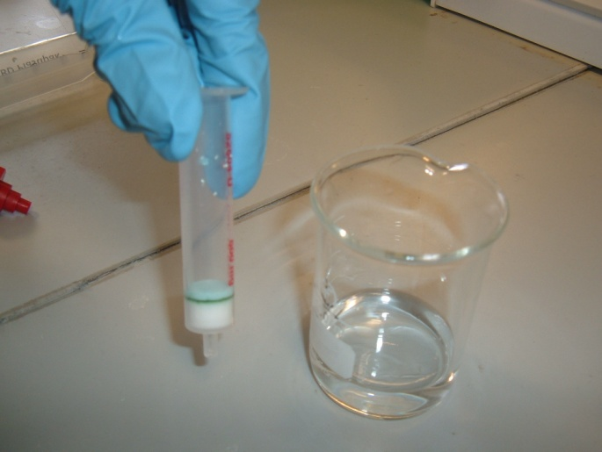
- Ensure the syringe barrel is fixed to the adaptor.
- Sit it in the top of a boiling tube.
- Use the measuring cylinder to measure out 10 cm³ of the 0.007M TBAP and pour it into the top of the syringe.
- Put in the plunger and push down gently on the syringe expelling the used 0.007M TBAP into the boiling tube below.
- Remove the syringe from the adaptor and now remove the plunger from the syringe
YOUR COLOUR ON THE CARTRIDGE IS NOW CLEAN

E) TAKING THE EXTRACTED COLOUR OFF THE CARTRIDGE
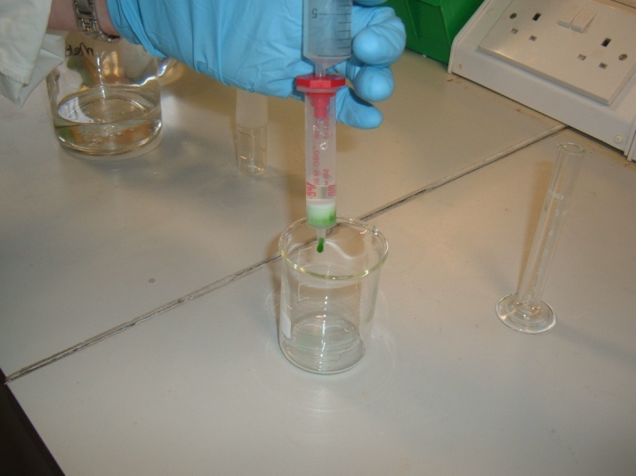
- You will need a CLEAN boiling tube.
- Sit the cartridge (with the adaptor fixed in the top of it) in the top of the boiling tube.
- Measure 2 cm³ of ethanol using a pipette, syringe or measuring cylinder and pour it into the top of the syringe.
- Put in the plunger and push down gently on the syringe, expelling the extracted colour into the boiling tube beneath.

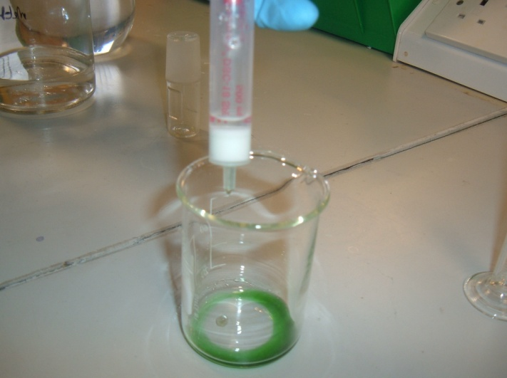
THE EXTRACTED COLOUR IS IN THE BEAKER AND IS READY TO BE ANALYSED.
* To get the most concentrated colour, watch the flow of the ethanol carefully and don’t collect the first few drops as they will be colourless. Equally, you can stop collecting before the whole 2 cm³ is through as the extract gets paler near the end.

Technician’s Guide

Apparatus per group | Number/amount for 10 groups | Comments
2 x 25 cm³ measuring cylinders | 20 (or 10) | One each could be used if it is rinsed out properly
2 x boiling tubes | 20
Test tube rack | 10
Ethanol (IDA) (15 cm³ per dye extraction) | 150 cm³ per extraction
Stirring rod | 10
Cartridge with syringe attachment* | 10 | If no syringe attachments are available, use an 11 mm rubber bung with one hole in
Tetrabutylammonium bisulphate 0.007M (20 cm³ per dye extraction) | 200 cm³ per extraction | RMM = 339.53  2.38g per litre
Tetrabutylammonium bisulphate 0.7M (2-3 drops per dye extraction) | 1-2 cm³ per extraction | It might prove easier for the teacher or technician prime the drink with the TBAP beforehand

Cartridges - Discovery DSC-18 6ml, 500mg -Available from Sigma http://www.sigmaaldrich.com/catalog/product/supelco/52604u?lang=en&region=GB
Cost - £76.50 for a pack of 30. This is expensive but the cartridges can be re used numerous times.
Syringe Adaptors - From Argilent, Cat No 12131001 –
http://www.chem.agilent.com/search/?Ntt=12131001
Cost - £50 for 15. Again this is expensive. These can, however, be re used indefinitely but if the cost is too high, it is possible to use an 11 mm rubber 1-hole bung.
Tetrabutylammonium bisulphate - Sigma
http://www.sigmaaldrich.com/catalog/product/sial/86868?lang=en&region=GB
Cost - £26.30 for 25g
The phosphate powder is very light and statically attracted to plastic weigh boats. It dissolves very readily in water. The bisulphate is easier to handle. The hydroxide comes as a 40% solution in water.
Food colourings
Tartrazine – Sigma http://www.sigmaaldrich.com/catalog/product/sigma/t0388?lang=en&region=GB
Cost - £18.20 for 100g
OR
Food colourings. Those from supermarkets are now all ‘natural’, plant colours. It is, however, still possible to get hold of the ‘traditional’ azo-dye type.
The ones used in testing were from See Woo Chinese supermarket in Glasgow
‘Hong’ brand
bright red powder
Ponceau 4R (E124), Tartrazine (E102).
£2.99 for 400g
‘Pride’ brand
Bright red powder
16% Allura red (E129), 1% tartrazine (E102)
£2.99 for 400g

Yellow colour
22% tartrazine (E102), 1% allura red (E129)
£2.99 for 400g

Deep orange colour
58% Sunset yellow (E110)
£2.99 for 400g

Recipe for ‘illegal’ drink
Add to clear lemonade at a rate of 1 – 2 g per litre.

