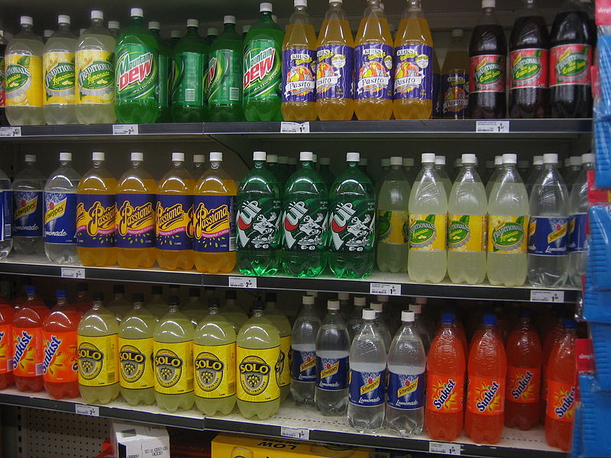

Using paper chromatography
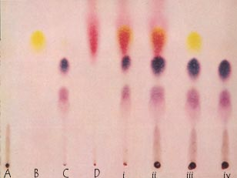
Chromatography is a technique used to separate non-volatile mixtures.
It works by exploiting different interactions between the dyes and the two components of the chromatography setup.
There are two main components in chromatography
A mixture of dyes is placed on some chromatography paper and a solvent is allowed to run up/along the paper carrying the different dyes different distances.
The stationary phase – this does not move and the liquids pass through it. (In ordinary paper chromatography, the paper is the stationary phase.)
The mobile phase – this is the fluid that moves through the stationary phase (like the water through filter paper)

Notes
Pencil is always used to mark a chromatography paper because ink may run and interfere with the chromatogram.
You may need to apply the colour for separation several times in order to get a strong enough colour to separate well. If so, allow each one to dry before applying the next drop – otherwise the drop will expand too much and blur the separation
Ensure the spot is dry before running the chromatogram. (Unless the solvent used for extraction is the same as the mobile phase solvent) Otherwise the composition of the solvent will be altered as it passes through the drop possibly compromising its effectiveness.
Make sure the spot is above the level of the solvent – otherwise the solvent will simply wash it off into the solution.
It is important to make sure the solvent is level and not at an angle so you do not get an angled solvent front.
Do not allow the sides of the paper to touch the sides of the container as that can make the solvent front run crookedly.

Equipment and materials
Materials required by each student/group:
1 sheet of chromatography paper | a small glass bottle
a rubber stopper for bottle with a slit about 3 mm deep along its narrow end | Capillary tube
pencil | ruler
Chromatography solvent - sodium chloride solution 0.1M | Samples of your extracted colours and reference ones
Instructions
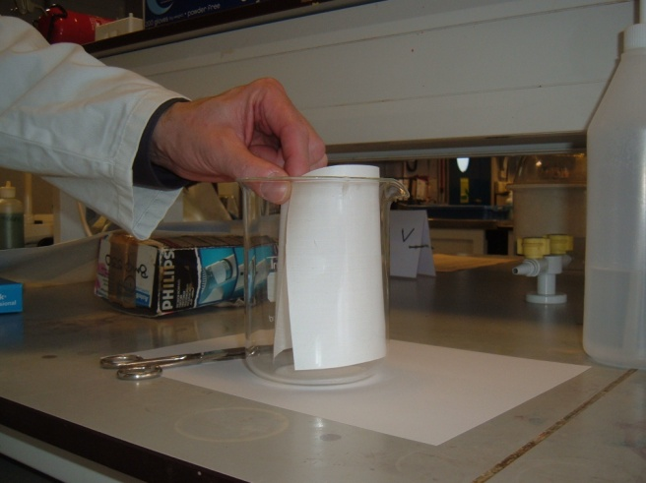
A Preparing the chromatography paper
- Take the sheet of chromatography paper. Cut the paper so that if fits into the beaker without touching the sides (see diagram below)

- Using a ruler, draw a light pencil line across the paper about 2.0cm from the bottom of the sheet (see diagram below)
- Draw dots or crosses along this line 2cm apart (see diagram below)
- Mark above each dot the numbers 1-8, which correspond to the colour standard numbers from the kit.
- Leave the middle dot and mark as “sample”.
1 2 3 4 sample 5 6 7 8
Dots or crosses 2cm apart
Pencil line 2cm up

B spotting the chromatography paper
- Using a capillary tube, apply a small spot of the unknown colour mixture (the extracted colour in the beaker) on the pencil line at the centre dot on the paper. (The colour spot should not exceed about 0.4 cm in diameter.)
- If the spot seems to be too small or too light in colour, you can make it darker by applying a second spot of colour (or more) directly on top of the dry first one.
(It is necessary to allow the spot to dry between applications of colour in order to keep it small in size.)
- Spot the paper with each of the available standard colours, allowing about 2.0 cm minimum distances between each different spot. Ensure the colour standards you apply match the number you have written in pencil at the top of the paper above each spot.
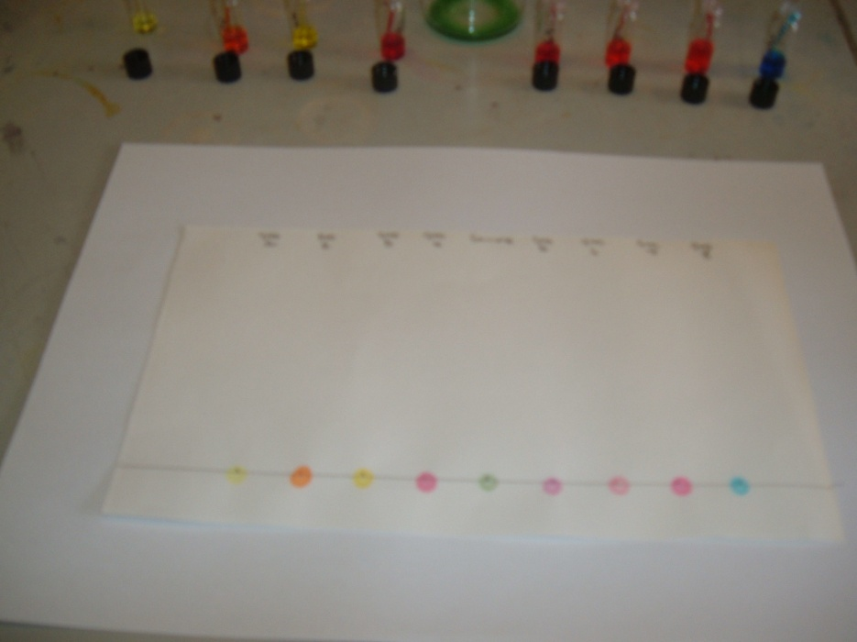

Prepared chromatography paper with spotting

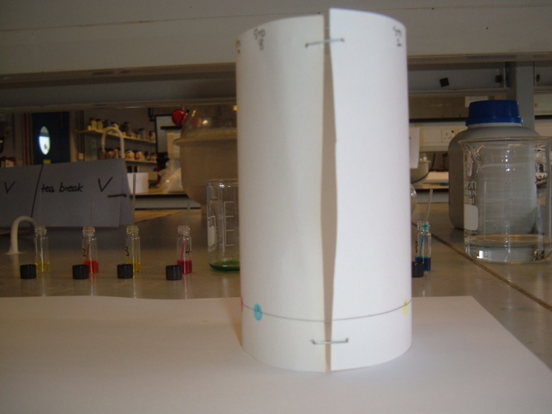
C Preparing the solvents
- Add 1% Sodium Chloride solution to a clean 600 ml beaker, to a depth of about 0.5 cm (this will require approximately 25 ml of solution).
- Bend the spotted chromatography paper into a cylindrical shape, butt the ends together (do not overlap the ends) and staple them as shown.
D Running the chromatogram
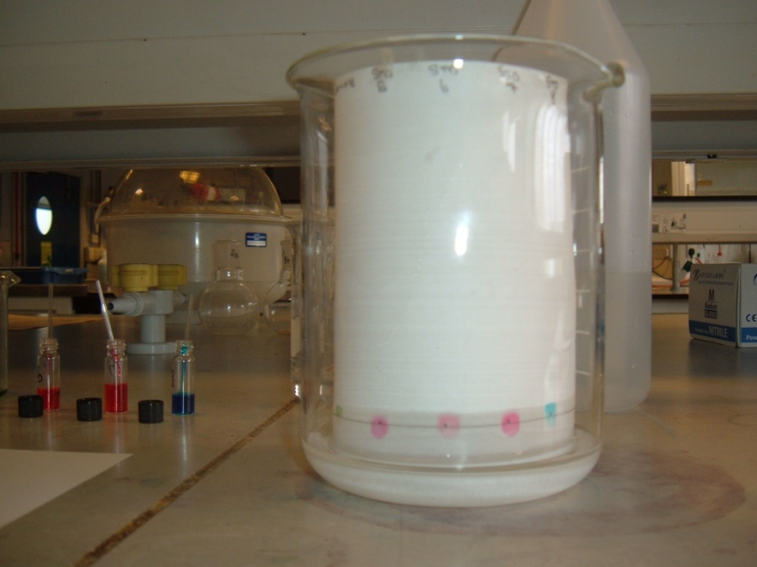
- Place the chromatography paper into the beaker making sure that the spots of dye are NOT below the 1% Sodium Chloride solution level and that the paper is NOT touching the sides of the beaker.

Important – make sure the spots you have made are ABOVE the level of the solution

- Cover the beaker a watch glass. (or some clingfilm) (See diagram below)
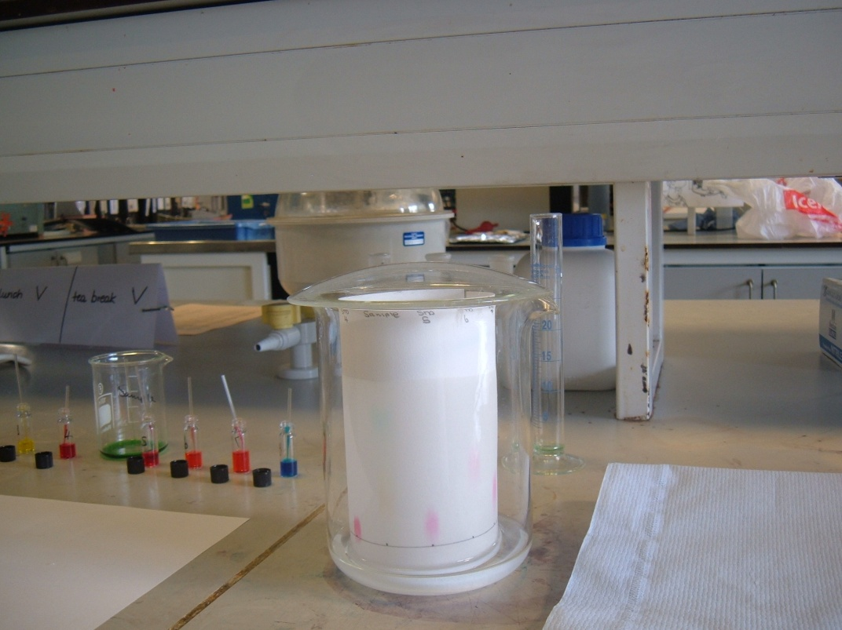

Watchglass covering beaker

- Allow the 1% solution of Sodium Chloride to move up the paper to within 1 cm of the top (this will take anywhere from 15 to 35 minutes).

E Collecting the results
- Remove the paper from the beaker, open it flat, and, using a pencil, mark the solvent front (the furthest level reached by the solvent).

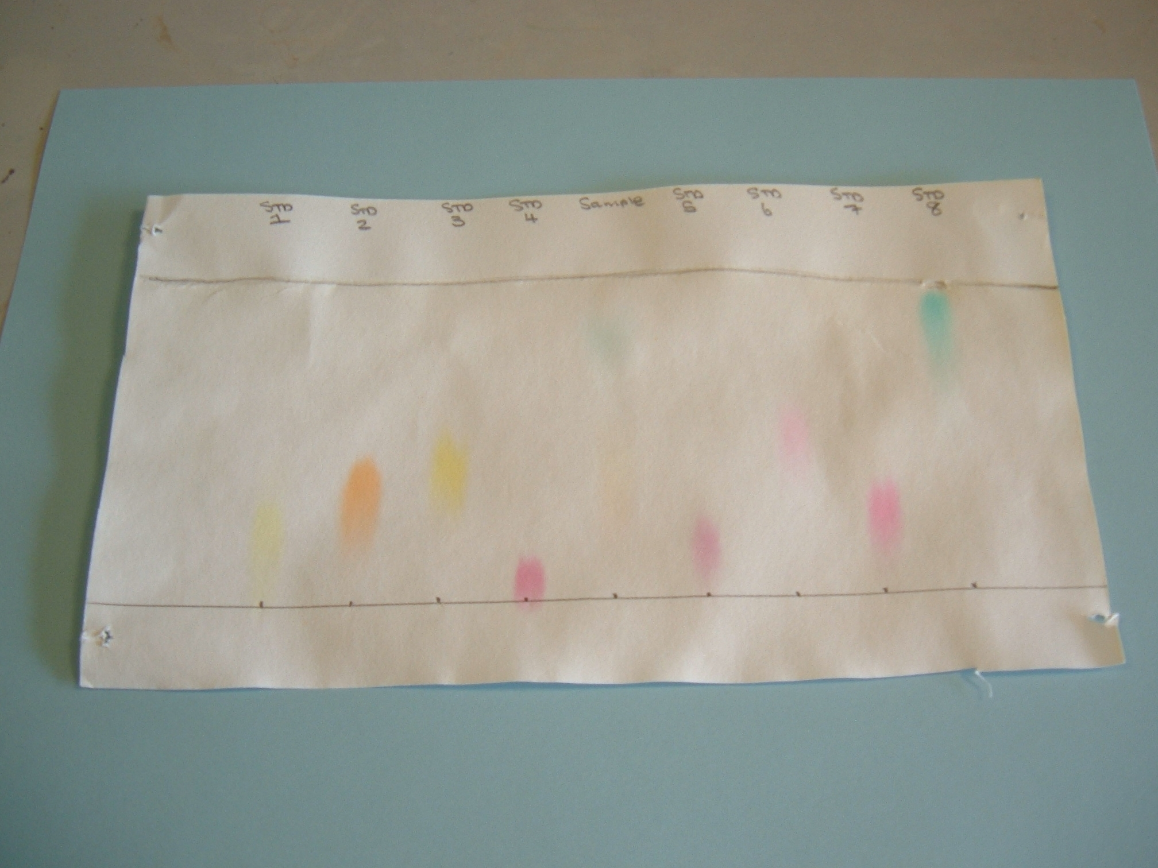
solvent front
outline of spot
Distance 1
Distance 2
origin

- Lay the chromatography paper on a paper towel to dry.
- Outline each spot on the chromatography paper in pencil. Measure and record the average distance from the spot or cross on the pencil line to the solvent front (shown above as Distance 1).
Record your results.
Measure and record the distance each spot moved from the origin in the table below (Shown above as distance 2).
This is used to work out the Rf values for each spot.
Remember you may have more than one spot in the unknown mixture and a measurement in cm should be obtained for each.

Results
Spot | Average distance from solvent front (cm) | Average distance from origin (cm)
Ref 1
Ref 2
Ref 3
Ref 4
Sample 1
Sample 2
Sample 3
Sample 4
Ref 5
Ref 6
Ref 7
Ref 8

INTERPRETATION OF RESULTS
By matching both the visual colour and the Rf value of each of the spots, you can determine the identity of the colours you extracted from the soft drink.
Save the chromatogram to hand in with your laboratory report.
CLEAN UP
Clean up all the glassware with soapy water.

Calculations
The Rf value for a spot is calculated using the formula:
The Rf value = Distance spot moved in cm / distance from origin to solvent front in cm
e.g. If your table shows

Ref 1 | 25 | 10

Then you Rf value will be 10/25 which will be 0.4
The Rf value will always be a decimal fraction.

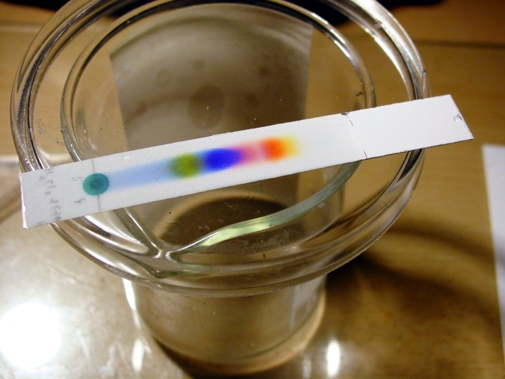
Using thin-layer chromatography
Thin-layer chromatography (TLC) is a chromatography technique used to separate non-volatile mixtures.
Thin-layer chromatography is performed on a sheet of glass, plastic, or aluminium foil, which is coated with a thin layer of adsorbent material, usually silica gel, aluminium oxide, or cellulose.
This layer of adsorbent is known as the stationary phase and performs the same function as the paper in more traditional paper chromatography.
After the sample has been applied on the plate, a solvent or solvent mixture (known as the mobile phase) is drawn up the plate by capillary action.
Because different chemicals travel up the TLC plate at different rates, separation is achieved.
Notes
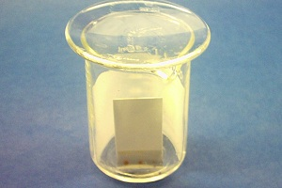
Pencil is always used to mark a chromatography plate (or paper) because ink may run and interfere with the chromatogram.
You may need to apply the colour for separation several times in order to get a strong enough colour to separate well. If so, allow each one to dry before applying the next drop – otherwise the drop will expand too much and blur the separation
Ensure the spot is dry before running the TLC plate. (Unless the solvent used for extraction is the same as the mobile phase solvent) Otherwise the composition of the solvent will be altered as it passes through the drop possibly compromising its effectiveness.
Make sure the spot is above the level of the solvent – otherwise the solvent will simply wash it off into the solution.
It is important to make sure the solvent is level and not at an angle so you do not get an angled solvent front.
Do not allow the sides of the TLC plate to touch the sides of the container as that can make the solvent front run crookedly.
Equipment and materials
Materials required by each student/group:
a TLC plate 66mm x 12mm | a small glass bottle
a rubber stopper for bottle with a slit about 3 mm deep along its narrow end | Capillary tube
pencil | ruler
Chromatography solvent - sodium chloride solution 0.1M | Samples of your extracted colours and reference ones
Instructions
- With a pencil mark a line across the TLC strip 10mm from one end. Mark a pencil dot in the middle of this line.
- Now measure 45mm from this line and draw another pencil line across the TLC.
Fit the TLC strip into the slit in the stopper with the line with the dot furthest from the stopper.
- Put it into the empty glass bottle. Mark the bottle about 5mm below the level of the pencilled dot and then remove the TLC strip from the stopper.
- Carefully pour solvent into the small glass tube up to this mark and replace the stopper without the TLC strip.
- Use the capillary tube to transfer tiny amounts of dye extract to the pencil dot on the TLC strip. Repeat this several times, drying between each application, until a dark spot is formed.
- Ensure the TLC strip is completely dry by placing it in a stream of hot air from the hair dryer for about 30 seconds.
- Remove the stopper from the bottle and attach the TLC strip (again with the pigment dot furthest from the stopper).
- Quickly return the stopper with attached TLC strip back inside the bottle making sure that:
  - the bottle is sitting upright and not at an angle
  - the green spot is above the solvent
  - the TLC strip is not touching the sides of the glass tube
- Watch the solvent move up the strip causing the leaf pigments to separate. Do not move the bottle as the solvent is running. (Why?)
- When the solvent reaches the second pencil line remove the TLC strip and immediately using a pencil mark the top end of any pigments visible.
- Calculate the Rf value for each pigment using the formula:
Rf = distance run by pigment (distance from pencil dot to top end of pigment)
distance run by solvent (should be distance between the two pencil lines)
- Identify the principal pigments using the table of Rf values below.

Results
Spot | Average distance from solvent front (cm) | Average distance from origin (cm)
Ref 1
Ref 2
Ref 3
Ref 4
Sample 1
Sample 2
Sample 3
Sample 4
Ref 5
Ref 6
Ref 7
Ref 8

INTERPRETATION OF RESULTS
By matching both the visual colour and the Rf value of each of the spots, you can determine the identity of the colours you extracted from the soft drink.
Save the chromatogram to hand in with your laboratory report.
CLEAN UP
Clean up all the glassware with soapy water.

Calculations
The Rf value for a spot is calculated using the formula:
The Rf value = Distance spot moved in cm / distance from origin to solvent front in cm
e.g. If your table shows

Ref 1 | 25 | 10

Then you Rf value will be 10/25 which will be 0.4
The Rf value will always be a decimal fraction.

