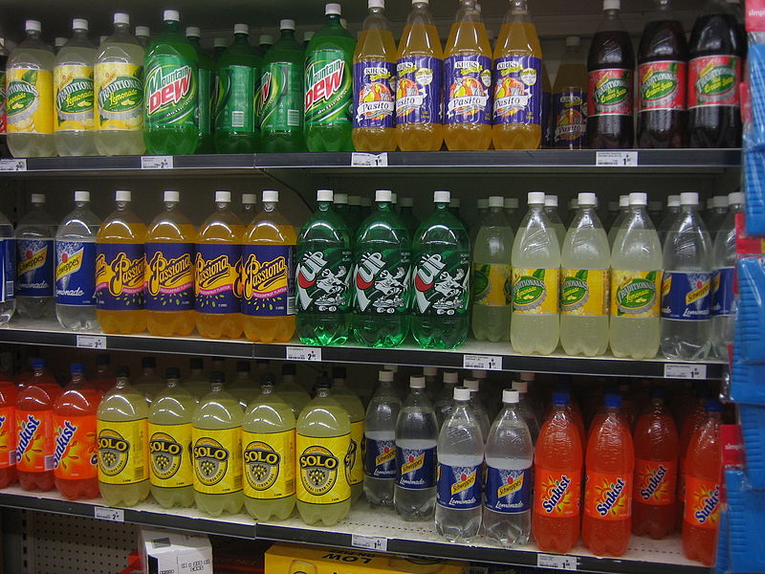
Introduction
Chromatography is a technique used to separate non-volatile mixtures.
It works by exploiting different interactions between the dyes and the two components of the chromatography setup.
There are two main components in chromatography
The stationary phase – this is the (usually solid) base that does not move and the liquids pass through it.
The mobile phase – this is the fluid, containing the substances to be separated, that moves through the stationary phase
There are many different forms of chromatography. A rather complex form has been used to extract and concentrate the colours – see the teacher’s guide for the separation of colours for details of how this works.
For the analysis, we are using some simpler techniques: either paper chromatography or thin-layer chromatography.
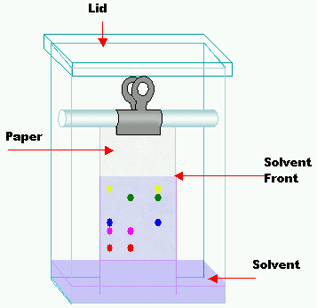
Paper chromatography
A coloured chemical sample is placed on a filter paper.
One end of the paper is placed in a solvent.
The solvent diffuses up the paper, dissolving the various molecules in the sample according to the polarities of the molecules and the solvent.
If the sample contains more than one colour, that means it must have more than one kind of molecule.
Because of the different chemical structures of each kind of molecule, the chances are very high that each molecule will have at least a slightly different polarity, giving each molecule a different solubility in the solvent.
The unequal solubilities cause the various colour molecules to leave solution at different places as the solvent continues to move up the paper.
The more soluble a molecule is, the higher it will migrate up the paper. If a chemical is very nonpolar it will not dissolve at all in a very polar solvent. This is the same for a very polar chemical and a very nonpolar solvent.
Thin-layer chromatography
The process is similar to paper chromatography with the advantage of faster runs, better separations, and the choice between different stationary phases. It is performed on a sheet of glass, plastic, or aluminium foil, which is coated with a thin layer of adsorbent material, usually silica gel, aluminium oxide or cellulose.
To run a thin layer chromatography, the following procedure is carried out:
A small spot of solution containing the sample is applied to a plate, about 1.5 cm from the bottom edge.
The solvent is allowed to completely evaporate off, otherwise a very poor or no separation will be achieved.
A small amount of an appropriate solvent is poured into a glass beaker or any other suitable transparent container (separation chamber) to a depth of less than 1 cm.
A strip of filter paper is put into the chamber so that its bottom touches the solvent and the paper lies on the chamber wall and reaches almost to the top of the container. The container is closed with a cover glass or any other lid and is left for a few minutes to let the solvent vapours ascend the filter paper and saturate the air in the chamber. (Failure to saturate the chamber will result in poor separation and non-reproducible results).
The TLC plate is then placed in the chamber so that the spot(s) of the sample do not touch the surface of the solvent in the chamber, and the lid is closed.
The solvent moves up the plate by capillary action, meets the sample mixture and carries it up the plate.
The plate should be removed from the chamber before the solvent front reaches the top of the stationary phase (continuation will give a misleading result) and dried.

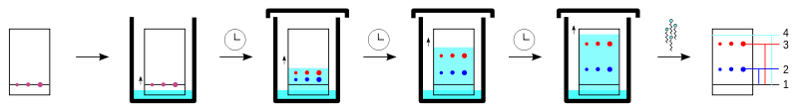
Notes
Pencil is always used to mark chromatography paper or TLC plates because ink may run and interfere with the chromatogram.
You may need to apply the colour for separation several times in order to get a strong enough colour to separate well. If so, allow each one to dry before applying the next drop – otherwise the drop will expand too much and blur the separation
For a TLC plate, you need very small drops so use a micro capillary or a micro-pipette
Ensure the spot is dry before running the chromatogram. (Unless the solvent used for extraction is the same as the mobile phase solvent) Otherwise the composition of the solvent will be altered as it passes through the drop possibly compromising its effectiveness.
Make sure the spot is above the level of the solvent – otherwise the solvent will simply wash it off into the solution.
It is important to make sure the solvent is level and not at an angle so you do not get an angled solvent front.
Do not allow the sides of the paper to touch the sides of the container as that can make the solvent front run crookedly.
As soon as the paper/plate is taken out, mark the solvent front with a pencil before the solvent evaporates and the front becomes impossible to see.

R_{f} values
The retardation factor (R_{f} factor) is the ratio of the distance travelled by the centre of a spot to the distance travelled by the solvent front
Calculate the Rf value for each pigment using the formula:
Rf = distance run by pigment (distance from pencil dot to top end of pigment)
distance run by solvent (should be distance between the two pencil lines)

The Experiment
In the UK, over recent years there has been a big move away from using artificial colours in general and in soft drinks in particular. It is harder to extract some of these natural colourants and also to find other information about them.
So the experiment requires a soft drink sample (or several) to be ‘spiked’ with an artificial colouring. It is possible to get suitable food colours from many Chinese supermarkets (online if you do not have one near you). Add at a rate of about 1 – 2g per litre. (Details in Technicians guide for extraction of colour).
Reference Samples
To identify the dyes, they need to be compared to reference samples. Ideally these should be run at the same time as variations between chromatograms can mean that any values may not be quite the same as published values.

Equipment and materials
Materials required by each student/group:
1 sheet of chromatography paper | a small glass bottle
a rubber stopper for bottle with a slit about 3 mm deep along its narrow end | Capillary tube
pencil | ruler
Chromatography solvent - sodium chloride solution 0.1M | Samples of your extracted colours and reference ones
Instructions
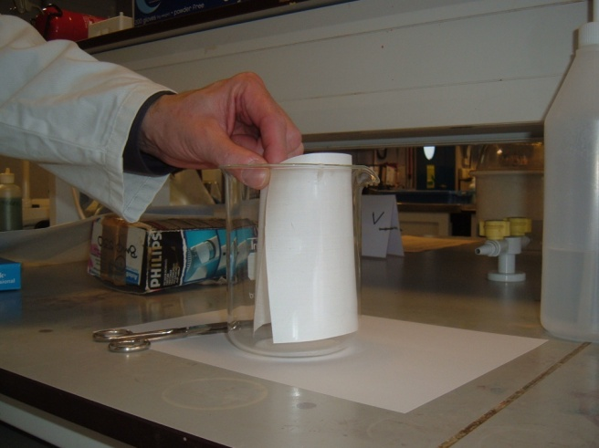
A Preparing the chromatography paper
- Take the sheet of chromatography paper. Cut the paper so that if fits into the beaker without touching the sides (see diagram below)

- Using a ruler, draw a light pencil line across the paper about 2.0cm from the bottom of the sheet (see diagram below)
- Draw dots or crosses along this line 2cm apart (see diagram below)
- Mark above each dot the numbers 1-8, which correspond to the colour standard numbers from the kit.
- Leave the middle dot and mark as “sample”.
1 2 3 4 sample 5 6 7 8
Dots or crosses 2cm apart
Pencil line 2cm up

B spotting the chromatography paper
- Using a capillary tube, apply a small spot of the unknown colour mixture (the extracted colour in the beaker) on the pencil line at the centre dot on the paper. (The colour spot should not exceed about 0.4 cm in diameter.)
- If the spot seems to be too small or too light in colour, you can make it darker by applying a second spot of colour (or more) directly on top of the dry first one.
(It is necessary to allow the spot to dry between applications of colour in order to keep it small in size.)
- Spot the paper with each of the available standard colours, allowing about 2.0 cm minimum distances between each different spot. Ensure the colour standards you apply match the number you have written in pencil at the top of the paper above each spot.
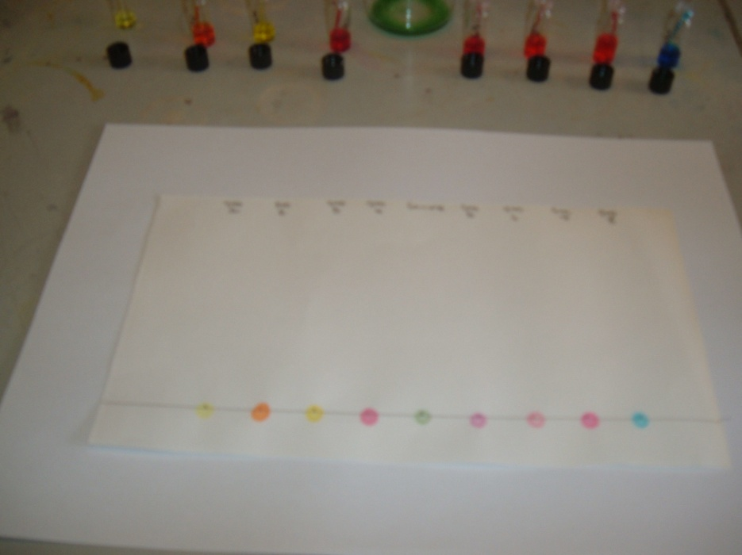

Prepared chromatography paper with spotting

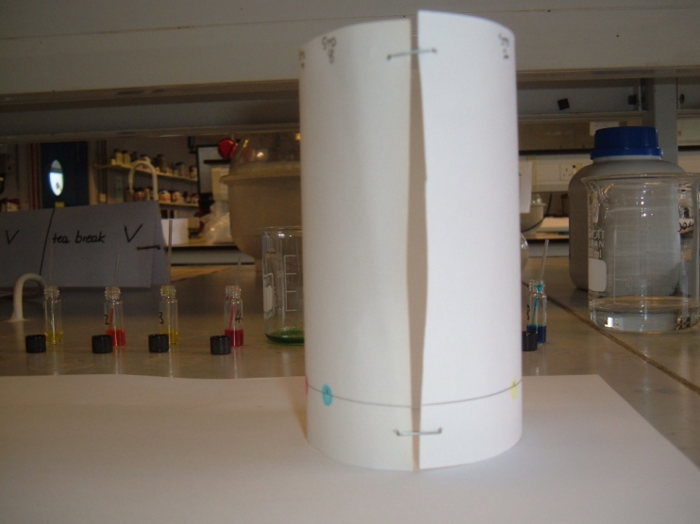
C Preparing the solvents
- Add 1% Sodium Chloride solution to a clean 600 ml beaker, to a depth of about 0.5 cm (this will require approximately 25 ml of solution).
- Bend the spotted chromatography paper into a cylindrical shape, butt the ends together (do not overlap the ends) and staple them as shown.
D Running the chromatogram
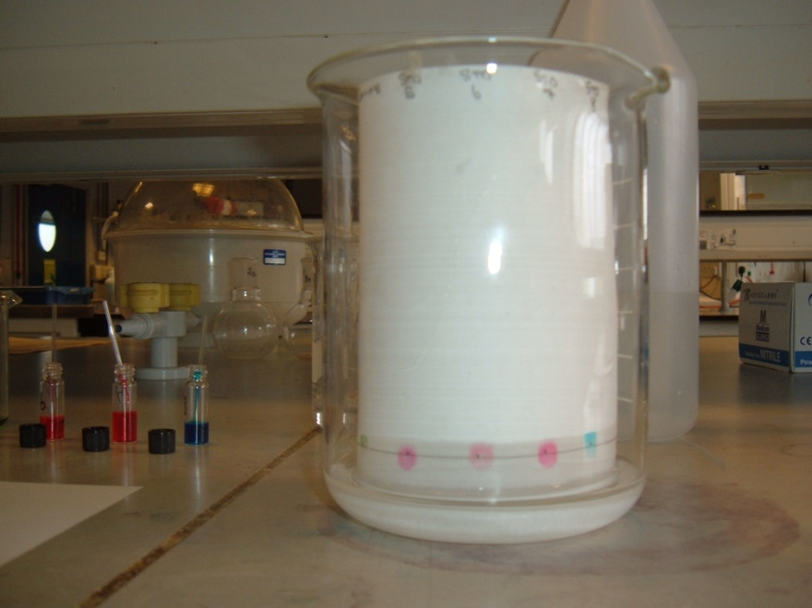
- Place the chromatography paper into the beaker making sure that the spots of dye are NOT below the 1% Sodium Chloride solution level and that the paper is NOT touching the sides of the beaker.

Important – make sure the spots you have made are ABOVE the level of the solution

- Cover the beaker a watch glass. (or some clingfilm) (See diagram below)
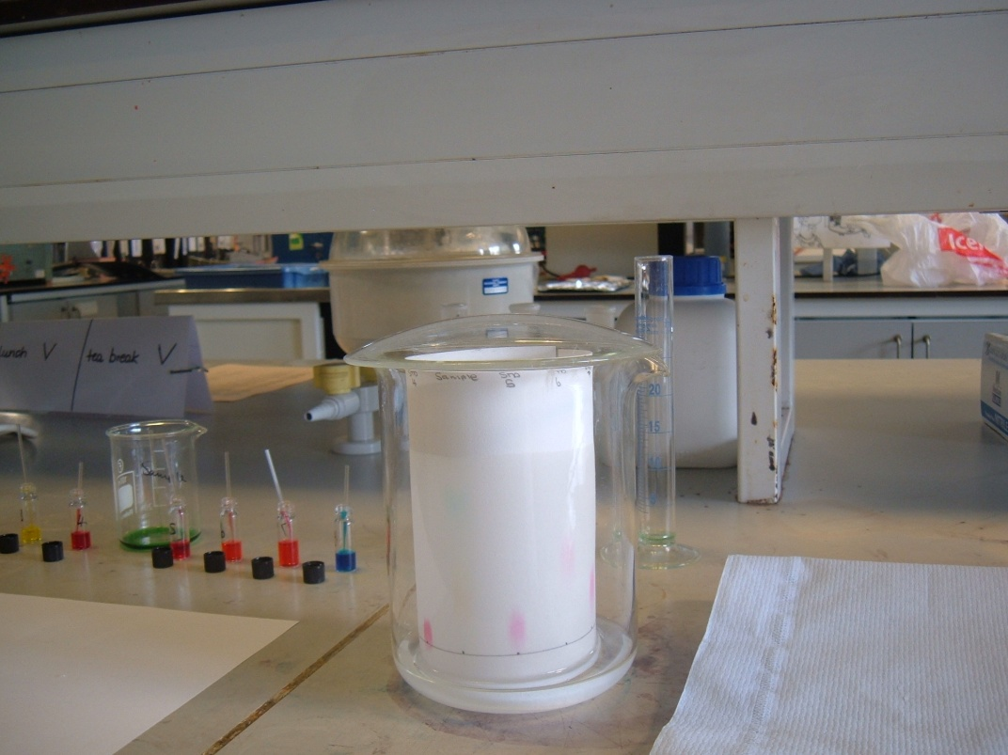

Watchglass covering beaker

- Allow the 1% solution of Sodium Chloride to move up the paper to within 1 cm of the top (this will take anywhere from 15 to 35 minutes).

E Collecting the results
- Remove the paper from the beaker, open it flat, and, using a pencil, mark the solvent front (the furthest level reached by the solvent).

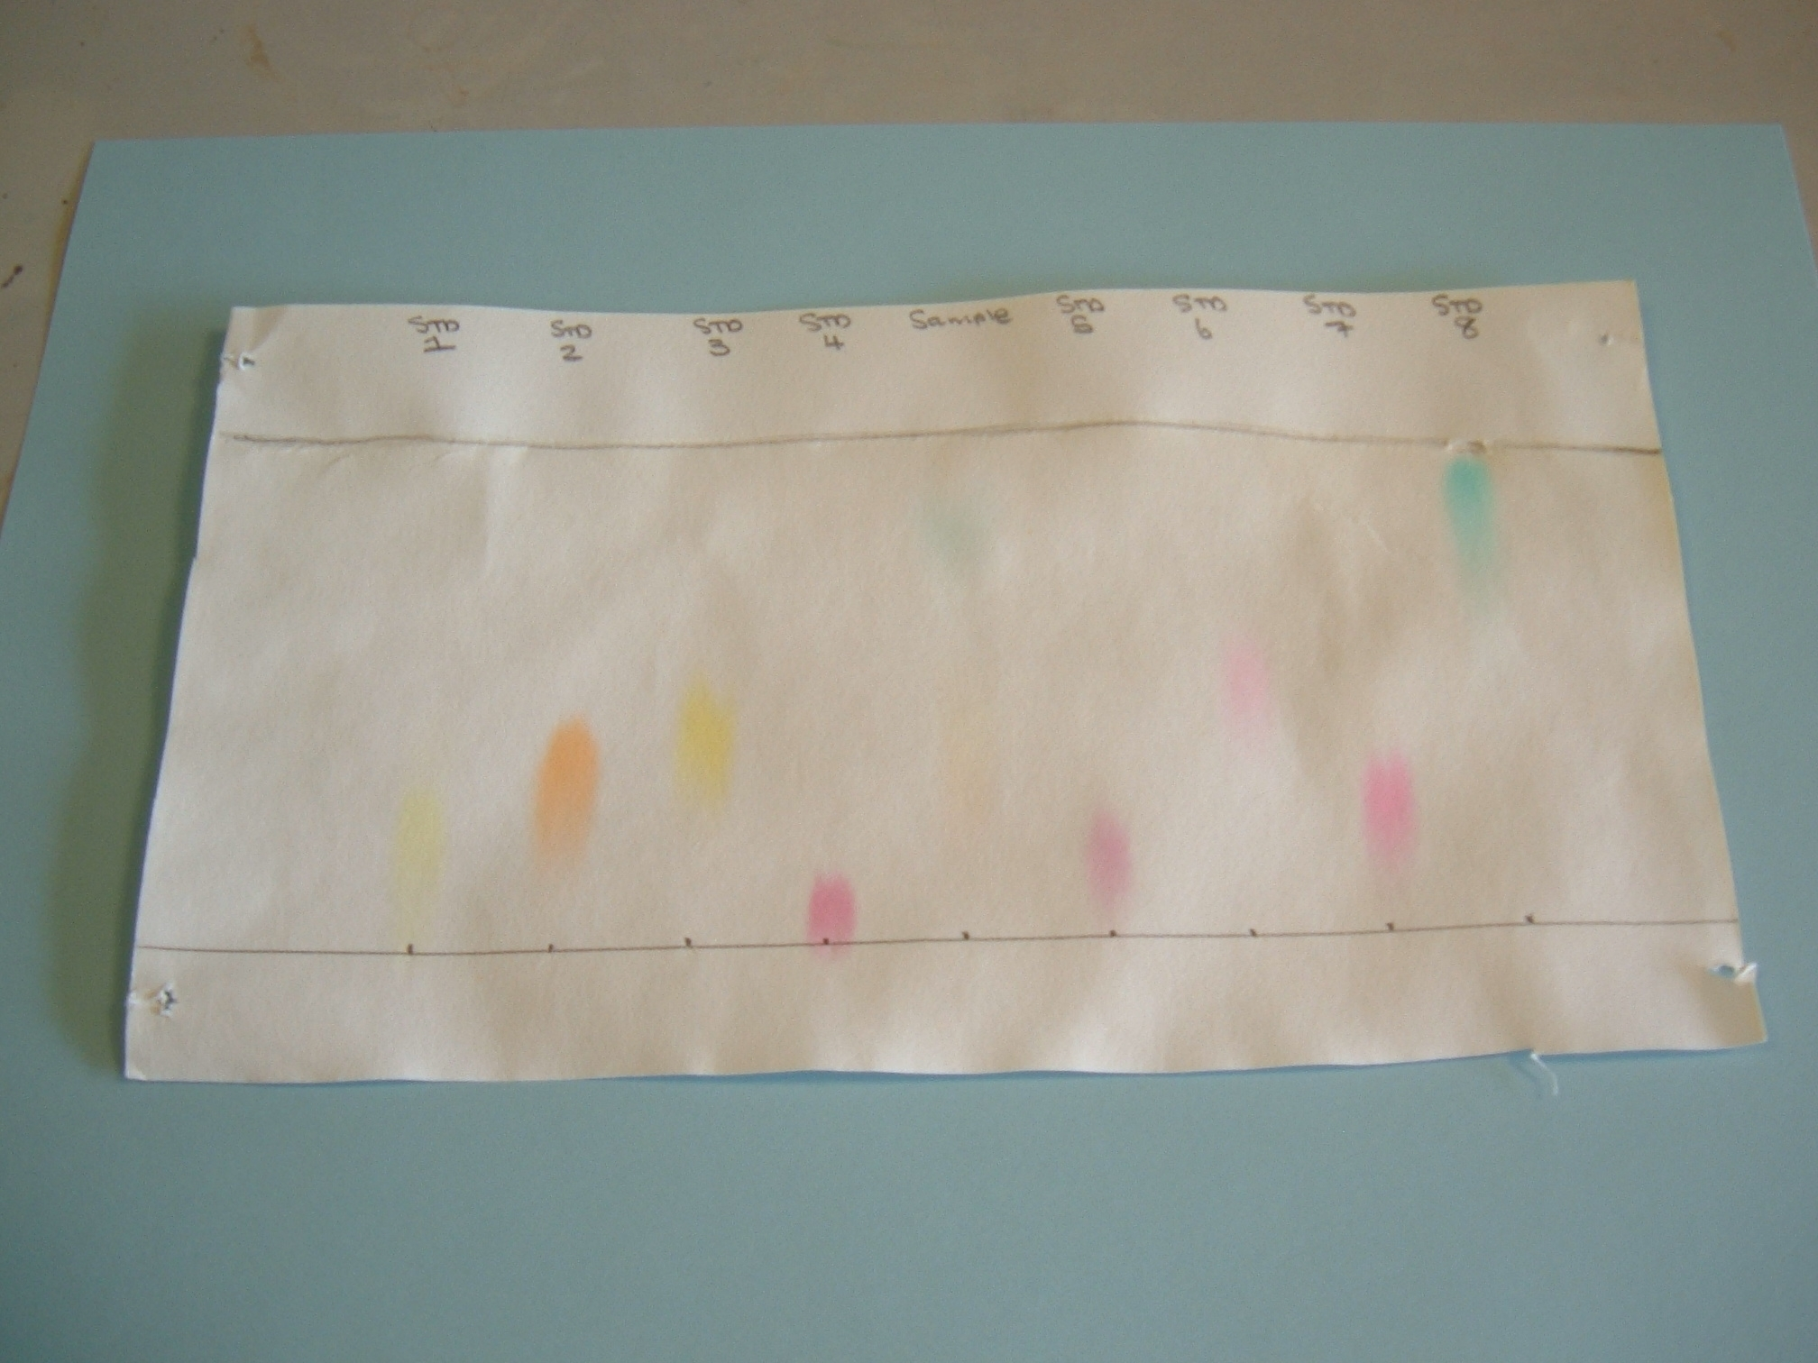
solvent front
outline of spot
Distance 1
Distance 2
origin

- Lay the chromatography paper on a paper towel to dry.
- Outline each spot on the chromatography paper in pencil. Measure and record the average distance from the spot or cross on the pencil line to the solvent front (shown above as Distance 1).

Pupils then record their results and calculate R_{f} values

thin-layer chromatography
Equipment and materials
Materials required by each student/group:
a TLC plate 66mm x 12mm | a small glass bottle
a rubber stopper for bottle with a slit about 3 mm deep along its narrow end | Capillary tube
pencil | ruler
Chromatography solvent - sodium chloride solution 0.1M | Samples of your extracted colours and reference ones
Instructions
- With a pencil mark a line across the TLC strip 10mm from one end. Mark a pencil dot in the middle of this line.
- Now measure 45mm from this line and draw another pencil line across the TLC.
Fit the TLC strip into the slit in the stopper with the line with the dot furthest from the stopper.
- Put it into the empty glass bottle. Mark the bottle about 5mm below the level of the pencilled dot and then remove the TLC strip from the stopper.
- Carefully pour solvent into the small glass tube up to this mark and replace the stopper without the TLC strip.
- Use the capillary tube to transfer tiny amounts of dye extract to the pencil dot on the TLC strip. Repeat this several times, drying between each application, until a dark spot is formed.
- Ensure the TLC strip is completely dry by placing it in a stream of hot air from the hair dryer for about 30 seconds.
- Remove the stopper from the bottle and attach the TLC strip (again with the pigment dot furthest from the stopper).
- Quickly return the stopper with attached TLC strip back inside the bottle making sure that:
  - the bottle is sitting upright and not at an angle
  - the green spot is above the solvent
  - the TLC strip is not touching the sides of the glass tube
- Watch the solvent move up the strip causing the leaf pigments to separate. Do not move the bottle as the solvent is running. (Why?)
- When the solvent reaches the second pencil line remove the TLC strip and immediately using a pencil mark the top end of any pigments visible.
- Calculate the Rf value for each pigment using the formula:
Rf = distance run by pigment (distance from pencil dot to top end of pigment)
distance run by solvent (should be distance between the two pencil lines)
- Identify the principal pigments using the table of Rf values below.

Pupils then record their results and calculate R_{f} values

Paper chromatography
Equipment | Amount needed for class of 10 groups | Comments
1 sheet of chromatography paper | 10 | Filter paper can be used as long as it is of good quality
pencil & ruler | 10
Chromatography solvent - sodium chloride solution 0.1M (approximately 25 cm³) | approximately 250 cm³
Capillary tubes (1 per sample) | (10 per sample) | It is possible to use each end of the tubes for different samples.  For paper chromatography, you can also use a Pasteur pipette – use a glass one with a fine point.
Samples of your extracted colours and reference ones
Watch glass / clingfilm | 10 | Some way of covering the beaker to keep the humidity level high.

The size of the sheet of chromatography paper, and thus the beaker it is in, will depend on the number of samples each group is running.

Thin-layer chromatography
Equipment | Amount needed for class of 10 groups | Comments
a TLC plate 66mm x 12mm | 10 | The size is not crucial
a rubber stopper for bottle with a slit about 3 mm deep along its narrow end | 10 | Or any other equipment that is normally used for running TLC plates
pencil & ruler | 10
Chromatography solvent - sodium chloride solution 0.1M (Volume will depend on the size of the container)
a small glass bottle |  | Or other tank normally used for running TLC plates
Capillary tube or micropipette | 10 (per sample) | It is possible to use each end of capillary tubes for different samples
Samples of your extracted colours and reference ones

