**Enthalpy**

Teacher / Technician Guide

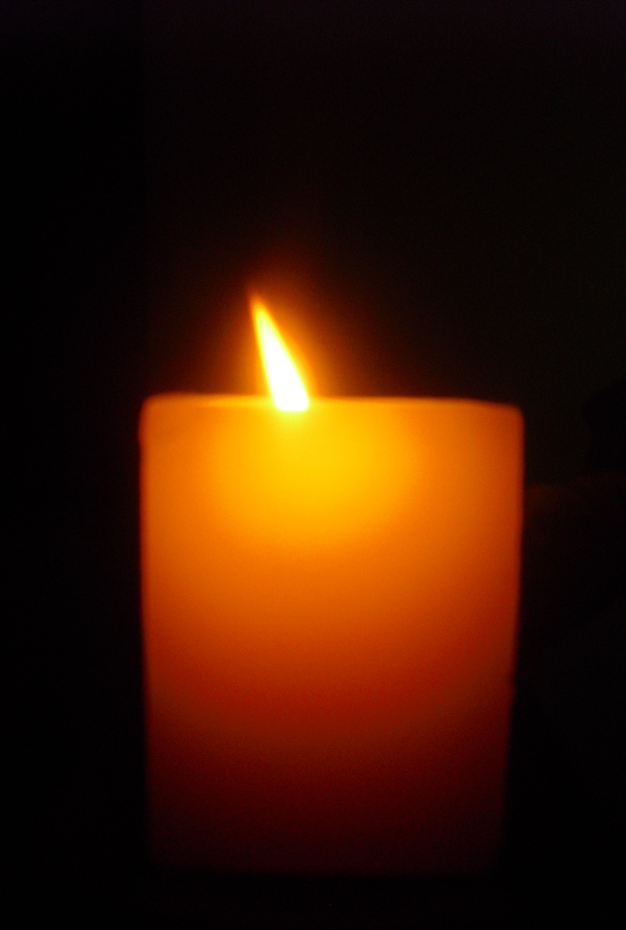

**Researching Chemistry**

**Higher**





Higher Physics Topical Investigation Skin Cancer—Prevention and Cure

2

**Investigation Brief**

Suntan creams stop harmful UV radiation reaching the skin. Manufacturers’ products are rated with a Sun Protection Factor (SPF). Suntan creams can have SPF values from 6 to over 50.

UV radiation monitors normally measure irradiance in output intensity per unit area. Thus, a typical low intensity UV lamp may emit approximately 10 mWcm-2.

The aim of this investigation is to determine the effect of various suntan creams on the transmission of UV radiation. In particular, the relationship between SPF and absorption should be found.

**Investigation Notes**

UV lamps can be harmful. Make sure that you read the safety leaflet which is supplied with the UV lamp. Some cheap UV monitors do not measure the irradiance of UV radiation. Rather, they give an indication of UV index. It is possible to undertake this investigation with such a monitor, but results will be less reliable and accurate. UV radiation does not pass through many transparent materials (including glass). However, UV transparent acrylics are readily available.

3

**Contents**

**Teachers Guide**

Page 3 Introduction

Page 4 The assignment

Page 6 The investigation

Page 8 Background chemistry

Page 11 Some resources to help with students research

Page 12 Experimental methods

Page 14 Sample results

**Technicians guide**

Page 19 Technicians Guide

Page 20 Risk Assessment

.

**Introduction**

Aim:

The assignment requires candidates to apply skills, knowledge and understanding to investigate a relevant topic in Chemistry.

This resource pack contains suggested investigative practical work for the following key area :

Unit : Chemistry in Society

Mandatory Course Key Area: Chemical Energy

Teachers should feel free to edit these investigations to suit the needs of their own students. For example, some teachers may wish to remove some of the experimental instructions from the student guides to make the planning process more challenging for able students.

Additionally, the list of investigations is by no means exhaustive; teachers are free to develop their own alternative investigation topics to enhance the experience for students. It is the assessor’s responsibility to ensure that the chosen topic will allow the candidate to provide evidence of an appropriate standard to achieve the full range of marks available.

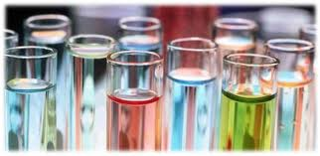

**The Assignment**

**The assignment has two stages:**

* Research stage
* Communication stage

The research stage involves gathering information/data from the internet, books, newspapers, journals, experiment/practical activity or any other appropriate source. Candidates must select, use and record their referenced sources.

Group work approaches are acceptable as part of the research stage when gathering information/data or undertaking an experiment/practical activity, but assessors must ensure that candidates are able individually to meet the evidence requirements of this assessment.

In the course of their assignment, candidates are required to:

* choose a relevant topic in chemistry (the assessor must review the appropriateness of the topic chosen)
* state appropriate aim (s)
* research the topic by selecting relevant data/information
* carry out risk assessment of procedure
* process and present relevant data/information
* analyse data/information
* state conclusions
* evaluate their investigation
* explain the underlying chemistry of the topic researched
* present the findings of the research in a report

The evidence for this assignment will consist of the report. Of the total of **20 marks** available for the assignment, the marking instructions provide **16 marks** for skills and **4 marks** for knowledge and understanding. The table below shows how these marks are allocated to each of the criteria against which the evidence will be assessed.

|  |  |
| --- | --- |
| Criteria | Mark allocation |
| Aim(s) | 1 |
| Applying knowledge and understanding of chemistry | 4 |
| Selecting information | 2 |
| Risk assessment | 1 |
| Processing and presenting data/information | 4 |
| Analysing data/information | 2 |
| Conclusion(s) | 1 |
| Evaluation | 3 |
| Presentation | 2 |

Detailed marking instructions for the Higher Assignment can be found using the following link:

<http://www.sqa.org.uk/files_ccc/GAInfoHigherChemistry.pdf>

**The investigations**

This enthalpy of neutralisation support pack for Researching Chemistry provides suggested investigative practical work for chemistry teachers as they plan learning and teaching for the assignment at Higher level.

There are three practical investigations labelled A-C below. It may be that the student investigates one or that students work in small groups and collate results at the end of the practical work. This will allow students to have raw data to help investigate focus questions provided.

It is vital that teachers ensure that pupil’s research and write up of the investigation is their own work (with the exception of raw data/results).

Industrial processes are designed to maximise profit and minimise the impact on the environment. Energy requirements would be a factor that industrial chemists would consider.

|  |  |
| --- | --- |
| Investigation | Title |
| A | Study the role of enthalpy in influencing the design of a chemical reaction. Find and compare the enthalpy of neutralisation for the **strong acid**s ( HCl,H2SO4 and HNO3 ) using Na OH as the **strong base**. |
| B | Study the role of enthalpy in influencing the design of a chemical reaction. Find the enthalpy of neutralisation for a **weak acid (ethanoic acid) and NaOH** and a **weak base(ammonia solution) with HCl** and compare these values to theory based data for **strong acids /bases reacting with strong acids/bases.** |
| C | Study the role of enthalpy in influencing the design of a chemical reaction. Find the enthalpy of neutralisation for a variety of combinations of **strong acid/base** and **weak acid/base** by experiment and calculation. |

Focus questions to consider:

1. Why do strong acids reacting with strong bases give closely similar values?
2. Why do these neutralisation reactions have values which differ from those involving strong acids or bases?
3. Investigate the enthalpy of neutralisation and explain differences in the values using a variety of lab strong/weak acids and strong/weak bases.

**Prior learning**

Learners will be expected to be familiar with the Key Area: Chemical Energy.

This learning journey should include enthalpy calculations used for industrial processes. The specific heat capacity, mass, temperature and moles used to calculate the enthalpy change for a reaction.

As a general introduction for this key area and the practical investigations, the specific links below could be used.

TWIG [http://www.twigonglow.com/films/energy-change-of-reactions-1450/](http://www.twigonglow.com/films/energy-change-of-reactions-1450/is)

<http://www.gcsescience.com/rc24-energy-level-diagram.htm>

<http://chemwiki.ucdavis.edu/Physical_Chemistry/Thermodynamics/Calorimetry/Application_of_calorimetry>

<http://www.bbc.co.uk/bitesize/higher/chemistry/calculations_1/potential_energy/revision/4/>

**Background Chemical Theory**

All chemical reactions involve energy changes. The study of energy changes is an important part of chemistry. Fundamental to the thermo-chemistry is the law of conservation of energy, which states that the energy is neither created or destroyed, but can be converted from one form to another.

**For industrial processes, it is essential that chemists can predict the quantity of heat energy taken in or given out. If reactions are endothermic, costs will be incurred in supplying heat energy in order to maintain the reaction rate. If reactions are exothermic, the heat produced may need to be removed to prevent the temperature rising.**

**Endothermic Reaction.**

Endothermic reactions are those that absorb heat energy. Energy is needed to break apart the bonds of the reactants and this is greater than the energy released when the chemicals recombine to form products. Hence the enthalpy of products is greater than that of the reactants, as indicated in this energy profile below.

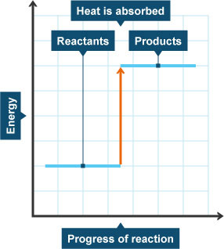

.

**Exothermic Reaction**

An exothermic reaction is one in which stored chemical energy is converted to heat energy (heat is released to the surroundings). Some energy is needed to start the reaction, to break apart the bonds of reacting compounds ( the reactants) but then as the chemicals recombine to form products of the reaction more energy is given out to the surroundings. The enthalpy of the products is lower than that of the reactants, as indicated in the energy profile below.

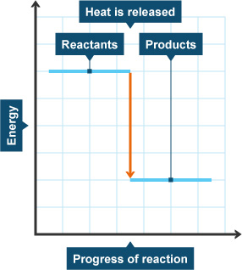

Chemical energy is also known as **enthalpy**. The change in chemical energy associated with chemical reactions can be measured. The specific heat capacity, mass and temperature can be used to calculate the enthalpy change for a reaction.

The equation for calculating the enthalpy change (heat change) is given by

∆ H = - c m ∆T

Where c is the specific heat capacity, m is the mass of the sample and ∆T is the change in temperature. The sign ∆H indicates the direction of the heat flow, positive for endothermic processes and negative for exothermic processes.

The heat absorbed or released during a chemical reaction is equal to the enthalpy change (delta H) for the reaction, at constant pressure. **Calorimetry is the measurement of heat absorbed or released during chemical and physical processes.**

*Definition: The standard enthalpy change of neutralisation is the enthalpy change when solutions of an acid and an alkali react together under standard conditions to produce 1 mole of water.*

*Example:*

*Hydrogen ions from the HCl react with hydroxide ions from the Na OH in a one-to-one ratio to produce water in the overall reaction:*

*H+(aq) + Cl–(aq) + Na+(aq) +OH–(aq)           H2O(l) + Na+(aq) + Cl–(aq)*

***Additional information:***

**Why do strong acids reacting with strong alkalis give closely similar values?**

We make the assumption that strong acids and strong alkalis are fully ionised in solution, and that the ions behave independently of each other. For example, dilute hydrochloric acid contains hydrogen ions and chloride ions in solution. Sodium hydroxide solution consists of sodium ions and hydroxide ions in solution.

The equation for any strong acid being neutralised by a strong alkali is essentially just a reaction between hydrogen ions and hydroxide ions to make water. The other ions present (sodium and chloride, for example) are just spectator ions, taking no part in the reaction.

The full equation for the reaction between hydrochloric acid and sodium hydroxide solution is:

http://www.chemguide.co.uk/physical/energetics/padding.gifhttp://www.chemguide.co.uk/physical/energetics/naohhcl.gif

. . . but what is actually happening is:

http://www.chemguide.co.uk/physical/energetics/padding.gifhttp://www.chemguide.co.uk/physical/energetics/makeh2o.gif

If the reaction is the same in each case of a strong acid and a strong alkali, it isn't surprising that the enthalpy change is similar.

**Why do weak acids or weak alkalis give different values?**

In a weak acid, such as ethanoic acid, at ordinary concentrations, something like 99% of the acid isn't actually ionised. That means that the enthalpy change of neutralisation will include other enthalpy terms involved in ionising the acid as well as the reaction between the hydrogen ions and hydroxide ions.

And in a weak alkali like ammonia solution, the ammonia is also present mainly as ammonia molecules in solution. Again, there will be other enthalpy changes involved apart from the simple formation of water from hydrogen ions and hydroxide ions.

For reactions involving ethanoic acid or ammonia, the measured enthalpy change of neutralisation is a few kilojoules less exothermic than with strong acids and bases.

For example, one source which gives the enthalpy change of neutralisation of sodium hydroxide solution with HCl as -57.9 kJ mol-1, gives a value of -56.1 kJ mol-1 for sodium hydroxide solution being neutralised by ethanoic acid.

For very weak acids, like hydrogen cyanide solution, the enthalpy change of neutralisation may be much less. A different source gives the value for hydrogen cyanide solution being neutralised by potassium hydroxide solution as -11.7 kJ mol-1, for example.

**Some resources to help with students research:**

|  |
| --- |
| <http://www.bbc.co.uk/bitesize/higher/chemistry/calculations_1/potential_energy/revision/4/> |
| <http://www.chemguide.co.uk/physical/energetics/neutralisation.html> |
| <http://www.chm.davidson.edu/vce/calorimetry/HeatofNeutralization.html> |
| <http://chemwiki.ucdavis.edu/Physical_Chemistry/Thermodynamics/Calorimetry/Virtual%3A_Calorimetry/Heat_of_Neutralization> |
| <http://www.youtube.com/watch?v=SV7U4yAXL5I> |
| <https://www.dartmouth.edu/~chemlab/techniques/calorimeter.html> |
| <http://www.google.co.uk/url?sa=t&rct=j&q=&esrc=s&frm=1&source=web&cd=5&ved=0CEwQFjAE&url=http%3A%2F%2Fwww.nrcresearchpress.com%2Fdoi%2Fpdf%2F10.1139%2Fv56-216&ei=wp0yU8aYOqqs0QXT44DoDg&usg=AFQjCNHbD3ho3vYYMi0lhdZMQqCmwmC-2w> |
| <http://www.tes.co.uk/teaching-resource/Heat-of-Neutralisation-6136620/> |
| <http://www.google.co.uk/url?sa=t&rct=j&q=&esrc=s&frm=1&source=web&cd=11&ved=0CCsQFjAAOAo&url=http%3A%2F%2Fwww.educationscotland.gov.uk%2FImages%2Fchemmolecalcsunitlabel_tcm4-148466.pdf&ei=7u0zU6d9iqLRBeaIgZgN&usg=AFQjCNEWY2BX8AHf8xcgyCFbKmEV0w9UNQ> |

**Textbook Resources**

|  |
| --- |
| Salters Higher Chemistry: Heinemann ISBN 0 435 63098 9 |
| New Higher Chemistry: *Eric Allan and John Harris* Hodder & Stoughton  Educational Scotland ISBN 0 340 72479 X |
| Higher Chemistry: *John MacGregor* Oliver & Boyd ISBN 0050 05080 X |
| General Chemistry: *Darrell D. Ebbing* Houghton Mifflin Company ISBN 0 395  74415 6 |
| Physical Chemistry: *P. W. Atkins* Oxford University Press ISBN 0 19 855284 X |

**Methods – for Investigations A - C**

Students will determine the heat released during various neutralisation reactions using a simple calorimeter made of polystyrene and a lid.

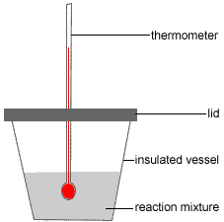

Two methods may be used to calculate the end point of neutralisation.

Regular temperature readings will be used to plot a Temperature vs Volume of acid/ base graph.

Extrapolate the graph to find the temperature rise.

Use the temperature rise and ∆H = - cm ∆ T to deduce the enthalpy of neutralisation for the particular combinations of acids and bases.

The following notes exemplify the two methods and specimen results for the strong acid HCl and the strong base Na OH.

Teachers may choose not to share these with students and use them as a guide or adapt them to suit.

Teachers may wish to allocate particular acid/base combinations to students.

**Method 1:**

1. Collect a dry polystyrene foam cup.

2. Collect and set up two burettes filled with 1.0 M NaOH and 1.0 M HCl respectively.

3. Record the initial burette readings.

4. Drain the specific volume of NaOH solution for Experiment 1 into the polystyrene foam cup according to the table below.

|  |  |  |  |  |  |
| --- | --- | --- | --- | --- | --- |
| Experiment | 1 | 2 | 3 | 4 | 5 |
| Volume of 1M NaOH (aq) (cm3) | 25 | 20 | 15 | 10 | 5 |
| Volume of 1M HCl (aq) (cm3) | 5 | 10 | 15 | 20 | 25 |

5. Allow the content of the polystyrene cup to equilibrate for a few minutes before the initial temperature is taken.

6. Quickly drain the specific volume of HCl for Experiment 1 into the polystyrene cup.

7. Swirl the reaction mixture gently and record the maximum temperature when reached.

8. Empty the contents of the polystyrene cup.

9. Repeat the same procedure for Experiment 2-5

**Method 2:**

1. Use a pipette to place 25cm3 of the NaOH solution into a dry polystyrene foam cup.

2. Measure and record the temperature of the solution.

3. Using the burette add 2cm3 of the HCl to the polystyrene cup.

4. Swirl the reaction mixture gently and record the maximum temperature when reached.

5. When the maximum temperature is reached, add another 2cm3 HCl.

6. The maximum temperature should be recorded again.

7. Repeat step 5 & 6 until a total volume of 40cm3 of acid is added.

Specimen Results for Method 1:

|  |  |  |  |  |  |
| --- | --- | --- | --- | --- | --- |
| Experiment | 1 | 2 | 3 | 4 | 5 |
| Volume of 1M NaOH(aq) (cm3) | 25 | 20 | 15 | 10 | 5 |
| Volume of 1M HCl (aq) (cm3) | 5 | 10 | 15 | 20 | 25 |
| Initial temperature (o C) | 22.6 | 22.6 | 22.6 | 22.4 | 23.5 |
| Maximum temperature (o C) | 24 | 26.2 | 28.2 | 26.9 | 25.0 |
| Change in temperature(o C) | 1.4 | 3.6 | 5.6 | 4.5 | 1.5 |

Specimen Graph for results above:

Students should produce a large scale graph on excel or hand drawn.



**o** C

**cm**3

Calculations using appropriate measurements:

The maximum change in temperature can be seen to be 5.8oC.

The volume of alkali added at this maximum temperature change is 14.7cm3

The volume of acid added = 30-14.7 = 15.3cm3

No of moles of HCl = C x V

= 1 x 0.0153

= 0.0153 mol

Mole ratio:

HCl : NaOH

1 : 1

0.0153: 0.0153

Therefore;

Concentration of NaOH = n /V

= 0.0153/ 0.0147

= 1.0408 mol/l

∆H = - cm ∆ T

= -30 x 4.18 x 5.8

= - 727.32 J

Enthalpy of neutralisation:

0.0153 moles 727.32 J

1 mol 727.32/0.0153

= -47.537 kJ/mol.

Specimen Results for Method 2

|  |  |  |  |  |  |  |  |
| --- | --- | --- | --- | --- | --- | --- | --- |
| Vol of acid (cm3) | 0 | 2 | 4 | 6 | 8 | 10 | 12 |
| Max Temp oC | 22.4 | 22.9 | 23.7 | 24.5 | 25.0 | 25.6 | 26 |
| Vol of acid (cm3) | 14 | 16 | 18 | 20 | 22 | 24 | 26 |
| Max Temp oC | 26.4 | 26.8 | 27.0 | 27.3 | 27.6 | 27.8 | 28.0 |
| Vol of acid (cm3) | 28 | 30 | 32 | 34 | 36 | 38 | 40 |
| Max Temp oC | 28.2 | 28.2 | 27.8 | 27.7 | 27.6 | 27.5 | 27.5 |

Specimen graph for the results above:



**cm**3

**o** C

Calculation using appropriate measurements:

The maximum temperature during the experiment was 28.30C.

volume of acid added to the experiment while the maximum temperature reached was 25.5cm3

No of moles of acid = CxV

= 1 X 0.025

No of moleof alkali : no of moles of acid

1 : 1

No of moles of alkali = 0.025 mol

Concentration of alkali = n/V

=0.025/0.025

= 1.00 mol/l

∆H = -cm ∆ T

= - (4.18) x (25.5+25) x (28.3-22.4)

= -4.18x 50.5 x5.9

= -1246.623 J

The enthalpy of neutralisation

= -1245.431/0.0255

= -48.840 kJ/mol

Additional sources of data using different combinations.

|  |  |  |
| --- | --- | --- |
| Class Group | Acid and alkali  combination | Enthalpy of  Neutralisation  kJmol-1 |
| 1 | HCl and Na OH | -47.52 |
| 2 | HNO3 and NaOH | -58.58 |
| 3 | H2 SO4 and NaOH | -59.52 |
| 4 | CH3 COOH and NaOH | -54.00 |
| 5 | HCl and NH3 | -44.70 |
| 6 | HNO3 and NH3 | -56.10 |
| 7 | H2 SO4 and NH3 | -55.64 |
| 8 | CH3 COOH and NH3 | -50.88 |

**Technician’s Guide.**

**Requirements ( per group )**

To investigate the enthalpy changes (∆H) of various acid – base neutralisation reactions.

The chemical and apparatus listed below will allow students to complete experimental work using METHOD 1 and METHOD 2. It may be they intend to chose one method only.

This chemical and apparatus list will meet the needs of investigation A,B and C.

|  |
| --- |
| **Chemicals and Apparatus** |
| 200cm3 of 1M concentration of each acid below:  HCl (aq), HNO3 (aq), H2SO4(aq), CH3COOH(aq) |
| 200cm3 of 1M concentration of each base below:  NaOH(aq), NH3(aq) |
| Thermometer or temperature probe |
| Polystyrene foam cup with lid |
| 50cm3 burette, |
| Filter funnel. |
| 25cm3 pipette |
| Pipette filler |
| 100cm3 beaker |

**Risk Assessment (Based on the HSE 5 Step)**

|  |  |
| --- | --- |
| Activity assessed | Enthalpy of neutralisation |
| *Date of assessment* | July 2014 |
| *Date of review (****Step 5****)* |  |
| *School* |  |
| *Department* |  |

| Step 1 | Step 2 | Step 3 | | Step 4 | | |
| --- | --- | --- | --- | --- | --- | --- |
| *List Significant hazards here:* | *Who might be harmed and how?* | *What are you already doing?* | *What further action is needed?* | *Action by whom?* | *Action by when?* | *Done* |
| 1.0 M Ethanoic Acid is of no significant hazard | Technician, teacher and students by spillage on skin or eye. | Avoid splashing – it will cause discomfort but no injury. |  |  |  |  |
| 1.0 M sodium hydroxide solution Is Corrosive. | Technician ( extra care must be taken if preparing from solid) NaOH, teacher and students | Rubber gloves should be worn by the technician if handling the solid.  Wear indirect vent goggles(BS EN166 3)  If spilled on skin, wash off with copious amounts of water. |  |  |  |  |
| 1.0 M sulphuric acid . Corrosive | Technician ( extra care must be taken if preparing from concentrated sulphuric acid), teacher and students. | Rubber gloves should be worn by the technician if handling concentrated sulphuric acid, teacher and student  Wear indirect vent goggles(BS EN166 3 )  If spilled on skin, wash off with copious amounts of water. |  |  |  |  |
| 1.0 M HCl. Is of no significant hazard | Technician should take care if preparing from concentrated hydrochloric acid), teacher and students. | Rubber gloves and indirect vent goggles (BS EN166 3) should be worn by the technician if handling concentrated hydrochloric acid, teacher and student  Avoid splashing 1M solution but it will cause discomfort rather than injury. |  |  |  |  |
| 1.0 M Nitric Acid. Corrosive. | Technician (extra care must be taken if preparing from concentrated nitric acid), teacher and students. | Rubber gloves should be worn by the technician if handling concentrated nitric acid, Wear indirect vent goggles (BS EN166 3)  If spilled on skin, wash off with copious amounts of water. |  |  |  |  |
| 1.0 M ammonia solution is an irritant. Ammonia solution (.880) is corrosive | When preparing 1M solution, technician should wear nitrile gloves and goggles (BS EN166 3) and work in a fume cupboard)  Demonstrator / technician by splashes while preparing the flask of ammonia. | Wear goggles (BN ES166 3) and nitrile gloves. Work in a well-ventilated room. |  |  |  |  |
| **Glassware:**  Thermometer  Burette,  pipette | Teacher, technician and pupil by handling glassware in the wrong way. | Demonstrator/Pupils are aware of how to handle broken glassware. |  |  |  |  |

|  |
| --- |
| **Description of activity:**  An acid – base neutralisation reaction will be carried out.  Different volumes of acids and bases will be measured using titration apparatus ( burette and pipette),  The acid and base will be mixed into a polystyrene foam cup.  The temperature will be measured using a temperature probe or an alcohol thermometer. |

|  |
| --- |
| **Additional comments:**  All solutions may be washed to waste with copious quantities of cold, running water.. |