**Biodiesel**

Teacher / Technician Guide





**Researching Chemistry**

**Higher**

Photo: Wikipedia, GDFL

Higher Physics Topical Investigation Skin Cancer—Prevention and Cure

2

**Investigation Brief**

Suntan creams stop harmful UV radiation reaching the skin. Manufacturers’ products are rated with a Sun Protection Factor (SPF). Suntan creams can have SPF values from 6 to over 50.

UV radiation monitors normally measure irradiance in output intensity per unit area. Thus, a typical low intensity UV lamp may emit approximately 10 mWcm-2.

The aim of this investigation is to determine the effect of various suntan creams on the transmission of UV radiation. In particular, the relationship between SPF and absorption should be found.

**Investigation Notes**

UV lamps can be harmful. Make sure that you read the safety leaflet which is supplied with the UV lamp. Some cheap UV monitors do not measure the irradiance of UV radiation. Rather, they give an indication of UV index. It is possible to undertake this investigation with such a monitor, but results will be less reliable and accurate. UV radiation does not pass through many transparent materials (including glass). However, UV transparent acrylics are readily available.

3

**Contents**

**Advice to students**

Page 3 Overview of the unit and activities

Page 4 Organising your work and carrying out the activities

Page 6 Assessment issues

Page 7 Why is this topical?

**Investigation and research briefs**

Page 9 **Investigation A** – “Is it cheaper to make your own biofuel from vegetable oil than to buy diesel from a local filling station?”

Page 16 **Investigation B** – “Waste not, want not. Is it cheaper to make your own biofuel from waste vegetable oil than to buy diesel from a local filling station?”

Page 26 **Investigation C** – “How good is biodiesel as a fuel?”

Page 35 **Investigation D** – “Does biodiesel burn more cleanly than conventional diesel?”

**Overview of the assignment and activities.**

The assignment has two stages:

• Research stage

• Communication stage

The research stage involves gathering information/data from the internet, books, newspapers, journals, experiment/practical activity or any other appropriate source. Candidates must select, use and record their referenced sources.

Group work approaches are acceptable as part of the research stage when gathering information/data or undertaking an experiment/practical activity, but assessors must ensure that candidates are able individually to meet the evidence requirements of this assessment.

In the course of their assignment, candidates are required to:

* choose a relevant topic in chemistry (the assessor must review the appropriateness of the topic chosen)
* state appropriate aim (s)
* research the topic by selecting relevant data/information
* carry out risk assessment of procedure
* process and present relevant data/information
* analyse data/information
* state conclusions
* evaluate their investigation
* explain the underlying chemistry of the topic researched
* present the findings of the research in a report

The evidence for this assignment will consist of the report. Of the total of 20 marks available for the assignment, the marking instructions provide 16 marks for skills and 4 marks for knowledge and understanding. The table below shows how these marks are allocated to each of the criteria against which the evidence will be assessed.

|  |  |
| --- | --- |
| Criteria | Mark allocation |
| Aim(s) | 1 |
| Applying knowledge and understanding of chemistry | 4 |
| Selecting information | 2 |
| Risk assessment | 1 |
| Processing and presenting data/information | 4 |
| Analysing data/information | 2 |
| Conclusion(s) | 1 |
| Evaluation | 3 |
| Presentation | 2 |

Detailed marking instructions for the Higher Assignment can be found using the following link:

<http://www.sqa.org.uk/files_ccc/GAInfoHigherChemistry.pdf>

The Biodiesel support pack for the Higher assignment contains a selection of four possible investigations, labelled A to D.

|  |  |
| --- | --- |
| **Investigation** | **Title** |
| A | Is it cheaper to make your own biofuel from vegetable oil than to buy diesel? |
| B | Waste not, want not. What, if any, are the advantages of making biodiesel from waste oil? |
| C | How effective is biodiesel as a fuel? |
| D | What effect does biodiesel have on the environment? |

Teachers should feel free to edit these investigations to suit the needs of their own students. For example, some teachers may wish to remove some of the experimental instructions from the student guides to make the planning process more challenging for able students.

Additionally, the list of investigations is by no means exhaustive; teachers are free to develop their own alternative investigation topics to enhance the experience for students.

# Why is this topical?

In the late 19th century, the combination of developing engine technology and the increasing availability of suitable fuel, led to the arrival of vehicles powered by the internal combustion engine.

Over the decades, the numbers of these vehicles has increased phenomenally. A combination of innovative manufacturing methods bringing prices down, such as Henry Ford’s production line, and the growing wealth of individuals, especially in the industrialised nations, has made these vehicles ubiquitous throughout most of the world. To the point where there are now well over a billion vehicles worldwide.

Increased vehicle ownership and usage leads to increased fuel usage. Worldwide consumption of petrol and diesel for vehicles is over 1,000 Gt (Gigatonnes) each.

This situation has many effects:

A recent study suggests that as many as 470,000 deaths are caused annually by air pollution. Vehicles, though not the only cause, are a major cause of this pollution.[[1]](#footnote-1)

Worldwide vehicles are responsible for over 15% of global CO2 emissions – and this figure does not include figures for vehicle manufacture or oil production.

Road traffic accidents kill 1.24 million people annually worldwide.

Interest in making diesel from vegetable oils has been around intermittently since the invention of the diesel engine itself. It was not, however, until the 1990s, largely due to attempts at reducing CO2 emissions, that biodiesel production became large scale.

It is not common, in the UK at least, for vehicles to run entirely on biodiesel – apart from some individuals and a few large organisations. In the European Union as a whole, though, diesel fuel usually has 7% biodiesel added to it.

**Media Items**

1. How biodiesel is made – Methes energy - <https://www.youtube.com/watch?v=xLa83KIaEyw>

2. A page from Strathclyde university summarising biodiesel production. [http://www.esru.strath.ac.uk/EandE/Web\_sites/02-03/biofuels/what\_biodiesel.htm](http://www.esru.strath.ac.uk/EandE/Web_sites/02-03/biofuels/what_biodiesel.htm%20)

3. An Oxfam report highlighting some problems with biofuel production - <http://www.oxfam.org/en/grow/policy/hunger-grains>

4. A comparison from Oregon of pollution from biodiesel and conventional diesel. [http://www.deq.state.or.us/aq/diesel/reducepollution.htm](http://www.deq.state.or.us/aq/diesel/reducepollution.htm%20)

5. Item from Penn State in the USA with a review of biodiesel including facts about engine performance. <http://pubs.cas.psu.edu/FreePubs/pdfs/uc204.pdf>

**The Chemistry**

It is often claimed that Rudolf Diesel developed his engine to run on vegetable oil but modern engines require a less viscous fuel with better burning properties. Oils are examples of triglycerides which are esters of 3 fatty acids (long chain alkyl acids) (which may be the same or different) and glycerol which has three hydroxyl (-OH) groups.

Oils are converted into bio-diesel by a trans-esterification process where three smaller alcohols, usually methanol, replace the glycerol. This reaction is reversible and can be catalysed by acid or more commonly alkali. An excess of the alcohol is used to drive the equilibrium as the excess can be recovered along with the sodium hydroxide or potassium hydroxide in the glycerol layer.

Cooking oil is mixed with methanol and a catalyst (potassium hydroxide). Cooking oil is a lipid called a triglyceride. The structure of this type of lipid is characteristic of all animal and plant fats. These consist of [propane-1,2,3-triol (glycerol)](javascript:doStructure('propane123.htm')) attached to three fatty acids. Differences among the fats are due to different fatty acids being connected to the glycerol.

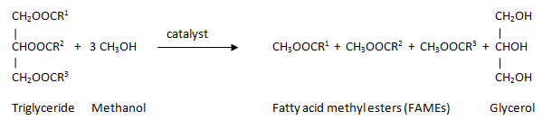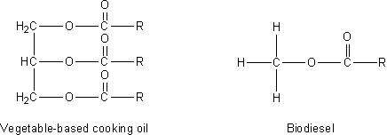

R is a hydrocarbon, similar to the one shown below

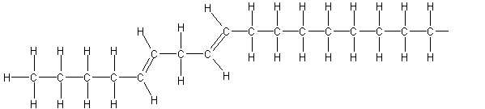

In making biodiesel the reaction breaks the bond between the propane-1,2,3-triol (glycerol) and the fatty acids. A methyl group is added to the end of the fatty acid. This is what we call biodiesel, with the other product being propane-1,2,3-triol (glycerol). The process is catalysed by potassium hydroxide.

In brief, in the transesterification reaction, the triglycerides are first hydrolysed to give fatty acids and glycerol and then new ester bonds are formed between the fatty acids and the methanol.

Methanol is the alcohol most commonly used as it will react rapidly and effectively. The use of methanol does, however, compromise the use of biodiesel as a green fuel, .as most methanol is produced from crude oil.

Making bio diesel using ethanol is a process that is comparatively more difficult than using methanol. The main reasons for this are :-

* The reaction is sensitive to the presence of water and so will not work well with normal IDA
* Getting highly pure ethanol that has less that .5 % water is difficult.
* This process is works best with KOH, as opposed to NaOH, which is a more expensive reagent.
* The oil needs to be heated to 120°C or more

There are, however, alternative methods being developed that will allow the use of ethanol.

As ethanol is already widely made from plant material, including cellulose wastes, this will be a much greener alternative.

It is apparently possible to make biodiesel from propanol as well but this proceeds more slowly still.

*A – “Is it cheaper to make your own biofuel from vegetable oil than to buy diesel from a local filling station?”*

**Research Brief**

Modern society is energy hungry. Our use of technology demands a huge supply of energy and we have devised many ways to supply this energy. Fossil fuels, including coal, oil and gas, provide a significant proportion of our energy requirements in this country. However, these energy sources are not sustainable. There is a limited supply of fossil fuels and we will eventually run out of them. Although the supplies of nuclear fuel can potentially last much longer, they too will eventually run out.

A lot of research is being undertaken to develop sustainable sources of energy, that is, sources that will not run out. These are **renewables**. Hydroelectric, solar, wind and tidal power are examples of renewable energy sources.

Most of these renewable, however, while fine for electricity generation or supplying houses and factories, are not suitable for small, mobile uses, in particular they are not suitable for cars and lorries.

In this initial research activity pupils will find out some background information about biofuels.

In carrying out your research you should answer the following questions.

**A - background**

* How much petrol / diesel is used in the UK – on average, per hour/day/week?
* What proportion of fuel is currently produced from non-sustainable sources?
* Some diesel fuels on sale in the UK are a blend of traditional mineral diesel obtained from crude oil and biodiesel. How much biodiesel is included in these blends?
* What proportion of our fuel requirements could be provided by biofuels?

**B - Focus questions**

A1 Different people have different reasons for being interested in producing biodiesel. What reasons are given for manufacturing biodiesel?

A2 What is the reaction used to produce biodiesel from edible oils? The answer should name the types of reactant molecules and should include a word equation for the reaction.

A3 What safety hazards are associated with the production of biodiesel?

A4 What different oils are used for the production of biodiesel and why are they chosen?

A5 What are the effects on a vehicle’s performance when using biodiesel compared to petroleum diesel?

A7 What arguments are given against biodiesel production?

A8 Biodiesel is described as being “carbon neutral”. What does this mean, and is this claim true?

Answer the questions by carrying out research. It is probable that some of this is best undertaken using web-based research. Pupils are advised to have completed an activity in which they consider the issues of undertaking web-based research. This may have been done during work on other units in Higher Chemistry.

Pupils may work individually or as part of a team.

Pupils should produce a report of their findings. This may be hand written, printed or electronic and saved in an e-portfolio.

If pupils work as part of a team that produces one report, each member of the team should include a short statement at the end of the report that indicates which part of the work he/she was responsible for.

**Investigation Brief**

The petrol and diesel used in cars are mixtures of hydrocarbons. In the engine, these fuels are burned and the rapid expansion in the cylinder due to the combustion produces movement of the pistons. This in turn is translated into movement of the vehicle.

Petrol and diesel are fossil fuels and this their burning produces a net increase in atmospheric carbon dioxide leading to climate change. So alternative fuels with a smaller ‘carbon footprint’ are being investigated. One of these is biodiesel, a series of esters made from alcohols and the fatty acids in oils.

The aim of this investigation is find out if biodiesel made from fresh vegetable oils might be a suitable replacement for the traditional fossil fuel.

Discuss how you will carry out the investigation.

Whilst planning your experimental work pupils should think about:

* which vegetable oil should be used in this experiment
* finding out the price of conventional diesel in local filling stations
* the apparatus and chemicals will needed
* the cost of the reagents used
* what hazards there are when making biodiesel and what will needs to be done to minimise risk.

Write your plan in your record of work.

**Making biodiesel**

Biodiesel is a mixture of [methyl esters](javascript:doStructure('methylester.htm')) of [fatty acids](javascript:doStructure('fattyacid.htm')) (long chain [carboxylic acids](http://www.rsc.org/Education/Teachers/Resources/green/glossary/home.htm#carboxylicacid)). It has similar properties to the diesel fuel made from crude oil that is used to fuel many vehicles. It can be made easily from vegetable cooking oil that contains compounds of fatty acids. The synthesis is a simple chemical reaction that produces biodiesel and [propane-1,2,3-triol (glycerol)](javascript:doStructure('propane123.htm')). Cooking oil is mixed with [methanol](javascript:doStructure('methanol.htm')) and potassium hydroxide is added as a catalyst. The products separate into two layers, with the biodiesel on the top. The biodiesel is separated and washed, and is then ready for further experimentation.

**Drying your oil**

### Equipment needed

A sample of the oil

**Either**

access to an oven at 120°C

**or**

* A bottle of anhydrous magnesium sulphate
* balance, weighing boat and spatula
* A clamp stand, boss head and clamp
* A filter funnel and filter paper

### Instructions

a) Place the beaker of filtered waste oil in the oven at 120°C and leave it overnight. This will remove the residual water.

**or**

b) Shake the sample with 3g anhydrous magnesium sulphate/100 cm3 of oil to remove any residual water.

Leave overnight and then filter.

**Making the potassium methoxide**

Potassium methoxide is made in advance.

**This process is hazardous and may be done by teachers or technicians. If by pupils the process should be closely supervised - Wear goggles and gloves**

### Equipment needed

* A balance able to read to 2 d.p.
* A weighing boat
* A spatula
* A bottle of potassium hydroxide (check the assay level is on the label) (Care: Corrosive)
* A bottle of methanol (Care: Flammable, Toxic)
* 2 x 250 cm3 beakers
* A measuring cylinder
* A magnetic stirrer, seeker and a stirring rod
* A bottle to store the potassium methoxide in
* Labels and hazardous pictograms for the bottle

### Instruction

1. Weigh out 4.5-4.6g potassium hydroxide (strongly corrosive)
2. Measure 100 cm3 methanol (highly flammable and toxic) and pour into a 250cm3 beaker
3. Pour the potassium hydroxide into the methanol and stir until dissolved.
4. This takes approximately 2 hours so you will need to use a magnetic stirrer
5. Some unreacted hydroxide may remain in the bottom of the beaker.
6. Bottle and label with toxic and corrosive pictograms.

**Preparing your biodiesel**

### Equipment needed

* A separating funnel
* A clamp stand, boss head and clamp or ring
* A beaker of oil
* A bottle of potassium methoxide solution
* A 100 cm3 measuring cylinder
* A 10 cm3 measuring cylinder
* A large beaker
* A bottle of salt solution

### Instructions

1. Measure 50 cm3 treated oil –either fresh or waste (filtered and dried) and place in the separating funnel
2. Add 10cm3 of the prepared potassium methoxide solution
3. Stopper and shake vigorously for 2 minutes. Occasionally remove the stopper and then replace. This is to relieve pressure in the separating funnel
4. Leave to separate overnight or place tubes in a centrifuge for 5 minutes
5. The glyceride should separate out to the bottom. The supernatant may be dark in colour.
6. Carefully remove the top layer of biodiesel using a teat pipette. Remove the bottom layer of glycerine from the separating funnel and return your biodiesel to it.
7. Add 10 cm3 of salt solution and invert it carefully 10 times. **DO NOT SHAKE** the mixture as an emulsion can form
8. Transfer the bottom salt water layer to a beaker
9. Weigh the amount of biodiesel you have collected and compare it to the amount of vegetable oil you started with.

B *– “Waste not, want not. Is it cheaper to make your own biofuel from used cooking oil than to buy diesel from a local filling station?”*

**Research Brief**

Modern society is energy hungry. Our use of technology demands a huge supply of energy and we have devised many ways to supply this energy. Fossil fuels, including coal, oil and gas, provide a significant proportion of our energy requirements in this country. However, these energy sources are not sustainable. There is a limited supply of fossil fuels and we will eventually run out of them. Although the supplies of nuclear fuel can potentially last much longer, they too will eventually run out.

A lot of research is being undertaken to develop sustainable sources of energy, that is, sources that will not run out. These are **renewables**. Hydroelectric, solar, wind and tidal power are examples of renewable energy sources.

Most of these renewable, however, while fine for electricity generation or supplying houses and factories, are not suitable for small, mobile uses, in particular they are not suitable for cars and lorries.

In this initial research activity you will find out some background information about biofuels.

In carrying out your research you should answer some of the following questions.

**A - background**

* How much petrol / diesel is used in the UK – on average, per hour/day/week?
* What proportion of fuel is currently produced from non-sustainable sources?
* Some diesel fuels on sale in the UK are a blend of traditional mineral diesel obtained from crude oil and biodiesel. How much biodiesel is included in these blends?
* What proportion of our fuel requirements could be provided by biofuels?

**B - Focus questions**

B1 What is the reaction that is used to produce biodiesel from edible oils? Your answer should name the types of reactant molecules and should include a word equation for the reaction.

B2 What changes take place in vegetable oils when used for deep fat frying?

B3 Making biodiesel is one possible use for used cooking oils. What other uses are there for used cooking oils..

B4 What are the safety hazards associated with the production of biodiesel?

B5 What hazards do used cooking oils pose to health or the environment?

B6 Can you buy biodiesel made from used cooking oils in Scotland? Your answer should include the price per litre of any oils you find for sale.

Answer the questions by carrying out research. It is probable that some of this is best undertaken using web-based research. Pupils are advised to have completed an activity in which they consider the issues of undertaking web-based research. This may have been done during work on other units in Higher Chemistry.

Pupils may work individually or as part of a team.

Pupils should produce a report of their findings. This may be hand written, printed or electronic and saved in an e-portfolio.

If pupils work as part of a team that produces one report, each member of the team should include a short statement at the end of the report that indicates which part of the work he/she was responsible for.

**Investigation Brief**

The petrol and diesel used in cars are mixtures of hydrocarbons. In the engine, these fuels are burned and the rapid expansion in the cylinder due to the combustion produces movement of the pistons. This in turn is translated into movement of the vehicle.

The petrol and diesel used in cars are mixtures of hydrocarbons. In the engine, these fuels are burned and the rapid expansion in the cylinder due to the combustion produces movement of the pistons. This in turn is translated into movement of the vehicle.

Petrol and diesel are fossil fuels and this their burning produces a net increase in atmospheric carbon dioxide leading to climate change. So alternative fuels with a smaller ‘carbon footprint’ are being investigated. One of these is biodiesel, a series of esters made from alcohols and the fatty acids in oils.

In many of our towns and cities, a lot of vegetable oil is used for deep frying the foods that are widely on sale. As the oils can only be used a certain number of times for this process, there is a lot of used vegetable oil that needs to be disposed of.

The aim of this investigation is find out if biodiesel made from waste vegetable oils might be a suitable replacement for the traditional fossil fuel.

Pupils should discuss how they will carry out the investigation.

Whilst planning experimental work they should think about:

* which vegetable oil will be used in this experiment
* finding out the price of conventional diesel in local filling stations
* the apparatus and chemicals needed
* the cost of the reagents used in the experiment
* what hazards there are when making biodiesel and what needs to be done to minimise risk.

Pupils should write their plan in their record of work.

**A method for making biodiesel from waste oil**

The process is very similar to the preparation of biodiesel from fresh vegetable oil. There are two differences.

1. Waste oil contains particles of food waste so it needs to be filtered
2. In waste oil a certain proportion of the triglycerides have been hydrolysed to leave free fatty acids (FFAs). A titration is needed to determine the level of FFAs so you can ensure that the correct amount of catalyst is added.

**Filtering your oil**

### What you do:

1. Filter the oil through a double layer of muslin to remove any debris from food preparation. The oil will still be cloudy after this treatment.
2. Now filter the cloudy oil through either a standard size coffee filter paper or through student grade filter paper. The oil will be a much clearer dark brown after this filtration.

(If you are filtering a large amount then the process takes time).

**Drying your oil**

### What you will need

* A sample of the filtered oil

Either

* access to an oven at 120°C

or

* A bottle of anhydrous magnesium sulphate
* balance, weighing boat and spatula
* A clamp stand, boss head and clamp
* A filter funnel and filter paper

### What you do:

1. Place the beaker of filtered waste oil in the oven at 120°C and leave it overnight. This will remove the residual water.

or

1. Shake the sample with 3g anhydrous magnesium sulphate/100 cm3 of oil to remove any residual water.

Leave overnight and then filter.

**Determining the amount of free fatty acids (FFA) present in the filtered oil**

Some of the oil will have been broken down into free fatty acids during the cooking process. This will require a larger addition of the base at the trans-esterification step than is required for new oil. It is necessary to determine how much of the waste oil has been broken down into free fatty acids to be able to calculate how much extra potassium hydroxide is required to neutralise the FFA.

### What you will need

* Filtered and dried oil.
* Propan-2-ol
* 10cm3 measuring cylinder
* 0.1% potassium hydroxide solution
* Test tubes and test tube rack.
* 1 cm3 disposable Pasteur pipette
* Thymol blue indicator

### What you do:

1) Blank (your control)

1. Add 5 drops of thymol blue indicator to 10 cm3 propan-2-ol: the solution should be pale yellow
2. Using a disposable 1cm3 graduated pipette, add a 0.1% potassium hydroxide solution drop wise with shaking until the colour change from yellow to blue is observed.
3. Repeat three times and take the average.

*Thymol blue is chosen as there is a definite change in colour in the pH range of the solution.*

2) Sample

1. Dissolve 1 cm3 of oil in 10 cm3 propan-2-ol.
2. Add 5 drops of thymol blue indicator
3. Using a disposable 1cm3 graduated pipette, add a 0.1% potassium hydroxide solution drop wise with shaking until the colour change from yellow to blue is observed.
4. Repeat three times and take the average.

*To get the measurement, you can either use the markings on the pipette to get the volume to the nearest ¼ cm3 or count the drops. You will need to check first but most 1 cm3 pasteur pipettes will give around 23 – 25 drops per cm3 so, knowing that and the number of drops, you can easily calculate the volume. The second method is more accurate but this level of accuracy is not essential.*

Subtract the average of the blank (control) from the average of the oil samples. The answer is the number of grammes of potassium hydroxide needed to neutralise the free fatty acids.

The actual amount of potassium hydroxide you need to add depends on the purity of your reagent.

|  |  |
| --- | --- |
| KOH Assay (%) | Mass to Add to 1 Litre (g) |
| 85 | 5.8 |
| 90 | 5.5 |
| 92 | 5.3 |
| 100 | 4.9 |

To each litre of oil, you need to add:

* 200 cm3 of methanol
* Mass of ethanol from the table above **plus** the extra mass determined from your titration

If you are using 50 cm3 of oil, as described in the method, you will have to work out the composition of your potassium methoxide in advance

**Making the potassium methoxide**

Potassium methoxide is made in advance.

**This process is hazardous and may be done for you - Wear goggles and gloves**

### What you will need

* A balance able to read to 2 d.p.
* A weighing boat
* A spatula
* A bottle of potassium hydroxide (check the assay level is on the label) (Care: Corrosive)
* A bottle of methanol (Care: Flammable, Toxic)
* 2 x 250 cm3 beakers
* A measuring cylinder
* A magnetic stirrer, seeker and a stirring rod
* A bottle to store the potassium methoxide in
* Labels and hazardous pictograms for the bottle

### What you do:

1. Weigh out the amount of potassium hydroxide (strongly corrosive) determined from your calculations above.
2. Measure the calculated volume of methanol (highly flammable and toxic) and pour into a 250cm3 beaker
3. Pour the potassium hydroxide into the methanol and stir until dissolved.
4. This takes approximately 2 hours so you will need to use a magnetic stirrer
5. Some unreacted hydroxide may remain in the bottom of the beaker.
6. Bottle and label with toxic and corrosive pictograms.

**Preparing your biodiesel**

### What you need:

A separating funnel

A clamp stand, boss head and clamp or ring

A beaker of oil

A bottle of potassium methoxide solution

A 100 cm3 measuring cylinder

A 10 cm3 measuring cylinder

A large beaker

A bottle of salt solution

### What you do:

1. Measure 50cm3 treated oil –either fresh or waste (filtered and dried) and place in the separating funnel
2. Add 10cm3 of the prepared potassium methoxide solution
3. Stopper and shake vigorously for 2 minutes. Occasionally remove the stopper and then replace. This is to relieve pressure in the separating funnel
4. Leave to separate overnight or place tubes in a centrifuge for 5 minutes
5. The glyceride should separate out to the bottom. The supernatant may be dark in colour.
6. Carefully remove the top layer of biodiesel using a teat pipette. Remove the bottom layer of glycerine from the separating funnel and return your biodiesel to it.
7. Add 10 cm3 of salt solution and invert it carefully 10 times. **DO NOT SHAKE** the mixture as an emulsion can form
8. Transfer the bottom salt water layer to a beaker
9. Weigh the amount of biodiesel you have collected and compare it to the amount of vegetable oil you started with.

C *– “How good is biodiesel as a fuel?”*

**Research Brief**

Modern society is energy hungry. Our use of technology demands a huge supply of energy and we have devised many ways to supply this energy. Fossil fuels, including coal, oil and gas, provide a significant proportion of our energy requirements in this country. However, these energy sources are not sustainable. There is a limited supply of fossil fuels and we will eventually run out of them. Although the supplies of nuclear fuel can potentially last much longer, they too will eventually run out.

A lot of research is being undertaken to develop sustainable sources of energy, that is, sources that will not run out. These are **renewables**. Hydroelectric, solar, wind and tidal power are examples of renewable energy sources.

Most of these renewable, however, while fine for electricity generation or supplying houses and factories, are not suitable for small, mobile uses, in particular they are not suitable for cars and lorries.

In this initial research activity pupils will find out some background information about biofuels.

In carrying out their research pupils should answer the following questions.

**A - background**

* How much petrol / diesel is used in the UK – on average, per hour/day/week?
* What proportion of fuel is currently produced from non-sustainable sources?
* Some diesel fuels on sale in the UK are a blend of traditional mineral diesel obtained from crude oil and biodiesel. How much biodiesel is included in these blends?
* What proportion of our fuel requirements could be provided by biofuels?
* What are the safety hazards associated with the production of biodiesel?

**B - Focus questions**

C1 How does the energy produced by biodiesel from fresh oil compare to that of petroleum diesel?

C2 How does the energy produced by biodiesel from waste oil compare to that of petroleum diesel?

C3 How does the energy obtained from burning biodiesel compare with the theoretical yield calculated from bond energies?

C4 What are the products produced when oil and biodiesel burn?

C5 What other products are produced in the manufacture of biodiesel. How can they be used or disposed of?

C6 How much carbon dioxide is produced when burning biodiesel compared to vegetable oil or petroleum diesel?

Pupils should answer the questions by carrying out research. It is probable that some of this is best undertaken using web-based research. Pupils are advised to have completed an activity in which they consider the issues of undertaking web-based research. This may have been done during work on other units in Higher Chemistry.

Pupils may work individually or as part of a team.

Pupils should produce a report of their findings. This may be hand written, printed or electronic and saved in an e-portfolio.

If pupils work as part of a team that produces one report, each member of the team should include a short statement at the end of the report that indicates which part of the work he/she was responsible for.

**Investigation Brief**

The petrol and diesel used in cars are mixtures of hydrocarbons. In the engine, these fuels are burned and the rapid expansion in the cylinder due to the combustion produces movement of the pistons. This in turn is translated into movement of the vehicle.

The petrol and diesel used in cars are mixtures of hydrocarbons. In the engine, these fuels are burned and the rapid expansion in the cylinder due to the combustion produces movement of the pistons. This in turn is translated into movement of the vehicle.

Petrol and diesel are fossil fuels and this their burning produces a net increase in atmospheric carbon dioxide leading to climate change. So alternative fuels with a smaller ‘carbon footprint’ are being investigated. One of these is biodiesel, a series of esters made from alcohols and the fatty acids in oils.

In order for biodiesel to be suitable as a replacement for conventional diesel, it needs to have certain characteristics. Amongst other things, it needs to burn easily enough and to give off a sufficient amount of energy. It needs to be able to flow round the engine and it needs to burn reasonably cleanly.

The aim of this investigation is find out if biodiesel made from vegetable oils (fresh or waste) might be a suitable replacement for the traditional fossil fuel.

Pupils should discuss how they will carry out the investigation.

Whilst planning experimental work they should think about:

* which vegetable oil will be used in this experiment
* finding out the price of conventional diesel in local filling stations
* the apparatus and chemicals needed
* the cost of the reagents used in the experiment
* what hazards there are when making biodiesel and what needs to be done to minimise risk.

Pupils should write their plan in their record of work.

**Investigation Brief**

### pH and Viscosity

### What you will need

### A sample of biodiesel, from fresh or waste oil.

### A sample of the oil you used

### Two test tubes (the same size) and a test tube rack

### A piece of pH paper and a colour chart

### What you do:

1. Pour some biodiesel into one of the test tubes.
2. Pour some oil into the empty test tube so the depth is the same as the biodiesel you have.
3. Tear two small pieces from the end of the pH paper you have. Make sure they are small enough not to get caught in the test tubes.
4. At the same time, add a piece to each test tube and shake them gently to make sure the paper gets wet and starts to sink into the liquids.
5. Watch how fast they sink and if they change colour.
6. Try to match the colour of each piece of pH paper to a number on the chart you have.

### Enthalpy of combustion

### What you will need

### Some of your biodiesel and the oil you made it from

### An evaporating basin

### A piece of cotton to make a wick from

### A piece of copper wire (to hold the wick together)

### A 100 cm3 measuring cylinder

### Access to a balance able to read to 2 decimal places

### This apparatus set up

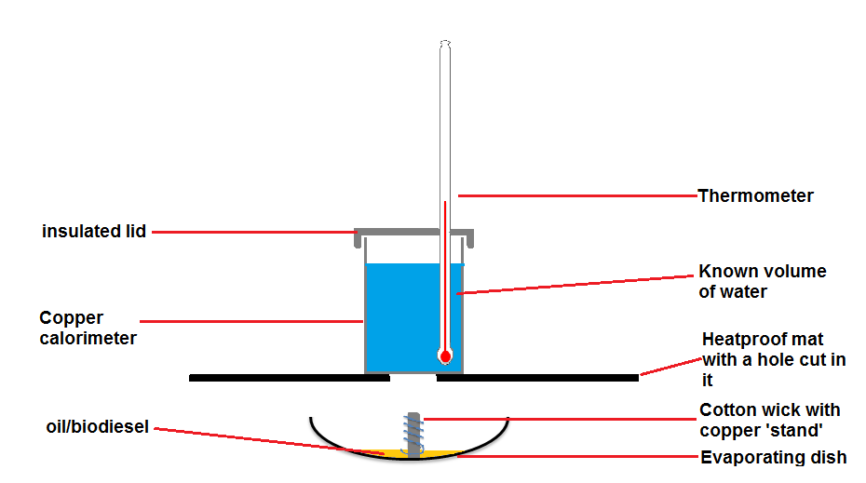

### The apparatus is sensitive to draughts. It is a good idea to construct a sort of box out of heatproof mats or corriflute or anything else suitable.

This should be carried out in a well ventilated room. If it is being repeated a lot then use a fume cupboard. Keep the fan off until the measurements are complete then switch it on to clear the fumes.

### What you do:

1. Make up wicks by rolling the cotton fabric, then wrap a length of copper wire around it to hold it together, making a foot so that it can stand in an evaporating basin (See photos below)
2. Accurately measure out 100 cm3 of cold water into the copper beaker
3. Place lid on and put it into the box unit making sure the thermometer bulb is submerged in the water in the copper can in the box unit. It should look like this when it is set up for the experiment:
4. Take the initial temperature reading of the water.
5. Weigh your basin and wick. Record its mass
6. Add 3 cm3 of your sample i.e. biodiesel/vegetable oil into the evaporating basin. Dip the end of the wick in the liquid and sit it in the basin.
7. Record the total mass of the basin, oil and wick.
8. Set the evaporating basin under the hole in the box and light the wick.
9. Watch the temperature increase. When it is 10 - 20°C above the starting temperature extinguish the flame by placing a heat mat over the basin.
10. Keep watching the temperature rise and record the final temperature when it stops
11. Weigh the evaporating basin again, record the reading and calculate the difference in mass.
12. Remove the copper beaker, clean the soot off, and refill with water for next sample.
13. Repeat with another sample. Repeat measurements can also be taken and averages calculated.
14. Now repeat the experiment using kerosene (this is very similar to diesel fuel).

Calculate the energy content of the oil and biodiesel burned and hence the energy content/g

Energy Content = cmΔT c = 4.18kJkg-1oC-1

Energy Content/g = cmΔT

Mass Loss

*D – “Does biodiesel burn more cleanly than conventional diesel”?*

**Research Brief**

Modern society is energy hungry. Our use of technology demands a huge supply of energy and we have devised many ways to supply this energy. Fossil fuels, including coal, oil and gas, provide a significant proportion of our energy requirements in this country. However, these energy sources are not sustainable. There is a limited supply of fossil fuels and we will eventually run out of them. Although the supplies of nuclear fuel can potentially last much longer, they too will eventually run out.

A lot of research is being undertaken to develop sustainable sources of energy, that is, sources that will not run out. These are **renewables**. Hydroelectric, solar, wind and tidal power are examples of renewable energy sources.

Most of these renewable, however, while fine for electricity generation or supplying houses and factories, are not suitable for small, mobile uses, in particular they are not suitable for cars and lorries.

In this initial research activity you will find out some background information about biofuels.

In carrying out their research pupils should answer the following questions.

**A - background**

* How much petrol / diesel is used in the UK – on average, per hour/day/week?
* What proportion of fuel is currently produced from non-sustainable sources?
* Some diesel fuels on sale in the UK are a blend of traditional mineral diesel obtained from crude oil and biodiesel. How much biodiesel is included in these blends?
* What proportion of our fuel requirements could be provided by biofuels?
* What are the safety hazards associated with the production of biodiesel?

**B - Focus questions**

D1 What are diesel particulates and what hazards do they pose?

D2 What monitoring of particulate levels has been undertaken in Scotland?

D3 Biodiesel is described as being “carbon neutral”. What does this mean, and is this claim true?

D4 What can be done to conventional diesel fuel to reduce the production of acid rain?

D5 What studies have been done comparing biodiesel emissions with conventional diesel fuel?

D6 Burning biodiesel reduces the levels of polycyclic aromatic hydrocarbons (PAH). Why do people want to reduce the emissions of polycyclic aromatic hydrocarbons?

Pupils should answer the questions by carrying out research. It is probable that some of this is best undertaken using web-based research. Pupils are advised to have completed an activity in which they consider the issues of undertaking web-based research. This may have been done during work on other units in Higher Chemistry.

Pupils may work individually or as part of a team.

Pupils should produce a report of their findings. This may be hand written, printed or electronic and saved in an e-portfolio.

If pupils work as part of a team that produces one report, each member of the team should include a short statement at the end of the report that indicates which part of the work he/she was responsible for.

**Investigation Brief**

The petrol and diesel used in cars are mixtures of hydrocarbons. In the engine, these fuels are burned and the rapid expansion in the cylinder due to the combustion produces movement of the pistons. This in turn is translated into movement of the vehicle.

The petrol and diesel used in cars are mixtures of hydrocarbons. In the engine, these fuels are burned and the rapid expansion in the cylinder due to the combustion produces movement of the pistons. This in turn is translated into movement of the vehicle.

Petrol and diesel are fossil fuels and this their burning produces a net increase in atmospheric carbon dioxide leading to climate change. So alternative fuels with a smaller ‘carbon footprint’ are being investigated. One of these is biodiesel, a series of esters made from alcohols and the fatty acids in oils.

As well as the problems associated with carbon dioxide emissions, petrol and diesel are in the spotlight because of other emissions: nitrogen and sulphur oxides can contribute to acid rain as well as irritating the lings, especially of people suffering from asthma; particulates produced by diesel engines can enter deep into the lungs and can lodge there, eventually leading to an increased chance of cancer. Indeed, it has recently been announced that from 2020, diesel vehicles that fail to meet stringent new standards will be charge double the fee to enter London.

The aim of this investigation is find out if biodiesel made from vegetable oils (fresh or waste) might be a suitable replacement for the traditional fossil fuel in terms of the pollutants it emits..

Pupils should discuss how they will carry out the investigation.

Whilst planning experimental work they should think about:

* how, using the apparatus described below, they could measure the quantity of particulates (soot) formed when a fuel burns
* how they could use the apparatus described below to measure the quantity of gases released which could cause the formation of acid rain
* how they will ensure a fair comparison of the two fuels
* what hazards there are when carrying out the experiment and how they will minimise risk.

Pupils should write their plan in their record of work.

The experiment described below can be adapted to give a measure of the amount of particulates (soot) and the quantity of acidic gases produced when a fuel is burnt.

### Burning products

# Safety

### Wear eye protection.

### Take care if you have to insert glass tubing into the stoppers yourself. Make sure that your teacher shows you the correct technique.

### What you will need

### Glass tubing

### Mineral wool

### samples of oil and biodiesel

### 0.1M sodium hydroxide

### crucible or sample cup

### vacuum pump

Set up the apparatus as shown below:

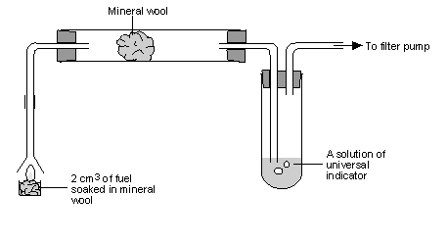

### What to do

1. Pour 125 cm3 of distilled water into the 250 cm3 flask and add 10 cm3 of universal indicator. Add one drop of 0.1 Msodium hydroxide solution and gently swirl the flask so that the colour of the solution is violet or at the most basic end of the universal indicator colour range.
2. Place 10 cm3 of this solution into the boiling tube.
3. Assemble the apparatus illustrated in Figure 1, attaching it to the filter pump with the vacuum tubing.
4. Place 2 cm3 of biodiesel onto a wad of mineral wool in the metal sample cup.
5. Turn on the water tap so the filter pump pulls air through the flask and ignite the biodiesel. Position the funnel directly over the burning fuel, so as to capture the fumes from the burning fuel.  Mark or note the position of the tap handle so you can run the pump at the same flow rate later in the experiment.
6. Allow the experiment to run until the universal indicator turns yellow and time how long this takes.
7. Record what happens in the funnel and in the glass tube containing the second piece of mineral wool.
8. Clean the apparatus, and repeat the experiment using 2 cm3 of kerosene (this is very similar to diesel fuel).

# Technician’s Guide

Requirements per group

**Investigation A - Is it cheaper to make your own biofuel from vegetable oil than to buy diesel?**

|  |  |
| --- | --- |
| 50 cm3 of one or more vegetable oils, dried (see below) | Separating funnel |
| Potassium methoxide (10 cm3 per oil sample) | Clamp stand, boss and clamp/ring |
| 5% Sodium chloride solution (10 cm3 per oil sample) | 10cm3 measuring cylinder |
| Large beaker | 100cm3 measuring cylinder |

**Investigation B - Waste not, want not. What, if any, are the advantages of making biodiesel from waste oil?**

|  |  |
| --- | --- |
| **Determination of FFAs** |  |
| 5 cm3 of filtered and dried oil | Propan-2-ol |
| 10cm3 measuring cylinder | 0.1% potassium hydroxide solution |
| Test tubes and test tube rack | 1 cm3 disposable Pasteur pipette |
| Thymol blue indicator |  |
| **Preparing the biodiesel** |  |
| 50 cm3 of one or more used vegetable oils, filtered and dried (see below) | Separating funnel |
| Potassium methoxide (10 cm3 per oil sample) | Clamp stand, boss and clamp/ring |
| 5% Sodium chloride solution (10 cm3 per oil sample) | 10cm3 measuring cylinder |
| Large beaker | 100cm3 measuring cylinder |

**Investigation C - How effective is biodiesel as a fuel?**

|  |  |
| --- | --- |
| **pH and Viscosity test** |  |
| Samples of one or more biodiesels (10 – 15 cm3) | Samples of the oils that the biodiesel was made from (10 – 15 cm3) |
| Test tubes and test tube rack) | pH paper and colour chart |
| Timer |  |
| **Enthalpy of combustion** |  |
| Samples of one or more biodiesels (3 cm3) | Samples of the oils that the biodiesel was made from (3 cm3) |
| Sample of kerosene (3 cm3) |  |
| 1 evaporating basin | Piece of cotton for making a wick (roughly 2 cm x 8 cm) |
| Piece of copper wire for forming the wick (roughly 10 cm) | 100cm3 measuring cylinder |
| Access to balance (2dp) | 1 thermometer |
| 1 copper calorimeter (aluminium/steel can may be substituted) | Cover for calorimeter/can with hole for thermometer |
| Heatproof mat with a hole in (or similar) | Draught shielding. |
| (possible need for access to fume cupboard) |  |

Apparatus for burning should be set up like this. The heatproof mat with the hole in can he held above the flame by clamps or simple by standing on objects of the right height.

There is no need to use this apparatus exactly as described. If you have another system to enable the measurement of enthalpy of combustion, that will be perfectly acceptable.

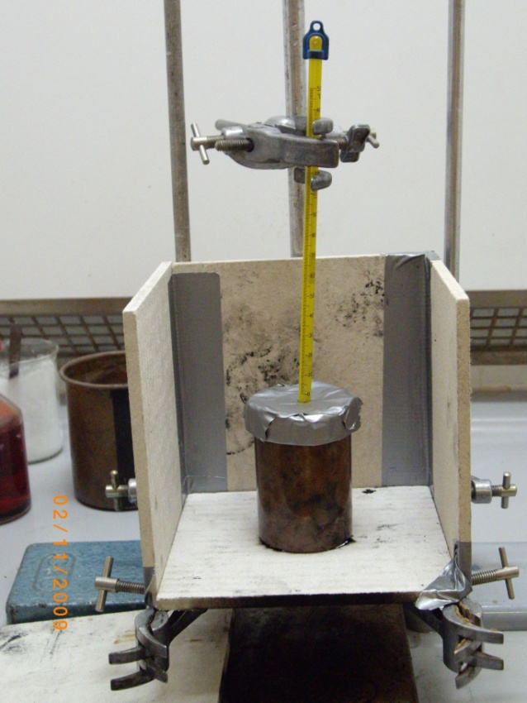The version of this set up shown in the picture (right) shows a ‘windbreak’ made from more heatproof mats held together with tape. This is just one possible way of avoiding draughts.

Burning the fuels will obviously make smoke. As soon as the desired temperature rise has been achieved, the flame should be extinguished – by putting a heatproof mat over the top of the evaporating basin.

If the fumes are becoming too much, the experiment can be carried out in a fume cupboard but the ventilation will affect the experiment so the fan should be left off until the heating is complete and it can then be switched on to remove the fumes.

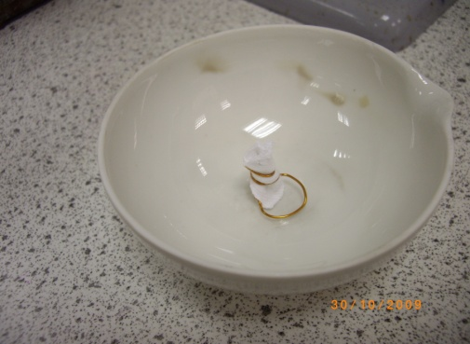Make up wicks by rolling the cotton fabric, then wrap a length of copper wire around it to hold it together making a foot so that it can stand in an evaporating basin (See photos below)

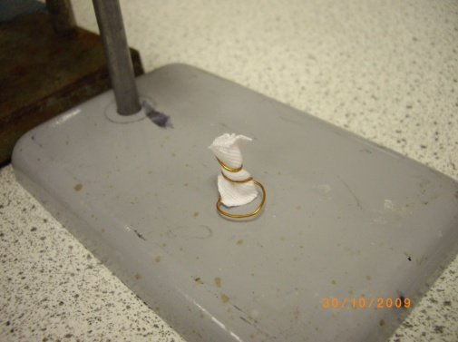

**Investigation D - What effect does biodiesel have on the environment?**

|  |  |
| --- | --- |
| Samples of one or more biodiesels (2 cm3) | Samples of the oils that the biodiesel was made from (2 cm3) |
| Sample of kerosene (2 cm3) |  |
| Vacuum pump | Mineral wool |
| Crucible or sample cup | Universal indicator solution |
| Sodium hydroxide (0.1 M) | Funnel and glass tubes set up as below. |



**Techniques**

**Filtering the oil**

|  |  |
| --- | --- |
| Used cooking oil | Large funnel |
| Large flask | muslin |
| Filter paper |  |

1. Filter the oil through a double layer of muslin to remove any debris from food preparation. The oil will still be cloudy after this treatment.
2. Now filter the cloudy oil through either a standard size coffee filter paper or through student grade filter paper. The oil will be a much clearer dark brown after this filtration.

(If you are filtering a large amount then the process takes time).

It is sensible to prepare 1 – 2 litres at a time as it will keep.

**Drying the oil**

There are 2 methods for this.

1) Place the oil in a beaker in an oven at 120°C overnight

OR

2) use magnesium sulphate

|  |  |
| --- | --- |
| Used cooking oil (filtered) | Anhydrous magnesium sulphate |
| Balance, weighing boat and spatula | muslin |
| Filter paper | Large flask with a stopper |
| clamp stand, boss head and clamp | A filter funnel and filter paper |

Shake the sample with 3g anhydrous magnesium sulphate/100 cm3 of oil to remove any residual water.

Leave overnight and then filter.

**Making the potassium methoxide**

Potassium methoxide is made in advance.

**Wear goggles and gloves**

### What you will need

|  |  |
| --- | --- |
| Balance (2dp), weighing boat and spatula | Potassium hydroxide |
| Methanol (200 cm3 per litre of oil) | 2 x 250 cm3 beakers |
| measuring cylinder | magnetic stirrer, |

### What you do:

1. Weigh out the amount of potassium hydroxide (strongly corrosive) determined from your calculations above.
2. Measure the calculated volume of methanol (highly flammable and toxic) and pour into a 250cm3 beaker
3. Pour the potassium hydroxide into the methanol and stir until dissolved.
4. This takes approximately 2 hours so you will need to use a magnetic stirrer
5. Some unreacted hydroxide may remain in the bottom of the beaker.
6. Bottle and label with toxic and corrosive pictograms.

The amount of potassium hydroxide will vary depending on:

The purity of the KOH

The amount of Free Fatty Acids in your used oil

For fresh oil, the potassium methoxide whould be made up with the following amounts of KOH per 200 cm3 of methanol

|  |  |
| --- | --- |
| KOH Assay (%) | Mass to Add to 1 Litre (g) |
| 85 | 5.8 |
| 90 | 5.5 |
| 92 | 5.3 |
| 100 | 4.9 |

For waste oil, you will need additional KOH as determined by the titration described in Investigation B

Risk Assessment: (based on HSE 5 Step Risk Assessment

|  |  |
| --- | --- |
| Activity assessed | Preparation and testing of biodiesel |
| *Date of assessment* | July 2014 |
| *SSERC_logo_new.jpgDate of review (****Step 5****)* |  |
| *School* |  |
| *Department* |  |

| Step 1 | Step 2 | Step 3 | | Step 4 | | |
| --- | --- | --- | --- | --- | --- | --- |
| *List Significant hazards here:* | *Who might be harmed and how?* | *What are you already doing?* | *What further action is needed?* | *Action by whom?* | *Action by when?* | *Done* |
| methanol-is Highly Flammable,  **Toxic** by ingestion, inhalation and skin absorption, It is particularly damaging to the eyes | Technician (possibly teacher) | In very well-ventilated area normally but in fume cupboard for large quantities or prolonged working with the compound. Use rubber or plastic gloves and eye protection. Beware repeated exposure.  Keep away from flames and all sources of ignition. Pressure can build up in bottles. |  |  |  |  |
| potassium hydroxide – **is Strongly corrosive solid** and solution and very harmful if swallowed. **Extremely dangerous to eyes** | Technician (possibly teacher) | Wear rubber gloves and goggles (BS EN166 3), even with dilute solutions. |  |  |  |  |
| potassium methoxide is toxic and corrosive | Technician/Teachers/pupils | Wear rubber or plastic gloves and eye protection, Use goggles ( BS EN 166 3) |  |  |  |  |
| Kerosine - **Harmful** if swallowed. May act as an **irritant.** | Technician/Teachers/pupils | Ensure good ventilation when using. Wear gloves goggles to BS EN 166 1 3. |  |  |  |  |

|  |
| --- |
| **Description of activity:**  Biodiesel can prepared from both fresh and waste (used) cooking oil by mixing with a concentrated alkaline solution and allowing the glycerol to settle from the resulting FAME (biodiesel). The biodiesel can be separated and then washed and dried.  Its pH and viscosity can be compared to the original starting oil.  The energy per gramme of biodiesel can be calculated and compared to that of the starting oil by burning samples in apparatus similar to that used for the Enthalpy of Combustion of alcohols. Care when using the apparatus due to risk of burning.  The energy in the biodiesel can also be compared to that in a fuel such as kerosene. |

|  |
| --- |
| **Additional comments:**  Kerosene can be burned instead of mineral diesel for comparative purposes.  **Mineral diesel must on no account be used in school as it contains benzene which is a banned carcinogen.**  See sheets for the design of the apparatus for burning samples and how to make the wick. Collect all solutions and keep for disposal. |

1. <http://iopscience.iop.org/1748-9326/8/3/034005/pdf/1748-9326_8_3_034005.pdf?_ga=1.6866101.626470151.1398941195> [↑](#footnote-ref-1)