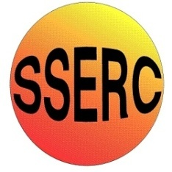

Chemical Demonstrations
Colour change chameleon

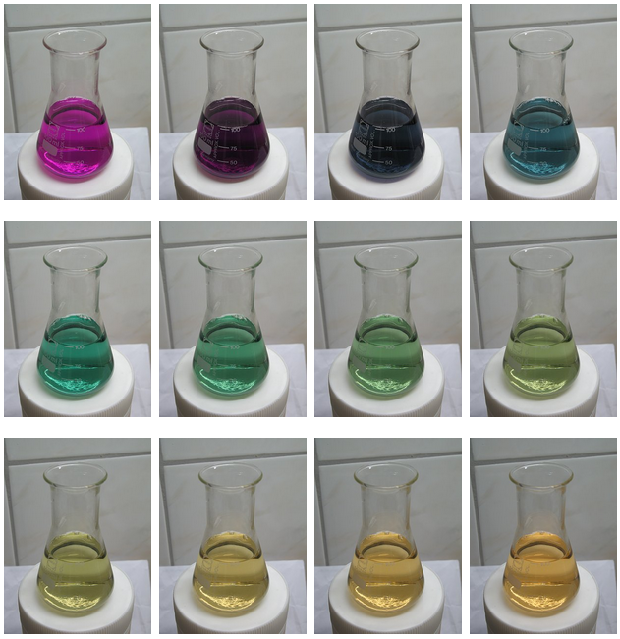
CfE Advanced Higher –
Inorganic and Physical Chemistry
Oxidation states of transition metals
Introduction
When a very dilute, alkaline solution of potassium manganate VII is slowly reduced by sucrose a beautiful range of colours is traversed as the manganese passes through different oxidation states, starting from purple/violet and ending in yellow/brown.
You will need
1 x 250 cm³ flask / beaker | magmestic stirrer (optional)
potassium manganate VII | Sodium hydroxide
sucrose

To Do
Preparation
a. 0.0025M potassium manganate VII solution – Dissolve 10mg of potassium manganate VII in 25 cm³ water
b. Make up 0.015M NaOH (0.6g in 1litre of distilled water)
Dissolve sucrose in the sodium hydroxide solution at a rate of 0.8g per 100 cm³ (2g in 250 cm³)
The demonstration
Place the flask of alkaline sucrose on the stirrer and pour in the potassium manganate VII.
Safety
Sodium hydroxide is corrosive so solutions should be made up with care.
Potassium manganate VII is a powerful oxidising agent. Keep away from flammable materials.
The solutions are of low hazard.
The solution will soon go from purple to blue and then from blue to green. Then, over the next few minutes, the green will slowly change to yellow.

Notes
If the reaction is going too fast, reduce the concentration of the hydroxide solution.
Adding too much manganate VII solution can make the solution too dark to see the colour changes clearly.
What is happening?
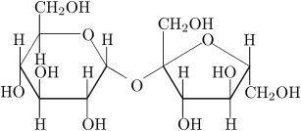
Manganate VII is slowly reduced by sugar in alkaline environments. Sugar is an organic compound, having many -OH groups, attached to carbon atoms, which also have a hydrogen atom attached directly to it. Such organic compounds, containing –C(H)(OH)– structures (secondary alcohol groups) are easily oxidized.
Sucrose
The oxidation of the –C(H)(OH)– structure is as follows, where the alcohol-group is oxidized to a ketone-group:
–C(H)(OH)– + 2OH– → –C(=O)– + 2H₂O + 2e
This reaction requires hydroxide ions. The observed speed of the reaction indeed is strongly depending on the concentration of sodium hydroxide. When a lot of sodium hydroxide is dissolved, e.g. a teaspoon full of solid, then the first part of the reaction only takes a few seconds instead of tens of seconds.
In alkaline environments, manganate VII ion first is reduced to manganate ion:
MnO₄– + e → MnO₄^{2–}
The left is deep purple, the right is deep green. When both are present, then light in the red end of the spectrum is absorbed by the green manganate, and at the same time, light at the blue end of the spectrum is absorbed by the violet manganate VII. This combination of absorptions make the solution almost appear black, hence the darkening at the start of the experiment. When almost all manganate VII is reduced to manganate, then the liquid looks beautifully deep green.
When there is excess sugar, then the manganate in turn is reduced further as follows:
MnO₄^{2–} + 2H₂O + 2e → MnO₂ + 4OH–
At the very low concentrations, used in this experiment, the MnO₂ does not precipitate, but a colloidal solution of hydrous MnO₂ is formed, which remains clear. Hydrous MnO₂ is brown, but at the low concentrations, used in this experiment, it is more yellow than brown.

